 |  | ISSN 0353-9555
STATISTICAL RELEASE |  | RS10
Number 053 - Year LXXIV, 29/02/2024
Labour Force Survey |  | SERB053 RS10 290224
Labour Force Survey, IV quarter 2023
In the fourth quarter 2023, number of the employed amounted to 2 870 200, and number of the unemployed to 288 200. Employment rate for the mentioned period amounted to 50.5%, while unemployment rate, in the same period, had the value of 9.1%.
Graph 1. Trend of employment/unemployment rates (in %), population 15+, 2021-2023
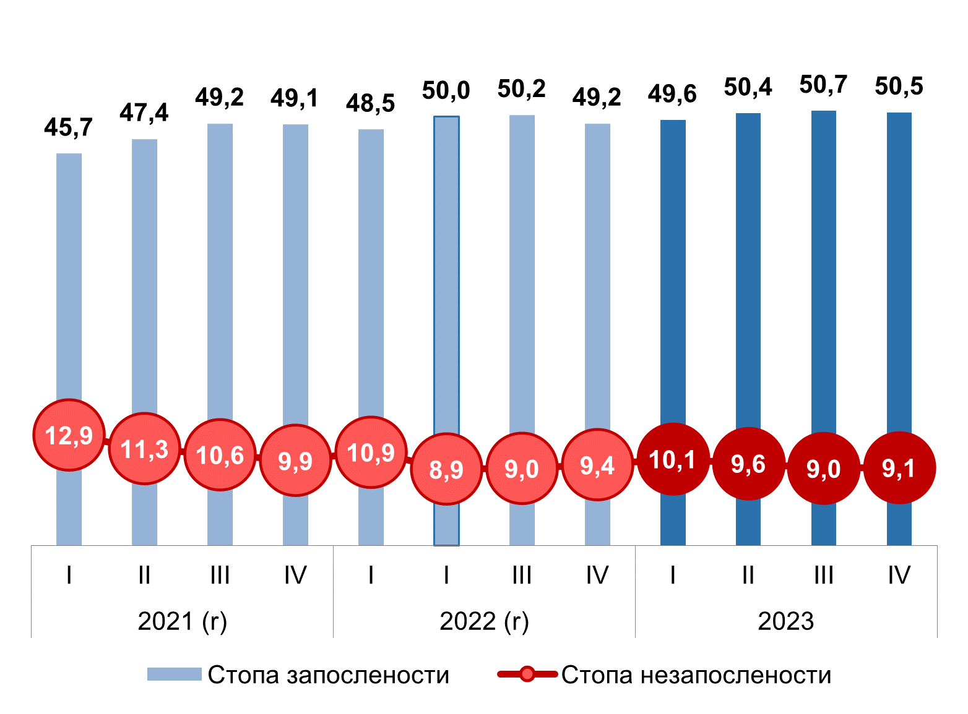
(r) revised data
Comparison with the same quarter of the previous year
According to the LFS data for the fourth quarter 2023, relative to the fourth quarter 2022, increased was active population and decreased was the population outside labour force. In scope of active population, noted was increased employment and decreased unemployment. In the fourth quarter, the number of the employed was 2 870 200, presenting the increase of 52 100 relative to the same quarter 2022. The number of the unemployed was decreased by 3 600 and amounted 288 200, which together with the employed presents the contingent of active population of 3 158 300. Population outside the labour force was decreased by 99 400 and in the observed quarter amounted to 2 524 000. Total number of population aged 15 and over amounted to 5 682 300, presenting the decrease of total number by 50 900.
The employment rate recorded a growth of 1.4 percentage points (p.p.) and recorded a value of 50.5%, while the unemployment rate was 9.1%, which represents a decrease of 0.3 p. p. compared to the fourth quarter of the previous year. The activity rate increased and the rate of the population not in the labour force fell by the same value of 1.3 p. p. and they amount to 55.6% and 44.4%, respectively.
Total increase in employment of 52 100 persons was recorded in both formal and informal employment. Total formal employment increased by 32 900 and amounted to 2 510 700 in the fourth quarter of 2023. Formal employment outside agriculture recorded an increase of 42 600, while formal employment in agriculture decreased by 9 700. Total informal employment amounted to 359 400 and on the inter-annual level, it recorded an increase of 19 200, of which 14 400 represents an increase in informal employment outside agriculture, and 4 700 in agriculture.
The rate of total informal employment is higher than in the fourth quarter of 2022 by 0.4 p. p. and amounted to 12.5%. The rate of informal employment outside agriculture increased by 0.4 p. p. and in the fourth quarter of 2023 it amounted to 6.8%, while in the agricultural sector it was higher by 1.9 p. p. and was 50.3%.
More favourable trends in the labour market compared to the fourth quarter of the previous year, which are reflected in the increase in employment and the decrease in the population outside the labour force, mainly refer to the female population, which in the observed quarter recorded a greater fluctuation of persons from the contingent of the population outside the labour force to the contingent of employed. In the fourth quarter, a significantly higher increase in the number of employed women was recorded, by 41 800 compared to men (+10,300), so the number of employed women was 1 310 400 and the number of employed men was 1 559 800. The number of the population out of the labour force, regarding females is lower by 77 200, and regarding male population by 22 100. In contrast to changes in the contingent of employed, the change in the number of unemployed persons shows an increase in the female population (9 800) and a decrease in the male population (13 400). Such developments led to the fact that in the fourth quarter of 2023, the number of unemployed women was 137 100, and the number of unemployed men was 151 000.
Belgrade Region and the Region of Southern and Eastern Serbia recorded an increase in employment and a decrease in unemployment and the population outside the labour force. In the Region of Vojvodina, there is a slightly different trend, which refers to the unemployed population, which recorded an increase of 15 500, while in the Region of Šumadija and Western Serbia, the trend is also different and shows a decrease in the employed population (-13 100 compared to the fourth quarter of the previous year). The employment rate increased the most in Vojvodina region (+2.3 p.p.) and in Belgrade region (+2.1 p.p.) and amounts to 51.1% and 56.1%, respectively. The increase in the employment rate in the Region of Southern and Eastern Serbia amounted to 1.4 p. p. and the rate of 45.4% is still the lowest, observed by regions. This rate in the Region of Šumadija and Western Serbia is lower by 0.3 p. p. and in the fourth quarter of 2023 it amounted to 48.8%.
The unemployment rate in the Belgrade region in the observed quarter was the lowest and amounted to 6.7%, which represents a decrease of 1.1 p. p. compared to the same quarter of the previous year. The highest unemployment rate was recorded in the Region of Southern and Eastern Serbia, so with a decrease of 1.0 p. p., amounted to 11.2%. The Region of Vojvodina and the Region of Šumadija and Western Serbia recorded unemployment rates of 9.2% and 9.9%, respectively.
The population of young people aged 15–24 in the fourth quarter of 2023 decreased by 6 200 persons compared to the same quarter of the previous year. The number of employed young people was 156 400, which represents a slight decrease of 700 people, while the number of unemployed people was 55 100, with an increase of 5 100 people compared to the same quarter of the previous year. The contingent of the young population outside the labour force decreased by 10 500 and in the fourth quarter of 2023 it amounted to 462 200.
The rate of NEET i.e. the share of young people aged 15-24 who neither work nor are in the process of education or training in the total population of young people, was 13.8% and compared to the same quarter of the previous year, it was higher by 2.0%.
In the population aged 15-29, the NEET rate was at the level of 17.4%, which represents an increase of 2.3 p. p. at the inter - annual level. The dominant influence on the year-on-year growth of the total NEET rate was the increase in this population category in the Region of South and East Serbia and in the Region of Šumadija and West Serbia in the population of women outside the labour force.
Comparison with the previous quarter
In the fourth quarter of 2023, compared to the third quarter of the same year, the total number of residents aged 15 and over decreased by 11 200 and amounted to 5 682 300, with a decrease in the number of employed by 18 400, and an increase in the number of unemployed by 2 500 and the number of the population outside the labour force by 4 700. The number of employed people in the fourth quarter of 2023 was 2 870 200, the number of unemployed 288 200, the number of the population outside the labour force 2 524 000, while the number of active (which includes employed and unemployed population together) amounted to 3 158 300.
The employment rate in the observed quarter was 50.5% and, compared to the previous quarter, it is lower by 0.2 p. p. A slight increase (of 0.1 p.p.) was recorded in the unemployment rate, as well as the rate of the population outside the labour force (0.2 p.p.), so these rates have values of 9.1% and 44.4%, respectively.
The total decrease in employment of 18 400 was predominantly influenced by the decrease in the number of employed in the male population, where that number is by 20 100 lower than in the third quarter, while the number of employed women is higher by 1 800. The number of employed men in the fourth quarter of 2023 was 1 559 800 and the employment rate was 57.0%, while the number of employed women was 1 310 400, with a rate of 44.5%. The slightly more favourable position of women on the labour market compared to the previous quarter is also noticeable in the contingent of the unemployed. The number of unemployed persons in the male population is higher by 4 500, while it is lower by 2 000 in the female population, which led to 151 000 unemployed men and 137 100 unemployed women in the fourth quarter of 2023. At the same time, the male unemployment rate increased by 0.3 p. p. and amounted to 8.8%, while the unemployment rate of women recorded a decrease of 0.1 p. p. and amounted to 9.5%.
As part of the overall reduction in the number of employed, the number of formally employed is lower by 7 900, and the number of informally employed by 10 400.
In the fourth quarter of 2023, the rate of total informal employment was 12.5%, which represents a decrease of 0.3 p. p. compared to the previous quarter. The rate of informal employment outside agriculture increased by 0.3%, while in agriculture it decreased by 3.2%.
Observed by region, the number of employed recorded the largest decrease in the Region of Šumadija and Western Serbia, by 27 200. A smaller decrease, of 8 400 employed, was recorded in the Region of Southern and Eastern Serbia, followed by a decrease of 3 200 in the Belgrade Region, while in the Region In Vojvodina, there was an increase in the number of employed by 20 300 compared to the previous quarter. Thus, the employment rate recorded an increase of 1.5 p. p. in the Region of Vojvodina, and it is lower by 1.7 p. p. in the Region of Šumadija and Western Serbia, by 0.6 p. p. in the Region of Southern and Eastern Serbia and by 0.2 p. p. in the Belgrade region. The region of Šumadija and Western Serbia recorded an increase in the unemployment rate and the rate of the population outside the labour force, for the same value of 1.1 p. p, while in the Region of Vojvodina both rates recorded a decline, the unemployment rate by 0.9 p. p. and the non-labour force population rate by 1.0 p. p. In the Belgrade region, in the fourth quarter, compared to the third quarter, the unemployment rate was slightly higher by 0.3 p.p., while the rate of the population outside the labour force remained unchanged. In the Region of South and East Serbia, the unemployment rate is lower by 0.2 p. p., while the rate of the population outside the labour force recorded an increase of 0.7 p. p.
The total number of persons aged 15-24 is lower by 1 300 compared to the previous quarter. The number of employed young people is lower by 10 500 and the number of young people outside the labour force is higher by 9 500. The mentioned trend led to a drop in the employment rate and at the same time an increase in the rate of the population outside the labour force by the same value of 1.5 p. p, as well as an increase in the unemployment rate of 1.1 p. p. compared to the third quarter of 2023.
The so-called NEET rate, which represents the share of young people aged 15-24 who neither work nor are in the process of education or training in the total population of young people (15‒24), recorded an increase of 0.9 p.p. in the quarter to quarter period.

Grades¹ are calculated from the first quarter of 2023 on the basis of demographic estimates for 2022 according to the final data from 2022 Census of Population, Households and Dwellings. Demographic estimates based on 2011 Census were used to calculate the grades as of the fourth quarter of 2022.
Due to the application of weights based on the most recent demographic indicators, the data from this statistical release are not comparable to previous data published in the same releases before 2023.
In order to ensure comparability, the data from 2021 and 2022 have been revised, based on a revision of demographic estimates according to the final results of 2022 Census.
This release compares data for the fourth quarter of 2023 with revised data from the fourth quarter of 2022 and data for the third quarter of 2023.
Revised data from 2021 have been updated in the database on the RZS website.
The post-census revision is carried out in accordance with the General Revision Policy of the RSO, which is fully aligned with the guidelines from the Manual on Revision Policy in the European Statistical System (ESS Guidelines on Revision Policy), which was adopted by the Committee of the European Statistical System (European Statistical System Committee).
The aim of the post-census revision of ARS data is to ensure comparability without breaking the time series.
Graph: Comparative overview of the most important LFS indicators (employment, unemployment and population outside of the labour force) for 2022 before (previous data) and after (revised data) the application of new weights

Explanation of terms:
Previous data - data based on a weighting system that implied the use of demographic estimates based on 2011 Census.
Revised data – data based on a weighting system that implies the use of demographic estimates based on 2022 Census.
¹ Ratings were calculated using the weights obtained by the calibration procedure.
For a more detailed explanation, see: https://publikacije.stat.gov.rs/G2017/Pdf/G20177069.pdf

Major indicators, fourth quarter 2023
Activity rate of people aged 15 and over in the fourth quarter 2023 amounted to 55.6%, the activity rates among men and women being 62.5% and 49.1%, respectively. The largest activity rate was recorded in Beogradski region (60.1%), followed by Region Vojvodine (56.2%), Region Sumadije i Zapadne Srbije, 54.2%, and in Region Juzne i Istocne Srbije 51.2%.
Employment rate of people aged 15 and over in the fourth quarter amounted to 50.5%, among men 57.0% and women 44.5%. The largest employment rate was noted in Beogradski region (56.1%), followed by Region Vojvodine (51.1%), and Region Sumadije i Zapadne Srbije (48.8%). Region Juzne i Istocne Srbije had the lowest value of employment rate (45.4%).
Informal employment rate in the mentioned quarter in all activities amounted to 12.5%. The informal employment rate in agricultural activities amounted to 50.3%, while in activities outside agriculture this rate amounted to 6.8%.
Unemployment rate of people aged 15 and over amounted to 9.1%, 8.8% for men and 9.5% for women. Observed on regional level, this rate was the lowest in Beogradski region (6.7%), followed by Region Vojvodine (9.2%), Region Sumadije i Zapadne Srbije (9.9%), and Region Juzne i Istocne Srbije (11.2%).
Table 1 Main indicators of labour market trend, Q4 2023
 | IV quarter 2023 | Changes relative to previous quarter |  | Changes relative to the same quarter of the previous year
 | (in thousand) | (in thousand) | % | (in thousand) | %
Total | 5682,3 | -11,2 | -0,2 | -50,9 | -0,9
Active | 3158,3 | -15,9 | -0,5 | 48,5 | 1,6
Employed | 2870,2 | -18,4 | -0,6 | 52,1 | 1,8
Formally employed. | 2510,7 | -7,9 | -0,3 | 32,9 | 1,3
Informally employed | 359,4 | -10,4 | -2,8 | 19,2 | 5,6
Unemployed | 288,2 | 2,5 | 0,9 | -3,6 | -1,2
Out of labour force | 2524,0 | 4,7 | 0,2 | -99,4 | -3,8
 | % | (p.p.)
Activity rate | 55,6 |  | -0,2 |  | 1,3
Employment rate | 50,5 |  | -0,2 |  | 1,4
Informal employment rate | 12,5 |  | -0,3 |  | 0,4
Unemployment rate | 9,1 |  | 0,1 |  | -0,3
Out of the labour force rate | 44,4 |  | 0,2 |  | -1,3
In the fourth quarter 2023, 11 512 households were interviewed, i.e. 28 288 persons aged 15 and over.
More detailed data can be obtained in the tables that are part of the Statistical Release on Labour Force Survey for the fourth quarter 2023 (RS10), on the address: http://publikacije.stat.gov.rs/G2024/Xls/G20241053.xlsx.

Methodological notes
Labour Force Survey (LFS) is the most complex and the only internationally comparable instrument for labour trends monitoring, registering demographic and socio–economic characteristics of population aged 15 and over.
The main aim of the survey is estimating the labour force volume, i.e. employed and unemployed population, where employment relates to work in both formal and informal sector.
Additionally, LFS deals with characteristics of employment (professional status of the employed persons, their activity, occupation, rights realized at work…) and unemployment (acquired education, duration of job seeking, previous working experience…), as well as characteristics of inactive population – their education, age, income source and readiness for involvement in labour market.
Persons (aged 15-89) who performed at least for an hour paid work (for cash or in kind) in the reference week, as well as persons who had an employment, but were temporarily absent from work in that week, are counted as employed persons.
Employment rate is the percentage share of employed in the total population aged 15 and over.
Informal employment is considered to be work in unregistered companies, work in registered companies without an employment contract, as well as the work of contributing family members.
Informal employment rate is the percentage share of informally employed in total employment.
Unemployed persons are the persons who, in the respective week, did no work for remuneration, who undertook active steps to find a job during four-week period preceding the respective week and who were able to start working in two-week time after the referent week.

Unemployment rate presents the percentage share of unemployed population in labour force (employed and unemployed).
Long-term unemployment rate presents the percentage share of the unemployed for one year and more, in labour force (employed and unemployed).
NEET rate – refers to share of persons aged 15 to 24 (оr 15 - 29) neither employed, nor in education, training, in total population of that age.
Active population (labour force) includes all employed and unemployed persons.

Activity rate (share of labour force) presents the percentage share of active population in the referent population aged 15 and over.
Out of the labour force population includes all persons in the observed population (aged 15 and over) who are not classified in employed and unemployed population. Out of the labour force population comprises students, pensioners, persons performing household tasks, as well as all other persons who performed no paid job in the observed week, did not actively seek a job and who were not able to start working in two-week time after the observed week.

Out of the labour force rate presents the percentage share of inactive population in total referent population aged 15 and over.
For more detailed description of the Survey and methodology of labour force, see https://data.stat.gov.rs/Metadata/24_Zarade/Html/240003_ESMS_G0_2021_1.html

Starting from 1999 the Statistical Office of the Republic of Serbia has not at disposal and may not provide available certain data relative to AP Kosovo and Metohija and therefore these data are not included in the coverage for the Republic of Serbia (total).

Contact: ars@stat.gov.rs, Phone: +381 11 2412 922, ext. 372
Published and printed by: Statistical Office of the Republic of Serbia, 11 050 Belgrade, MilanaRakica 5
Phone: +381 11 2412922 (telephone exchange) ● Fax: +381 11 2411260 ● www.stat.gov.rs
Responsible: Dr Miladin Kovačević, Director
Circulation: 20 • Periodicity: quarterly

