|  |  |  |
| --- | --- | --- |
| ZnakRZS | Statistical Office of the Republic of Serbia |  |
| ISSN 0353-9555 |
| **STATISTICAL RELEASE** | | **SV22** |
| Number 051 • Year LXXIV, 04/03/2024 | |
| **Statistics of Transport and Communications** | | SRB051 SV22 040324 |
|  |

First time registered road motor vehicles and trailers and

##### injury road accidents

##### - IV quarter 2023 -

From the total number of first-time registered road motor vehicles and trailers during the fourth quarter of 2023, produced in 2023, in relation to the total number of registered vehicles, the most represented were trailer vehicles (53.3%), while the number of new passenger cars was the smallest (16.1%).

During the 4th quarter of 2023, it can be noted that number of first-time registered buses and lorries decreased, while the number of other road motor vehicles and trailers increased. The greatest number of road motor vehicles was produced by the following manufacturers: *Volkswagen, Audi, Škoda, Opel*, *and Peugeot*.

Based on the results, it can be concluded that the most frequent number of freight vehicles was of the capacity up to 999 kg, as well as that the greatest number of such vehicles was with diesel motor energy.

Regarding the recently manufactured passengers’ vehicles, observed in percentages, and regarding motor energy used, those with petrol motor energy prevailed, as well as those with the engine size of up to 2000 cm3.

Total number of injury road accidents with casualties in the fourth quarter of 2023 increased by 7.7%, relative to the same period 2022. Increase of injury road accidents with persons killed outside built-up areas amounted to 5.6%.

Number of casualties in the fourth quarter of 2023 was increased by 10.2%, respective to the same period 2022, and number of injured persons within built-up areas increased by 7.0%.

The number of pedestrians killed in the fourth quarter of 2023 is by 37.1% higher than in the same quarter last year.

**1a. Age structure of first-time registered road motor vehicles and trailers**

|  |  |  |  |  |  |  |  |  |
| --- | --- | --- | --- | --- | --- | --- | --- | --- |
|  | Mopeds | Motorcycles | Passengers cars | Buses | Lorries (trucks) | Trailers and semi-trailers | Special purpose motor vehicles | Agricultural tractors |
|  |  |  |  |  |  |  |  |  |
| **Total** | **206** | **722** | **39114** | **222** | **5778** | **2052** | **315** | **2546** |
| Older than 2 years | 62 | 373 | 32287 | 143 | 3865 | 914 | 192 | 1826 |
| Manufactured in 2022 | 43 | 43 | 518 | 5 | 90 | 44 | 19 | 121 |
| Manufactured in 2023 | 101 | 306 | 6309 | 74 | 1823 | 1094 | 104 | 599 |

Source: Ministry of the Interior.

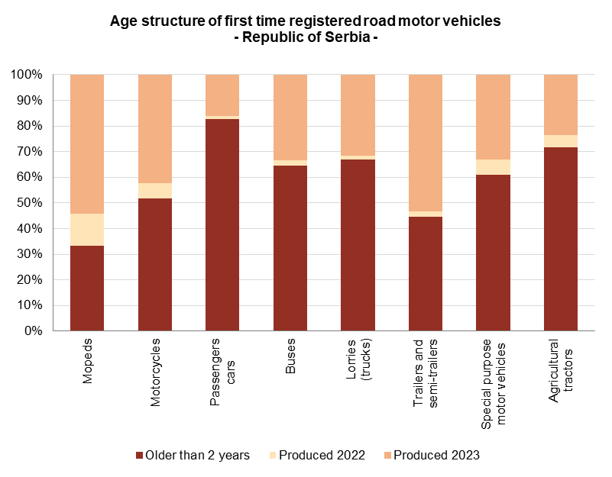

**1. First time registered road vehicles and trailers**

|  |  |  |  |  |  |  |  |  |  |  |  |  |  |
| --- | --- | --- | --- | --- | --- | --- | --- | --- | --- | --- | --- | --- | --- |
|  | IV quarter 2022 | | | | | | IV quarter 2023 | | | | | | IV quarter 2023  IV quarter 2022 |
| Total | Grad Beograd | Region Vojvodine | Region Šumadije i Zapadne Srbije | Region Južne i Istočne Srbije | Region Kosovo i Metohija | Total | Grad Beograd | Region Vojvodine | Region Šumadije i Zapadne Srbije | Region Južne i Istočne Srbije | Region Kosovo i Metohija |
|  |  |  |  |  |  |  |  |  |  |  |  |  |  |
| Mopeds | 131 | 38 | 40 | 20 | 33 | - | 186 | 42 | 67 | 38 | 39 | - | 142.0 |
| Motorcycles | 564 | 188 | 152 | 137 | 87 | - | 722 | 254 | 185 | 138 | 145 | - | 128.0 |
| Passengers cars | 36593 | 12213 | 8947 | 9789 | 5629 | 15 | 39114 | 14052 | 9378 | 9823 | 5861 | - | 106.9 |
| Buses | 277 | 118 | 56 | 48 | 55 | - | 222 | 109 | 44 | 38 | 31 | - | 80.1 |
| Lorries (trucks) | 6015 | 2629 | 1155 | 1662 | 569 | - | 5778 | 2581 | 1126 | 1444 | 627 | - | 96.1 |
| Trailers and semi-trailers | 1942 | 463 | 595 | 601 | 283 | - | 2052 | 465 | 621 | 641 | 325 | - | 105.7 |
| Special purpose motor vehicles | 301 | 85 | 125 | 58 | 33 | - | 315 | 75 | 103 | 96 | 41 | - | 104.7 |
| Agricultural tractors | 2449 | 220 | 664 | 1102 | 459 | 4 | 2546 | 265 | 516 | 1101 | 664 | - | 104.0 |

Source: Ministry of the Interior.

**2. First time registered lorries by load capacity**

|  |  |  |  |  |
| --- | --- | --- | --- | --- |
| Load capacity (kg) | IV quarter 2022 | | IV quarter 2023 | |
| Total | up to 2 years | Total | up to 2 years |
|  |  |  |  |  |
| **Total** | **6015** | **2367** | **5778** | **1913** |
| Up to 999 | 3678 | 1591 | 3418 | 1214 |
| 1000-1499 | 1431 | 442 | 1473 | 419 |
| 1500-2999 | 150 | 27 | 162 | 33 |
| 3000-4999 | 120 | 52 | 109 | 49 |
| 5000-6999 | 78 | 18 | 91 | 30 |
| 7000-9999 | 125 | 46 | 139 | 45 |
| 10000-14999 | 143 | 36 | 143 | 29 |
| 15000 and over | 290 | 155 | 243 | 94 |

Source: Ministry of the Interior.

**3. First time registered lorries by type of motor energy**

|  |  |  |  |  |
| --- | --- | --- | --- | --- |
| Type of motor energy | IV quarter 2022 | | IV quarter 2023 | |
| Total | up to 2 years | Total | up to 2 years |
|  |  |  |  |  |
| **Total** | **6015** | **2367** | **5778** | **1913** |
| Petrol | 320 | 300 | 254 | 237 |
| Diesel1) | 5130 | 1750 | 4924 | 1374 |
| Petrol-LPG | 404 | 215 | 353 | 246 |
| Others | 161 | 102 | 247 | 56 |

Source: Ministry of the Interior.

1) Diesel motor fuel includes Diesel and Euro diesel.

**4. First time registered passengers’ cars by engine size and the most dominant type of motor energy**

|  |  |  |  |  |
| --- | --- | --- | --- | --- |
| Size of engine (cm3) | IV quarter 2022 | | IV quarter 2023 | |
| Total | up to 2 years | Total | up to 2 years |
|  |  |  |  |  |
| **Total** | **36593\*** | **5075\*** | **39114** | **6827** |
|  | motor energy - petrol | | motor energy - petrol | |
| **Total** | **12379** | **2793** | **12745** | **3011** |
| Up to 1399 | 8221 | 1590 | 8428 | 1760 |
| 1400-1999 | 3906 | 1130 | 4067 | 1187 |
| 2000 and more | 252 | 73 | 250 | 64 |
|  | motor energy - diesel1) | | motor energy - diesel1) | |
| **Total** | **21291** | **992** | **21840** | **1403** |
| Up to 1399 | 1957 | 30 | 1629 | 7 |
| 1400-1999 | 17786 | 871 | 18622 | 1328 |
| 2000 and more | 1548 | 91 | 1589 | 68 |

Source: Ministry of the Interior.

*) Corrected data.

1) Diesel motor fuel includes Diesel and Euro diesel.

**5. Number of injury road accidents with casualties1)2)**

|  |  |  |  |  |  |  |
| --- | --- | --- | --- | --- | --- | --- |
| Location of accidents | IV quarter 2022 | | | IV quarter 2023 | | |
| Total injury accidents | with persons killed | with persons injured | Total injury accidents | with persons killed | with persons injured |
|  |  |  |  |  |  |  |
| **Total** | **3437** | **129** | **3308** | **3702** | **146** | **3556** |
| Within built-up areas - total | 2655 | 58 | 2597 | 2824 | 71 | 2753 |
| Outside built-up areas - total | 782 | 71 | 711 | 878 | 75 | 803 |

Source: Ministry of the Interior.

1) Without data for Kosovo and Metohia.

2) The number of traffic accidents with injured and killed persons.

**6. Number of casualties1)2)**

|  |  |  |  |  |  |  |  |  |  |  |
| --- | --- | --- | --- | --- | --- | --- | --- | --- | --- | --- |
| Location of accidents | IV quarter 2022 | | | | | IV quarter 2023 | | | | |
| Total casualties | killed | injured | | | Total casualties | killed | injured | | |
| total | seriously | slightly | total | seriously | slightly |
|  |  |  |  |  |  |  |  |  |  |  |
| **Total** | **4790** | **138** | **4652** | **782** | **3870** | **5278** | **155** | **5123** | **927** | **4196** |
| Within built-up areas - total | 3520 | 60 | 3460 | 545 | 2915 | 3777 | 74 | 3703 | 630 | 3073 |
| Outside built-up areas - total | 1270 | 78 | 1192 | 237 | 955 | 1501 | 81 | 1420 | 297 | 1123 |

Source: Ministry of the Interior.

1) Without data for Kosovo and Metohia.

2) It refers to the number of victims according to the place of the event and the type of injury.

**7. Number of road traffic injuries1)2)**

|  |  |  |  |  |  |  |  |  |
| --- | --- | --- | --- | --- | --- | --- | --- | --- |
|  | IV quarter 2022 | | | | IV quarter 2023 | | | |
| Driver | Passenger | Pedestrian | Others | Driver | Passenger | Pedestrian | Others |
|  |  |  |  |  |  |  |  |  |
| **Total number** | **2498** | **1427** | **859** | **6** | **2739** | **1628** | **904** | **7** |
| Killed | 80 | 23 | 35 | - | 80 | 27 | 48 | - |
| Injured | 2418 | 1404 | 824 | 6 | 2659 | 1601 | 856 | 7 |

Source: Ministry of the Interior.

1) Without data for Kosovo and Metohia.

2) Refers to the number of victims according to the category of event participants.

|  |
| --- |
|  |

Contact: [roksalana.djordjevic@stat.gov.rs](mailto:roksalana.djordjevic@stat.gov.rs), phone: +381 11 329-02-42

Published and printed by: Statistical Office of the Republic of Serbia, Milana Rakića 5, Belgrade

Phone: +381 11 2412922 ● Fax: +381 11 2411260 ● stat.gov.rs

Responsible: Dr Miladin Kovačević, Director

Circulation: 20 • Issued quarterly