 | Republic of Serbia  Statistical Office of the Republic of Serbia | ISSN 0353-9555
STATISTICAL RELEASE |  | RS10
Number 327 - Year LXXIII, 30.11.2023.
Labour Force Survey |  | SERB327 RS10 301123
Labour Force Survey, III quarter 2023
In the third quarter of 2023, the number of the employed was 2 888 500, and the number of the unemployed was 285 700. The employment rate for the given period was 50.7%, while the unemployment rate was 9.0%.
Graph 1. Employment/unemployment rates (in %), population 15+, 2021-2023
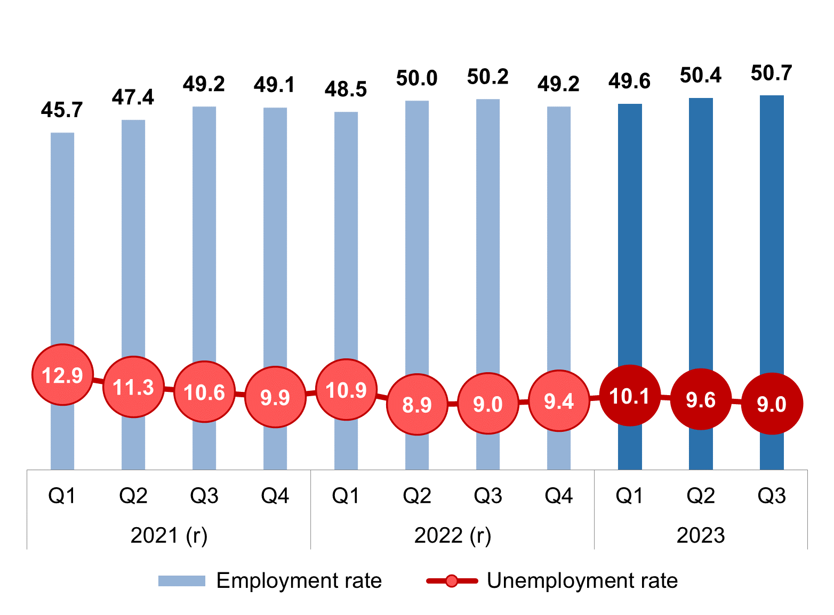
(r) Revised data.
Comparison with the same quarter of the previous year
According to the data from the Labour Force Survey, in the third quarter of 2023, compared to the third quarter of the previous year, there were negligible changes in the labour market regarding three main contingents of the population on the labour market. There was a slight increase in the employment rate (0.5 percentage points- p.p.) and a decrease in the rate of the population outside the labour force for 0.7 p.p., while the unemployment rate remained unchanged.
Compared to the third quarter of 2022, total population aged 15 and over decreased by 56 900 and in the third quarter of 2023 it amounted to 5 693 500. The number of active persons increased by 3 900, and the contingent of the population outside the labour force decreased by 60 800. The number of active persons in the third quarter of 2023 was 3 174 200, and the number of the population outside the labour force was 2 519 300. Within the contingent of the active population, the so-called labour force, the number of the employed increased by 3 000 and the number of the unemployed by 900 persons. Thus, the number of the employed in the third quarter was 2 888 500, and the number of unemployed was 285 700.
Within total employment, there was an increase in formal employment and a decrease in informal employment. Total formal employment increased by 16 400 and amounted to 2 518 700. Formal employment increased dominantly in non-agricultural activities (33 300), while in the agricultural sector there was a decrease in the number of formally employed (16 900). Total informal employment (369 900 persons), year – on - year, decreased by 13 300, of which 6 700 represents a decrease in agricultural activities, and 6 600 in non-agricultural activities.
The rate of total informal employment is lower compared to the third quarter of 2022 by 0.5 p.p. and in the third quarter of 2023 it was 12.8%. Informal employment outside agriculture is lower by 0.3 p.p. and in the third quarter of 2023 it was 6.5%, while in the agricultural sector it was higher by 1.4 p.p. and amounted to 53.5%.
Observed by gender, the number of active persons decreased by 6 700 in the male population and in the third quarter of 2023 it amounted at 1 726 400. Within this contingent, there was a decrease in the number of employed persons by 8 500 and an increase in the number of unemployed males by 1 800. In the third quarter of 2023, there were 1 579 900 employed and 146 500 unemployed men. In the female population, however, there was an increase in the number of active persons by 10 600, primarily due to an increase in employment by 11 500 persons. The number of active women was 1 447 800, and the number of employed women was 1 308 600. At the same time, the number of the population outside the labour force in both sexes recorded a decrease, namely by 21 800 in the male population and by 39 000 in the female population. The number of population outside the labour force in the male population was 1 014 500 and in the female population 1 504 900.
Observed by territory, all regions recorded a slight increase in the employment rate, with the exception of Vojvodina Region, where a decrease of 0.9 p.p. was recorded. The most noticeable increase in the employment rate was recorded in Region Šumadija i Zapadna Srbija (1.6 p.p.). At the same time, Vojvodina Region is the only one to record an increase in the unemployment rate by 3.2 p. p, while the other three regions achieve a decrease in the mentioned rate (the largest in Region Šumadija i Zapadna Srbija, 1.6 p. p.). The rate of the population outside the labour force is lower in all regions compared to the same quarter of 2022. In Vojvodina Region, this rate is lower by 1.0 p. p., while the smallest decrease was achieved in the Beogradski Region (- 0.2 p. p.).
In the third quarter of 2023, the population of young people aged 15-24 decreased by 7 100 compared to the same quarter of the previous year. The number of young people outside the labour force decreased by 4 500, the number of the unemployed by 2 600, while the number of the employed young people remained unchanged. Thus, the number of employed young people in the observed quarter was 166 900, the number of unemployed was 55 400, and the number of the population outside the labour force was 452 700.
The share of the young people aged 15-24 who neither work nor are in the process of education or training in the total youth population, i.e. the NEET rate, was 12.8% and compared to the same quarter of the previous year, it is lower by 0.7%. In the population aged 15-29, the NEET rate was at the level of 15.8%, which represents a slight increase of 0.4 p. p. in the observed period.
Comparison with the previous quarter
In the third quarter of 2023, compared to the second quarter, the total population aged 15 and over decreased by 11 300 and amounted to 5 693 500. The number of unemployed persons, which in the third quarter of 2023 was 285 700 decreased by 20 900, the number of people outside the labour force was 2 519 300 and recorded a decrease by 2 300. The number of employed persons increased by 11 900 and amounted to 2 888 500. Such developments in the labour market led to an increase in the employment rate by 0.3 p. p., reducing the unemployment rate by 0.6 p.p., while the rate of the population outside the labour force remained unchanged. Rate of employment in third quarter amounted to 50,7%, rate of unemployment 9,0%, while outside the labour force population rate was at level of 44,2%.
In the male population, there was a decrease in the number of employed persons (1 300) and the number of unemployed persons (10 500), as well as an increase in the number of the population outside the labour force by 6 200. In the third quarter of 2023, there were 1 579 900 employed men, 146 500 unemployed and 1 014 500 out of the labour force. In contrast to the male population, in the female population, the contingent of the employed recorded an increase of 13 200, the contingent of the population outside the labour force decreased by 8 600, as well as the number of unemployed that also decreased, as in the male population, by 10 400. In the third quarter of 2023, there were 1 308 600 employed, 139 200 unemployed, and 1 504 900 women out of the labour force.
Within the overall increase in the number of employees by 11 900, informal employment increased by 15 500, while formal employment decreased by 3 600. Quarter-on-quarter increase of informal employment was concentrated in the agricultural sector (growth of 16 200), which is expected considering seasonality of agricultural works, while other sectors of activity (together) recorded a slight decrease in informal employment (700). At the same time, the total number of formally employed is lower by 3 600, with a decrease of 7 400 in non-agricultural sector, and an increase of 3 800 in agricultural sector.
An interregional comparison with the previous quarter shows an increase in the employment rate in all regions (the highest in Region Južna i Istočna Srbija by 2.0 p.p.), except in Region Vojvodina, where a decrease in this rate by 1.9 p.p. was recorded. The unemployment rate is growing in Region Vojvodina by 2.2 p. p. while it is recording a decline in the remaining three regions. The largest decrease in the unemployment rate was in the Region Južna i Istočna Srbija (2.4 p.p.), where at the same time a decrease in the rate of the population outside the labour force by 0.8 p.p. was recorded. Region Vojvodina recorded the highest increase in the rate of the population outside the labour force (0.7 p.p.), while in Beogradski Region this rate remained the same as in the second quarter of 2023.
The total number of population aged 15-24 is lower by 1 300 compared to the previous quarter. The number of active young people increased by 9 100, and the number of the population outside the labour force decreased by 10 500. Such a trend led to an increase in the employment rate by 1.0 p. p. as well as unemployment rate by 0.2 p. p., while the rate of the youth population outside the labour force is lower by 1.4 p. p.
The so-called NEET rate (15-24) in the quarter – on - quarter period increased by 1.2 p. p.

Estimates¹ were calculated starting from the first quarter of 2023 on the basis of demographic estimates for 2022, according to final results of 2022 Population Census. Demographic estimates based on 2011 Census were, for the last time, used to calculate the grades for the fourth quarter of 2022.
Due to the application of weights based on the most recent demographic indicators, the data from this statistical release are not comparable to previous data published in the same statistical releases before 2023.
In order to ensure comparability, data from 2021 and 2022 have been revised, on the basis of the revision of demographic estimates according to the final results of 2022 Census.
This release compares data for the third quarter of 2023 with the revised data from 2022 and the data for the second quarter of 2023.
Revised data from 2021 have been updated in the database on SORS website.
The post-census revision is carried out in accordance with the General Audit Policy of the Statistical Office of the Republic of Serbia, which is fully aligned with the guidelines from the Manual on Revision Policy in the European Statistical System (ESS Guidelines on Revision Policy), which was adopted by the European Statistical System Committee.
The goal of post-census revision of LFS data is to ensure comparability of data without interrupting the time series.
Graph: Comparative overview of the most important LFS indicators (employment, unemployment and population outside the labour force) for the year 2022 before (previous data) and after (revised data) the application of new weights

Explanation of terms:
Previous data - data based on a weighting system that implied the use of demographic estimates based on 2011 Census.
Revised data - data based on a weighting system that implies the use of demographic estimates based on 2022 Census.
¹⁾ Estimates were calculated using the weights obtained by the calibration procedure. For a more detailed explanation, see: https://publikacije.stat.gov.rs/G2017/PdfE/G20177069.pdf

Major indicators, third quarter of 2023
Activity rate of people aged 15 and over in the third quarter of 2023 amounted to 55.8%, where the activity rate of men and women was 63.0% and 49.0%, respectively. The largest activity rate was recorded in Beogradski Region (60.1%). In Region Šumadija i Zapadna Srbija this rate recorded value of 55.3%, in Region Vojvodina, 55.2%, and in Region Južna i Istočna Srbija, 51.9%.
Employment rate of people aged 15 and over amounted to 50.7%, among men 57.6% and women 44.3%. The largest employment rate was noted in Beogradski region (56.3%), followed by Region Šumadija i Zapadna Srbija, 50.5% and Region Vojvodina, 49.6%. Employment rate in Region Južna i Istočna Srbija had the lowest value (46.0%).
Informal employment rate in the mentioned quarter in all activities amounted to 12.8%. The informal employment rate in agricultural activities amounted to 53.5%, while in activities outside agriculture this rate amounted to 6.5%.
Unemployment rate of people aged 15 and over amounted to 9.0%, specifically 8.5% for men and 9.6% for women. Observed on regional level, this rate was the lowest in Beogradski Region (6.4%), followed by Region Šumadija i Zapadna Srbija, 8.8%. Somewhat higher rate was recorded in Region Vojvodina, 10.1%, as well as in Region Južna i Istočna Srbija, 11.4%.
Table 1 Main indicators of labour market trend, Q3 2023
 | Q3 2023 | Changes relative to previous quarter |  | Changes relative to same quarter of the previous year
 | (in thousand) | (in thousand) | % | (in thousand) | %
Population 15+ | 5693.5 | -11.3 | -0.2 | -56.9 | -1.0
Active | 3174.2 | -9.0 | -0.3 | 3.9 | 0.1
Employed | 2888.5 | 11.9 | 0.4 | 3.1 | 0.1
Formally employed | 2518.7 | -3.6 | -0.1 | 16.4 | 0.7
Informally employed | 369.9 | 15.5 | 4.4 | -13.3 | -3.5
Unemployed | 285.7 | -20.9 | -6.8 | 0.9 | 0.3
Outside the labour force | 2519.3 | -2.3 | -0.1 | -60.8 | -2.4
 | % | (p.p.)
Activity rate | 55.8 |  | 0.0 |  | 0.7
Employment rate | 50.7 |  | 0.3 |  | 0.5
Informal employment rate | 12.8 |  | 0.5 |  | -0.5
Unemployment rate | 9.0 |  | -0.6 |  | 0.0
Outside the labour force rate | 44.2 |  | 0.0 |  | -0.7
In the third quarter of 2023, the Survey was conducted on the sample of 11 423 households, i.e. 24 959 persons aged 15 and over.
Detailed data are available in the tables being part of the statistical release from the Labour Force Survey for the second quarter 2023 (RS10), at: http://publikacije.stat.gov.rs/G2022/Xls/G20231327.xlsx.

Methodological notes
Labour Force Survey (LFS) is the most complex and the only internationally comparable instrument for labour trends monitoring, registering demographic and socio–economic characteristics of population aged 15 and over.
The main aim of the survey is estimating the labour force volume, i.e. employed and unemployed population, where employment relates to work in both formal and informal sector.
Additionally, LFS deals with characteristics of employment (professional status of the employed persons, their activity, occupation, rights realized at work…) and unemployment (acquired education, duration of job seeking, previous working experience…), as well as characteristics of outside the labour force population – their education, age, income source and readiness for involvement in labour market.
Persons (aged 15-89) who performed at least for one hour paid work (for cash or in kind) in the reference week, as well as persons who had an employment, but were temporarily absent from work in that week, are counted as employed persons.
Employment rate is the percentage share of employed in the total population aged 15 and over.
Informal employment is considered to be work in unregistered companies, work in registered companies without an employment contract, as well as the work of unpaid family workers.
Informal employment rate is the percentage share of informally employed in total employment.
Unemployed persons are the persons who, in the respective week, did no work for remuneration, who undertook active steps to find a job during four-week period preceding the respective week and who were able to start working in two-week time after the referent week.

Unemployment rate presents the percentage share of unemployed population in labour force (employed and unemployed).
Long-term unemployment rate presents the percentage share of the unemployed for one year and more, in labour force (employed and unemployed).
NEET rate – refers to share of persons aged 15 to 24 (or 15 - 29) neither employed, nor in education, training, in total population of that age.
Active population (labour force) includes all employed and unemployed persons.

Activity rate (share of labour force) presents the percentage share of active population in the referent population aged 15 and over.
Outside the labour force population includes all persons in the observed population (aged 15 and over) who are not classified in employed and unemployed population. Out of the labour force population comprises students, pensioners, persons performing household tasks, as well as all other persons who performed no paid job in the observed week, did not actively seek a job and who were not able to start working in two-week time after the observed week.

Outside the labour force rate presents the percentage share of outside the labour force population in total referent population aged 15 and over.
More detailed description of the Survey methodology can be found at the link https://data.stat.gov.rs/Metadata/24_Zarade/Html/240003_ESMS_G0_2021_3.html

Starting from 1999 the Statistical Office of the Republic of Serbia has not at disposal and may not provide available certain data relative to AP Kosovo and Metohija and therefore these data are not included in the coverage for the Republic of Serbia (total).

Contact: ars@stat.gov.rs, Phone: +381 11 2412 922, ext. 372
Published and printed by: Statistical Office of the Republic of Serbia, 11 050 Belgrade, MilanaRakica 5
Phone: +381 11 2412922 (telephone exchange) ● Fax: +381 11 2411260 ● stat.gov.rs
Responsible: Dr Miladin Kovačević, Director
Circulation: 20 • Periodicity: quarterly

