 | Republic of Serbia  Statistical Office of the Republic of Serbia | ISSN 0353-9555
STATISTICAL RELEASE |  | RS10
Number 154 - Year LXXIII, 31.08.2023.
Labour Force Survey |  | SERB154 RS10 090623
Labour Force Survey, II quarter 2023
In the second quarter 2023 the number of employed persons amounted to 2 876 600, and that of unemployed persons to 306 600. The employment rate for the observed period was 50.4%, and the unemployment rate was 9.6%.
Graph 1. Employment/unemployment rates (in %), population 15+, 2022-2023
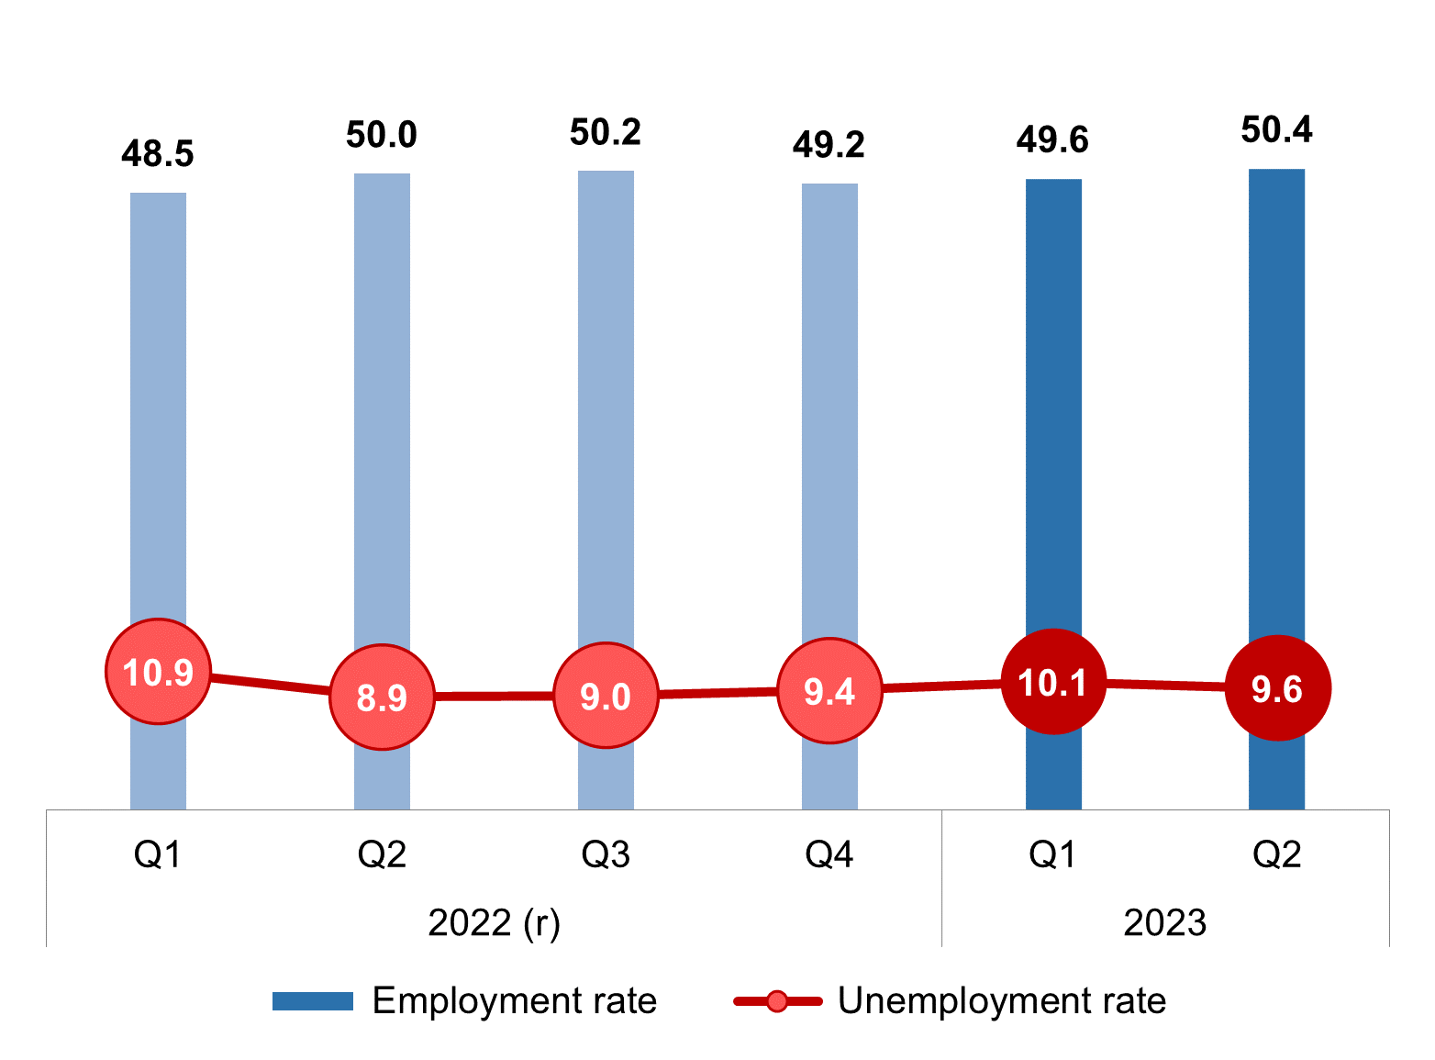
(r)-Revised data.
Comparison with the same quarter of the previous year
The data of the Labour Force Survey indicate that in the second quarter 2023, relative to the second quarter 2022, there was an increase both in the employment rate, by 0.5 p.p. and unemployment rate by 0.7 p.p. and that the rate of the population outside the labour force decreased by 1.0 p.p.
The total observed population (population aged 15 and over) decreased in the interannual period by 62 700, and amounts to 5 704 800. The contingent of the population outside the labour force in the second quarter 2023, relative to the second quarter 2022, droped by 82 700, and amounts to 2 521 600, while the contingent of active population increased by 20 000. Within the contingent of active population, the number of unemployed persons increased by 25 500, while the number of employed persons was slightly lower, by 5 500.
Within total employment the number of formally employed persons increased by 33 300, and amounts to 2 522 300. The number of informally employed persons decreased by 38 800, and amounts to 354 300. The number of informally employed persons outside agriculture went down by 25 300, while that of informally employed persons outside agriculture went down by 13 500.

The rate of total informal employment in the second quarter 2023 amounted to 12.3% and, relative to the second quarter 2022, was down by 1.3 p.p. The rate of informal employment outside agriculture was 6.5%, while the same rate in agriculture amounted to 52.0%, and when compared with the same period of the previous year, both rates decreased, by 1.0 p.p. and 1.3 p.p. respectively).
Observed by sex, the data for the second quarter 2023 indicate that the number of employed persons among the female population increased by 20 700, and that the number of employed men decreased by 26 200. The number of unemployed persons noted growth in both sexes, 7 900 unemployed women and 17 600 unemployed men, relative to the same quarter of the previous year.
Observed territorially, the largest unemployment growth (4.1 p.p.) was followed at the same time by the largest fall of employment of 2.5 p.p. recorded in Region Južne i Istočne Srbije. At the international level, the employment rate recorded the largest growth in Region Vojvodine (1.9 p.p.), followed by Beogradski Region where the employment rate increased by 1.4 p.p. and by Region Šumadije i Zapadne Srbije with an increase of 0.4 p.p.
The population of youth aged 15−24 in the second quarter 2023 decreased by 8 000 persons, and amounts to 676 400. Relative to the second quarter 2022, the number of employed youth decreased by 10 400, amounting to 160 600, while the number of unemployed youth increased by 14 300, now amounting to 52 700. In the same period, the contingent of youth population outside the labour force fell by 11 900, to 463 200.
The so-called NEET rate, i.e. the share of young people aged 15−24 who are neither in employment, education or training in the total population was 11.7%, which, relative to the second quarter 2022, represents a decrease of 0.8 p.p. In the population aged 15−29 the NEET rate was 13.8%, recording an interannual increase of 0.1 p.p.
Comparison with the previous quarter
In the second quarter 2023, relative to the first quarter 2023, employment increased by 39 000, unemployment decreased (-10 600) and so did the outside the labour force population (-39 600), which led to a higher employment rate by 0.8 p.p, lower unemployment rate by 0.4 p.p. and lower rate of the outside labour force population by 0.6 p.p.
Observed by sex, employment increase is more noticeable in the male population, where the number of employed persons is higher by 25 500 than in the previous quarter, while the mentioned increase in the female population was 13 500. Employment in the male population increased due to the decrease in unemployment and outside the labour force population. The male population on interquarterly level saw a fall of the number of the unemployed by 12 100 and of the outside the labour population by 18 900. The female population, in the second quarter 2023 relative to the second quarter of the same year, saw a decrease in the contingent of the outside the labour force population, by 20 700 and an increase of the number of employed persons, by 13 500, as well a sligth increase in the number of unemployed persons, 1 500.
Within total employment that increased by 39 000 in the second quarter 2023, relative to the first quarter, growth was primarily noted in formal employment, by 34 000, and in informal employment, by 4 900.
The largest employment growth was recorded in Region Vojvodine (by 28 500) which conditioned employment rate growth by 2.0 p.p. Employment growth was followed by a fall in the contingent of the outside the labour force population (by 25 700 persons), i.e. 1.6 p.p. and fall of the number of unemployed persons by 5 600, i.e. 0.9 p.p. Employment increase and the decrease in the number of outside the labour force population, considerably lower than in the Region Vojvodine, were noted also in Beogradski Region and Region Šumadije i Zapadne Srbije, while Region June i Istočne Srbije had the same employment rate as in the previous quarter (44.0%), and recorded a fall of the unemployment rate of 1.1 p.p.
In the youth population aged 15−24 the number of unemployed persons remained unchanged, the number of employed persons recorded slight growth (+1 700) аnd the outside the labour force population decreased by 3 000 reltive to the first quarter of 2023. Therefore, this led to employment rate increase of 0.3 p.p. and unemployment rate decrease of 0.2 p.p., as well as to the increase in the outside the labour force population of 0.3 p.p. in this age category.
Тhe so-called NEET rate, i.e. the share of young people aged 15−24, who are in employment, education or training, in the total youth population, relative to the first quarter 2023, increased by 0.3 p.p.

Scores¹ were calculated starting from the first quarter of 2023 on the basis of demographic estimates for 2022, according to final results of 2022 Population Census.
Due to the application of weights based on the most recent demographic indicators, the data from this statistical release are not comparable to previous data published in the same statistical releases before 2023.
In order to ensure the comparability of the data from the first quarter of 2023 with the data from 2022, the LFS data was revised based on the revision of demographic estimates based on final 2022 Census results. Demographic estimates based on 2011 Census were, for the last time, used to calculate the grades for the fourth quarter of 2022.
In this statistical release, the data for the second quarter of 2023 is compared with the revised data for 2022 and the final results for the first quarter of 2023.
In the coming months, after the publication of the revised data on population estimates in the inter-census period, the LFS data will be revised for the relevant period before 2022.
The revised data will be subsequently updated in the database on SORS website.
The post-census revision is carried out in accordance with the General Audit Policy of the Statistical Office of the Republic of Serbia, which is fully aligned with the guidelines from the Manual on Revision Policy in the European Statistical System (ESS Guidelines on Revision Policy), which was adopted by the European Statistical System Committee.
The goal of post-census revision of ARS data is to ensure comparability of data without interrupting the time series.
Graph: Comparative overview of the most important LFS indicators (employment, unemployment and population outside the labour force) for the year 2022 before (previous data) and after (revised data) the application of new weights

Explanation of terms:
Previous data - data based on a weighting system that implied the use of demographic estimates based on 2011 Census.
Revised data - data based on a weighting system that implies the use of demographic estimates based on 2022 Census.
¹⁾ Scores were calculated using the weights obtained by the calibration procedure. For a more detailed explanation, see: https://publikacije.stat.gov.rs/G2017/PdfE/G20177069.pdf

Major indicators, second quarter of 2023
Activity rate of the population aged 15 and over in the second quarter 2023 amounted to 55.8%, the activity rate of men being 63.3%, аnd of women 48.8%. Beogradski Region recorded the largest activity rate of 60.1%, followed by Region Vojvodine where this rate was 55.9%. In Region Šumadije i Zapadne Srbije the activity rate was 55.5%, while the lowest value was registered in Region Južne i Istočne Srbije (51.1%).
Employment rate of the population aged 15 and over amounted to 50.4%, among men 57.6%, аnd among women 43.8%. Beogradski region recorded the largest employment rate (55.4%). It is followed by Region Vojvodine with a rate of 51.5%, аnd then by Region Šumadije i Zapadne Srbije where the employment rate was 49.8%. This rate was the lowest in Region Južne i Istočne Srbije (44.0%).
Informal employment rate in the first quarter amounted to 12.3%. The informal employment rate in agriculture was 52.0%, while in activities outside agriculture this rate was 6.5%.
Unemployment rate of the population aged 15 and over amounted to 9.6%, among men 9.0% and among women 10.4%. At regional level, this rate had the lowest value in Beogradski region (7.7%), then in Region Vojvodine (7.9%), while the highest rate was recorded in Region Južne i Istočne Srbije (13.8%). Region Šumadije i Zapadne Srbije had the same unemployment rate as in the first quarter 2023 (10.2%).
Table 1 Main indicators of labour market trend, Q2 2023
 | Q2 2023 | Changes relative to previous quarter |  | Changes relative to same quarter of the previous year
 | (in thousand) | (in thousand) | % | (in thousand) | %
Population 15+ | 5704.8 | -11.3 | -0.2 | -62.7 | -1.1
Active | 3183.2 | 28.3 | 0.9 | 20.0 | 0.6
Employed | 2876.6 | 39.0 | 1.4 | -5.5 | -0.2
Formally employed | 2522.3 | 34.0 | 1.4 | 33.3 | 1.3
Informally employed | 354.3 | 4.9 | 1.4 | -38.8 | -9.9
Unemployed | 306.6 | -10.6 | -3.3 | 25.5 | 9.1
Outside the labour force | 2521.6 | -39.6 | -1.5 | -82.7 | -3.2
 | % | (p.p.)
Activity rate | 55.8 |  | 0.6 |  | 1.0
Employment rate | 50.4 |  | 0.8 |  | 0.5
Informal employment rate | 12.3 |  | 0.0 |  | -1.3
Unemployment rate | 9.6 |  | -0.4 |  | 0.7
Outside the labour force rate | 44.2 |  | -0.6 |  | -1.0
In the second quarter 2023, 11 638 households were interviewed, i.e. 28 581 persons aged 15 and over.
Detailed data are available in the tables being part of the statistical release from the Labour Force Survey for the second quarter 2023 (RS10), at: http://publikacije.stat.gov.rs/G2023/XlsE/G202231236.xlsx.

Methodological notes
Labour Force Survey (LFS) is the most complex and the only internationally comparable instrument for labour trends monitoring, registering demographic and socio–economic characteristics of population aged 15 and over.
The main aim of the survey is estimating the labour force volume, i.e. employed and unemployed population, where employment relates to work in both formal and informal sector.
Additionally, LFS deals with characteristics of employment (professional status of the employed persons, their activity, occupation, rights realized at work…) and unemployment (acquired education, duration of job seeking, previous working experience…), as well as characteristics of outside the labor force population – their education, age, income source and readiness for involvement in labour market.
Persons (aged 15-89) who performed at least for one hour paid work (for cash or in kind) in the reference week, as well as persons who had an employment, but were temporarily absent from work in that week, are counted as employed persons.
Employment rate is the percentage share of employed in the total population aged 15 and over.
Informal employment is considered to be work in unregistered companies, work in registered companies without an employment contract, as well as the work of unpaid family workers.
Informal employment rate is the percentage share of informally employed in total employment.
Unemployed persons are the persons who, in the respective week, did no work for remuneration, who undertook active steps to find a job during four-week period preceding the respective week and who were able to start working in two-week time after the referent week.

Unemployment rate presents the percentage share of unemployed population in labour force (employed and unemployed).
Long-term unemployment rate presents the percentage share of the unemployed for one year and more, in labour force (employed and unemployed).
NEET rate – refers to share of persons aged 15 to 24 (or 15 - 29) neither employed, nor in education, training, in total population of that age.
Active population (labour force) includes all employed and unemployed persons.

Activity rate (share of labour force) presents the percentage share of active population in the referent population aged 15 and over.
Outside the labour force population includes all persons in the observed population (aged 15 and over) who are not classified in employed and unemployed population. Out of the labour force population comprises students, pensioners, persons performing household tasks, as well as all other persons who performed no paid job in the observed week, did not actively seek a job and who were not able to start working in two-week time after the observed week.

Outside the labour force rate presents the percentage share of outside the labor force population in total referent population aged 15 and over.
More detailed description of the Survey methodology can be found at the link https://data.stat.gov.rs/Metadata/24_Zarade/Html/240003_ESMS_G0_2021_3.html

Starting from 1999 the Statistical Office of the Republic of Serbia has not at disposal and may not provide available certain data relative to AP Kosovo and Metohija and therefore these data are not included in the coverage for the Republic of Serbia (total).

Contact: ars@stat.gov.rs, Phone: +381 11 2412 922, ext. 372
Published and printed by: Statistical Office of the Republic of Serbia, 11 050 Belgrade, MilanaRakica 5
Phone: +381 11 2412922 (telephone exchange) ● Fax: +381 11 2411260 ● stat.gov.rs
Responsible: Dr Miladin Kovačević, Director
Circulation: 20 • Periodicity: quarterly

