Foreign Affiliates in the Republic of Serbia in 2016

Introduction

In the process of harmonising structural business statistics with European statistical standards, the Statistical Office of the Republic of Serbia has been calculating, since the referent 2011, the main indicators of inward statistics on foreign affiliates in the Republic of Serbia (inward FATS). The survey is defined in the Regulation EC No 716/2007 of the European Parliament and of the Council on Community statistics on the structure and activity of foreign affiliates. In the circumstances of globalisation, constant capital fluctuation and world financial and economic crisis, these indicators are growingly becoming the focus of interest of users of all profiles.

This statistics describes the activity of resident business entities in the reporting country (Republic of Serbia) being under the control of foreign enterprises. These are enterprises in which the share of foreign capital (one or more countries) in the total capital is 50% and more. The main objective of this statistics is to show the share and influence of these enterprises on the domestic economy.

The data are collected by means of the questionnaire Structural Business Survey (SBS 01), meaning that covered are active enterprises and other legal entities classified by CA activities 2010 (except sections K and O). Part of the data comes from administrative sources. The results are presented by CA activities (sections B-J and L-N) and countries where seats the ultimate controlling institutional unit of the foreign affiliate. This is an institutional unit being the last in the chain of control and not being controlling by any other unit.

Basic data, 2016

In 2016 there were 2713 foreign affiliates in Serbia (section B-J and L-N) with 223125 persons employed. The total turnover realised by these enterprises in 2016 amounted to 3163 billion dinars while the value added by factor costs was 598 billion dinars.

Observed by CA activities, the following is worth stating:

- The number of foreign affiliates in the Republic of Serbia amounted to 2713, which was 3.0% of the total number of enterprises covered by SBS 01, sections B-J and L-N (hereinafter SBS coverage). In the set of foreign affiliates, the largest number of them were predominantly dealing in the sections Wholesale and retail trade; repair or motor vehicles and motorcycles (37.5%), then in Manufacturing (23.6%) and in Professional, scientific and technical activities (12.1%).
- Foreign affiliates employed 21.0% of the total number of persons employed in SBS coverage. In the set of foreign affiliates over 80% of persons employed were in the sections Manufacturing (50.1%), Wholesale and retail trade; repair of motor vehicles and motorcycles (22.5%) and Administrative and support service activities (8.8%).
- The share of foreign affiliates in the total realised value added in SBS coverage was 32.4%, meaning that the total value added was to that extent under the control of enterprises with majority foreign capital. The largest contribution to the value added of foreign affiliates (over 80%) was that in Manufacturing (51.1%), then Wholesale and retail trade; repair and motor vehicles and motorcycles (18.5%) and Information and communication (12.8%). In Manufacturing, the greatest share in the value added was noted in the divisions Manufacture of food products (18.0%), Manufacture of motor vehicles, trailers and semi-trailers (14.0%) and Manufacture of coke and refined petroleum products (12.0%).
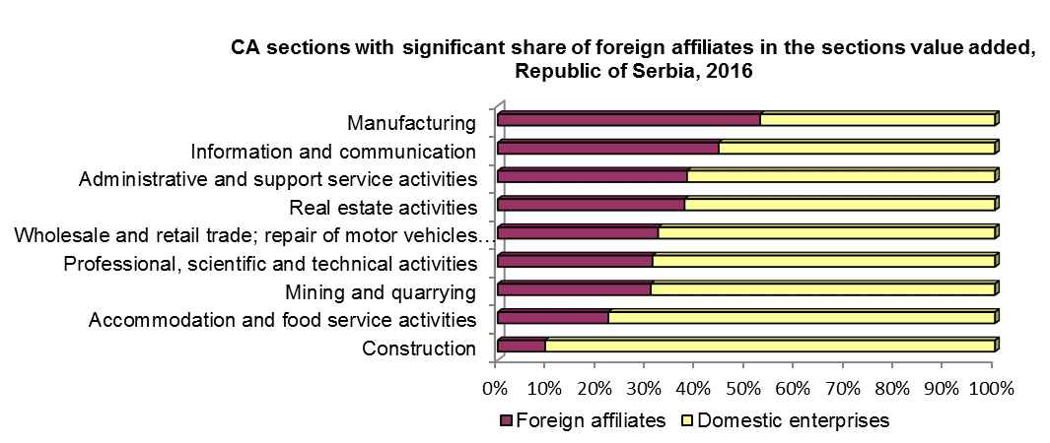

Observed by countries where seats the ultimate controlling institutional unit of the foreign affiliate, the most important results are as follows:

- 77.2% of the number of foreign affiliates originate from EU member countries, 21.0% from countries outside the European Union and 1.8% from offshore financial centres.
- 79.3% of the number of persons employed in foreign affiliates originate from EU member countries, 19.4% from countries outside the European Union and 1.3% from offshore financial centres.
- 71.0% of the value added produced in foreign affiliates originate from EU member countries, 28.0% from countries outside the European Union and 1.0% from offshore financial centres.
- 23.5% оf the total value added in SBS coverage was under the control of capital from ten countries, primarily Netherlands (3.5%), Germany (3.4%), Russian Federation (3.2%), Italy (2.5), Austria (2.2%), then USA, France, Great Britain, Croatia, Slovenia. Affiliates in these countries engaged 13.7% of the total number of persons employed in SBS coverage.
