29.06.2018

INTERNAL MIGRATION, 2017

The Statistical Office of the Republic of Serbia communicates the statistical release on persons who have changed their place of permanent residence on the territory of the Republic of Serbia during 2017.
In 2017, the number of 120 355 persons have changed the place of permanent residence, i.e. moved from one to another settlement on the territory of the Republic of Serbia. The average age of persons who have changed the place of permanent residence is 34.3 years (34.7 for males and 34.0 for females).
Starting from 1998 the Statistical Office of the Republic of Serbia has not at disposal and may not provide available certain data relative to AP Kosovo and Metohia and therefore these data are not included in the coverage for the Republic of Serbia (total).

Graph 1. Persons who have changed residence within the Republic of Serbia during 2017,
by age and sex
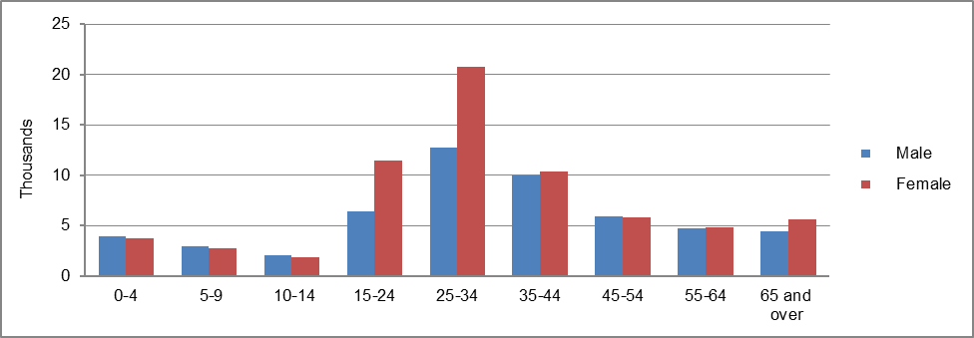

In the Republic of Serbia in 2017 the most persons moved within the cities/municipalities of the same area (38.5%), and the least between settlements on the territory of the same municipality/city (23.5%). From the total of 25 areas in the Republic of Serbia, the largest number of migratory movements was made on the territory of Beogradska oblast, namely 49 494 persons (41.1%) moved to this area and 43 057 persons (35.8%) moved out. Within the four regions of the Republic of Serbia, in 2017 Beogradski region and Region Vojvodine expressed a positive migration balance (larger number of persons that moved in when related to persons that moved out).

Table 1. Persons who have changed residence within the Republic of Serbia during 2017, by area they moved from/to

 | Moved from |  |  |  | Moved to |  |  |  | Migration balance
 | Total | From another area | From another cities/ municipalities of the same area | From another settlement of the same city/ municipality | Total | To another area | To another cities/ municipalities of the same area | To another settlement of the same city/ municipality
REPUBLIC OF SERBIA | 120355 | 45774 | 46302 | 28279 | 120355 | 45774 | 46302 | 28279 | 0
SRBIJA – SEVER | 76856 | 28736 | 37478 | 10642 | 69749 | 21629 | 37478 | 10642 | 7107
Beogradski region | 49494 | 15433 | 30800 | 3261 | 43057 | 8996 | 30800 | 3261 | 6437
Region Vojvodine | 27362 | 13303 | 6678 | 7381 | 26692 | 12633 | 6678 | 7381 | 670
SRBIJA – JUG | 43499 | 17038 | 8824 | 17637 | 50606 | 24145 | 8824 | 17637 | -7107
Region Šumadije i Zapadne Srbije | 24964 | 8931 | 4474 | 11559 | 29051 | 13018 | 4474 | 11559 | -4087
Region Južne i Istočne Srbije | 18535 | 8107 | 4350 | 6078 | 21555 | 11127 | 4350 | 6078 | -3020

From the total of 169 municipalities/cities of the Republic of Serbia, 38 municipalities/cities expressed a positive migration balance in 2017, while in 130 municipalities/cities the migration balance was negative, and in one municipalitz the number of persons who moved to and moved out during 2017 was equal, thus the migration balance equallled 0.
The municipality of Zvezdara was notable for its largest positive migration balance that was noted to be 2 231, followed by the municipality of Novi Sad where the positive migration balance was 2 084, municipality Palilula (Grad Beograd), 1 601, municipality Voždovac, 899 etc.
A larger number of persons that moved out in relation to those that moved in was the most expressive for the territory of the municipality of Stari grad, where the migration balance was noted to be -419, followed by the municipalities of Kraljevo (-385), Savski venac (-373), Leskovac (-363), Smederevo (-350), Užice (-330), etc.
Regarding economic activity, 56.7% of migrants are supported persons, 34.7% are active persons, while the share of persons with personal income equals 8.6%.

According to the Law on Citizens’ residence and domicile (“Official Gazette of the Republic of Serbia” number 87/201), residence is „the palce in which a citizen has settled in with the intention to live in permanently, i.e. place i which is the centre of her/his every day activities, professional, economic, social and other relationships prooving her/his permanent connection with the place she/he has settled in“.

