Statistical Office of the Republic of Serbia | Press Release  Belgrade, Milana Rakica 5  Phone +381 11 2412-922  www.stat.gov.rs  stat@stat.gov.rs

January 25, 2018

AVERAGE SALARIES AND WAGES PAID IN DECEMBER 2017

The average gross salaries and wages paid in December 2017 amounted to dinars 74 887. The average net salaries and wages (tax and contributions excluded) paid in December 2017 totalled 54 344 dinars.
Compared to the average gross salaries and wages paid in November 2017, this was an increase of 14.1% in nominal and in real terms, while average net salaries and wages recorded increase of 14.2% both in nominal and in real terms.
Compared with the same month last year, average gross and net salaries and wages increased by 1.7% in nominal terms and decreased by 1.3% in real terms.

Average salaries and wages and nominal indices | Trend of net salaries and wages real indices
XII 2017 XII 2017 XII 2017  XI 2017 XII 2016  Gross RSD 74.887 114,1 101,7  Net RSD 54.344 114,2 101,7  Net (EUR)1⁾ 456 114,0 105,3 | 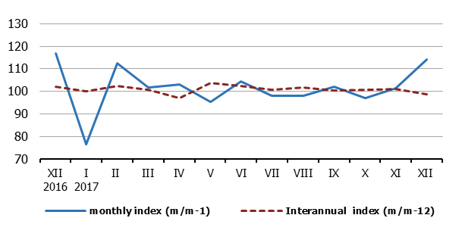
Increase of salaries and wages paid in December, relative to November 2017, presents the result of, first of all, the dynamics of payment. Namely, due to New Year and Christmas holidays, earnings are traditionally paid at the end of December instead of at the beginning of January. Additionally, at the end of the year, payment of unpaid earnings, as well as of quarterly and annual bonuses is also performed, thus influencing increase of salaries and wages paid in December 2017.

Information: From 2018, the Statistical Office of the Republic of Serbia will calculate average salaries and wages on the basis of Tax Administration data. Due to the transition to a new data source and a new methodology, monthly Statistical release on average salaries and wages will be published 55 days after the end of reference month to which earnings relate. Therefore, the average earnings for January will be published on March 26, 2018.
More detailed information on changes in the calculation of average earnings and the implementation of the new methodology will be available on the SORS website on February 26, 2018.
NOTE: Starting from 1999 the Statistical Office of the Republic of Serbia has not at disposal and may not provide available certain data relative to AP Kosovo and Metohia and therefore these data are not included in the coverage for the Republic of Serbia (total).

Contact person:  Jelena Milakovic, Head  Unit for earnings statistics  Phone: +381 11 2412 350  Information and Dissemination Unit  Phone: +381 11 2401-284  stat@stat.gov.rs | Director  Dr Miladin Kovacevic
¹⁾ Average monthly EUR exchange rate is overtaken from the NBS website.

