 | Republic of Serbia  Statistical Office of the Republic of Serbia | ISSN 0353-9555
STATISTICAL RELEASE |  | GR30
Number 252 – Year LXVIII, 14/09/2018
Construction Statistics |  | SERB252 GR30 140918

Issued building permits, July 2018
– Preliminary results –

In July 2018, 1 831 building permits were issued, presenting the increase of 13.0% in relation with July 2017. Total number of issued permits in the period January - July 2018 recorded increase of 10.5% relative to the same period 2017.
Observed by types of constructions, in July 2018, 77.4% of issued permits related to buildings and 22.6% to civil engineering. When referring only to buildings, 58.0% related to residential buildings and 42.0% to non–residential ones, while regarding civil engineering, the largest number related to pipelines, communication and electric power lines (69.5%).
According to the permits issued in July 2018, building of 1 829 dwellings with average area of 81.5 m² was recorded. Number of dwellings decreased by 20.7% when compared to the same period 2017. Out of the total number of dwellings in new residential buildings, 13.3% of dwellings will be built in single-dwelling buildings, with average area of 145.1 m², while 84.8% of dwellings will be in the buildings with three and more dwellings, with significantly smaller average area of 70.0 m².
Anticipated value of works on new building in July 2018 amounts to 73.2% of totally anticipated value of works. Observed by areas, the greatest construction activity is expected in Beogradska oblast, 36.4% of the anticipated value of new construction followed by Moravička oblast (11.7%), Sremska oblast (10.3%), Južnobačka oblast (5.6%) and Južnobanatska oblast (5.0%), while the shares of other areas were from 0.2% up to 4.3%.

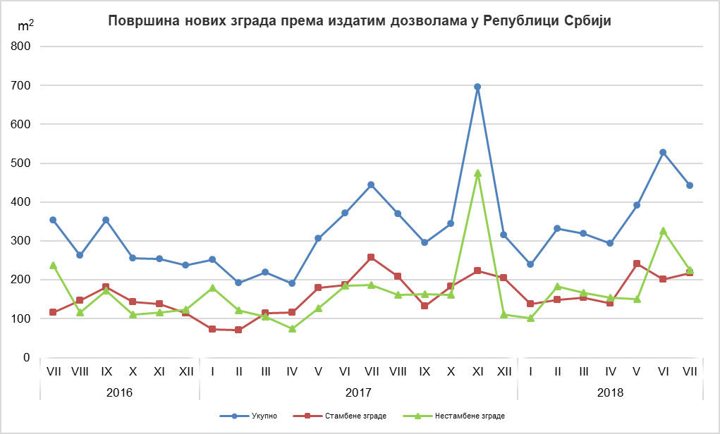
Area of new buildings in the Republic of Serbia, according to the issued permits

Non-residential buildings
Residential buildings
Total

Indices of issued building permits in the Republic of Serbia
 | I–VII 2018  I–VII 2017 | VII 2018  VI 2018 | VII 2018  VII 2017 | VII 2018  ∅ 2017
Total
Number | 110.5 | 97.7 | 113.0 | 118.9
Anticipated value of works | 115.9 | 83.0 | 53.1 | 114.6
Buildings
Number | 110.2 | 97.6 | 108.7 | 121.5
Anticipated value of works | 136.3 | 84.5 | 117.9 | 144.9
Area | 129.5 | 82.5 | 98.9 | 130.8
Civil engineering
Number | 111.2 | 98.1 | 131.1 | 110.7
Anticipated value of works | 91.3 | 78.6 | 19.5 | 69.2
Dwellings
Number | 125.1 | 86.1 | 79.3 | 112.0
Useful area | 127.6 | 91.1 | 86.4 | 122.6

Notes:

The data on issued building permits are overtaken from the Central Register of Integrated Procedures, which has been, according to the Law on planning and construction (“Official Gazette of the Republic of Serbia“, number 132/14, article 8) administered by the Serbian Business Registers Agency (SBRA). The data on dwellings, unavailable in Central Register of Integrated Procedures, are filled in by the Ministry competent for construction affairs, responsible authorities of the Autonomous Province, city or municipality that, according to the Law on planning and construction (“Official Gazette of the Republic of Serbia“, number 132/14, article 133), issue construction permits.
In the scope of this survey, the concept of „building permit“ comprises the building permit for construction and the decision which approves the execution of works following the article 145 of the Law on planning and construction. The issued building permits and approvals for works executions, based on harmonized request, included are only if the construction is approved for the first time.
This statistical survey comprises the issued building permits for all types of constructions described in the Classification of Types of Constructions, i.e. buildings and other civil engineering works and these are presented by territories where the planned works are performed in the country.

Data on issued building permits show the future trends of construction activity and enable an insight in investments’ structure on state and local self – government level.

Starting from 1999 the Statistical Office of the Republic of Serbia has not at disposal and may not provide available certain data relative to AP Kosovo and Metohija and therefore these data are not included in the coverage for the Republic of Serbia (total).
Detailed methodological notes of this survey can be found on the site of the Statistical Office of the Republic of Serbia:

http://www.stat.gov.rs/istrazivanja/methodology-and-documents/?a=05&s=0.

Contact: gabrijela.rosic@stat.gov.rs, Phone: 011 2412-922 ext. 260
Published and printed by: Statistical Office of the Republic of Serbia, 11 050 Belgrade, Milana Rakica 5
Phone: +381 11 2412922 (telephone exchange) ● Fax: +381 11 2411260 ● www.stat.gov.rs
Responsible: Dr Miladin Kovačević, Director
Circulation: 20 ● Issued monthly

