 | Statistical Office of the Republic of Serbia
 |  | ISSN 0353-9555
STATISTICAL RELEASE |  | SV10
Number 179 • Year LXVIII, 29/06/2018
Statistics of Transport and Communications |  | SERB179 SV10 290618

Total transport of passengers and goods, 2016 and 2017
The total number of transported passengers in 2017, relative to the previous year, decreased by 6.6% and in domestic transport we saw a decrease of 7.3%. An increase of 2.6% was recorded in international transport. A decrease of 6.8% in the number of passengers carried is notable in road transport and of 7.4% in railway transport, while urban transport recorded an increase which is not comparable with the previous year due to changes in the methodology of measuring the number of passengers transported, made by the City of Belgrade. The total performance expressed in pkm increased by 1.4%, the domestic transport of passengers being down by 1.6%, and the international transport being up by 3.9%. A decrease in pkm traveled, when compared to the previous year, was noted in all modes of transport: road (0.6%), railway (14.2%), but urban transport saw an increase which is not comparable with the previous year. The exception is only air traffic that has recorded a growth of 6.5%.
The volume of transported goods in 2017, relative to the previous year, increased by 2.0%, with a simultaneous operations volume growth of 8.4%, expressed in tkm. Recorded was an increase in the average ton kilometer in land transport: from 304.2 km in 2016 to 326.3 km in 2017. A larger quantity of goods in 2017, relative to 2016, was transported by all modes of transport, except by inland waterways.
The number of transported passengers in railway transport, relative to the previous year, noted a fall of 7.4% and the performance expressed in pkm saw a fall of 14.2%. A fall of the performance was recorded in the domestic passenger transport and international transport. The quantity of goods carried is smaller in domestic goods transport, while larger in imports and exports and in transit.
The total number of passenger carried in road transport decreased, relative to the previous year, by 6.8%, the international passenger transport noting a growth of 8.2%. The total number of passengers carried in domestic transport decreased by 7.3%. The total volume of operations, shown in pkm, fell by 0.6%, recording a fall of 0.2% in domestic passenger transport, and of 1.9% in international passenger transport. The total quantity of goods carried in road transport in 2017, in relation to 2016, increased by 2.3%. The volume of operations, in tkm, increased by 15.8% which is indicative of a longer average journey.
Oil pipeline transport increased by 5.1%. In the same period, natural gas pipeline transport grew by 13.9%. The volume of operations, in tkm, is higher by 7.6% as far as crude oil transport is concerned, and by 12.0% in natural gas pipeline transport.
Air transport, as far as passengers carried and total operations volume are concerned, indicates growth. Transported passengers’ number, compared to the previous year, increased by 0.1%, and total operations volume by 6.5%. When we observe goods transport, the situation in air transport is similar. Namely, in 2017, when compared to 2016, we can notice a growth of quantities of goods transported, of 38.1%, and of total operations volume, of 102.5%.
The border traffic of road passenger vehicles coming into Serbia increased by 0.9% in 2017 if compared to 2016. The number of vehicles with national registration plates increased by 8.5% with simultaneous fall of 3.1% of vehicles with foreign registration plates. The number of freight vehicles which entered the national territory, increased over the same period by 10.1%, and those which exited it increased by 6.9%. Due to changes in the methodology of measuring the number of freight vehicles in transit, data are not comparable with previous years.
Compared to the previous year, there was a decrease of 14.4% of call minutes in fixed telephony. The initial communications in mobile telephony increased by 1.6%, and SMS decreased by 9.0%.Classic mailing, i.e. postal services in 2017, compared to 2016, noted the following movements: letter mails increased by 2.8%, parcels increased by 32.9% and payment traffic services decreased by 8.1%.
The total number of employees decreased by 3.4% in relation to the previous year.
1. Total transport of passengers and goods
 | 2016 | 2017 | 2017/2016
 | PASSENGER TRANSPORT
Transported passengers, thousand¹⁾ | 65243 | 60952 | 93.4
Domestic transport | 60366 | 55947 | 92.7
International transport | 4877 | 5005 | 102.6
Land transport | 62583 | 58289 | 93.1
Railway transport | 6092 | 5639 | 92.6
Road transport | 56491 | 52651 | 93.2
Urban transport | 860167 | 1021036 | 118.7
Air transport | 2660 | 2662 | 100.1
Passenger kilometers, million¹⁾ | 7728 | 7835 | 101.4
Domestic transport | 3559 | 3502 | 98.4
International transport | 4169 | 4333 | 103.9
Land transport | 4720 | 4631 | 98.1
Railway transport | 438 | 376 | 85.8
Road transport | 4282 | 4255 | 99.4
Urban transport | 5161 | 6126 | 118.7
Air transport | 3008 | 3203 | 106.5
 | TRANSPORT OF GOODS
Transported goods, thousand tons²⁾ | 29429 | 30003 | 102.0
Domestic transport | 12578 | 10967 | 87.2
Exports | 4358 | 4972 | 114.1
Imports | 9090 | 10483 | 115.3
Transit | 3128 | 3245 | 103.8
International transport | 275 | 336 | 122.2
Land transport | 27415 | 28555 | 104.2
Railway transport | 11896 | 12352 | 103.8
Road transport | 9897 | 10120 | 102.3
Pipeline transport | 5622 | 6083 | 108.2
Inland waterways transport | 2014 | 1448 | 71.9
Air transport | 4.816 | 6.651 | 138.1
Ton kilometers, million²⁾ | 9267 | 10043 | 108.4
Domestic transport | 1554 | 1340 | 86.2
Exports | 2206 | 2599 | 117.8
Imports | 3790 | 4253 | 112.2
Transit | 1483 | 1561 | 105.3
International transport | 234 | 290 | 123.9
Land transport | 8340 | 9318 | 111.7
Railway transport | 3087 | 3289 | 106.6
Road transport | 4299 | 4980 | 115.8
Pipeline transport | 954 | 1049 | 110.0
Inland waterways transport | 927 | 725 | 78.2
Air transport | 10.246 | 20.752 | 202.5

¹⁾ No urban transport.
²⁾ No air transport.

2. Transport of passengers and goods, by branches
 | 2016 | 2017 | 2017/2016
 | RAILWAY TRANSPORT
PASSENGER TRANSPORT
Transported passengers, thousand | 6092 | 5639 | 92.6
Domestic transport | 5771 | 5347 | 92.7
International transport | 321 | 292 | 91.0
Passenger kilometers, million | 438 | 376 | 85.8
Domestic transport | 370 | 318 | 85.9
International transport | 68 | 58 | 85.2
TRANSPORT OF GOODS
Transported goods, thousand tons | 11896 | 12352 | 103.8
Domestic transport | 3635 | 3202 | 88.1
Exports | 2429 | 2624 | 108.0
Imports | 2918 | 3469 | 118.9
Transit | 2914 | 3057 | 104.9
Ton kilometers, million | 3087 | 3289 | 106.6
Domestic transport | 640 | 532 | 83.1
Exports | 506 | 567 | 112.0
Imports | 528 | 691 | 130.9
Transit | 1413 | 1499 | 106.1

2. Transport of passengers and goods, by branches (continued)
 | 2016 | 2017 | 2017/2016
 | ROAD TRANSPORT
PASSENGER TRANSPORT
Transported passengers, thousand | 56491 | 52651 | 93.2
Domestic transport | 54595 | 50600 | 92.7
International transport | 1896 | 2051 | 108.2
Passenger kilometers, million | 4282 | 4255 | 99.4
Domestic transport | 3189 | 3183 | 99.8
International transport | 1093 | 1072 | 98.1
TRANSPORT OF GOODS
Transported goods, thousand tons | 9897 | 10120 | 102.3
Domestic transport | 5882 | 5230 | 88.9
Exports | 1808 | 2215 | 122.5
Imports | 1856 | 2291 | 123.4
Transit | 351 | 384 | 109.4
International transport | 76 | 48 | 63.2
Ton kilometers, million | 4299 | 4980 | 115.8
Domestic transport | 690 | 624 | 90.4
Exports | 1619 | 1948 | 120.3
Imports | 1726 | 2098 | 121.6
Transit | 264 | 310 | 117.4
International transport | 30 | 20 | 66.7
 | URBAN TRANSPORT
PASSENGER TRANSPORT
Transported passengers, million | 860 | 1021 | 118.7
Passenger kilometers, million | 5161 | 6126 | 118.7
 | PIPELINE TRANSPORT
OIL PIPELINES
Transported oil, thousand tons | 3646 | 3833 | 105.1
Domestic transport | 1444 | 1377 | 95.4
Imports | 2202 | 2456 | 111.5
Transit | - | - | -
Ton kilometers, million | 447 | 481 | 107.6
Domestic transport | 107 | 102 | 95.3
Imports | 340 | 379 | 111.5
Transit | - | - | -
GAS PIPELINES
Transported gas, thousand tons | 1976 | 2250 | 113.9
Domestic transport | 475 | 439 | 92.4
Imports | 1365 | 1675 | 122.7
Transit | 136 | 136 | 100.0
Ton kilometers, million | 507 | 568 | 112.0
Domestic transport | 30 | 26 | 86.7
Imports | 440 | 505 | 114.8
Transit | 37 | 37 | 100.0
 | INLAND WATERWAYS TRANSPORT
TRANSPORT OF GOODS
Transported goods, thousand tons | 2014 | 1448 | 71.9
Domestic transport | 1142 | 719 | 63.0
Exports | 121 | 133 | 109.9
Imports | 749 | 592 | 79.0
Transit | 2 | 4 | 200.0
Transport among international ports | - | -
Ton kilometers, million | 927 | 725 | 78.2
Domestic transport | 87 | 56 | 64.4
Exports | 81 | 84 | 103.7
Imports | 756 | 580 | 76.7
Transit | 3 | 5 | 166.7
Transport among international ports | - | - | -

2. Transport of passengers and goods, by branches (continued)
 | 2016 |  | 2017 |  | 2017/2016
 |  | AIR TRANSPORT
PASSENGER TRANSPORT
Transported passengers, thousand |  | 2660 |  | 2662 | 100.1
Domestic transport |  | 0 |  | 0 | -
International transport |  | 2660 |  | 2662 | 100.1
Passenger kilometers, million |  | 3008 |  | 3203 | 106.5
Domestic transport |  | 0 |  | 0 | -
International transport |  | 3008 |  | 3203 | 106.5
TRANSPORT OF GOODS
Transported goods, tons |  | 4.816 |  | 6.651 | 138.1
Domestic transport |  | 0 |  | 0 | -
International transport |  | 4.816 |  | 6.651 | 138.1
Ton kilometers, thousond |  | 10.246 |  | 20.752 | 202.5
Domestic transport |  | 0 |  | 0 | -
International transport |  | 10.246 |  | 20.752 | 202.5

Graph. 1. Scope of work, by branches, 2017
– Republic of Serbia –

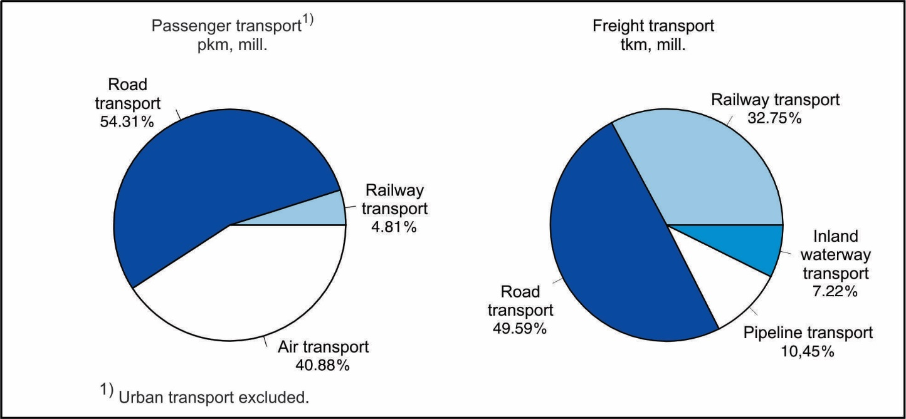

3. Additional and supplementary activities in transport
 | 2016 | 2017 | 2017/2016
 | SERVICES IN RAILWAY TRANSPORT
Total goods traffic, thousand tons | 11898 | 12352 | 103.8
Traffic volume, thousand tons | 8984 | 9295 | 103.5
Domestic traffic – unloading | 3636 | 3202 | 88.1
Exports | 2429 | 2624 | 108.0
Imports | 2919 | 3469 | 118.8
Transit | 2914 | 3057 | 104.9
 | BORDER TRAFFIC OF ROAD MOTOR VEHICLES
Total passenger cars traffic, come in | 7883794 | 7954452 | 100.9
Domestic vehicles | 2687219 | 2916663 | 108.5
Foreign vehicles | 5196575 | 5037789 | 96.9
Austria | 221952 | 225433 | 101.6
Bosnia and Herzegovina (incl. RS) | 233578 | 222743 | 95.4
Bulgaria | 107916 | 134530 | 124.7
Hungary | 490621 | 397552 | 81.0
Germany | 258795 | 324257 | 125.3
Republic of Macedonia | 135061 | 147007 | 108.8
Romania | 160183 | 135552 | 84.6
Croatia | 127334 | 30664 | 24.1
Montenegro | 131686 | 121968 | 92.6
Switzerland | 132264 | 114098 | 86.3
Other | 3197185 | 3183985 | 99.6
Passenger cars | 7726862 | 7790271 | 100.8
Buses | 146554 | 153329 | 104.6
Motorcycles | 10378 | 10852 | 104.6
Freight road vehicles
Come in | 536383 | 590297 | 110.1
Domestic vehicles | 263376 | 297103 | 112.8
Foreign vehicles | 273007 | 293194 | 107.4
Come out | 747361 | 798704 | 106.9
Domestic vehicles | 515810 | 558703 | 108.3
Foreign vehicles | 231551 | 240001 | 103.6
Transit | ... | ... | ...
Domestic vehicles | ... | ... | ...
Foreign vehicles | ... | ... | ...

Graph. 2. Border transport of passenger car for, entrance
– Republic of Serbia –
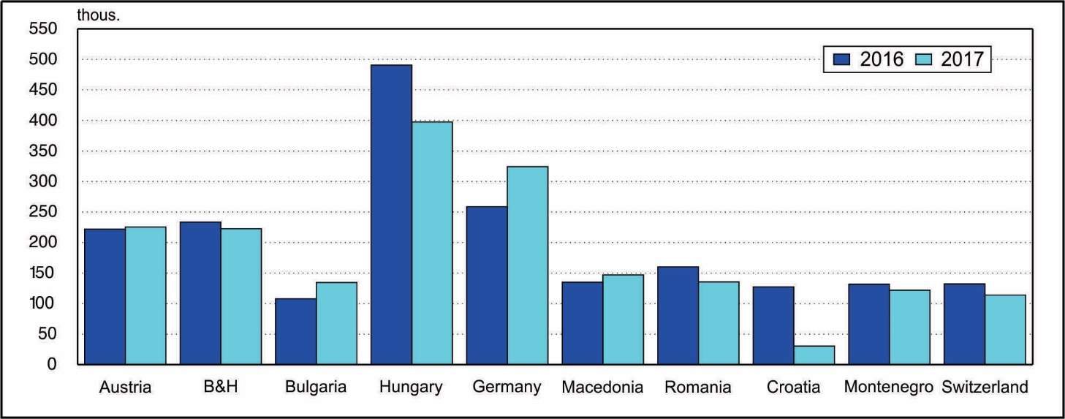

3. Additional and supplementary activities in transport (continued)
 | 2016 | 2017 | 2017/2016
 | INTERNAL WATERWAYS TRANSPORT SERVICES
 | GOODS TRAFFIC IN PORTS
Total goods traffic, thousand tons | 8411 | 7111 | 84.5
Traffic volume, thousand tons | 7269 | 6392 | 87.9
Domestic traffic | 2284 | 1439 | 63.0
Unloading | 1142 | 719 | 63.0
Loading | 1142 | 720 | 63.0
International traffic | 9935 | 9023 | 90.8
Exports | 2452 | 1918 | 78.2
Domestic boats | 428 | 371 | 86.7
Foreign boats | 2024 | 1547 | 76.4
Imports | 3675 | 3754 | 102.1
Domestic boats | 814 | 707 | 86.9
Foreign boats | 2861 | 3047 | 106.5
Transit | 3808 | 3351 | 88.0
Domestic boats | 31 | 33 | 106.5
Foreign boats | 3777 | 3318 | 87.8
 | AIR TRANSPORT SERVICES
 | AIRPORT PASSENGER TRAFFIC
Passenger traffic volume, thousand | 5048 | 5980 | 119.5
Domestic traffic, departures | 0 | 0 | -
International traffic | 5048 | 5980 | 119.5
Departures | 2533 | 3002 | 120.6
Domestic planes | 1352 | 1501 | 114.6
Foreign planes | 1181 | 1501 | 127.2
Arrivals | 2515 | 2978 | 118.4
Domestic planes | 1336 | 1489 | 111.5
Foreign planes | 1179 | 1489 | 126.3
 | CARGO HANDLING
Handled tons, thousand | 8080 | 6773 | 83.8
Operation tons, thousand | 9189 | 8015 | 87.2
Mechanical | 9128 | 7991 | 87.5
Manual | 61 | 24 | 39.3
Unloaded | 2417 | 1876 | 77.6
Loaded | 3152 | 2375 | 75.3
Directly handled, overloaded | 3309 | 3264 | 98.6
Transfer | 311 | 501 | 161.1

* Corrected data.

4. Mailing activities and telecommunications
 | 2016 | 2017 | 2017/2016
 | MAILING ACTIVITIES – TRANSPORT AND DELIVERY
Letter mails, million | 278 | 286 | 102.8
Domestic traffic, dispatched | 272 | 279 | 102.7
International traffic, dispatched and received | 6 | 7 | 116.7
Parcel mails, thousand | 693 | 921 | 132.9
Domestic traffic, dispatched | 621 | 844 | 135.9
International traffic, dispatched and received | 72 | 77 | 106.9
Payment traffic services, thousand pcs. | 147702 | 135691 | 91.9
 | TELECOMMUNICATIONS
Fixed telephony, minutes, million | 5836 | 4995 | 85.6
Mobile telephony
Outcoming calls, minutes, million | 16363 | 16624 | 101.6
Short messages sent, million | 7598 | 6917 | 91.0
Multimedial messages sent, thousand | 12329 | 11244 | 91.2

5. Employed in transport, storage and communications
 | 2016 | 2017 | 2017/2016
Transport – total | 44471 | 42954 | 96.6
Land transport | 41240 | 39284 | 95.3
Railway transport | 12420 | 10229 | 82.4
Road transport | 16266 | 16307 | 100.3
Urban transport | 11295 | 11619 | 102.9
Pipeline transport | 1259 | 1129 | 89.7
Inland waterways transport | 538 | 507 | 94.2
Air transport | 2693 | 3163 | 117.5
Mailing activities | 14868 | 14980 | 100.8
Telecommunications | 10282 | 11685 | 113.6

6. Fuel consumption in transport, storage and telecommunications
 | 2016 | 2017 | 2017/2016
Transport - total
Coal, thousand tons | - | - | -
Diesel, thousand tons | 285 | 179 | 62.8
Petrol, thousand tons | - | - | -
Electricity, thousand MWh | 166 | 158 | 95.1
Kerosene, thousand tons | 119 | 120 | 100.8

Land transport
Coal, thousand tons | - | - | -
Diesel, thousand tons | 276 | 171 | 62.0
Petrol, thousand tons | - | - | -
Electricity, thousand MWh | 166 | 158 | 95.1

Railway transport
Coal, thousand tons | - | - | -
Diesel, thousand tons | 10 | 10 | 100.0
Electricity, thousand MWh | 120 | 116 | 96.6

Road transport
Diesel, thousand tons | 154 | 161 | 104.5
Petrol, thousand tons | - | - | -

Urban transport
Diesel, thousand tons | 112 | 87 | 77.7
Electricity, thousand МWh | 46 | 42 | 91.3
Inland waterways transport
Diesel, thousand tons | 9 | 8 | 88.9

Air transport
Kerosene, thousand tons | 119 | 120 | 100.8

7. Passenger and goods transport, by months, 2017

7.1. Passenger transport, by months, 2017
 | Transported passengers, thousand |  |  |  |  | Passenger kilometers, mill.
 | Total | Land transport |  |  | air | Total | Land transport |  |  | air
 |  | all | railway | road |  |  | all | railway | road
Total | 60956 | 58290 | 5639 | 52651 | 2666 | 7837 | 4631 | 376 | 4255 | 3206
January | 4564 | 4401 | 374 | 4027 | 163 | 547 | 333 | 24 | 309 | 214
February | 4535 | 4402 | 389 | 4013 | 133 | 494 | 333 | 24 | 309 | 161
March | 5251 | 5086 | 448 | 4638 | 165 | 579 | 380 | 28 | 352 | 199
April | 5210 | 5002 | 483 | 4519 | 208 | 637 | 380 | 31 | 349 | 257
May | 5754 | 5543 | 536 | 5007 | 211 | 677 | 425 | 32 | 393 | 252
June | 5157 | 4899 | 488 | 4411 | 258 | 726 | 412 | 33 | 379 | 314
July | 4715 | 4372 | 511 | 3861 | 343 | 795 | 393 | 42 | 351 | 402
August | 4787 | 4439 | 484 | 3955 | 348 | 813 | 401 | 38 | 363 | 412
September | 5398 | 5097 | 458 | 4639 | 301 | 814 | 453 | 31 | 422 | 361
October | 5317 | 5084 | 544 | 4540 | 233 | 642 | 373 | 34 | 339 | 269
November | 5132 | 4986 | 469 | 4517 | 146 | 534 | 360 | 29 | 331 | 174
December | 5134 | 4979 | 455 | 4524 | 155 | 580 | 388 | 30 | 358 | 192

7.2. Goods transport, by months 2017
 | Transported cargo, thousand t |  |  |  |  |  |  | Ton kilometers, million
 | Total | Land transport |  |  |  | river | air | Total | Land transport |  |  |  | river | air
 |  | all | railway | road | pipe-  line |  |  |  | all | railway | road | pipe-  line
Total | 30010 | 28555 | 12352 | 10120 | 6083 | 1448 | 6.651 | 10063 | 9317 | 3289 | 4980 | 1049 | 725 | 20.752
January | 2058 | 2043 | 899 | 537 | 607 | 15 | 0.490 | 688 | 675 | 236 | 306 | 133 | 12 | 1.481
February | 2166 | 2151 | 979 | 693 | 479 | 14 | 0.466 | 727 | 717 | 261 | 357 | 99 | 9 | 1.286
March | 2685 | 2557 | 1168 | 888 | 501 | 128 | 0.598 | 907 | 824 | 312 | 420 | 92 | 82 | 1.677
April | 2439 | 2282 | 1049 | 789 | 444 | 156 | 0.506 | 831 | 755 | 279 | 400 | 77 | 74 | 1.627
May | 2584 | 2424 | 1046 | 909 | 469 | 160 | 0.520 | 865 | 796 | 287 | 444 | 65 | 67 | 1.544
June | 2574 | 2410 | 982 | 962 | 467 | 164 | 0.596 | 863 | 789 | 264 | 461 | 64 | 72 | 2.037
July | 2492 | 2358 | 974 | 922 | 462 | 133 | 0.594 | 819 | 759 | 262 | 429 | 68 | 58 | 1.890
August | 2624 | 2496 | 1054 | 960 | 482 | 128 | 0.543 | 856 | 784 | 275 | 442 | 67 | 70 | 1.834
September | 2593 | 2450 | 1064 | 926 | 460 | 142 | 0.577 | 867 | 787 | 272 | 451 | 65 | 78 | 1.939
October | 2651 | 2495 | 1096 | 878 | 521 | 156 | 0.444 | 873 | 804 | 297 | 421 | 86 | 68 | 1.098
November | 2596 | 2456 | 990 | 878 | 588 | 140 | 0.561 | 881 | 814 | 271 | 431 | 112 | 65 | 1.787
December | 2547 | 2433 | 1053 | 778 | 602 | 113 | 0.756 | 886 | 813 | 273 | 418 | 122 | 70 | 2.552

Contact: Prvoslav.Mutavdzic@stat.gov.rs; phone: 011 3290-268
Published and printed by: Statistical Office of the Republic of Serbia, Milana Rakica 5, Belgrade
Phone: +381 11 2412922 ● Fax: +381 11 2411260 ● www.stat.gov.rs
Responsible: Dr Miladin Kovačević, Director
Circulation: 20 • Issued annually

