 | Statistical Office of the Republic of Serbia
 |  | ISSN 0353-9555
STATISTICAL RELEASE |  | LP12
Number 071 • Year LXVIII, 15/03/2018
Household Budget Survey |  | SERB071 LP12 150318
Income in money and in kind and individual consumption of households,
4th quarter 2017

− Preliminary results −

The data were obtained through Household Budget Survey, which has been conducted since 2003 according to international standards and recommendations of Eurostat, International Labour Organization (ILO) and UN, thus providing international data comparability. The survey collects the data on income and household consumption, i.e. the data on basic elements of individual consumption. Besides, the survey compiles also the data on some important living standard indicators (dwelling conditions, supply with durable consumer goods, etc.), as well as some basic data related to demographic, economic and social features of households.
In this survey, a two-stage stratified sample is applied, with enumeration districts as primary and households as secondary selection units. Every fifteen days, 370 households are interviewed, i.e. 8856 households annually.
Of the total number of households envisaged for interview in the fourth quarter (2214 for the Republic of Serbia), the number of 1599 households (72%) was interviewed.
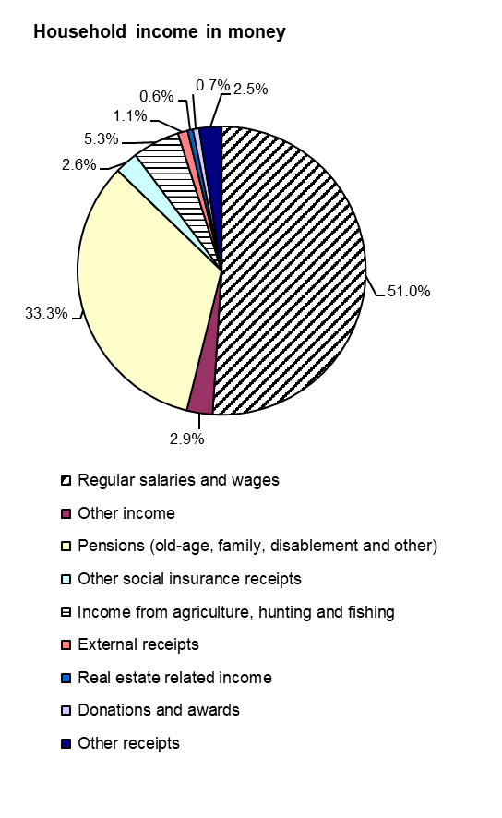 | 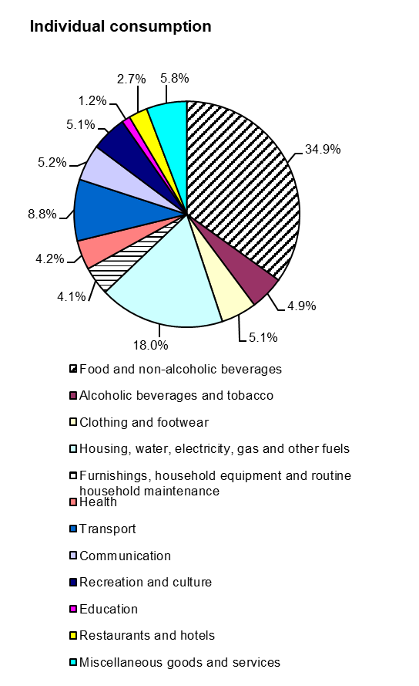
- Income in money and in kind and individual consumption
− Household average −
− All households −

RSD
 | Republic of Serbia
 | total | Srbija – sever |  | Srbija – jug
 |  | Beogradski region | Region Vojvodine | Region Šumadije i Zapadne Srbije | Region Južne i Istočne Srbije | Region Kosovo i Metohija
Monthly average
Number of households surveyed | 1599 | 303 | 461 | 444 | 391 | …
Number of households assessed | 2466316 | 605006 | 690551 | 656902 | 513857 | …
Members, average number | 2.71 | 2.65 | 2.55 | 2.86 | 2.84 | …
Consumption units, average number | 2.14 | 2.08 | 2.03 | 2.23 | 2.24 | …
Income in money and in kind – total | 63674 | 74574 | 60400 | 61059 | 58588 | …
Household income in money | 61282 | 73786 | 58975 | 57247 | 54823 | …
Regular salaries and wages | 31273 | 42837 | 29890 | 26878 | 25136 | …
Other income | 1780 | 1983 | 2159 | 1214 | 1757 | …
Pensions (old-age, family, disablement and other) | 20383 | 24265 | 18911 | 18707 | 19929 | …
Other social insurance receipts | 1599 | 1228 | 1471 | 1899 | 1828 | …
Income from agriculture, hunting and fishing | 3236 | 260 | 3834 | 5461 | 3091 | …
External receipts | 677 | 462 | 894 | 536 | 821 | …
Real estate related income | 344 | 424 | 532 | 210 | 170 | …
Donations and awards | 446 | 782 | 254 | 387 | 385 | …
Other receipts | 1544 | 1545 | 1030 | 1955 | 1706 | …
Household receipts in kind | 2392 | 788 | 1425 | 3812 | 3765 | …
Earned receipts in kind | 52 | 90 | 42 | 37 | 38 | …
Natural consumption | 2340 | 698 | 1383 | 3775 | 3727 | …
Individual consumption – total | 64086 | 70548 | 61249 | 63467 | 61080 | …
Food and non-alcoholic beverages | 22283 | 23407 | 21579 | 22273 | 21915 | ...
Alcoholic beverages and tobacco | 3154 | 2560 | 3085 | 3268 | 3794 | ...
Clothing and footwear | 3245 | 3765 | 3138 | 3054 | 3021 | ...
Housing, water, electricity, gas and other fuels | 11541 | 11596 | 11202 | 12591 | 10589 | ...
Furnishings, household equipment and routine  household maintenance | 2599 | 2538 | 2474 | 2445 | 3038 | ...
Health | 2713 | 3647 | 2389 | 2403 | 2442 | ...
Transport | 5664 | 6622 | 4885 | 6122 | 5000 | ...
Communication | 3355 | 4042 | 3194 | 3089 | 3106 | ...
Recreation and culture | 3295 | 4311 | 3526 | 2484 | 2810 | ...
Education | 781 | 1230 | 566 | 910 | 381 | ...
Restaurants and hotels | 1741 | 2388 | 1505 | 1716 | 1331 | ...
Miscellaneous goods and services | 3715 | 4442 | 3706 | 3112 | 3653 | ...

2. Structure of income in money and in kind and individual consumption
- All households -

%
 | Republic of Serbia
 | total | Srbija – sever |  | Srbija – jug
 |  | Beogradski region | Region Vojvodine | Region Šumadije i Zapadne Srbije | Region Južne i Istočne Srbije | Region Kosovo i Metohija
Monthly average
Number of households surveyed | 1599 | 303 | 461 | 444 | 391 | …
Number of households assessed | 2466316 | 605006 | 690551 | 656902 | 513857 | …
Members, average number | 2.71 | 2.65 | 2.55 | 2.86 | 2.84 | …
Consumption units, average number | 2.14 | 2.08 | 2.03 | 2.23 | 2.24 | …
Income in money and in kind – total | 100.0 | 100.0 | 100.0 | 100.0 | 100.0 | …
Household income in money | 96.2 | 98.9 | 97.6 | 93.8 | 93.6 | …
Regular salaries and wages | 49.1 | 57.5 | 49.5 | 44.2 | 42.9 | …
Other income | 2.8 | 2.7 | 3.6 | 2.0 | 3.0 | …
Pensions (old-age, family, disablement and other) | 32.0 | 32.5 | 31.3 | 30.6 | 34.0 | …
Other social insurance receipts | 2.5 | 1.6 | 2.4 | 3.1 | 3.1 | …
Income from agriculture, hunting and fishing | 5.1 | 0.3 | 6.3 | 8.9 | 5.3 | …
External receipts | 1.1 | 0.6 | 1.5 | 0.9 | 1.4 | …
Real estate related income | 0.5 | 0.6 | 0.9 | 0.3 | 0.3 | …
Donations and awards | 0.7 | 1.0 | 0.4 | 0.6 | 0.7 | …
Other receipts | 2.4 | 2.1 | 1.7 | 3.2 | 2.9 | …
Household receipts in kind | 3.8 | 1.1 | 2.4 | 6.2 | 6.4 | …
Earned receipts in kind | 0.1 | 0.1 | 0.1 | 0.1 | 0.1 | …
Natural consumption | 3.7 | 1.0 | 2.3 | 6.1 | 6.3 | …
Individual consumption – total | 100.0 | 100.0 | 100.0 | 100.0 | 100.0 | …
Food and non-alcoholic beverages | 34.9 | 33.3 | 35.2 | 35.2 | 35.9 | …
Alcoholic beverages and tobacco | 4.9 | 3.6 | 5.0 | 5.1 | 6.2 | …
Clothing and footwear | 5.1 | 5.3 | 5.1 | 4.8 | 4.9 | …
Housing, water, electricity, gas and other fuels | 18.0 | 16.4 | 18.3 | 19.8 | 17.3 | …
Furnishings, household equipment and routine  household maintenance | 4.1 | 3.6 | 4.0 | 3.9 | 5.0 | …
Health | 4.2 | 5.2 | 3.9 | 3.8 | 4.0 | …
Transport | 8.8 | 9.4 | 8.0 | 9.6 | 8.2 | …
Communication | 5.2 | 5.7 | 5.2 | 4.9 | 5.1 | …
Recreation and culture | 5.1 | 6.1 | 5.8 | 3.9 | 4.6 | …
Education | 1.2 | 1.7 | 0.9 | 1.4 | 0.6 | …
Restaurants and hotels | 2.7 | 3.4 | 2.5 | 2.7 | 2.2 | …
Miscellaneous goods and services | 5.8 | 6.3 | 6.1 | 4.9 | 6.0 | …

3. Comparative review of income in money and in kind and individual consumption of households

RSD
 | 2016 |  |  |  | 2017
 | I quarter | II quarter | III quarter | IV quarter | I quarter | II quarter | III quarter | IV quarter
Income in money and in kind – total | 59182 | 58656 | 60011 | 60639 | 60065 | 60195 | 61729 | 63674
Individual consumption – total | 60626 | 60158 | 60615 | 61467 | 61370 | 61477 | 62190 | 64086

Methodological explanations

A survey unit is taken to be every single - or several - member household, selected according to the sample plan. A household is: a) a community of persons, whose members live and prepare food together and jointly spend the earned income and b) a single person, living, preparing food and spending the earned income on his/her own.
The survey applies the method of diary keeping (a household keeps a consumption diary for fifteen, i.e. sixteen days) regarding individual consumption of food and services and the interview method on the basis of questionnaires, where the reference period for durables is twelve months, for semi-durables, agriculture, hunting and fishing - three months, and for earnings – one month.

Household income in money and in kind comprises income in money and the money value of natural consumption and receipts in kind, which were available to households in the respective survey period.

Household income in money

- Regular salaries and wages cover the income from regular employment.
- Other income comprises money receipts for overtime work, pursuant to purchase order, author’s deed contract, etc.
- Pensions (old-age, family, disablement and other) cover the receipts pursuant to pension and disablement insurance and supplementary payments.
- Other social insurance related receipts include: social aid, supplements and other welfare receipts; receipts in cases of unemployment and temporary unemployment; alimentation and support; health insurance related receipts, disablement insurance related receipts and supplements; children allowances; student grants and remuneration, i.e. compensations for trade students.
- Income from agriculture, hunting and fishing includes earnings of households that are active in agriculture, hunting and fishing.
- External receipts include money donations from abroad.
- Real estate related income comprises room and flat rents, interests, dividends, etc.
- Donations and awards comprise money donations, lottery related receipts, etc.
- Other receipts saving deposits raised, returned loans, decreased cash amounts in households, refunded nationalized property, life insurance and real estate insurance premiums, etc.

Household receipts in kind

- Earned receipts in kind include food, clothes, footwear, household expenditures (electricity, phone, registration fees, car fuel) paid by employer, etc.
- Natural consumption comprises the value of products from own household production that are used for individual consumption (food, drinks, wood for heating, etc.)

Individual consumption of households is presented by the following groups of COICOP classification (Classification of individual consumption by purpose): Food and non-alcoholic beverages; Alcoholic beverages and tobacco; Clothing and footwear; Housing, water, electricity, gas and other fuels; Furnishings, household equipment and routine household maintenance; Health; Transport; Communication; Recreation and culture; Education; Restaurants and hotels and Miscellaneous goods and services.

The published data relate to income in money and in kind and individual consumption in the 4th quarter 2017 and they present monthly average values by household, given in dinar amounts (RSD).

Starting from 1999 the Statistical Office of the Republic of Serbia has not at disposal and may not provide available certain data relative to AP Kosovo and Metohia and therefore these data are not included in the coverage for the Republic of Serbia (total).

Contact: natasa.mijakovac@stat.gov.rs Phone: 011 2412-922 ext. 242
Published and printed by: Statistical Office of the Republic of Serbia, 11 050 Belgrade, Milana Rakica 5
Phone: +381 11 2412922 (telephone exchange) ● Fax: +381 11 2411260 ● www.stat.gov.rs
Responsible: Dr Miladin Kovačević, Director
Circulation: 20 • Issued quarterly

