|  |
| --- |
| 29. November 2016 |

Time use in the Republic of Serbia, 2010 and 2015

The publication *Time Use in the Republic of Serbia, 2010 and 2015* came as a result of two interview-based time use surveys that the Statistical Office of the Republic of Serbia conducted in the territory of the Republic of Serbia. The first *Time Use Survey (TUS)* was carried out in 2010, in the period from 15 February 2010 until the end of February 2011. The second survey, *Seasonal Time Use Survey (LTUS – Light Time Use Survey)*, was implemented over four months in 2015, i.e. in February, May, August and November.

The Time Use Survey in Serbia is aimed at showing how women and men use their time daily and nightly, on weekdays or weekends. The obtained results are potentially valuable, since they offer an image on how women and men spend their time, illustrating the activities that certain group carries out, in what place and what is the total amount of time spent on each activity.

In order to obtain the data on time use, the main instrument applied for the survey was diary where household members aged 15 and over were expected to mark the time when they performed their daily activities.

With the aim to ensure facilitated data presentation, the activities were classified into six main groups: paid work, unpaid work, study, personal care, free time and other activities covering unspecified activities and travelling.

**Graph 1. Average time spent on activities, population aged 15 years and over, by sex; all days, Republic of Serbia, 2015 (hours)**

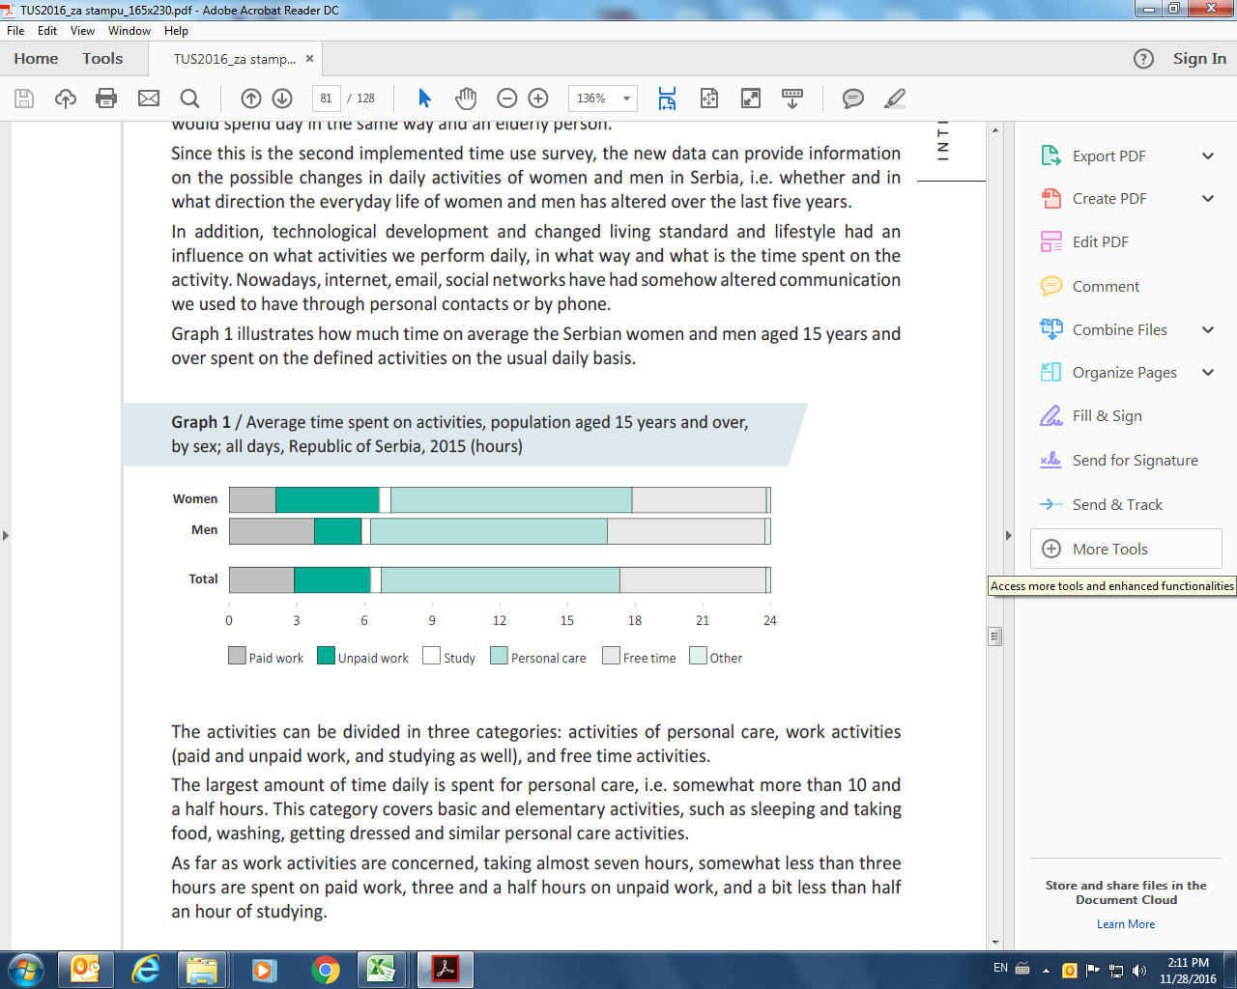

The Serbian population aged 15 and over on average spend almost seven hours doing some kind of work (of which, near to three hours on paid work, and three hours and a half on unpaid work), somewhat less than half an hour is spent on studying, the largest part of a day on personal care activities (10 hours and a half), and the remaining time can be taken as free time and on these activities we spend six hours and a half.

Unfortunately, the survey results confirmed the stereotypes valid here. Regardless whether employed or not, women spend twice more time doing housework, and spend twice less time on paid work activities than men.

Regarding paid work, on average men are twice longer engaged on these activities, i.e. three hours and 46 minutes, and women two hours and four minutes.

A completely different image can be seen concerning unpaid work, since women spend twice more time doing housework than men: four hours and 36 minutes to two hours and five minutes.

Regardless whether employed or not, housework is mainly done by women; therefore it becomes the second shift for those employed. Women spend on unpaid work activities more than four hours and a half daily on average, and men somewhat more than two hours, which means that women spend twice longer time on these activities.

Therefrom, when total work is observed we may conclude that women work almost seven hours, and men work almost six hours; however, women spend almost two-thirds of the time on unpaid activities, and men on paid activities.

When the data from 2010 are compared to those from 2015, the changes occurred concerning the daily distribution of time on the six categories of activities, both regarding women and men.

It is an interesting fact that both for women and men the time spend on paid work remained on an almost unchanged level as five years before. However, unpaid work was slightly reduced on average both for women and men.

The most expressive changes relate to personal care and free time activities. In 2015 both women and men spent over 30 minutes less time on average on personal care activities, such as sleeping, taking food, personal hygiene, etc. than five years before. The subject difference went in favour of free time activities. As far as other activities are concerned, the differences between the time spent on them in 2010 and in 2015 are negligible.

**Methodological notes**

**Main definitions**

Average time spent on certain activity relates to all persons in the survey. It is calculated by dividing the total time spent on certain activity by the number of persons in the survey.

The main categories of activities are the following:

**Paid work** assumes the time spent doing the main and second job, lunch break and time commuting to and back from work, as well as other job related activities.

**Unpaid work** assumes cooking, cleaning and tidying up house, laundry and ironing, household repairs, shopping, taking care of children and adults, unpaid work related travelling, etc.

**Studying** includes time spent on attending school or university classes, doing homework, learning foreign languages or driving, travelling and other studying related activities.

**Personal care** activities include time spent on sleeping, taking food and drinks, on personal hygienic needs, dressing, but also lying in bed due to illness and other personal activities.

**Free time** is the time spent together with family or friends, on entertainment, culture or sport, watching TV, resting or as leisure time, on reading books or papers, PC work or games, as well as the time spent on free time related travelling.

**Other activities** are those related to unspecified activities and travelling.