 | Statistical Office of the Republic of Serbia
 |  | ISSN 0353-9555
STATISTICAL RELEASE |  | SV10
Number 171 • Year LXIII, 28/06/2013
Statistics of Transport and Communications |  | SERB171 SV10 280613

Total transport of passengers and goods, 2011 and 2012

– Republic of Serbia –

The total number of transported passengers in 2012, relative to the previous year, decreased by 1.1%, whereof the decrease of 1.2% was recorded in domestic transport. An increase of 1.9% was recorded in international transport. A decrease of 1.1% in the number of passengers carried is notable in road transport, and railway transport records the decrease of 3.4% in the number of passengers carried. In public transport a negative growth rate of 1.1% has been recorded. The total performance expressed in pkm increased by 0.2%, the domestic transport of passengers being down by 0.4%, and the international transport being up by 1.5%. The only increase in pkm traveled of 2.0%, relative to the previous year, was noted in air transport.
The volume of transported goods in 2012, relative to the previous year, decreased by 9.6%, with a simultaneous operations volume decrease of 6.9%, expressed in tkm. These trends indicate an increased average ton kilometer in land transport: from 283.0 km in 2011 to 302.0 km in 2012. A smaller quantity of goods in 2012, relative to 2011, was transported by inland waterways, pipelines and air. An increase of goods transported of 19.0% was recorded in road transport.
The number of transported passengers in railway transport, relative to the previous year, noted a fall of 3.4% and the performance expressed in pkm decreased by 0.2%. Faster growth of the performance was recorded in the domestic passenger transport than in the international passenger transport. The quantity of goods carried is smaller in domestic goods transport, as well as in imports, exports and transit of goods by rail.
The total number of passengers carried in road transport decreased, relative to the previous year, by 1.1%, the international passenger transport noting a growth of 1.1%. The total number of passengers carried in domestic transport decreased by 1.1%. The total volume of operations, shown in pkm, fell by 0.3%, noting a fall of 0.8% in domestic passenger transport and a growth of 4.2% in international passenger transport. The total quantity of goods carried in road transport in 2012, in relation to 2011, increased by 19.0%. The volume of operations in tkm grew by 29.7%, showing the increase of average journey.
Oil pipeline transport increased by 1.9%. In the same period, natural gas pipeline transport fell by 3.6%. The volume of operations in tkm is lower by 5.1% as far as crude oil transport is concerned, and higher by 11.3% in natural gas pipeline transport.
Air transport, as far as passengers carried and total operations volume are concerned, indicates growth. Transported passengers’ number, compared to the previous year, increased by 8.7%, and total operations volume by 2.0%. When observing the goods transport, the situation in air transport is totally different. Namely, in 2012, when compared to 2011, a fall of quantities of goods transported of 17.2% can be noticed, as well as a fall of total operations volume of 27.7%.
The border traffic of road passenger vehicles entering Serbia decreased by 10.5% in 2012, if compared to 2011. The number of vehicles with domestic registration plates decreased by 13.4% and of vehicles with foreign registration plates by 8.8%. The number of freight vehicles which entered the national territory, increased by 2.5% in the same period, and the number of vehicles in exit decreased by 1.3%. Transit throughout the Republic of Serbia was up by 5.8%.
The volume of services in fixed telephony has been measured since 2010 according to a new measurement unit – the minute. The initial communications in mobile telephony increased by 18.4% and SMS by 6.1%.
Classic postal services in 2012, compared to 2011, noted the following trends: letter mails increased by 3.7%, parcels decreased by 0.9% and payment traffic services decreased by 2.3%.
The total number of employees increased by 3.2% in relation to the previous year.

1. Total transport of passengers and goods
 | 2011 |  | 2012 | 2012/2011
PASSENGER TRANSPORT
Transported passengers, thousand¹⁾ | 78098 |  | 77235 | 98.9
Domestic transport | 75048 |  | 74126 | 98.8
International transport | 3050 |  | 3109 | 101.9
Land transport | 76813 |  | 75838 | 98.7
Railway transport | 6123 |  | 5917 | 96.6
Road transport | 70690 |  | 69921 | 98.9
Public transport | 874569 |  | 865029 | 98.9
Air transport | 1285 |  | 1397 | 108.7
Passenger kilometers, million¹⁾ | 6592 |  | 6607 | 100.2
Domestic transport | 4468 |  | 4451 | 99.6
International transport | 2124 |  | 2156 | 101.5
Land transport | 10524 |  | 10453 | 99.3
Railway transport | 541 |  | 540 | 99.8
Road transport | 4652 |  | 4640 | 99.7
Public transport | 5331 |  | 5273 | 98.9
Air transport | 1399 |  | 1427 | 102.0
TRANSPORT OF GOODS
Transported goods, thousand tons²⁾ |  | 24712 | 22339 | 90.4
Domestic transport |  | 10826 | 10027 | 92.6
Exports |  | 3063 | 2761 | 90.1
Imports |  | 6465 | 5764 | 89.2
Transit |  | 4160 | 3515 | 84.5
International transport |  | 198 | 272 | 137.4
Land transport |  | 22566 | 20341 | 90.1
Railway transport |  | 12620 | 9451 | 74.9
Road transport |  | 5080 | 6047 | 119.0
Pipeline transport |  | 4866 | 4843 | 99.5
Inland waterways transport |  | 2146 | 1998 | 93.1
Air transport |  | 2.230 | 1.846 | 90.4
Ton kilometers, million²⁾ |  | 7247 | 6748 | 93.1
Domestic transport |  | 1545 | 1318 | 85.3
Exports |  | 1247 | 1422 | 114.0
Imports |  | 2165 | 1999 | 92.4
Transit |  | 2050 | 1758 | 85.8
International transport |  | 240 | 250 | 104.2
Land transport |  | 6521 | 6144 | 94.2
Railway transport |  | 3611 | 2769 | 76.7
Road transport |  | 1907 | 2474 | 129.7
Pipeline transport |  | 1003 | 901 | 89.8
Inland waterways transport |  | 726 | 604 | 83.2
Air transport |  | 2.748 | 1.988 | 72.3

¹⁾ No public transport.
²⁾ No air transport.

2. Transport of passengers and goods, by branches
 |  | 2011 | 2012 | 2012/2011
RAILWAY TRANSPORT
PASSENGER TRANSPORT
Transported passengers, thousand | 6123 |  | 5917 | 96.6
Domestic transport | 5356 |  | 5214 | 97.3
International transport | 767 |  | 703 | 91.7
Passenger kilometers, million | 541 |  | 540 | 99.8
Domestic transport | 317 |  | 333 | 105.0
International transport | 224 |  | 207 | 92.4
TRANSPORT OF GOODS
Transported goods, thousand tons | 12620 |  | 9451 | 74.9
Domestic transport | 3987 |  | 2727 | 68.4
Exports | 2238 |  | 1524 | 68.1
Imports | 2497 |  | 1995 | 79.9
Transit | 3898 |  | 3205 | 82.2
Ton kilometers, million | 3611 |  | 2769 | 76.7
Domestic transport | 721 |  | 473 | 65.6
Exports | 514 |  | 335 | 65.2
Imports | 416 |  | 331 | 79.6
Transit | 1960 |  | 1630 | 83.2

2. Transport of passengers and goods, by branches (continued)
 | 2011 | 2012 | 2012/2011
ROAD TRANSPORT
PASSENGER TRANSPORT
Transported passengers, thousand | 70690 | 69921 | 98.9
Domestic transport | 69692 | 68912 | 98.9
International transport | 998 | 1009 | 101.1
Passenger kilometers, million | 4652 | 4640 | 99.7
Domestic transport | 4151 | 4118 | 99.2
International transport | 501 | 522 | 104.2
TRANSPORT OF GOODS
Transported goods, thousand tons | 5080 | 6047 | 119.0
Domestic transport | 3475 | 3680 | 105.9
Exports | 646 | 971 | 150.3
Imports | 720 | 1043 | 144.9
Transit | 41 | 81 | 197.6
International transport | 198 | 272 | 137.4
Ton kilometers, million | 1907 | 2474 | 129.7
Domestic transport | 446 | 442 | 99.1
Exports | 560 | 838 | 149.6
Imports | 644 | 913 | 141.8
Transit | 17 | 31 | 182.4
International transport | 240 | 250 | 104.2
PUBLIC TRANSPORT
PASSENGER TRANSPORT
Transported passengers, million | 875 | 865 | 98.9
Passenger kilometers, million | 5331 | 5273 | 98.9
PIPELINE TRANSPORT
OIL PIPELINES
Transported oil, thousand tons | 2803 | 2855 | 101.9
Domestic transport | 1440 | 1701 | 118.1
Imports | 1363 | 1154 | 84.7
Transit | - | - | -
Ton kilometers, million | 311 | 295 | 94.9
Domestic transport | 101 | 121 | 119.8
Imports | 210 | 174 | 82.9
Transit | - | - | -
GAS PIPELINES
Transported oil, thousand tons | 2063 | 1988 | 96.4
Domestic transport | 351 | 418 | 119.1
Imports | 1503 | 1377 | 91.6
Transit | 209 | 193 | 92.3
Ton kilometers, million | 692 | 606 | 87.6
Domestic transport | 124 | 138 | 111.3
Imports | 512 | 415 | 81.1
Transit | 56 | 52 | 92.9
INLAND WATERWAYS TRANSPORT
TRANSPORT OF GOODS
Transported goods, thousand tons | 2146 | 1998 | 93.1
Domestic transport | 1573 | 1501 | 95.4
Exports | 179 | 266 | 148.6
Imports | 382 | 195 | 51.0
Transit | 12 | 36 | 300.0
Transport among international ports | - | - | -
Ton kilometers, million | 726 | 604 | 83.2
Domestic transport | 153 | 144 | 94.1
Exports | 173 | 249 | 143.9
Imports | 383 | 166 | 43.3
Transit | 17 | 45 | 264.7
Transport among international ports | - | - | -

2. Transport of passengers and goods, by branches (continued)
 | 2011 | 2012 | 2012/2011
AIR TRANSPORT
PASSENGER TRANSPORT
Transported passengers, thousand | 1285 | 1397 | 108.7
Domestic transport | 0 | 0 | -
International transport | 1285 | 1397 | 108.7
Passenger kilometers, million | 1399 | 1427 | 102.0
Domestic transport | 0 | 0 | -
International transport | 1399 | 1427 | 102.0
TRANSPORT OF GOODS
Transported goods, thousand tons | 2230 | 1846 | 82.8
Domestic transport | - | - | -
International transport | 2230 | 1846 | 82.8
Ton kilometers, million | 2748 | 1988 | 72.3
Domestic transport | - | - | -
International transport | 2748 | 1988 | 72.3

Graph 1- Operations volume, by transport branches, 2012
- Republic of Serbia -

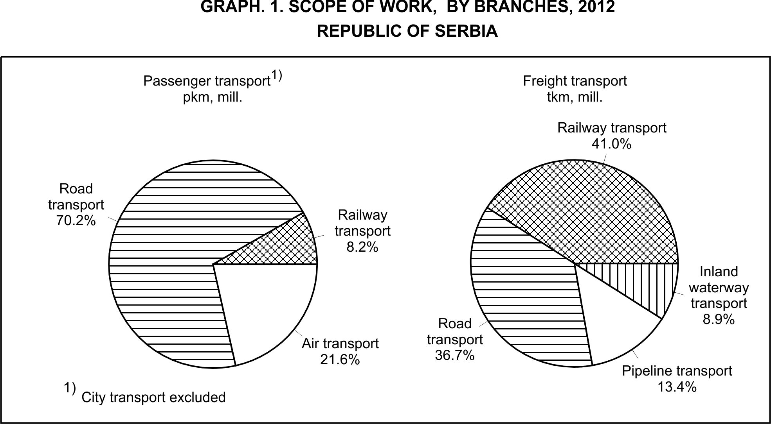

3. Additional and supplementary activities in transport
 | 2011 | 2012 | 2012/2011
SERVICES IN RAILWAY TRANSPORT
Total goods traffic, thousand tons | 12709 | 8973 | 70.6
Traffic volume, thousand tons | 8722 | 6246 | 71.6
Domestic traffic – unloading | 3987 | 2727 | 68.4
Exports | 2238 | 1524 | 68.1
Imports | 2497 | 1995 | 79.9
Transit | 3898 | 3205 | 82.2
BORDER TRAFFIC OF ROAD MOTOR VEHICLES
Total passenger cars traffic, come in | 6377003 | 5710303 | 89.5
Domestic vehicles | 2309563 | 2000770 | 86.6
Foreign vehicles | 4067440 | 3709533 | 91.2
Austria | 134153 | 141147 | 105.2
Bosnia and Herzegovina (incl. RS) | 529847 | 355469 | 67.1
Bulgaria | 114115 | 69286 | 60.7
Hungary | 190525 | 200108 | 105.0
Germany | 271089 | 132725 | 49.0
Republic of Macedonia | 222754 | 84076 | 37.7
Romania | 83420 | 215523 | 258.4
Croatia | 155738 | 96985 | 62.3
Montenegro | 349055 | 173154 | 49.6
Switzerland | 92480 | 76600 | 82.8
Other | 1924264 | 2164460 | 112.5
Passenger cars | 6223566 | 5560505 | 89.3
Buses | 146594 | 142884 | 97.5
Motorcycles | 6843 | 6914 | 101.0
Freight road vehicles
Entry | 330032 | 337997 | 102.4
Domestic vehicles | 208741 | 216514 | 103.7
Foreign vehicles | 121291 | 121483 | 100.2
Exit | 477983 | 471601 | 98.7
Domestic vehicles | 295382 | 306060 | 103.6
Foreign vehicles | 182601 | 165541 | 90.7
Transit | 393491 | 416366 | 105.8
Domestic vehicles | 14434 | 16309 | 113.0
Foreign vehicles | 379057 | 400057 | 105.5

Graph 2- Border transport of passenger cars, entrance
- Republic of Serbia -
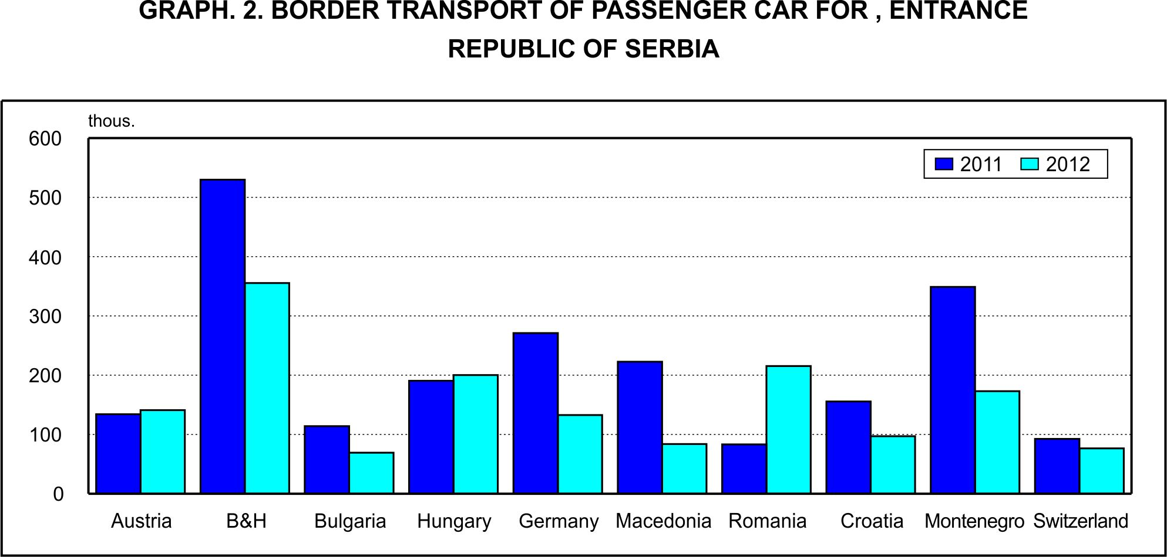

3. Additional and supplementary activities in transport (continued)
 | 2011 |  | 2012 |  | 2012/2011
INTERNAL WATERWAYS TRANSPORT SERVICES
GOODS TRAFFIC IN PORTS
Total goods traffic, thousand tons |  | 7964 |  | 6630 |  | 83.2
Traffic volume, thousand tons |  | 6391 |  | 12458 |  | 194.9
Domestic traffic |  | 3146 |  | 3002 |  | 95.4
Unloading |  | 1573 |  | 1501 |  | 95.4
Loading |  | 1573 |  | 1501 |  | 95.4
International traffic |  | 8148 |  | 9456 |  | 116.1
Exports |  | 1841 |  | 3283 |  | 178.3
Domestic boats |  | 179 |  | 327 |  | 182.7
Foreign boats |  | 1662 |  | 2956 |  | 177.9
Imports |  | 2977 |  | 1846 |  | 62.0
Domestic boats |  | 382 |  | 237 |  | 62.0
Foreign boats |  | 2595 |  | 1609 |  | 62.0
Transit |  | 3330 |  | 4327 |  | 129.9
Domestic boats |  | 12 |  | 47 |  | 391.7
Foreign boats |  | 3318 |  | 4280 |  | 129.0
AIR TRANSPORT SERVICES
AIRPORT PASSENGER TRAFFIC
Passenger traffic volume, thousand |  | 3151 |  | 3392 |  | 107.6
Domestic traffic, departures |  | 0 |  | 0 |  | -
International traffic |  | 3151 |  | 3392 |  | 107.6
Departures |  | 1578 |  | 1700 |  | 107.7
Domestic planes |  | 646 |  | 701 |  | 108.5
Foreign planes |  | 932 |  | 999 |  | 107.2
Arrivals |  | 1573 |  | 1691 |  | 107.5
Domestic planes |  | 645 |  | 695 |  | 107.8
Foreign planes |  | 928 |  | 996 |  | 107.3
CARGO HANDLING
Handled tons, thousand |  | 7105 |  | 5907 |  | 83.1
Operation tons, thousand |  | 8281 |  | 7533 |  | 91.0
Mechanical |  | 8257 |  | 7495 |  | 90.8
Manual |  | 24 |  | 38 |  | 158.3
Unloaded |  | 2301 |  | 2655 |  | 115.4
Loaded |  | 2748 |  | 3073 |  | 111.8
Directly handled, overloaded |  | 2750 |  | 1441 |  | 52.4
Transfer |  | 482 |  | 363 |  | 75.3

4. Postal activities and telecommunications
 | 2011 | 2012 | 2012/2011
POSTAL ACTIVITIES – TRANSPORT AND DELIVERY
Letter mails, million | 301 | 312 | 103.7
Domestic traffic, dispatched | 295 | 306 | 103.7
International traffic, dispatched and received | 6 | 6 | 100.0
Parcel mails, thousand | 555 | 550 | 99.1
Domestic traffic, dispatched | 514 | 504 | 98.1
International traffic, dispatched and received | 41 | 46 | 112.2
Payment traffic services, thousand pcs. | 143341 | 140097 | 97.7
TELECOMMUNICATIONS
Fixed telephone lines, minutes, million | 10737 | 9332 | 86.9
Cellular lines
Outgoing calls, minutes, million | 10240 | 12121 | 118.4
Short messages sent, million | 9578 | 10159 | 106.1
Multimedia messages sent, thousand | 25178 | 27343 | 108.6

5. Employed in transport, storage and communications
 | 2011 | 2012 | 2012/2011
Transport – total | 44684 | 45851 | 103.2
Land transport | 41486 | 42783 | 103.7
Railway transport | 18557 | 18356 | 98.9
Road transport | 10378 | 11215 | 108.1
Public transport | 11205 | 11561 | 105.4
Pipeline transport | 1346 | 1651 | 122.7
Inland waterways transport | 1244 | 1052 | 84.6
Air transport | 1954 | 2016 | 103.2
Postal activities | 14939 | 15068 | 100.9
Telecommunications | 13606 | 13403 | 98.5

6. Fuel consumption in transport, storage and telecommunications
 | 2011 | 2012 | 2012/2011
Transport - total
Coal, thousand tons | - | - | -
Diesel, thousand tons | 191 | 206 | 107.9
Petrol, thousand tons | - | - | -
Electricity, thousand MWh | 216 | 186 | 86.1
Kerosene, thousand tons | 69 | 60 | 87.0

Land transport
Coal, thousand tons | - | - | -
Diesel, thousand tons | 180 | 198 | 110.0
Petrol, thousand tons | - | - | -
Electricity, thousand MWh | 216 | 186 | 86.1

Railway transport
Coal, thousand tons | - | - | -
Diesel, thousand tons | 10 | 8 | 80.0
Electricity, thousand MWh | 170 | 143 | 84.1

Road transport
Diesel, thousand tons | 97 | 111 | 114.4
Petrol, thousand tons | - | - | -

Public transport
Diesel, thousand tons | 73 | 71 | 97.3
Electricity, thousand МWh | 46 | 43 | 93.5
Inland waterways transport
Diesel, thousand tons | 11 | 8 | 72.7

Air transport
Kerosene, thousand tons | 69 | 60 | 87.0

7. Passenger and goods transport, by months, 2012

7.1. Passenger transport, by months, 2012
 | Transported passengers, thousand |  |  |  |  | Passenger kilometers, mill.
 | Total | Land transport |  |  | air | Total | Land transport |  |  | air
 |  | all | railway | road |  |  | all | railway | road
Total | 77235 | 75838 | 5917 | 69921 | 1397 | 6607 | 5180 | 540 | 4640 | 1427
January | 5935 | 5859 | 435 | 5424 | 76 | 469 | 390 | 36 | 354 | 79
February | 5644 | 5581 | 312 | 5269 | 63 | 411 | 347 | 24 | 323 | 64
March | 6865 | 6780 | 444 | 6336 | 85 | 510 | 424 | 34 | 390 | 86
April | 6771 | 6660 | 477 | 6183 | 111 | 545 | 431 | 40 | 391 | 114
May | 7093 | 6978 | 507 | 6471 | 115 | 575 | 458 | 44 | 414 | 117
June | 6673 | 6530 | 525 | 6005 | 143 | 609 | 463 | 60 | 403 | 146
July | 5613 | 5429 | 542 | 4887 | 184 | 642 | 459 | 71 | 388 | 183
August | 5632 | 5443 | 508 | 4935 | 189 | 650 | 461 | 59 | 402 | 189
September | 6634 | 6486 | 519 | 5967 | 148 | 597 | 446 | 44 | 402 | 151
October | 6987 | 6878 | 585 | 6293 | 109 | 559 | 445 | 46 | 399 | 114
November | 6791 | 6705 | 541 | 6164 | 86 | 523 | 431 | 41 | 390 | 92
December | 6597 | 6509 | 522 | 5987 | 88 | 517 | 425 | 41 | 384 | 92

7.2. Goods transport, by months 2012
 | Transported cargo, thousand t |  |  |  |  |  |  | Ton kilometers, million
 | Total | Land transport |  |  |  | river | air | Total | Land transport |  |  |  | river | air
 |  | All | railway | road | pipe-  line |  |  |  | all | railway | road | pipe-  line
Total | 22341 | 20341 | 9451 | 6047 | 4843 | 1998 | 1.846 | 6750 | 6144 | 2769 | 2474 | 901 | 604 | 1.988
January | 1731 | 1648 | 785 | 339 | 524 | 83 | 0.143 | 491 | 484 | 213 | 150 | 121 | 7 | 0.153
February | 1334 | 1332 | 524 | 309 | 499 | 2 | 0.151 | 421 | 421 | 152 | 146 | 123 | 0 | 0.167
March | 1913 | 1750 | 943 | 493 | 314 | 163 | 0.151 | 603 | 540 | 280 | 185 | 75 | 63 | 0.161
April | 1895 | 1709 | 864 | 493 | 352 | 186 | 0.128 | 591 | 532 | 249 | 219 | 64 | 59 | 0.140
May | 2020 | 1748 | 836 | 538 | 374 | 272 | 0.166 | 596 | 518 | 241 | 221 | 56 | 78 | 0.187
June | 1904 | 1664 | 743 | 567 | 354 | 240 | 0.181 | 585 | 507 | 225 | 229 | 53 | 78 | 0.199
July | 1857 | 1665 | 792 | 561 | 312 | 192 | 0.162 | 557 | 503 | 237 | 221 | 45 | 54 | 0.173
August | 1817 | 1629 | 746 | 580 | 303 | 188 | 0.150 | 529 | 486 | 224 | 222 | 40 | 43 | 0.164
September | 1727 | 1591 | 763 | 555 | 273 | 136 | 0.146 | 560 | 499 | 234 | 230 | 35 | 61 | 0.155
October | 2067 | 1835 | 852 | 572 | 411 | 232 | 0.162 | 580 | 521 | 240 | 217 | 64 | 59 | 0.172
November | 1978 | 1814 | 805 | 569 | 440 | 164 | 0.153 | 589 | 535 | 232 | 217 | 86 | 54 | 0.159
December | 2096 | 1956 | 798 | 471 | 687 | 140 | 0.153 | 646 | 598 | 242 | 217 | 139 | 48 | 0.158

Contact: sandra.mihajlovic@stat.gov.rs Phone: +381 11 3617321
Published and printed by: Statistical Office of the Republic of Serbia, Milana Rakica 5, Belgrade
Phone: +381 11 2412922 ● Fax: +381 11 2411260 ● www.stat.gov.rs
Responsible: Dragan Vukmirovic, PhD, Director
Circulation: 20 • Issued annually

