 | Statistical Office of the Republic of Serbia | ISSN 0353-9555
STATISTICAL RELEASE |  | ZS50
Number 144 • Year LXIII, 17/06/2013
Environmental statistics |  | SERB144 ZS50 170613

Water use and protection against pollution in the Republic of Serbia, 2012
– Preliminary results –
The data represent the preliminary results of the Survey on water use and protection against pollution in the Republic of Serbia in 2012. The tables present data on abstracted, used, discharged, reused water from industry as well as water losses.
In 2012, water abstraction was by 9.5% increased relative to 2011, whereof, 7.1% more ground and spring water was abstracted and 9.5% more surface water.
Starting from 1999 the Statistical Office of the Republic of Serbia has not at disposal and may not provide available certain data relative to AP Kosovo and Metohia and therefore these data are not included in the coverage
for the Republic of Serbia (total).

1. Abstracted, used, discharged, reused water from industry and water losses from industry, 2010–2012
Republic of Serbia mill. m³
 | 2010 | 2011 | 2012
Abstracted water¹⁾ | 232 257 | 155 904 | 170 698
From public water supply | 18 | 19 | 20
From self-supply | 232 239 | 155 885 | 170 678
From ground and spring water | 31 | 28 | 30
From surface water | 232 208 | 155 857 | 170 648
Water losses | - | - | 2
Water use | 232 257 | 155 904 | 170 696
For production | 232 247 | 155 893 | 170 684
Flowing water in hydropower plants | 229 114 | 152 423 | 167 630
For cooling purposes²⁾ | 3 032 | 3 368 | 2 951
Recirculated water | - | - | 2
Water in technological process | 48 | 48 | 52
As a raw material | 10 | 10 | 10
For other purposes | 53 | 55 | 51
For sanitary use | 10 | 11 | 12
Discharged water³⁾ | 3 134 | 3 446 | 3 046
Wastewater | 102 | 78 | 95
Cooling water | 3 032 | 3 368 | 2 951
Treated water | 165 | 136 | 119
Reused water | - | - | 1

¹⁾ Water used for hydropower plants is included.
²⁾ Included are all waters for cooling purposes in electricity production and other technological processes.
³⁾ Water used for hydropower plants is excluded.
Of the total 3 067 446 thous. m³ of abstracted waters, 99.4% are from self-supply (surface water - 98.4%, ground water - 1.0%) and 0.6% is from public water supply.
The following divisions are particularly marked: Electricity, gas, steam and air conditioning supply, Manufacture of basic metals, Manufacture of food products and Manufacture of chemicals and chemical products that abstract and use 98.6% of the total water quantity.
2. Water abstraction from industries, by type of supply system, 2012

Republic of Serbia thous. m³
 | Total | From public water supply | Self-supply
 |  |  | Ground water | Surface water
Abstracted water¹⁾ | 3 067 446 | 19 555 | 30 007 | 3 017 884
Mining and quarrying | 11 297 | 891 | 2 339 | 8 067
Manufacturing | 78 128 | 16 398 | 24 691 | 37 039
Electricity, gas , steam and air conditioning supply | 2 978 021 | 2 266 | 2 977 | 2 972 778
Water intensive industries | 3 025 587 | 8 411 | 17 093 | 3 000 083
Electricity, gas , steam and air conditioning supply | 2 978 021 | 2 266 | 2 977 | 2 972 778
Manufacture of basic metals | 21 475 | 1 381 | 717 | 19 377
Manufacture of food products | 17 341 | 2 526 | 12 434 | 2 381
Manufacture of chemicals and chemical products | 8 750 | 2 238 | 965 | 5 547

¹⁾ Water used for hydropower plants, which is not included in this table, in 2012 amounted 167 630 mill. m³.

Graph 1 - Abstracted water from industry in the Republic of Serbia, by type of supply system, 2012
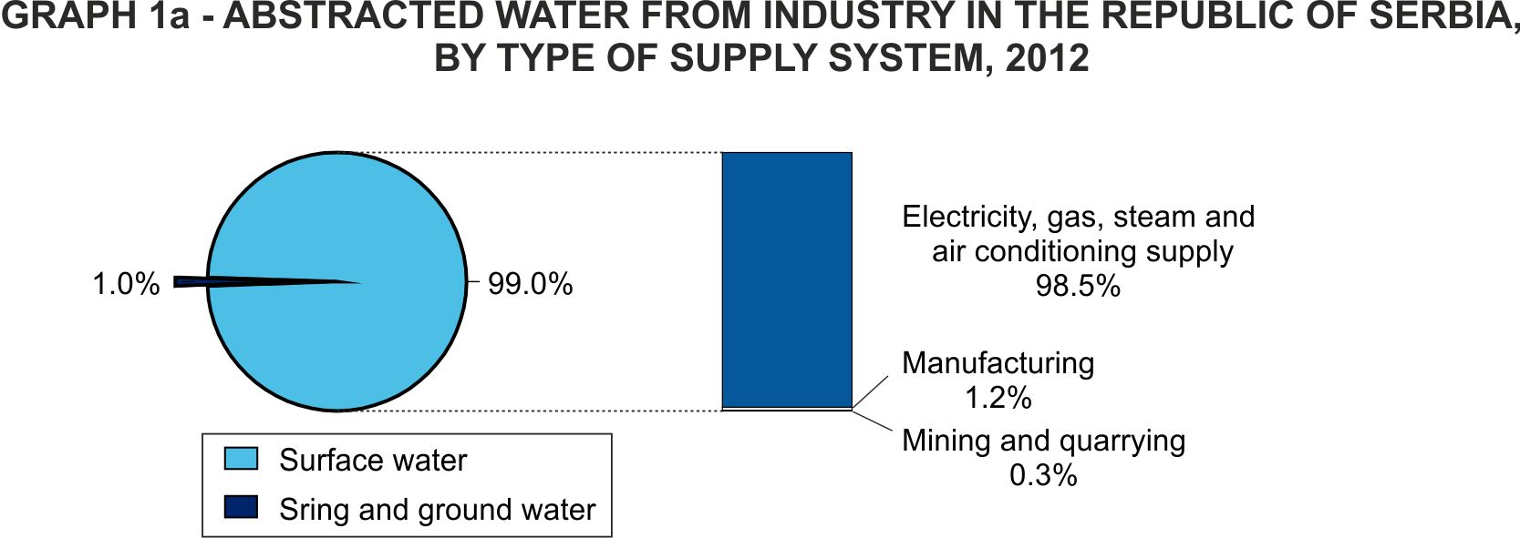
Out of the total used water in industries, 97.1% refers to water used in sections Electricity, gas, steam and air conditioning supply, 2.5% to water used in Manufacturing, while 0.4% relates to water used in Mining and quarrying.

3. Water use in industry, by type of use, 2012

Republic of Serbia thous. m³
 | Total water use in industry | Cooling water for electricity generation | Other cooling water | Water in technological process | Sanitary water | Other industrial use of water | Water losses
Water use¹⁾ | 3 065 813 | 2 929 346 | 21 657 | 51 603 | 11 900 | 51 307 | 1 633
Mining and quarrying | 10 933 | 0 | 205 | 8 378 | 1 469 | 881 | 364
Manufacturing industry | 76 870 | 73 | 20 680 | 35 079 | 8 658 | 12 380 | 1 258
Electricity, gas, steam and air conditioning supply | 2 978 010 | 2 929 273 | 772 | 8 146 | 1 773 | 38 046 | 11
Water intensive industries | 3 024 458 | 2 929 338 | 19 026 | 26 612 | 4 862 | 44 620 | 1 129
Electricity, gas, steam and air conditioning supply | 2 978 010 | 2 929 273 | 772 | 8 146 | 1 773 | 38 046 | 11
Manufacture of basic metals | 20 510 | - | 14 499 | 4 857 | 928 | 226 | 965
Manufacture of food products | 17 188 | 65 | 2 157 | 8 107 | 1 345 | 5 514 | 153
Manufacture of chemicals and chemical products | 8 750 | - | 1 598 | 5 502 | 816 | 834 | -

¹⁾ Water used for hydropower plants, which are not included in this table, in 2012 amounted to 167 630 mill. m³.

Graph 2 – Water use in industry in the Republic of Serbia, by type of use, 2012
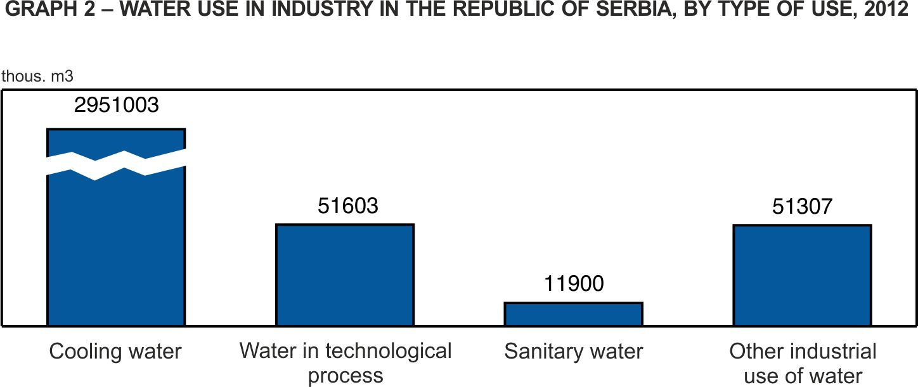
Of the total disharged wastewater from industry, 45.7% comes from section Electricity, gas, steam and air conditioning supply, 48.7% from Manufacturing and 5.6% from Mining and quarrying.

4. Discharged¹⁾ water form industry, 2012

Republic of Serbia thous. m³
 | Укупно | Испуштене воде, од тога:
 |  | за хлађење | рециркулационе воде | отпадне воде
Discharged water | 3 046 166 | 2 951 003 | 215 | 95 163
Mining and quarrying | 5 546 | 205 | - | 5 341
Manufacturing industry | 67 121 | 20 753 | 23 | 46 368
Electricity, gas, steam and air conditioning supply | 2 973 499 | 2 930 045 | 192 | 43 454
Water intensive industries | 3 014 351 | 2 948 364 | 200 | 65 987
Electricity, gas, steam and air conditioning supply | 2 973 499 | 2 930 045 | 192 | 43 454
Manufacture of basic metals | 19 485 | 14 499 | - | 4 986
Manufacture of food products | 15 493 | 2 222 | 8 | 13 271
Manufacture of chemicals and chemical products | 5 874 | 1 598 | - | 4 276

¹⁾ In total discharged water, water used for hydropower plants are not included.

Graph 3 – Total discharged and treated water from industry in the Republic of Serbia, 2012
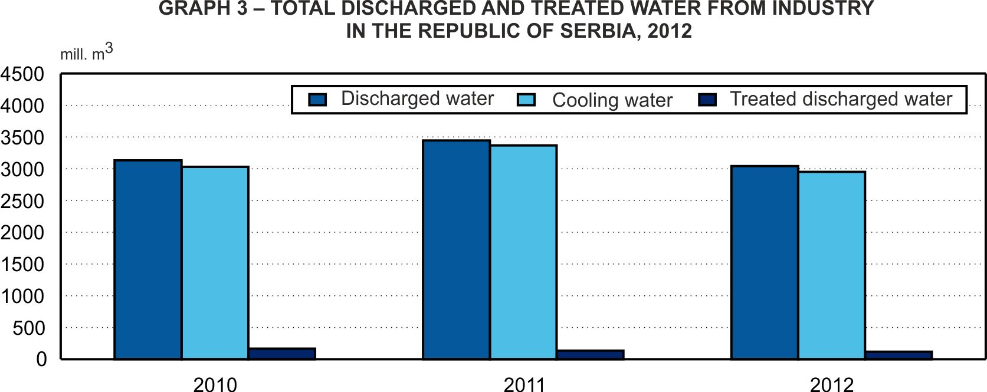

5. Treated and reused water from industry, 2012

Republic of Serbia thous. m³
 | Treated discharged water |  |  |  | Reused water
 | Total | Primary treatment | Secondary treatment | Tertiary treatment
Treated and reused water | 118 953 | 108 508 | 3 985 | 6 460 | 966
Mining and quarrying | 3 564 | 1 566 | 1 998 | - | 2
Manufacturing industry | 38 016 | 30 070 | 1 486 | 6 460 | 100
Electricity, gas, steam and air conditioning supply | 77 373 | 76 872 | 501 | - | 864
Water intensive industries | 106 769 | 101 135 | 1 701 | 3 933 | 871
Electricity, gas, steam and air conditioning supply | 77 373 | 76 872 | 501 | - | 864
Manufacture of basic metals | 14 275 | 13 431 | 2 | 842 | -
Manufacture of food products | 8 510 | 5 776 | 1 050 | 1 684 | 1
Manufacture of paper and paper products | 4 605 | 4 555 | - | 50 | 6
Manufacture of chemicals and chemical products | 2 006 | 501 | 148 | 1 357 | -

Graph 4. Treated discharged water in the Republic of Serbia, by type of treatment, 2012.

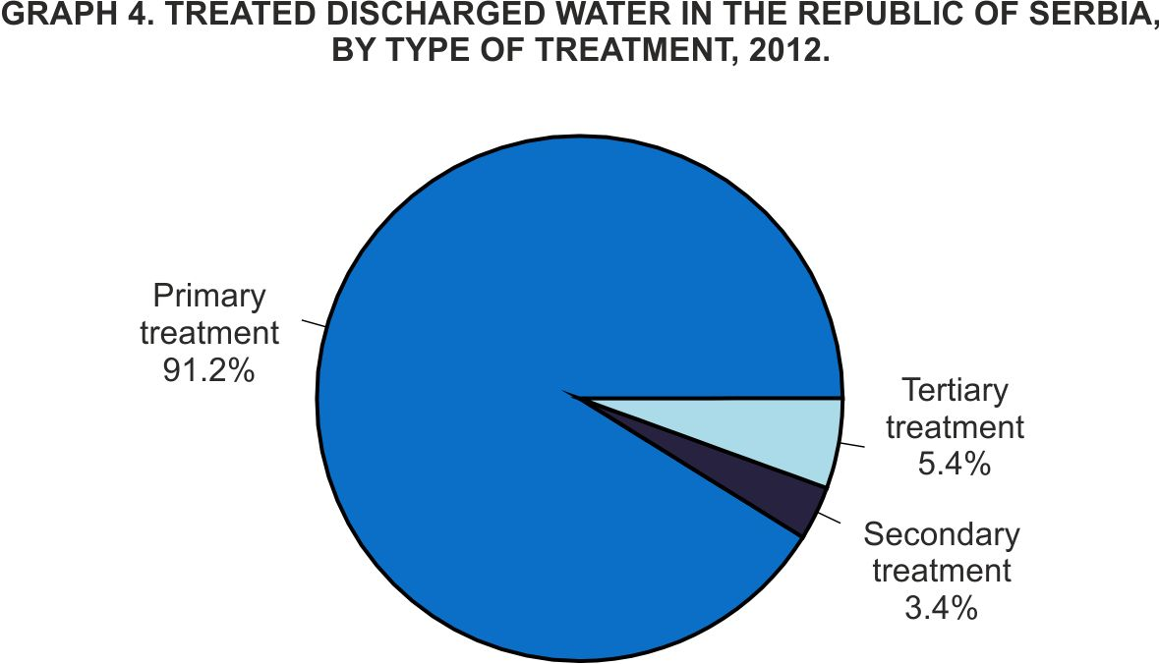

Methodological notes

Methodological explanations on Water use and protection against pollution can be found on the SORS website: http://webrzs.stat.gov.rs/WebSite/Public/PageView.aspx?pKey=201
Data series on Water use and protection against pollution from the reference year 2002 are available within the SORS database: http://webrzs.stat.gov.rs/WebSite/public/ReportView.aspx , and as a part of the SORS publications: http://webrzs.stat.gov.rs/WebSite/Public/PageView.aspx?pKey=200.

Contact:milijana.ceranic@stat.gov.rs; ana.vignjevic@stat.gov.rs phone: 0112412922 ext.246
Published and printed by: Statistical Office of the Republic of Serbia, Milana Rakica 5, Belgrade
Phone: +381 11 2412922 ● Fax: +381 11 2411260 ● www.stat.gov.rs
Responsible: Dragan Vukmirovic, PhD, Director
Circulation: 20 • Issued annually

