|  |  |
| --- | --- |
|  |  |
|  | |  | | --- | | **Statistical Office of the Republic of Serbia** | |
|  |

Animal production statistics

in the Republic of Serbia

**National Methodological Report**

Reference period: 2018

**July, 2019**

Contents

1. Livestock statistics 5

1.1 Responsible institution and contact person 5

1.2 Legal framework 5

1.3. Population 5

1.4. Description of data source 7

1.4.1. Survey on agricultural production – Animal production, 2017 7

1.4.1.1. Reference period and categories 7

1.4.1.2. Sample 11

1.4.1.3. Organisation of data collection 12

1.4.2. Survey on number of pigs, 2018 14

1.4.2.1. Reference period and categories 14

1.4.2.2. Sample 14

1.4.2.3. Organisation of the data collection 15

1.4.3. Other types of data collection 16

1.4.4. Use of administrative data 16

1.5. Publication and dissemination 16

1.6 Annexes 17

2. Meat statistics 18

2.1 Responsible institution and contact person 18

2.2 Legal framework 18

2.3 Population 18

2.4 Categories and reference period 19

2.5 Description of the data source 20

2.5.1 Survey 21

2.5.2 Other types of data collection 22

2.5.3 Use of administrative data 22

2.6 Organisation of the data collection 22

2.7 Data publication and dissemination 23

2.8 Annexes 23

3. Milk statistics 24

3.1 Responsible institution and contact person 24

3.2 Legal framework 24

3.3 Population 24

3.4 Categories and reference period 25

3.5 Description of the data source 29

3.5.1 Survey 30

3.5.2 Other types of data collection 30

3.5.3 Use of administrative data 31

3.6 Organisation of the data collection 31

3.7 Publication and dissemination 31

3.8 Annexes 32

4. Poultry statistics 33

4.1 Responsible institution and contact person 33

4.2 Legal framework 33

4.3 Population 33

4.4 Categories and reference period 35

4.5 Description of the data source 36

4.5.1 Survey 37

4.5.2 Other types of data collection 37

4.5.3 Use of administrative data 37

4.6 Organisation of data collection 37

4.7 Data publication and dissemination 38

4.8 Annexes 38

Annex I 39

Annex II 41

Annex III 46

Annex IV 48

Annex V 51

Annex VI 55

Livestock statistics

1.1 Responsible institution and contact person

Statistical Office of the Republic of Serbia, 5 Milana Rakica St, Belgrade, Serbia

Dragana Pogarcic, Head   
Group for livestock and fishery statistics   
Statistical Office of the Republic of Serbia  
5 Milana Rakica St, Belgrade, Serbia  
phone: +381 11 2412 922 ext. 243  
E-mail: [dragana.pogarcic@stat.gov.rs](mailto:%20username@stat.gov.rs)  
[www.stat.gov.rs](http://www.stat.gov.rs)

1.2 Legal framework

In accordance with the Official Statistics Law (Official Gazette of RS, No 104/09), Regulation on defining the plan of official statistics for the referent year and Regulation (EC) No 1165/2008 (Regulation (EC) No 1165/2008 of 19 November 2008 concerning livestock and meat statistics and repealing Council Directives 93/23/EEC, 93/24/EEC and 93/25/EEC).

1.3. Population

In the period from 2006 to 2011 the data on the number and weight of livestock by species (cattle, pigs, sheep, goats, poultry) and by categories as defined in Annex II (Regulation (EC) No 1165/2008), were obtained by the regular annual Survey on livestock number for family agricultural holdings and the Annual survey of livestock breeding for enterprises, farm cooperatives and other organisations with the status of legal entities. These regular statistical surveys were envisaged to provide the data on primary animal products, i.e. eggs (total), honey, milk and wool, as well as the data on livestock balance by species (cattle, pigs, sheep, poultry). Data on number of livestock by species and categories from 2006 to 2012 were sent to Eurostat. Data for 2012 were estimated on the basis of regular statistical surveys on animal production in past years, data on slaughter statistics and foreign trade in 2012 and results of the Census of Agriculture 2012.

The Census of Agriculture 2012 (hereinafter referred to as: AC) was conducted in the Republic of Serbia in the period from 1 October to 15 December 2012, in accordance with the Law on the Census of Agriculture 2011 (Official Gazette of RS, No 24/11). The applied instruments, coverage, features and definitions are all in accordance with the World Programme for the Census of Agriculture, 2010 (FAO-UN) and Eurostat methodology (Regulation (EC) No 1166/2008 of the European Parliament and the Council of 19 November 2008 on farm structure surveys and the survey on agricultural production methods and repealing Council Regulation (EEC) No 571/88).

The observation units for the AC are agricultural holdings in the territory of the Republic of Serbia.

Agricultural holding is a technical and economic independent production unit with a single management on which an enterprise, farm cooperative, institution or another legal entity, unincorporated enterprise or family holding undertakes agricultural activities listed in Annex I Regulation (EC) No 1166/2008, either as primary or secondary activity.

Family holding means every family or other community of people living together and sharing subsistence expenses out of their respective income (including single households), which members (one or more) are engaged in agricultural production, being either their primary or secondary activity, having a single management, sharing joint production means (land, machinery, buildings) and its member’s labour, the holder of which is a physical person, and it is engaged as follows:

* cultivates /uses 50 or more ares of agricultural land for agricultural production, or
* cultivates /uses less than 50 ares of agricultural land, however practises intensive crop farming, fruits growing, viticulture, growing of vegetables and flowers (including production under glasshouses and poly/tunnels), production of mushrooms and livestock raising, i.e. engages in other forms of agricultural production intended for the market, or
* as of 30 September 2012 raises: two heads of cattle, or one head of cattle and 2 heads of pig, goat, sheep in total, or 5 heads of sheep or goats, or 3 heads of pig, or 4 heads of pig, goat, sheep in total, or 50 heads of poultry, or 20 colonies of bees.

The final AC data were published on 21 December 2013, and some of these data are presented in the table below.

*Table 1* Data on number of livestock by species, number of beehives and number of holdings (AC final data)

|  |  |  |
| --- | --- | --- |
| Number of agricultural holdings, total | | 631 552 |
| Cattle | Number of heads | 908 102 |
| Number of holdings | 177 252 |
| Buffaloes | Number of heads | 1 978 |
| Number of holdings | 568 |
| Pigs | Number of heads | 3 407 318 |
| Number of holdings | 355 052 |
| Sheep | Number of heads | 1 736 440 |
| Number of holdings | 154 972 |
| Goats | Number of heads | 231 837 |
| Number of holdings | 62 930 |
| Poultry | Number of heads | 26 711 220 |
| Number of holdings | 413 792 |
| Horses | Number of heads | 16 910 |
| Number of holdings | 10 095 |
| Beehives | Number | 665 022 |
| Number of holdings | 31 287 |

On the basis of the obtained AC data, the new samples for the survey on livestock number (Survey on agricultural production – Animal production) were created in December 2013 and 2014. Also, the Agricultural Statistics Development Strategy envisaged the introduction of the Survey on number of pigs (state as of 23 May). This survey was conducted for the first time in 2014 and together with the Survey on agricultural production – Animal production in December provides the data on the number of pigs in the required periodicity.

Statistical Farm Register (SFR) was established in 2015 as one of the goals of AC. Starting from 2015, SFR is used as a frame for sample selection. Updating of SFR is carried out by Register of holdings (Ministry of Agriculture, Forestry and Water Management), Statistical Business Register and data obtained in regularly statistical surveys.

1.4. Description of data source

Data sources are the Survey on agricultural production – Animal production and the Survey on number of pigs.

The data with state as on 1 December 2018 are estimated on the basis of the Farm Structure Survey 2018 (in the text below: FSS) first results, the results of December survey in the previous years and other available sources, since the Survey on agricultural production – Animal production was not conducted in 2018 because of the FSS implementation. This survey was carried out in the period from 1 October – 30 November 2018, on the sample of around 120 000 (near 20%) agricultural holidngs. CAPI method was applied for interviewing family holdings and holdings of unincorporated enterprises, while CAWI and PAPI method were applied for interviewing holdings of legal units. Among others, obtained were the data on number of livestock by species and categories with the state as on 30 September, as well as the data on animal production (production of milk, milk products, eggs-total, eggs for consumption, wool and honey) in the last 12 months from the critical moment (30 September). Detailed FSS National Methodological Report was transmitted to Eurostat in June 2019. The parts of FSS questionnaire related to animal production statistics are shown in Annex I.

1.4.1. Survey on agricultural production – Animal production, 2017

1.4.1.1. Reference period and categories

The Survey on agricultural production – Animal production is carried out in the period from 2 – 16 December.

The objective of this survey is to obtain the data on number and trade of livestock by species and categories, including data on slaughtering of livestock on holdings by months, data on number of beehives, production of milk and milk products, wool, eggs-total, eggs for consumption and honey, as well as data on utilization of own produced livestock products by holding. These data create the basis for the calculation of animal production and EAA calculation.

The data on number of livestock by species and categories referred to the state as on 1 December (critical moment). The other data collected referred to the previous 12 months started from the date of the critical moment.

The first results need to be available by 15 February.

The data referred to livestock species and categories are listed below.

**Cattle**

**Cattle – domestic** animals species *Bos Taurus*.

*Calves*– cattle animals (males and females) aged 8 months or under, regardless of the kind of feeding or the purpose of raising (slaughter or breeding).

*Young cattle* – cattle animals older than 8 months, but not over 12 months, regardless of sex or purpose of raising.

*For slaughter before turning 1 year*– heads raised for slaughter before turning 1 year, if this purpose is determined.

*Other male heads*– all other male heads aged not over 1 year which are raised for breeding or slaughter after they reached 1 year or their purpose is not yet determined.

*Other female heads*– all other female heads aged not over 1 year which are raised for breeding or slaughter after they reached 1 year or their purpose is not yet determined.

*Heifers* – female heads aged 1 year or more that have not calved yet (including heifers in calf).

*Heifers in calf* – female heads aged 1 year or more which are in calf for the first time and which are expected to give the first offspring.

*Cows* – female heads aged 1 year or more, which have been calved at least once (cows in calf, already calved cows, and sterile cows).

*Dairy cows* – cows which purpose of raising is exclusively or principally for the production of milk for human consumption and /or for processing. Included are cull cows for slaughter whether they are fattened or not between their last lactation and their slaughter.

*Other cows* – cows other than dairy cows, including draught cows (cows – dairy cows).

*Bulls for service* – male heads, not castrated, used for breeding, aged 1 year or more.

*Bullocks* – castrated male bovine animals, aged 1 year or more, mainly used for work and draught.

*Cattle in fattening* – the total number of heads set aside for fattening, irrespective of the sex, age and fattening technique, intended for slaughter after reaching certain mass.

Data on number of calves, young cattle, heifers in calf and bulls for service, bullocks and cattle in fattening are obtained for national purposes.

Given that the number of buffaloes in the Republic of Serbia is significant, data for this type of livestock are not obtained.

**Pigs**

*Pigs* –domestic animals species *Sus scrofa domestica*.

*Piglets*– young heads with live weight of less than 20 kg.

*Young male heads* – breeding male heads with live weight of 50 kg and more that not yet used for breeding;

*Gilts* – breeding female heads with live weight 50 kg and more not yet farrowed including gilts covered for the first time;

*Gilts covered for the first time*– breeding female heads with live weight 50 kg and more not yet farrowed but expected to give first offspring;

*Sows*– breeding female heads with live weight 50 kg and more that farrowed at least once including covered sows;

*Covered sows* – breeding female heads with live weight 50 kg and more that farrowed at least once and that are covered;

*Boars* – breeding male pigs with live weight 50 kg and more used for breeding.

*Pigs in fattening* – the total number of heads set aside for fattening, irrespective of the sex, age, mass and fattening technique, intended for slaughter after reaching certain mass (data obtained for the national purposes).

For the purposes of data transmission to Eurostat, data by presented categorization for national needs can be easily transformed into data for the categories listed in Annex II Regulation (EC) No 1165/2008: boars +young male heads = boars (EU); covered sows + giltscovered for the first time = covered sows (EU); giltscovered for the first time = covered sows for the first time (EU); sows - covered sows +gilts - giltscovered for the first time = other sows (EU); gilts – gilts covered for the first time = gilts not yet covered (EU).

**Sheep**

*Sheep*– domestic animals species *Ovis aries*.

*Lambs*– the total number of heads, both females (which are not put to the ram for the first time) and males, under 1 year of age, irrespective of the aim of raising them.

*Breeding ewes*– female heads which have lambed at least once, as well as heads put to the ram for the first time;

*Milk ewes*– ewes kept exclusively or principally for the production of milk for human consumption and/or for processing into dairy products, including cast milk sheep (whether fattened or not between last lactation and slaughter).

*Other breeding ewes* – ewes other than milk ewes;

*Other sheep* – other male and female heads not included in the previous categories.

For the purposes of data transmission to Eurostat, data by presented categorization for national needs can be easily transformed into data on other sheep according to Annex II Regulation (EC) No 1165/2008: lambs +other sheep= other sheep (EU)

**Goats**

*Goats* –domestic animals species*Capra aegagrus hircus*.

*Kids* – the total number of young heads, both females (which are not kidded or matted first time) and males, under 1 year of age, irrespective of the aim of raising them.

*Goats already kidded*– female heads already kidded at least once.

*Goats matted first time*– female young breeding heads which are expected to give first offspring.

*Other goats* – other male and female heads not included in the previous categories.

For the purposes of data transmission to Eurostat, data by presented categorization for national needs can be easily transformed into data on other goats according to Annex II Regulation (EC) No 1165/2008: kids + other goats = other goats (EU)

**Poultry**

*Broilers*– chicks, chicken species *Gallus gallus* raised for production in intensive conditions, which in 6 to 8 weeks reach 1.8 to 2.5 kg live weight, when they are slaughtered.

*Laying hens* – female heads chicken species *Gallus gallus* which have reached certain gender maturity for laying eggs. This also includes hens taken out of production.

*Other chickens* – other domestic birds of the species *Gallus gallus* not included in the previous categories.

*Turkeys* –female and male domestic bird species *Meleagris spp*.

*Geese*–female and male domestic bird species *Anser anser dom.*

*Ducks* –female and male domestic bird species *Anas* sppand *Carina moschata.*

*Other birds*– birds rose on the holding for the production of meat, eggs, (not for hunting or hobby), which have not been mentioned in species (pheasants male and female, quails, pigeons, ostriches etc.).

Data on poultry by species and categories are obtained for national purposes.

Comparative table of EU and national categorisation of livestock is given below.

*Table 2* EU and National categorisation of livestock – comparative table

|  |  |
| --- | --- |
| **EU categorisation** | **National categorization** |
| **Cattle** |  |
| Bovine animals aged not over 1 year | = |
| Calves and young cattle for slaughter | = |
| Other | = |
| Male | = |
| Female | = |
| Bovine animals aged over 1 year but under 2 years (except females that have calved) | = |
| Male | = |
| Female (heifers; animals that have not yet calved | = |
| For slaughter | = |
| Other | = |
| Bovine animals of 2 years and over | = |
| Male | = |
| Female | = |
| Heifers | = |
| Heifers for slaughter | = |
| Other | = |
| Cows | = |
| Dairy cows | = |
| Other | = |
| **Pigs** |  |
| Piglets with a live weight of less than 20 kg | = |
| Pigs with a live weight of 20 kg or more but less than 50 kg | = |
| Fattening pigs, including cull boars and cull sows with a live weight: | = |
| Of 50 kg or more but less than 80 kg | = |
| Of 80 kg or more but less than 110 kg | = |
| Of 110 kg or more | = |
| Breeding pigs with a live weight of 50 kg and over |  |
| Boars | Boars +Young male heads |
| Covered sows, of which: | Covered sows + Giltscovered for the first time |
| Sows covered for the first time | Giltscovered for the first time |
| Other sows, of which: | Sows - Covered sows +Gilts - Giltscovered for the first time |
| Gilts not yet covered | Gilts – Gilts covered for the first time |
| **Sheep** |  |
| Ewes and ewe lambs put to the ram: | = |
| Milk ewes and milk ewe lambs put to the ram | = |
| Other ewes and milk ewe lambs put to the ram | = |
| Other sheep | Lambs +Other sheep |
| **Goats** |  |
| Goats which have already kidded and goats which have been mated: | = |
| Goats which have already kidded | = |
| Goats mated for the first time | = |
| Other goats | Kids +Other goats |

1.4.1.2. Sample

Observation units are family holdings involved in agricultural production, legal entities and unincorporated agricultural enterprises, i.e. producers which are selected in sample for Survey on agricultural production – Animal production, 2017.

Stratified simple random sample was selected.

**Sample frame** consists of all active agricultural holdings from Statistical Farm Register.

Sample frame contains 499 694 units. Out of that number, 569 units are legal entities, and 116 are unincorporated agricultural enterprises, i.e. producers, the rest are 499 009 family holdings. The sample frame covers 100 % of livestock population in SFR, which is in accordance with the Regulation (EC) No 1165/2008, Article 3.

The stratification was done according to legal status, size of agricultural holding and territory (NUTS 2 level). Agricultural holdings are classified into four size classes, according to the criteria given in the table.

*Table 3* Criteria for size classes of agricultural holdings

|  |  |  |  |  |
| --- | --- | --- | --- | --- |
|  | Size class | | | |
| 1 | 2 | 3 | 4 |
| Cattle | >=50 | 20-49 | 10-19 | <10 |
| Pigs | >=70 | 30-69 | 10-29 | <10 |
| Sheep | >=100 | 50-99 | 10-49 | <10 |
| Goats | >=50 | 20-49 | 10-19 | <10 |
| Poultry | >=5 000 | 100-4 999 | 50-99 | <50 |
| Beehives | >=150 | 50-149 | 10-49 | <10 |

All legal entities and unincorporated agricultural enterprises, i.e. producers from the frame are included in the sample. The allocation was done according to Neyman allocation method using Bethel algorithm. The final sample contains 9 608 units.

The unit non-response rate equals 10.33 % (of the units). Sample weights were corrected for non-response. The coefficients of variation for main variables are given in the following table.

*Table 4* Coefficients of variation for main variables

|  |  |  |  |  |  |  |  |  |
| --- | --- | --- | --- | --- | --- | --- | --- | --- |
| CV | | | | | | | | |
| Cattle | Cows | Pigs | Sows | Sheep | Goats | Poultry | Horses | Beehives |
| 4.23% | 4.19% | 2.24% | 2.38% | 2.90% | 6.30% | 5.74% | 18.44% | 5.21% |

Since only data from SFR were used for constructing a sampling frame, the problem of undercoverage was present but it was not measured. The overcoverage rate equals around 10%.

Related to non-sampling errors, the control of material (material completeness and correctness of completed forms) and error corrections were carried out during the receipt of material and the controlled data entry at the SORS regional offices. The controlled entry was carried out also by the operators in the course of implementing the Survey on agricultural production – Animal production, 2017 by phone. There is no record on the number of these corrected errors. The final control was done by the SORS headquarters in Belgrade. In this stage, the errors relative to livestock number were not frequently encountered, but only so-called ‘light’ errors, concerning the discrepancy from the given intervals, e.g. of weight or production per livestock head, etc. As a rule, these errors are corrected only if resulted from wrong entry.

1.4.1.3. Organisation of data collection

The data collection is done by means of face to face interview for family holdings and unincorporated agricultural enterprises, i.e. producers (total 4 617) and by reporting method (by post) for legal entities (total 569). For all three kinds of observation units the same questionnaire is used.

The direct participants implementing the survey included 112 interviewers for family holdings and unincorporated agricultural enterprises, i.e. producers selected and authorized by the SORS director. The SORS Regional Offices (16 of them), are in charge of organisation of one day training for interviewers in municipality points. During the training, interviewers are provided with material: necessary number of questionnaires, handbooks/manuals and authorisations. The interviewers are obligated to attend the training courses and to act according to the Handbook and instructions provided in training, during their fieldwork. The duration of the fieldwork activities is 15 days. After that the interviewers deliver the survey material to the responsible person from the SORS Regional Office, for their territory. The responsible person is obligated to check with the interviewer the completeness and correctness of material and hand it over for data entry.

The data entry and data correction according to the criterion of logic and calculation control is carried out at the Regional Offices. The final material control and the creation of output tables developed with estimated indicators, as well as data release is done at the SORS headquarters in Belgrade.

For the purpose of financial effectiveness, a certain number of family holdings (4 422) were interviewed by operators (18) through phone calls with computerised support (CATI method), from the centralised call centre at the SORS in Belgrade. The SORS made the selection and organized training for the operators, established duty service during the course of the interview and organised their activities. In the phone interview, *Blaise* programming technique was applied for the controlled data entry.

IST program (established in SORS) was applied for the processing of the collected data.

The timetable is given below.

|  |  |  |
| --- | --- | --- |
| **DATE** | TASK | **CONDUCTED BY** |
| 20 October 2017 | Sample creation | Sample division |
| 25 October 2017 | Creating the list of households for infield direct interviewing and interviewing by mail, and the list of households for phone interview. | Sample division |
| 01 November 2017 | Sending the list of households for direct interview and interviewing by mail to the SORS Regional Offices | Agricultural statistics division |
| 10 November 2017 | Selection of interviewers and supplying the main data on interviewers to the Agricultural statistics division | SORS and SORS Regional Offices |
| 18 November 2017 | Distribution of material (questionnaires, material, licences and contracts for interviewers) to the Regional Offices | Agricultural statistics division |
| 18-19 November 2017 | Training organized for the Regional Offices | Agricultural statistics division |
| 20 November 2017 | Preparation of application for controlled data entry, creation and production of output tables | Agricultural statistics division and  IT sector |
| 20-29 November 2017 | Checking address data of holdings of legal entities selected for the sample, delivering questionnaires and notice on survey by mail; sending notice to selected holdings | SORS Regional Offices |
| 20-29 November 2017 | Selecting operators for call centre, signing contracts, supplying required instructions, one-day training | Agricultural statistics division |
| 25-29 November 2017 | One-day training for interviewers, distributing material and signing contracts with interviewers | SORS Regional Offices |
| 2- 16 December 2017 | Interviewing (data collection) | Interviewers, operators in call centre |
| By 17 December 2017 | Delivery of filled questionnaires to the Regional Offices | Interviewers, legal entities in the sample |
| 17 December 2017  - 15 January 2018 | Data entry and data control | SORS Regional Offices |
| 15 January – 15 February 2018 | Further data processing and production of the first results on the number of livestock; Data transferred to Eurostat; | Agricultural statistics division |
| By 20 February 2018 | PO12 release produced and launched with the first results on number of livestock; | Agricultural statistics division |
| 1 April 2018 | Releasing the final results on number of livestock and animal production (total slaughtering, slaughtering out of slaughterhouses, production on meat, milk honey, wool and eggs) | Agricultural statistics division |
| By 15 May 2018 | The final data transferred to Eurostat | Agricultural statistics division |

1.4.2. Survey on number of pigs, 2018

1.4.2.1. Reference period and categories

Survey on number of pigs is carried out in period from 24 May -7 June.

The goal of this survey is to obtain data on number of pigs by categories. These data are used to ensure pig meat production forecast in the required periodic.

The data referred to the state on 23 May (critical moment).

The first results are available by 30 June and the final results by 15 October.

The data on pigs referred to the categories listed below.

**Pigs**

*Pigs* –domestic animals species *Sus scrofa domestica*.

*Piglets*– young heads with live weight less than 20 kg.

*Young male heads* – breeding male heads with live weight of 50 kg and more that were not yet used for breeding;

*Gilts* – breeding female heads with live weight 50 kg and more, not yet farrowed, including gilts covered for the first time;

*Gilts covered for the first time*– breeding female heads with live weight 50 kg and more, not yet farrowed but expected to give first offspring;

*Sows*– breeding female heads with live weight 50 kg and more, farrowed at least once, including covered sows;

Covered sows – breeding female heads with live weight 50 kg and more, farrowed at least once and covered;

*Boars* – breeding male heads with live weight 50 kg and more, used for breeding.

*Pigs in fattening* – the total number of heads set aside for fattening, irrespective of the sex, age, mass and fattening technique, intended for slaughter after reaching certain mass (data obtained for the national purposes).

For the purposes of data transfer to Eurostat, data by presented categorization for national needs can be easily transformed into data for the categories listed in Annex II Regulation (EC) No 1165/2008: boars +young male heads = boars (EU); covered sows + giltscovered for the first time = covered sows (EU); giltscovered for the first time = covered sows for the first time (EU); sows - covered sows +gilts - giltscovered for the first time = other sows (EU); gilts - giltscovered for the first time = gilts not yet covered (EU).

1.4.2.2. Sample

Observation units are active agricultural holdings (family holdings, legal entities and unincorporated agricultural enterprises, i.e. producers) that are selected in the sample for the Survey on number of pigs, 2018.

Stratified simple random sample was selected.

**Sample frame** consists of all active agricultural holdings, which are engaged in pigs breeding according to the Statistical Farm Register.

The sample frame contains 350 834 units. Out of that number, 162 units are legal entities, and 25 are unincorporated agricultural enterprises, i.e. producers; the rest are family holdings. The sample frame covers 100 % of pig’s population in SFR, which is in accordance with the Regulation (EC) No 1165/2008, Article 3.

The stratification was done according to legal status, size of agricultural holding and territory (NUTS 2 level). The agricultural holdings are classified into five size classes, according to criteria given in the table.

*Table 5* Criteria for size classes of agricultural holdings

|  |  |  |  |  |  |
| --- | --- | --- | --- | --- | --- |
|  | Size class | | | | |
| 1 | 2 | 3 | 4 | 5 |
| Pigs | >=70 | 30-69 | 10-29 | 3-9 | <3 |

All legal entities and unincorporated agricultural enterprises, i.e. producers from the frame are included in the sample. Also all family holdings from the size class ’1’ are included in the sample. A simple random sample was selected from the remaining strata. Allocation is done according to the Neyman allocation method.

The final sample contains 6 189 units (162 legal entities, 25 unincorporated agricultural enterprises, i.e. producers and 6 002 family holdings).

The operators in charge of implementing the Survey on number of pigs by phone carried out the controlled data entry. No records on the number of corrected errors during the process of data entry are available.

The non-response rate equals around 20 %. In the estimation phase, planned sample weights were adjusted for non-response. Coefficients of variation for main variables are given in the following table.

*Table 6* Coefficients of variation for main variables

|  |  |
| --- | --- |
| CV | |
| Pigs | Sows |
| 2.52% | 2.65% |

The overcoverage rate equals around 11%. It was telephone survey and there was no information if agricultural holding ceased to exist, which can have significant impact on coverage error.

1.4.2.3. Organisation of the data collection

For the purpose of financial effectiveness, the selected holdings (6 189) were interviewed by operators (14) through phone calls with computerised support (CATI method), from the centralised call centre at the SORS in Belgrade. The SORS made the selection and organized training for the operators, established duty service during the course of the interview and organised their activities. In the phone interview,IST program was applied for the controlled data entry and data processing.

The timetable is given below.

|  |  |  |
| --- | --- | --- |
| **DATE** | TASK | **CONDUCTED BY** |
| 1 May | Sample creation | Sample division |
| 10 May | Creating the list with identification data for the selected holdings | Sample division |
| 15 May | Sending notice to selected holdings | Agricultural statistics division |
| 15 May | Preparation of application for controlled data entry, creation and production of output tables | Agricultural statistics division and  IT sector |
| 15-23 May | Selecting operators for call centre, signing contracts, supplying required instructions, one-day training | Agricultural statistics division |
| 24 May - 07 June | Interviewing | Call centre /Operators |
| 07- 30 June | Data processing, data control and production of the first results | Agricultural statistics division |
| By 15 September | Preliminary data sent to Eurostat | Agricultural statistics division |
| By 15 October | Transmission final data to Eurostat | Agricultural statistics division |

1.4.3. Other types of data collection

No other types of data collection are applicable.

1.4.4. Use of administrative data

Data obtained by the Survey on agricultural production – Animal production are official data on number of livestock, by species and categories. The data available from the Register of Cattle kept by the Ministry of Agriculture, Forestry and Water Management (MoA) are used just for the analysis and validation of estimated number of cattle.

1.5. Publication and dissemination

The first results of the Survey on agricultural production – Animal production are published as the statistical release PO12, while the final data are published within the Statistical Yearbook of the Republic of Serbia; they are also available at the SORS website, included in the database. These forms of dissemination are also applied in 2018.

The final results of the Survey on number of pigs are available at the SORS website.

The deadlines for publishing and dissemination of data of the Survey on agricultural production – Animal production and the Survey on number of pigs are given in timetables. The data are available on NUTS 2 level.

The main data users are MoA and other ministries, the Chamber of Commerce, other institutions and individuals.

The collected data are available only as aggregated data. The personal and other collected data shall constitute official statistics, and as such, are confidential and subject to special protection, to be provided in all phases of the survey implementation.

All persons directly implementing the surveys are obligated to act in accordance with the Official Statistics Law and to keep the data obtained in the course of the survey as trade secret. Any abuse of official statistics is subject to misdemeanour liability, as stipulated by the Law.

1.6 Annexes

Questionnaires:

Parts of FSS questionnaire related to animal production statistics (Annex I)

Survey on agricultural production – Animal production, 2017 (Annex II)

Survey on number of pigs, 2018 (Annex III)

Meat statistics

* 1. Responsible institution and contact person

Statistical Office of the Republic of Serbia, 5 Milana Rakica St, Belgrade, Serbia

Dragana Pogarcic, Head   
Group for livestock and fishery statistics   
Statistical Office of the Republic of Serbia  
5 Milana Rakica St, Belgrade, Serbia  
phone: +381 11 2412 922 ext. 243  
E-mail: [dragana.pogarcic@stat.gov.rs](mailto:%20username@stat.gov.rs); [www.stat.gov.rs](http://www.stat.gov.rs)

* 1. Legal framework

In accordance with the Official Statistics Law (Official of RS, No 104/09), Regulation on defining the plan of official statistics for the referent year and Regulation (EC) No 1165/2008 (Regulation (EC) No 1165/2008 of 19 November 2008 concerning livestock and meat statistics and repealing Council Directives 93/23/EEC, 93/24/EEC and 93/25/EEC) and Cooperation Agreement between MoA and SORS - Annex 1, signed on 14 January 2014.

* 1. Population

In the territory of the Republic of Serbia, 311 slaughterhouses have been approved.

Starting from 2008, the data on livestock slaughtering at slaughterhouses are provided monthly from the records kept by MoA – the Veterinary administration regional offices.

The total slaughter of livestock in the territory of the Republic of Serbia is estimated on the basis of the balance of live animals. It should be noted that because of the estimation method applied, the slaughter of animals includes all unregistered turnover of animals.

Slaughter out of slaughterhouses represents the difference of total slaughter and slaughter at slaughterhouses. Results shown that the slaughter out of slaughterhouses is significant in the territory of the Republic of Serbia and it is of seasonal character (e.g. slaughter of pigs in winter and slaughter of lambs in spring). In the table below presented is the share of slaughter of animals out of slaughterhouses in the total slaughter, by species, in 2018.

*Table 7* Share of slaughtering out of slaughterhouses (%), 2018 (estimation)

|  |  |
| --- | --- |
| Cattle | 46.8 |
| Pigs | 61.4 |
| Sheep | 92.4 |
| Goats | 99.7 |
| Poultry | 20.2 |

Of the total number of cattle slaughtered out of slaughterhouses, 72.3% are animals under one year old, i.e. 63.0% calves.

Chosen method of estimation of monthly slaughter out of slaughterhouses is based on three-year average of realized total slaughter by months and categories. Data on slaughter out of slaughterhouses are calculated as the difference between total slaughter and slaughter in slaughterhouses by categories for the referent month.

For the national purposes, meat production presents the net weight of slaughtered livestock from domestic production (total slaughter in the territory of the RS – imports of live animals + exports of live animals) with deduction of raw fats. For deriving net weight from gross weight (live animals weight), the SORS use data of the survey on slaughter of livestock animals at slaughterhouses.

According to Regulation (EC) No 1165/2008, regarding the number of livestock by species in the territory of the Republic of Serbia, it is necessary to forecast the gross domestic production (GIP) of meat expressed in the number of heads by categories, as listed in Annex V of the mentioned Regulation: bovine animals annually, (four semesters), pigs semi-annual (four quarters), and sheep annually (two semesters).

* 1. Categories and reference period

Monthly data on slaughter at slaughterhouses refer to the number, gross and carcass (net) weight of slaughtered livestock animals, by species and categories listed in Annex IV, Regulation (EC) No 1165/2008.

*Carcass weight* of slaughtered livestock animals and poultry means the weight of cold carcass, i.e. the weight of slaughtered animal body after the animal is bled and some parts eliminated, according to species:

Horses: whole body of slaughtered animal after skinning, presented without organs contained in thoracic/abdominal cavities, head, tail and feet (severed at carp metacarpal or tars metatarsal joints); kidneys, kidney fat and pelvic fat are included in carcass weight;

Bovine animals: whole body of slaughtered animal after skinning, presented without organs contained in thoracic/abdominal cavities, head, tail and feet (severed at carp metacarpal or tars metatarsal joints); kidneys, kidney fat, sexual organs and attached muscles are not included in carcass weight;

Sheep and goats: whole body of slaughtered animal presented without organs contained in thoracic/abdominal cavities, head, and feet (severed at carp metacarpal or tars metatarsal joints), without tail, sexual organs and attached muscles; kidneys and kidney fat are included in carcass weight;

Poultry: animal slaughtered, plucked and drawn. For poultry, as edible parts included are heart, liver, gizzard, neck, feet and head. This is the only difference in relation to the EU definition of the term “carcass”; therefore for the purpose of data envisaged to be sent to Eurostat, net weight was recalculated as “65% chicken”.

Pigs: body of slaughtered pig, bled and eviscerated, presented without tongue, bristles, hooves, sexual organs, flare fat, kidneys and diaphragm.

* 1. Description of the data source

Since 2008, data on slaughtering at slaughterhouses are provided monthly according to the records kept by MoA – the Veterinary administration (administrative data).

By conducting the Survey on agricultural production – Animal production compiled are the data on livestock animals purchased by holdings (number and weight), sold by holdings (number and weight), slaughtered on holdings (number and weight), perished (number) and number and weight of livestock at the end of the reference year. The number of born heads is calculated with the use of the same coefficient applied for EAA purposes and the results of the surveys from the previous years (five-year average): 0.80 calves per cow, 16.38 piglets per sow, 1.90 kids per breeding goat, 1.30 lambs per breeding sheep.

The estimated number from the previous year, as well as the data on export and import of livestock are available, so the balance of livestock (cattle, pig, sheep and poultry) can be provided:

1. Animal heads at the beginning of year (number and weight, Survey on agricultural production – Animal production, previous year)

2. Livestock born (number, calculated by applying coefficients for EAA purposes)

3. Import (number and weight, Customs Administration)

4. Export (number and weight, Customs Administration)

5. Total slaughtering (number and weight, estimated on the basis of the balance of live animals)

6. Perished (number, Survey on agricultural production – Animal production, reference year)

7. Animal heads at the end of year (number and weight, Survey on agricultural production – Animal production, reference year).

The difference between total slaughtering (number and weight) and slaughtering at slaughterhouses (number and weight) represents slaughter out of slaughterhouses.

The structure of slaughter out of slaughterhouses by categories (Annex IV, Regulation (EC) No 1165/2008) and months was provided by the Surveys on agricultural production – Animal production.

These data for 2018 were provided based on the FSS first results, imports and exports data, December results for the previous years and other available sources.

As regards GIP meat forecast, in order to implement the method of forecast presented at the Workshop on animal production statistics (4-5 February 2013, Vienna) in 2013, the SORS started to create the database (from 2009) that consists of following elements: slaughtered livestock at slaughterhouses, slaughtered livestock out of slaughterhouses, export and import of live animals. The data refer to the number of livestock, by species and categories (calves and young cattle, heifers, cows, bulls and bullocks, piglets, pigs with live weight of 20-49 kg, pigs with live weight of 50 kg or more, lambs, other sheep) for each element, on monthly basis. After completing and updating the database, started was the GIP meat forecast calculation for cattle, pigs and sheep based on the results of the Survey on agricultural production – Animal production, 2014. The data were for the first time forwarded to Eurostat in February 2015. Given that the number of pigs in the Republic of Serbia is over 3 000 000, based on the results of the May/June Survey on number of pigs 2015 the GIP meat forecast for pigs was provided by the same method and transmitted to Eurostat in September 2015. Ever since GIP meat forecast have been regularly provided and transmitted to Eurostat in the required periodicity.

The calculation of GIP meat forecast is performed as follows: realized gross domestic production for each listed category is calculated per month of the referent year, and then the share of realized gross domestic production of the corresponding category in the previous year (in the previous state) is calculated, too. The average value of the last three coefficients is applied to the number of the appropriate categories of livestock according to the latest results and the forecast is shown in the appropriate periods.

*Table 8*  GIP meat forecast for cattle



* + 1. Survey

The description of the Survey on agricultural production – Animal production, 2017 is given under 1.4.1, as well as short description of the FSS. Description of the Survey on number of pigs, 2018 is given under 1.4.2.

* + 1. Other types of data collection

No other types of data collection are applicable.

* + 1. Use of administrative data

Since pursuant to the legislation the veterinary and sanitary administration are envisaged to control and maintain the records on slaughter of livestock, and in order to ensure the best possible quality data that could meet both our national and Eurostat requirements, monthly reporting on slaughter of livestock in registered slaughterhouses was introduced by MoA – the Veterinary administration regional offices from 2008 as a regular reporting. Up to 2016 these regional offices sent reports based on their records on slaughter in slaughterhouses on their territory to the SORS by e-mail. From 2016 web form data entry is in use. SORS aggregate these data – provide monthly data on national level, publish and transmit them to Eurostat.

Data source for external trade statistics (import and export of livestock) is the Uniform Administrative Document (UAD) on exports and imports of goods. Customs officials and authorised shipping agents transmit in electronic form all documents to the RS Customs Administration. The SORS/External trade and transport statistics division takes over single administrative documents, ready for automatic data processing, from the Customs Administration and carries out further statistical control and processing.

* 1. Organisation of the data collection

The organisation and data collection principles for the Survey on agricultural production – Animal production, 2017 are given under 1.4.1.3. and for the Survey on number of pigs, 2018 are given under 1.4.2.3.

Due to the legislation, the Veterinary Administration is envisaged to control and maintain the records on slaughter in slaughterhouses. In 2007 monthly reporting on slaughter in registered slaughterhouses was introduced by MoA – the Veterinary Administration regional offices (25) as a pilot reporting. Starting from 2008, the data on slaughtering in slaughterhouses were provided regularly from the records kept by MoA – the Veterinary Administration regional offices, in the monthly periodicity. The veterinary inspectors in charge of conducting the official control in slaughterhouses and maintaining records on slaughter in the administrative district covered by the respective regional office of the Veterinary Administration filled excel tables and forwarded them to SORS before the 20th day in a month with the data for the previous month, by e-mail. The data entry (Visual Basic 6) and data processing, as well as the data publishing and transmitting to Eurostat were carried out by SORS.

The web form data entry for slaughter in slaughterhouses as more efficient technique for providing relevant data started in 2016. Application developed in .net technology, and database is Microsoft SQL Server 2008 R2. Content of the web form for providing data on slaughter in slaughterhouses is given in attach (Annex IV).

* 1. Data publication and dissemination

The annual data on total slaughter and slaughter at slaughterhouses are published in the Statistical Yearbook of Republic of Serbia and they are also available at the SORS website within the database. Starting from 2015 the annual data on slaughter out of slaughterhouses by categories (Annex IV, Regulation (EC) No 1165/2008) are forwarded to Eurostat on regular basis. In addition, the estimated data on slaughter out of slaughterhouses by months and categories are forwarded to Eurostat starting from 2016. The data on monthly slaughtering at slaughterhouses are published in the Monthly statistical bulletin and have been delivered to Eurostat since 2012.

The main data users are MoA and other ministries, the Chamber of Commerce, other institutions and individuals.

The collected data are available only as aggregated data for the public. Personal and other collected data shall constitute official statistics, and as such, are strictly confidential and subject to special protection to be provided in all phases of the surveys implementation.

All direct participants conducting the surveys are obligated to act in accordance with the Official Statistics Law, and to keep the data obtained in the course of the survey as trade secret. In accordance with the Law, any abuse of official statistics is subject to misdemeanour liability.

* 1. Annexes

Content of the web form for providing data on slaughter in slaughterhouses (Annex IV)

Milk statistics

* 1. Responsible institution and contact person

Dragana Pogarcic, Head   
Group for livestock and fishery statistics   
Statistical Office of the Republic of Serbia  
5 Milana Rakica St, Belgrade, Serbia  
phone: +381 11 2412 922 ext. 243  
E-mail: [dragana.pogarcic@stat.gov.rs](mailto:%20username@stat.gov.rs)  
[www.stat.gov.rs](http://www.stat.gov.rs)

* 1. Legal framework

In accordance with the Official Statistics Law (Official Gazette of RS, No 104/09), Regulation on defining the plan of official statistics for the referent year and Council Directive 96/16/EC of March 1996 on statistical surveys of milk and milk products and Commission Decision (97/80/EC) of 18 December 1996 laying down provisions for the implementation of Council Directive 96/16/EC on statistical surveys of milk and milk products and Cooperation Agreement between MoA and SORS - Annex 1, signed on 14 January 2014.

* 1. Population

Starting from 2010, two surveys on milk and milk products have been carried out: Monthly input of raw cow’s milk and milk products obtained at dairies and Annual input of raw cow’s milk and milk products obtained at dairies. The basic problem encountered in carrying out these two surveys was poor coverage of dairies. Before IPA 2011, out of the total number of 142 dairies in that time only 25% responded on regular statistical requests for data.

In order to improve coverage, as well as the quality of data obtained and, in the same time, to reduce the burden on respondents, the cooperation with MoA was established. With this regard, during 2013 a few meetings were held which resulted in the decision to reduce the annual survey and to expand the list of products in monthly periodicity that would be supported by MoA – Veterinary administration (*Monthly input of row milk – all milk and products obtained in dairies*). In order to ensure continuity and quality of data collected, as well as to define the future obligation and duties, Annex I of the Cooperation Agreement between MoA and SORS was signed on 14 January 2014. All these activities resulted in the increased response of dairies − up to 80%, which all together process more than 95% of the purchased milk. Starting from January 2015 web form data entry has been introduced.

According to the latest data available (December 2018), there are 156 dairies registered in the territory of the Republic of Serbia. It should be noted that these dairies produce considerable amounts of milk for human consumption with milk fat contents out of the defined intervals, i.e. milk for human consumption with milk fat contents from 0.51-1.49% or 1.81-3.49%. According to the national and EU definitions this milk can’t be defined as whole or semi-skimmed or skimmed milk, but it is included within semi-skimmed milk for the purpose of providing reliable data on milk statistics (table B).

According to the last available data regarding production of milk on the holdings the total milked quantity amounted to 1,590.00 thousand tonnes (all milk − cow, ewe and goat), with the share of cow’s milk in the total milked quantity equal to 96.7%. 54.60% of the total milked quantity (all milk) was delivered to dairies and 33.07% was used at holdings (consumed by holdings’ members, processed and used as animal feed). The losses at holdings equal 0.09%, and the rest of (12.24%) was envisaged for direct sale.

* 1. Categories and reference period

The applicable definitions of milk and milk products are given below.

*Raw cow's milk* *–* a natural secretion of mammary gland of cow from breeding, obtained by one or more times of milking, which is nothing to add or subtract.

*Raw ewe's milk* *–* a natural secretion of the mammary gland of ewe from breeding, obtained by one or more times of milking, which is nothing to add or subtract.

*Raw goat’s milk* *–* a natural secretion of the mammary gland of the goat from breeding, obtained by one or more times of milking, which is nothing to add or subtract.

*Drinking milk**–* whole milk, semi-skimmed and skimmed milk containing no additives (except vitamins and mineral supplements). Relates only to milk intended for direct consumption, normally in containers of 2 l or less.

*Whole milk –* milk which has been subject to one heat treatment and whose milk fat content is at least 3.50%.

*Whole milk pasteurised –* whole milk obtained by means of high temperature treatment for a short time (at least 720С for 15 seconds, or any equivalent combination).

*Whole milk sterilised – UHT milk**–* milk which has been subject to high pasteurisation treatment – UHT milk, produced by applying a continuous flow of heat involving high temperature for a short period of sterilization (at least 1350С in equivalent combination with sterilization period).

*Semi-skimmed milk –* milk which has been subject to one heat treatment, whose milkfat content is at least 1, 50% and at most 1, 80 %.

*Semi-skimmed milk pasteurised –*semi-skimmed milk subjected to high temperature treatment for a short time (at least 720С for 15 seconds, or any equivalent combination).

*Semi-skimmed UHT milk –*semi-skimmed milk which has been subject to high pasteurisation (UHT) treatment, produced by applying a continuous flow of heat involving high temperature for a short period (at least 1350С in equivalent combination with sterilization period).

*Skimmed milk –* milk which has been subject to at least one heat treatment and whose fat content has been brought to not more than 0.5%.

*Skimmed milk pasteurised –*skimmed milk subjected to high temperature treatment for a short time (at least 720С for 15 seconds, or any equivalent combination).

*Skimmed UHT milk –*skimmed milk which has been subject to high pasteurisation (UHT) treatment, produced by applying a continuous flow of heat involving high temperature for a short period (at least 1350С in equivalent combination with sterilization period).

*Buttermilk**–*residual product (may be acid or acidified) of the processing of milk or cream into butter, without additives. Buttermilk with additives shall be included in drinks with milk base (code 15). Buttermilk powder is presented within powdered dairy products (code 22). Buttermilk can be produced with or without lactic acid bacteria.

*Cream –* a film of fat that forms naturally on the surface of milk by slow agglomeration of emulsifying fat globules; it is removed from by skimming it from the surface of milk or extracted from milk by centrifuging; it has milk fat content of at least 10% of the weight of the product.

*Cream with fat content not exceeding 29% –* included is pasteurized, sterilized and UHT/uperised cream, acidified or not, regardless packing.

*Cream with fat content not less than 29%* *–* included is pasteurized, sterilized and UHT/uperised cream, acidified or not, regardless packing.

*Acidified milk products –* produced by fermentation of milk and milk products derived exclusively from milk, which is allowed to add ingredients necessary for their manufacture, provided that these ingredients are not added as a partially or completely surrogate for any milk component, by using starter cultures for milk products. Acidified milk productsmay contain up to 10 % milk fat. Acidified milk products can be enriched with flavouring ingredients (fruit, fruit puree, fruit pulp, jam, fruit syrup, fruit juice, honey, chocolate, cocoa, nuts, coffee, and other flavouring additives), sugars, sweeteners and flavourings.

*Acidified milk products with additives –*acidified milk products containing additives (fruit, vegetables, natural fibres). Products with added sugar/sweeteners or special pro-biotic cultures shall be presented under code 142.

*Acidified milk products without additives –*acidified milk products containing no additives, and products with added sugar/sweeteners or special pro-biotic cultures *(kephir)*.

*Drinks with milk base –*other liquid products containing at least 50 % milk products, including products based on buttermilk, whey, etc., with added caseinates, milk protein concentrates, sugar, cocoa, chocolate, coffee, fruit, fruit products and other similar natural additives and flavours. Here included are chocolate milk, milk ice coffee, buttermilk containing additives and flavours. Drinks with milk base must have a characteristic flavour, odour and colour, depending on the used basic raw material or added ingredient.

*Other fresh products –*produced by the method of heat treatment of milk and / or whey and added ingredients, which take on a strong, thick-liquid and / or foam structure by special technological process (ice cream, ice milk, ice cream, frozen fruit desserts, frozen flavoured dessert), regardless their packaging.

*Ice cream –* milk-based ice cream of the total quantity of fresh products.

*Concentrated milk**–*product obtained by partial elimination of water, from whole milk, semi-skimmed or skimmed milk, with or without added sugar.

*Concentrated milk – unsweetened –* concentrated milk without added sugar.

*Concentrated milk – sweetened**–* concentrated milk with added sugar.

*Powdered dairy products –* products obtained by eliminating water from cream, whole milk, semi-skimmed milk, skimmed milk, buttermilk and acidified milk. Also includes milk powder manufactured in dairies and contained in powders for infants and in animal feeds.

*Cream milk powder**–* milk powder obtained by eliminating water from cream milk, with a milk fat content of not less than 42 % by weight of the product.

*Whole milk powder –*milk powder obtained by eliminating water from whole milk, with milk fat content of 26 % and less than 42 % by weight of the product.

*Partly skimmed-milk powder –*milk powder obtained by eliminating water from partly skimmed milk, with a milk fat content of more than 1.5 % and less than 26% by weight of the product.

*Skimmed-milk powder –*milk powder obtained by eliminating water from skimmed milk, with maximum milk fat content of 1,5 % by weight of the product.

*Buttermilk powder**–*powder product made by eliminating water from buttermilk.

*Other powdered products**–* curdled milk and cream, *kephir* and other fermented or acidified milk and cream, whether or not containing added sugar or other sweetening matter or flavoured or containing added fruit or cocoa. Also includes mixtures of powdered products, and protein-based powdered products.

*Butter and other yellow fat dairy products**–*include butter and other yellow fat products, expressed in butter equivalent with milk fat content equal to 82 % by weight of the product.

*Butter**–* product with milk fat content of not less than 82%, maximum water content of 16 % and maximum dry non-fat milk-material content of 2%.

*Other yellow fat products**–*includes product similar to butter with reduced milk fat content of less than 80 % by weight and various kinds of spreads except cheese-based, with milk fat contents of 10 - 80%. Kajmak is included (reduced – fat butter).

*Kajmak**–*product obtained as fat layer or crust separated from thermally, i.e. heat treated and cooled milk (data obtained for national purposes).

*Cheese –* fresh or matured, solid or semi-solid product, obtained by coagulating milk, cream, whey cream or buttermilk, alone or in combination, by the action of rennet or other suitable coagulating agents, and by partly draining the whey resulting from such coagulation. The total quantity of cheese shall be presented in two modes:

* by kind of milk *–* cow cheese, ewe cheese, goat cheese, other cheese (mixed milk types);
* by hardness categories*–* the subdivision into main hardness categories depends on moisture content on fat-free basis (MFFB): MFFB = (water content weight / total weight – weight of fat content) x 100
* soft cheese – MFFB not less than 67%,
* semi-hard cheese – MFFB not less than 54 and less than 69%,
* hard cheese – MFFB not less than 49 and less than 56%,
* extra-hard cheese – MFFB less than 51%,
* fresh cheese – products obtained from sour milk from which most of the serum has been removed (e.g. by draining or pressing). Also includes curds (other than in powder form) containing sugar and added fruits up to 30% by weight, as well as fresh whey cheese (obtained by concentrating whey and adding milk or milk fat).

The quantities of cheese used for manufacture of processed cheese are not included.

*Processed cheese* – product obtained by grinding, mixing, melting and emulsifying under the action of heat and with the aid of emulsifying agents, with or without the addition of milk components and/or other foodstuffs.

*Casein and caseinates* – casein is the main protein constituent of milk. It is obtained from skimmed milk by precipitation (curdling), generally with acids or rennet. The heading covers various types of casein, regardless the method of curdling applied. Caseinates (casein slats) include sodium and ammonia salts (soluble caseinates) that are usually used for manufacture of concentrated foodstuffs and pharmaceutical products.

*Whey* – product obtained during the manufacture of cheese or casein.

*Whey delivered in liquid state* –included is also whey used as animal feed. Quantities used as raw materials for other processing shall be excluded.

*Lactose*–milk sugar

*Lactalbumin*–one of the main components of whey protein.

Certain definitions do not fully correspond to the definitions given in Annex I (List of milk products/ Explanatory notes) Council Directive 96/16/EC. Comparative table of national and EU definitions of milk and milk products is given below.

*Table 9* National and EU definitions of milk and milk products – comparative table

|  |  |
| --- | --- |
| **Milk and milk products** | **National definitions** |
| Drinking milk | = EU (11) |
| Raw milk | =EU (111) |
| Whole milk | =EU (112) |
| Semi-skimmed milk | =EU (113) |
| Skimmed milk | Max. fat content =0,50% instead 0.30%, EU (114) |
| Buttermilk | =EU (12) |
| Cream | =EU (13) |
| Acidified milk | =EU (14) |
| Drinks with a milk base | =EU (15) |
| Other fresh products | =EU (16) |
| Concentrated milk | =EU (21) |
| Powdered dairy products | =EU (22) |
| Butter | =EU (23) |
| Cheese | MFFB in semi-hard cheese from 54 to 69% instead from 55 to 62% , EU (2423);  MFFB in hard cheese from 49 to 56% instead from 47 to 55%, EU (2424);  MFFB in and extra hard cheese less than 51% instead less than 47%, EU (2425). |
| Processed cheese | =EU (25) |
| Casein and Caseinates | =EU (26) |
| Whey | =EU (27) |
| Other manufactured products | =EU (28) |

* 1. Description of the data source

Monthly data on input of cow's milk and milk products at dairies have been made available since 2012 (Table A). Starting from January 2015 detailed monthly data on dairy activities are obtained by downloading the evidention of the MoA. Evidention is provided on the basis of monthly reports of dairies submitted through the web form (*Monthly input of raw milk and products obtained at dairies*). SORS is responsible for data processing and publishing.

Annual data for Table B are calculated on the basis of the regular monthly statistical surveys related to the repurchase of agricultural products and monthly reports from dairies (*Monthly input of row milk – all milk and products obtained in dairies*). Utilization of milk for the preparation of certain dairy products is calculated by output method (on the basis of content of milk fat and protein in final milk products obtained by dairies).

The triennial data (Table D, E, F, G, and H) are obtained by special processing of data on milk purchase and milk products in the referent year (2018).

The data on annual production and utilization of milk (all milk) on farms (Table C) and the regional data on production of cow’s milk (Table I) are collected by the Survey on agricultural production – Animal production for the respective referent year. These data for 2018 are provided on the basis of the FSS first results and the results of December survey for the previous years. The utilization of milk for the production of certain dairy products on farms (table C) is calculated on the basis of coefficients presented in the following table.

*Table 10* Milk norms for certain milk products

|  |  |  |
| --- | --- | --- |
|  | | Required quantity of milk |
| 1. | 1 kg cheese | 5-10 ℓ |
| 2. | 1,6 kg cheese and 0,25 kg *kajmak* or 0,25 kg *kajmak* and around 9 ℓ skimmed milk | 10 ℓ |
| 3.* | 1kg butter | 22.5kg |
| 4.* | 1kg cream | 0.263kg*fat content of cream (20%) |
| 5. | 1 ℓ acidified milk | 1 ℓ |

For recalculating milk volume into milk weight measure, the following equation was applied: 1 ℓ milk = 1.03 kg milk.

*Commission regulation (EC) No 595/2004 of 30 March 2004

All data in the monthly, annual (except data for the Table I) and triennial periodicity are available for the national level only.

For the purposes of calculating the annual data on milk and milk products, data on import and export of milk, cream and other milk products in larger packages by dairies in the reference year are also in use (data from external trade statistics).

The additional data sources are the surveys of the SORS Division of domestic trade statistics regarding the purchase of agricultural products from individual producers (*Monthly report on purchase of agricultural products from family holdings*) and the realization of own production of legal entities in agriculture (*Monthly survey on the realization of agricultural production of legal entities*), as well as the monthly and annual data from industry statistics used for validation of the obtained results.

* + 1. Survey

The description of the Survey on agricultural production – Animal production, 2017 is given under 1.4.1, as well as a short description of the FSS.

* + 1. Other types of data collection

For the purpose of validating data on milk fat and protein content obtained from the regular monthly reports of dairies, used were the data on average milk fat and protein content in milk products provided by experts in the field of technology of milk and milk products from the Faculty of Veterinary Medicine – University of Belgrade. Further, results of SORS Division of Industry (data on produced milk products on monthly basis pursuant to the Nomenclature of industrial products in accordance with the Classification of Activities and data on annual basis pursuant to the PRODCOM) are used for data validation, too.

* + 1. Use of administrative data

In order to provide unique data that will meet international and natonal needs and according to the Cooperation Agreement – Annex I, evidention of MoA on milk and milk products in dairies is basis for providing necessary data in monthly, annual and triennial periodicity.

Data source for external trade statistics (data on import and export of whole milk, row milk, skimmed milk and cream in quantities in bulk or in container of 2 ℓ or more, by dairies) is the Uniform Administrative Document (UAD) on exports and imports of goods. Customs officials and authorised shipping agents transmit in electronic form all documents to the RS Customs Administration. The SORS/External trade and transport statistics division takes over single administrative documents, ready for automatic data processing, from the Customs Administration and carries out further statistical control and processing.

* 1. Organisation of the data collection

The description of organisation and data collection for the Survey on agricultural production – Animal production, 2017 is given under 1.4.1.3.

For providing evidention on milk and milk products in dairies web form data entry is applied based on organizational principle, in monthly periodicity. The application development is made in .net technology and the database is Microsoft SQL Server 2008 R2. The dairies are required to submit data until the 20th day of every month for the previous month. In order to avoid double presentations, *RAW MILK – INPUT**–* relates to and shall be filled only by dairies that purchase milk directly from agricultural holdings or from collection centres, or that have own production. Raw milk repurchased from other dairies or imported shall not be included. The production of milk products relates to all dairies, but when completing the reports by dairies, the following quantities of milk products are excluded:

* + Products that a dairy sold out to other dairies in the country, regardless the purpose of their use (packing or further processing);
  + Own-produced milk products that a dairy uses as raw material for manufacturing other milk products.

Given that the response of dairies is not complete, the data on quantities of milk products in dairies are estimated on the basis of the obtained structure of production of dairy products in dairies and the data on the total repurchase of milk.

* 1. Publication and dissemination

The monthly data on input of cow's milk and milk products at dairies have been made available since 2012 and these data are regularly submitted to Eurostat (Table A).

Starting from 2015, the tables in annual and triennial periodicity are regularly sent to Eurostat.

The relevant data are available for the public on the SORS website only as aggregated data. The personal and other collected data shall constitute official statistics, and as such are confidential and subject to special protection, to be provided in all phases of the survey implementation.

All direct participants in providing data are obligated to act in accordance with the Law on the Official Statistics, and to keep the data obtained as trade secret. Any abuse of official statistics is subject to misdemeanour liability, in accordance with the Law.

* 1. Annexes

Content of the web form for reporting on *Monthly input of row milk – all milk and products obtained in dairies* (Annex V)

Poultry statistics

* 1. Responsible institution and contact person

Statistical Office of the Republic of Serbia, 5 Milana Rakica St, Belgrade, Serbia

Dragana Pogarcic, Head   
Group for livestock and fishery statistics   
Statistical Office of the Republic of Serbia  
5 Milana Rakica St, Belgrade, Serbia  
phone: +381 11 2412 922 ext. 243  
E-mail: [dragana.pogarcic@stat.gov.rs](mailto:%20username@stat.gov.rs); [www.stat.gov.rs](http://www.stat.gov.rs)

* 1. Legal framework

In accordance with the Official Statistics Law (Official of RS, No 104/09), Regulation on defining the plan of official statistics for the referent year and Commission Regulation (EC) No 617/2008 of 27 June 2008 laying down detailed rules for implementing Regulation (EC) No 1234/2007 as regards marketing standards for eggs for hatching and farmyard poultry chicks, Regulation (EC) No 1165/2008 (Regulation (EC) No 1165/2008 of 19 November 2008 concerning livestock and meat statistics and repealing Council Directives 93/23/EEC, 93/24/EEC and 93/25/EEC), 11/2017 ESS Agreement on statistics on eggs for consumption and Cooperation Agreement between MoA and SORS - Annex 1, signed on 14 January 2014.

* 1. Population

The data on number and gross weight of poultry (broilers, laying hens, other chickens, turkeys, geese, ducks and other birds raised) with the state as on 1 December, as well as number of laying hens and total production of eggs in the last 12 months have been obtained by December survey since 2006. In order to provide data on eggs for consumption as well as the source for validating data on activities of hatcheries, the questionnaire for December Survey on agricultural production 2017 – Animal production was modified (explained in 4.5 Description of the data source). According to the obtained results, with the state as on 1 December 2017, the total number of poultry in the Republic of Serbia is 16. 338 millions of heads. In the total number of poultry, the share of broilers equals 30.5%, laying hens – 54.9%, other chickens – 12.2%, turkeys – 1.0%, ducks – 0.8%, geese – 0.4% and other poultry – 0.2%. The total number of produced eggs by the same source is 1 759 millions, of which 96.7% are eggs for consumption. Data on number of poultry as on 1 December 2018 (16.232 millions of heads) are estimated on the basis of FSS first results, the results of December survey for the previous years and other available sources.

The data on number of poultry - by species, obtained by conducting FSS in the theritory of the Republic of Serbia with a state as on 30 September are given in the following table:

*Table 11* Number of poultry in millions of heads, as on 30 September 2018, FSS

|  |  |
| --- | --- |
| Broilers | 11.722 |
| Laying hens | 8. 996 |
| Other chickens | 1. 826 |
| Turkeys | 0.224 |
| Ducks | 0.174 |
| Geese | 0.078 |
| Other poultry | 0.165 |
| TOTAL | 23. 184 |

Regarding eggs for consumption, producers of eggs with less than 350 laying hens are the most represented in the Republic of Serbia and there is no national threshold for obtaining relevant data. The data on the national laying hen population and eggs producers obtained in the Agricultural Census 2012 (state as of 30 September) are shown in the following table:

*Table 12* Number of eggs producers and number of laying hens, Agriculture Census 2012

|  |  |  |
| --- | --- | --- |
|  | Number of  eggs producers | Number of  laying hens |
| Total | 276603 | 8426673 |
| 5000 or more laying hens | 160 | 3217510 |
| 350 – 4999 laying hens | 551 | 832497 |
| Less than 350 laying hens | 275892 | 4376666 |

The presented data indicate that the share of laying hens of smaller producers (less than 350 laying hens) in the total number of laying hens is significant (51,9%). FSS results are similar:

*Table 13* Number of eggs producers, number of laying hens and number of produced eggs for consumption producers, FSS (2018)

|  |  |  |  |
| --- | --- | --- | --- |
|  | Number of eggs producers | Number of laying hens | Number of produced eggs for consumption, in millions |
| Total | 291282 | 8996039 | 1710.18 |
| 5000 or more laying hens | 124 | 3710811 | 749.95 |
| 350 – 4999 laying hens | 358 | 525176 | 122.25 |
| Less than 350 laying hens | 290800 | 4760052 | 837.98 |

Coefficient of variation for FSS data on number of laying hens (table 13) is 2.18 and for produced eggs for consumption is 3.28.

Before the implementation of IPA 2015, monthly data on hatcheries’ activity or annual data on hatcheries’ structure were not available. Since MoA is responsible for the implementation of Regulation (EC) No 617/2008 in the Republic of Serbia, a meeting with the representatives of MoA and SORS was held in September 2017 with the aim to examine the possibilities and forms of cooperation on providing data on hatcheries’ activity and structure. The tasks were assigned and after the implementation of the agreement, the regular transmission of monthly and annual data regarding hatcheries’ activity and structure started from 2019 by eDamis. There are 40 registrated hatcheries in the Republic of Serbia, of which 34 were active in 2018. Their capacity is shown in the following table:

*Table 14* Capacity of hatcheries, 2018

|  |  |  |
| --- | --- | --- |
| Capacity - intervals | Number of hatcheries | Capacity, total |
| up to 50000  50001-100000  100001-200000  200001-500000  500001 and more | 4  6  5  15  4 | 133800  400000  784400  5485880  3595680 |

Estimated number of eggs placed in incubation - total in 2018 is 86 187 thousands, of which 99,6% is share of hen eggs (mainly for production of chicks for meat - 88,9%).

Regarding the trade of chicks and poultry meat (slaughter in slaughterhouses), the regular transmission of relevant data to Eurostat by eDamis started in 2012. It must be noted that all explanations related to poultry meat statistics is covered by part **2. Meat statistics.**

* 1. Categories and reference period

*Poultry* – domestic birds of the species Gallus gallus, Meleagris spp. (turkeys), Anas spp. and Cairina moschata (ducks) and Anser anser dom. (geese). Domestic birds of the species Coturnix spp. (quails), Phasianus spp. (pheasants), Numida meleagris dom. (guineafowl), Columbinae spp. (pigeons) and Struthio camelus (ostriches) are included. However, birds raised in confinement for hunting purposes and not for meat production are not covered.

*Chickens* – domestic birds of the species Gallus gallus. Boiling hens are included together with chickens.

*Turkeys* – domestic birds of the species Meleagris spp.

*Ducks* – domestic birds of the species Anas spp. and Cairina moschata.

*Geese* – domestic birds of the species Anser anser dom.

*Eggs for consumption* – poultry eggs in shell, not fertilised for incubation.

*Eggs for hatching* – eggs intended to be placed in incubation to obtain chicks. Chicks are then used either for utility (laying of eggs for consumption or slaughtering for meat) or for breeding (production of eggs for hatching, i.e. parent or grandparent stock).

*Chicks* – live farmyard poultry, the weight of which does not exceed 185 grammes.

*Table type chicks* - chicks intended to be fattened and slaughtered before reaching sexual maturity.

*Utility chicks* – chicks of one of the following types:

*Laying chicks* – chicks intended to be raised with a view to produce eggs for consumption.

*Dual-purpose chicks* – chicks intended either for laying or for the table.

*Parent stock chicks* – chicks intended for the production of utility chicks.

*Grandparent stock chicks* - chicks intended for the production of parent stock chicks.

*Cockerel for sexing* – male chicks resulting from the sexing of potential laying chicks.

According to ESS Agreement on statistics on eggs for consumption, the reference year is the calendar year and the number of laying hens refers to 31 December. Based on the obtained results in 2017 December survey, the average number of laying hens is 8 852 thousands of heads, and the number of laying hens as on 1 December is 8 973 thousands of heads. FSS results also show that there is no significant difference between these two phenomena: the average number of laying hens is 8 891 thousands of heads and the number of laying hens as on 30 September is 8 996 thousands of heads. Since there are no significant changes in the number of laying hens during the year, the obtained data on number of laying hens in annual periodicity refer to 1 December and production of eggs for consumption - to the previous 12 months started from the date of the critical moment (1 December). If December survey is not conducted in the reference year for structural survey, the number of laying hens for that year will be provided by the structural survey.

Data on activity of hatcheries and trade of chicks refer to the referent month and data on structure of hatcheries refer to the calendar year.

* 1. Description of the data source

Having in mind the lack of finances and the need to reduce the burden of the reporting units, as well as fact that there are no packing centres in the Republic of Serbia, the only available source for providing data on laying hens and eggs for consumption is the December Survey on agricultural production – Animal production. Under IPA 2015 programme this questionnaire was modified based on the expert suggestions as regards eggs production: produced eggs were divided in eggs for hatcheries and eggs for consumption, and the average number of hens (instead of the total number of hens) in the referent year would be required in future (Annex II). Since the December survey was not conducted in 2018 because of the FSS implementation, the questionnaire for FSS was modified, too. In addition to the structural issues, the FSS questionnaire contained questions on animal production, including production off eggs for consumption (Annex I). The same approach to compiling data will be applied in the years of structural surveys in the future. The deadline for providing annual data is 30 June following the end of the reference year.

From 2019 the data on activity of hatcheries are to be provided from administrative source on monthly basis, and the deadline is four weeks after the referent month. The deadline for providing data on structure of hatcheries based on monthly data on hatcheries activity for the referent year is 31 January of the following year.

The data on trade of chicks are downloaded from external trade statistics and the deadline is up to 45 days after the referent month.

* + 1. Survey

The description of the Survey on agricultural production 2017 – Animal production is given under 1.4.1, as well as the short description of FSS.

* + 1. Other types of data collection

No other types of data collection are applicable.

* + 1. Use of administrative data

MoA is responsible for the implementation of Regulation (EC) No 617/2008 in the Republic of Serbia, and in accordance with Cooperation Agreement between MoA and SORS - Annex 1 signed on 14 January 2014 it is also resposible for providing appropriate records on the activity of hatcheries. SORS is obligated to ensure technical assistance to MoA, including processing and dissemination of these data. More details are given under 4.6.

The data source for external trade statistics (imports and exports of livestock, including the data on trade of chicks) is the Uniform Administrative Document (UAD) on exports and imports of goods. Customs officials and authorised shipping agents transmit in electronic form all documents to the RS Customs Administration. The SORS/External trade and transport statistics division takes over single administrative documents, ready for automatic data processing, from the Customs Administration and carries out further statistical control and processing.

* 1. Organisation of data collection

The organisation and data collection principles for the December survey are given under 1.4.1.3.

Related to the activities of hatcheries, in order to ensure proper records of MoA, the application for web form data entry which refers to hatcheries’ activity was developed in .net technology, and the database is Microsoft SQL Server 2008 R2. The hatcheries perform controlled web form data entry on monthly basis, by the 10th day in a month for the previous month. The content of the web form for data on the activity of hatcheries is given in Annex VI. The application allows the creation of monthly and annual aggregates. SORS performs the downloading, processing and dissemination of these data.

* 1. Data publication and dissemination

By sending the data on eggs for consumption in June 2019 established is the regular transmission to Eurostat of all required data related to statistics of poultry. Currently, Eurostat and MoA are only users of available data on poultry statistics, which are provided under IPA 2015 (except data on poultry number, and poultry meat statistics). The activities of publishing these data on the SORS website are developed.

The data on poultry number, as well as the poultry meat statistics are published in the Statistical Yearbook of Republic of Serbia, and they are also available at the SORS website within the database. The data on monthly slaughtering of poultry at slaughterhouses are published in the Monthly statistical bulletin and have been delivered to Eurostat since 2012. The main data users are MoA and other ministries, the Chamber of Commerce, other institutions and individuals. The obtained data are available only as aggregated data for the public. Individual and other collected data constitute official statistics, and as such, are strictly confidential and subject to special protection, which need to be ensured in all phases of the surveys’ implementation.

All direct participants in the proces of providing data are obligated to act in accordance with the Official Statistics Law, and to keep the data as trade secret. In accordance with the Law, any abuse of official statistics is subject to misdemeanour liability.

* 1. Annexes

Content of the web form for data on the activity of hatcheries (Annex VI)

Annex I

Parts of FSS questionnaire related to animal production statistics

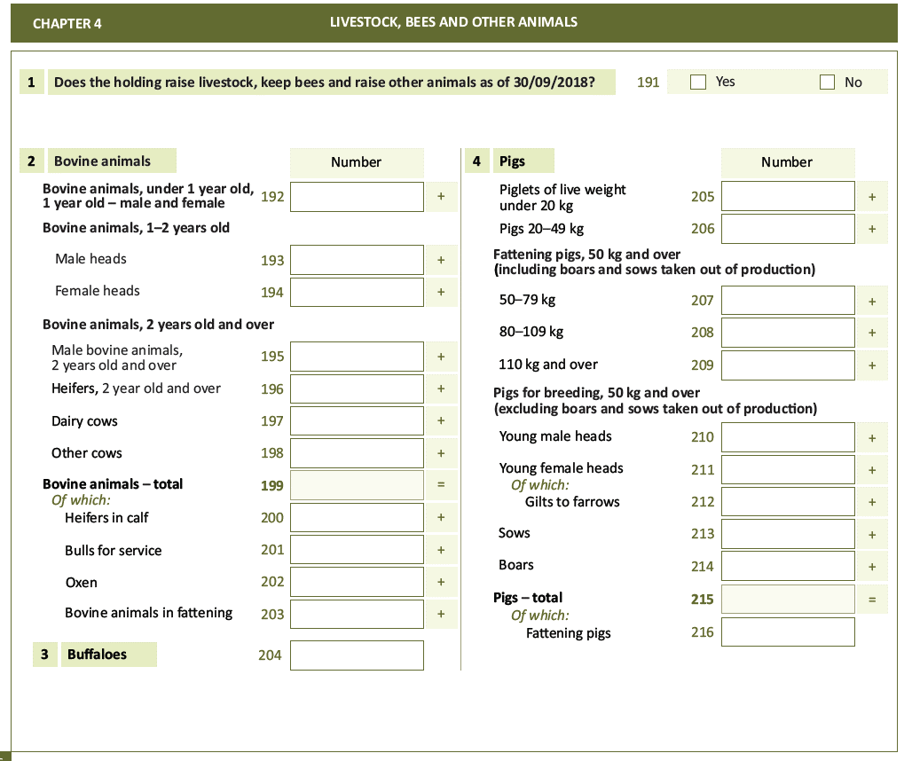

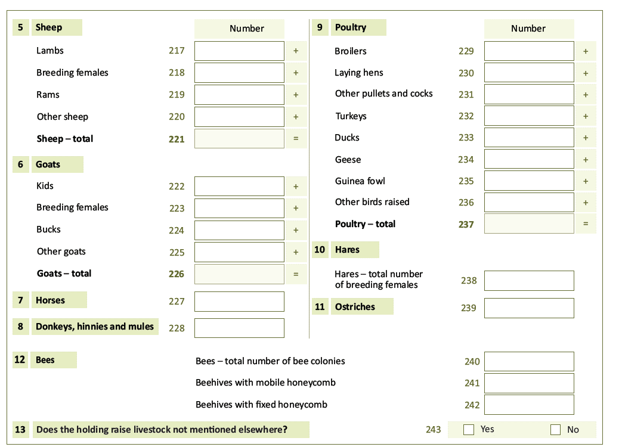

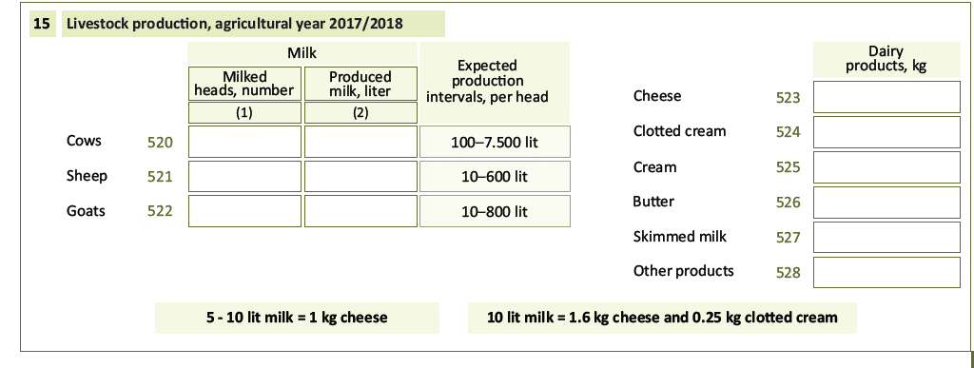

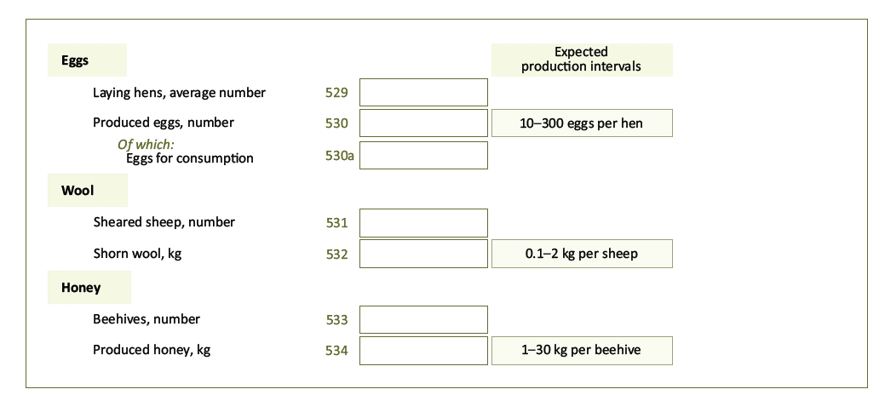

Annex II

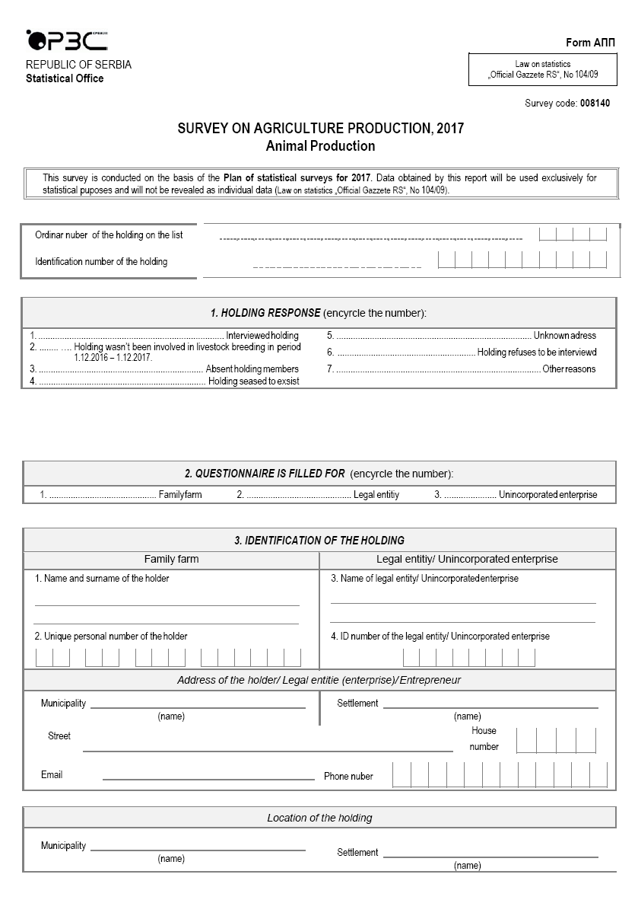

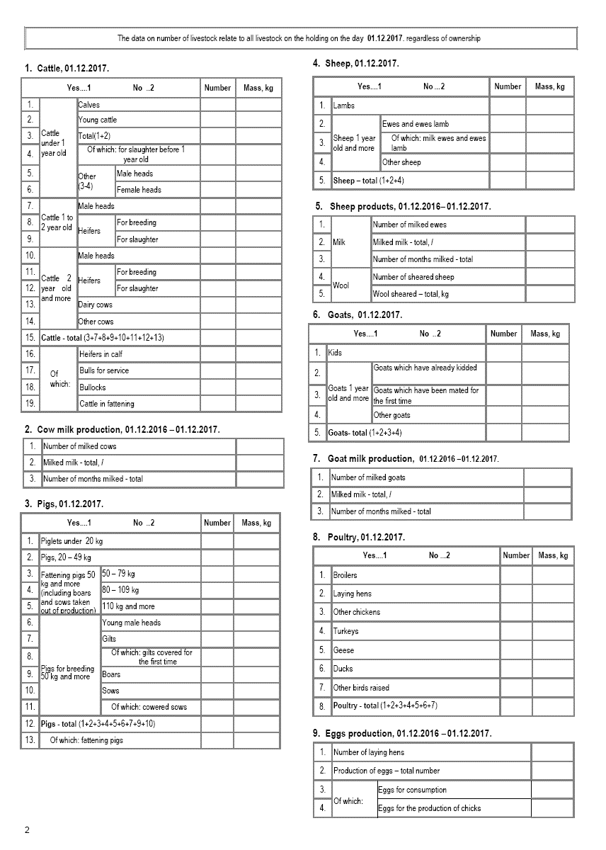

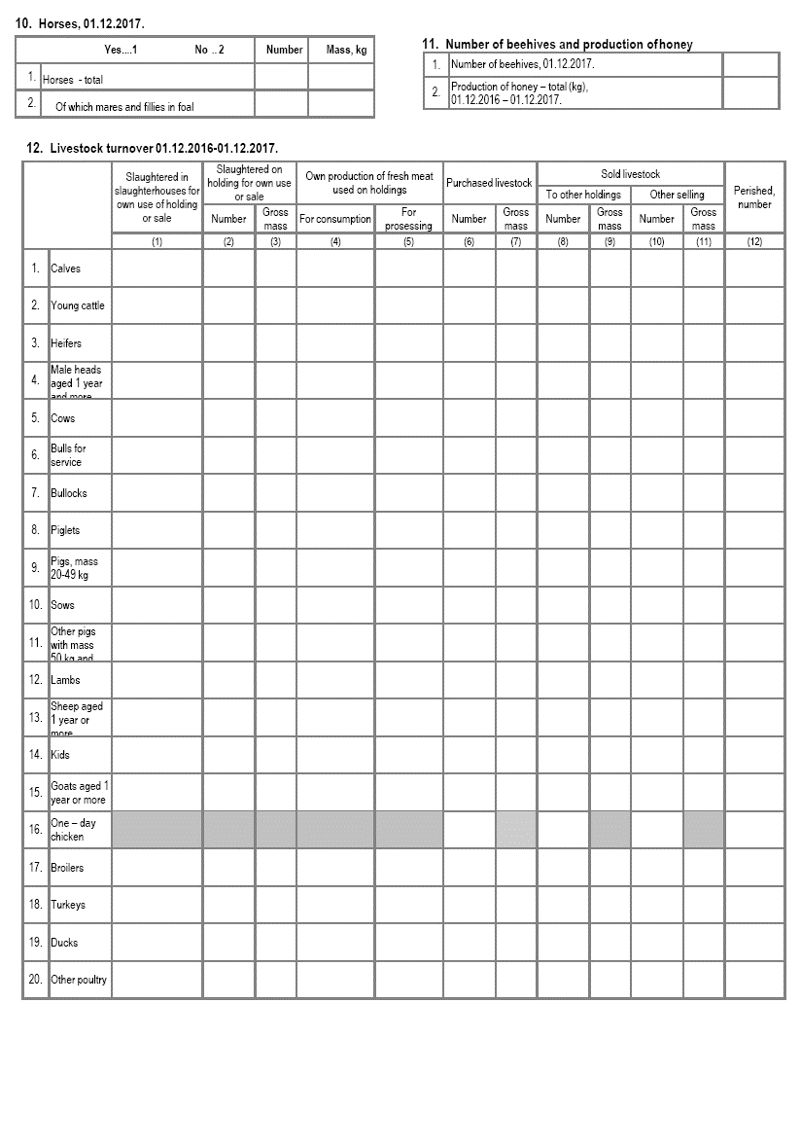

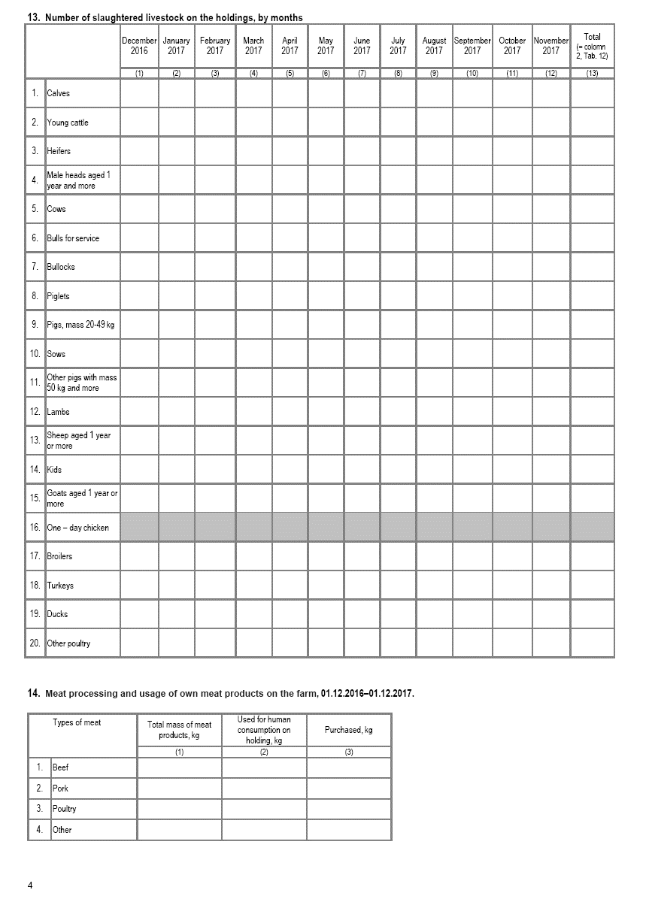

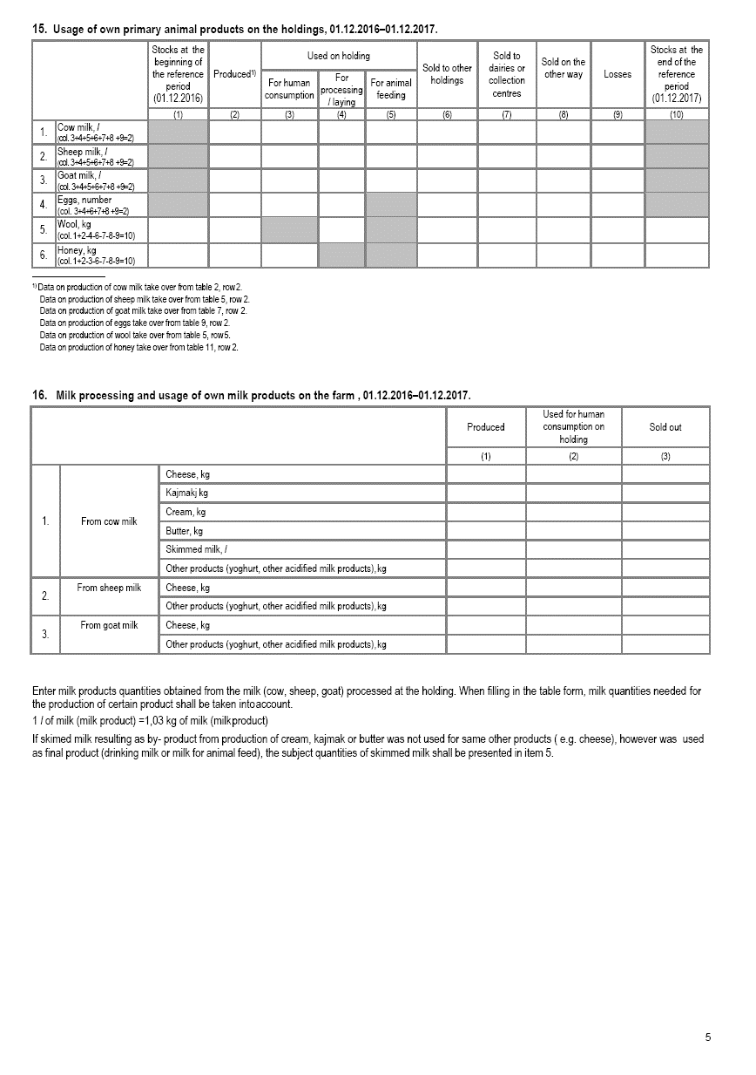

Annex III

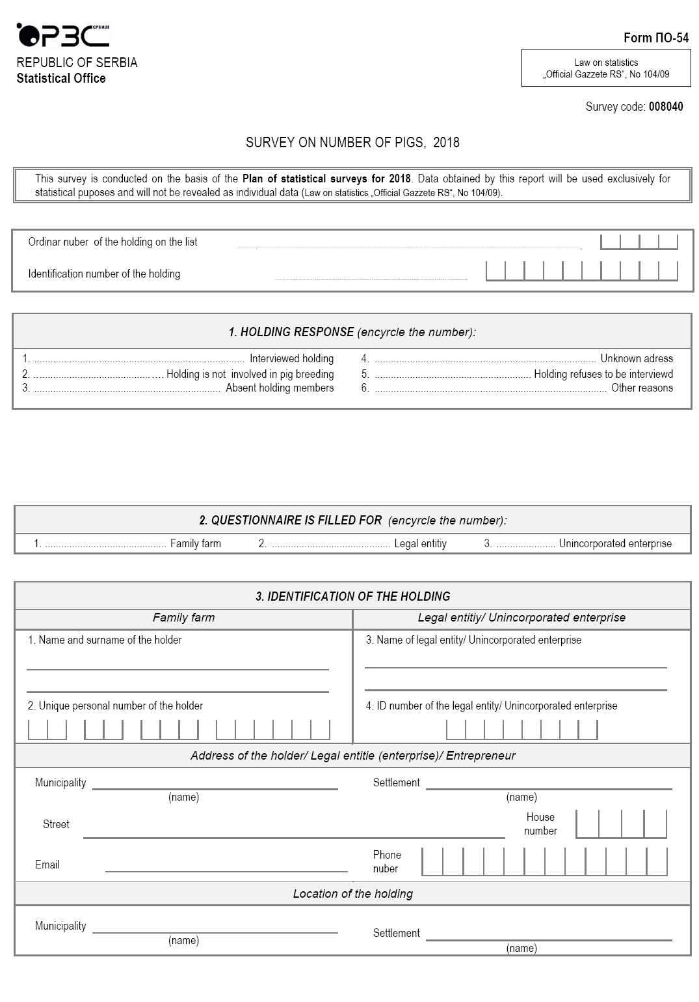



Annex IV

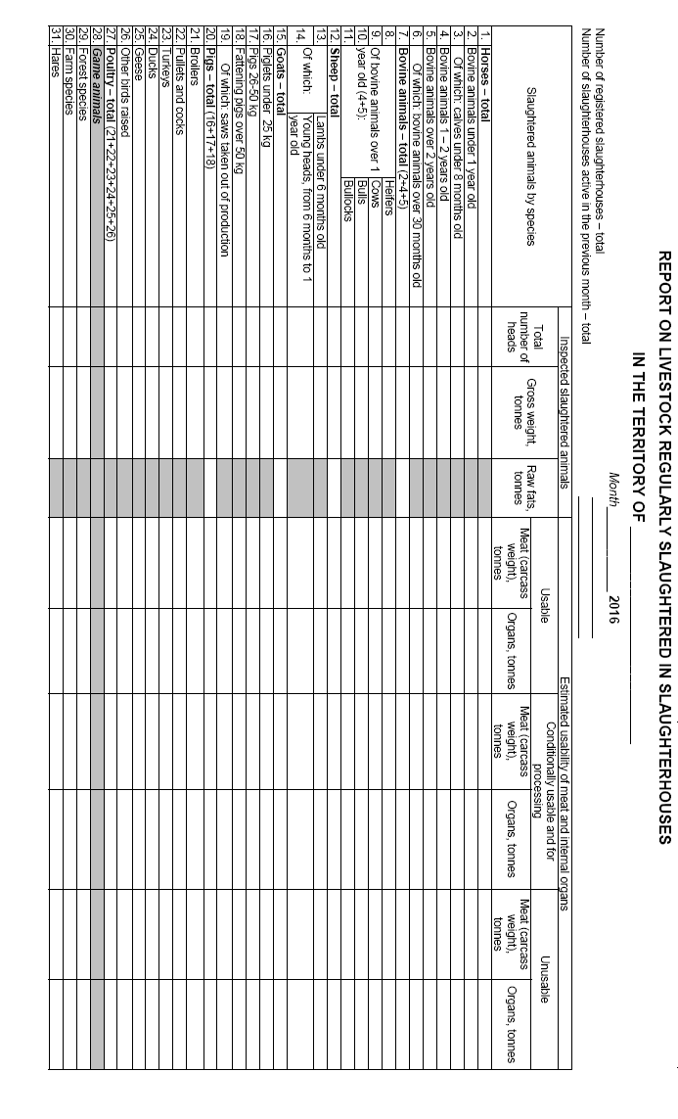

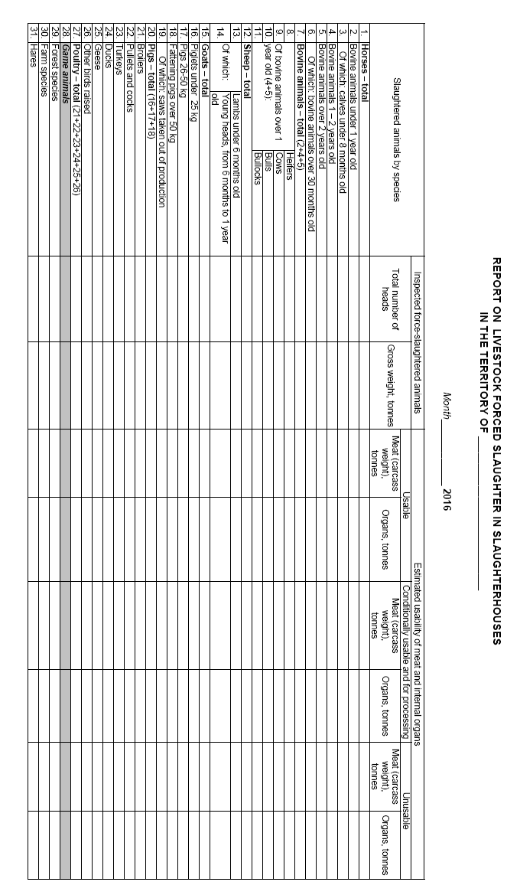

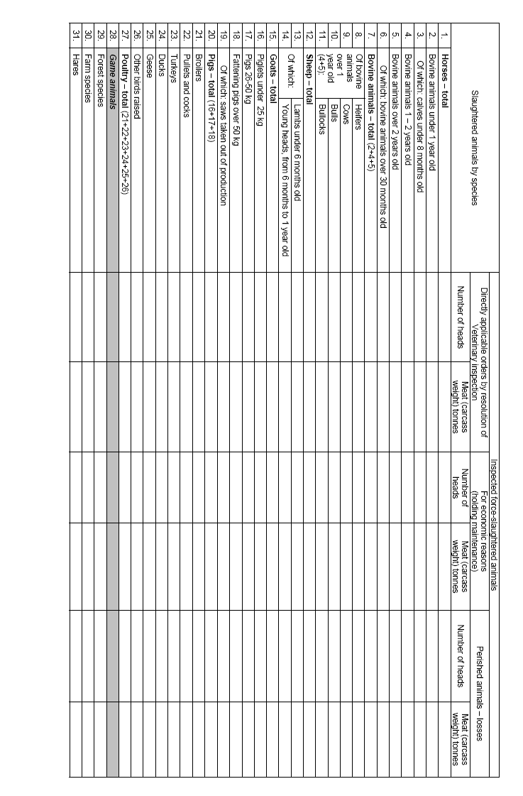

Annex V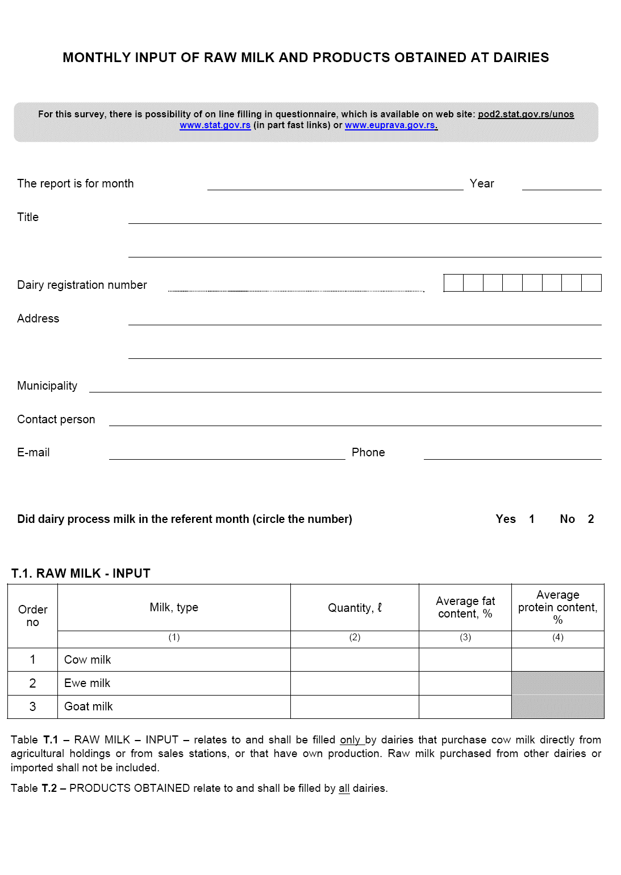

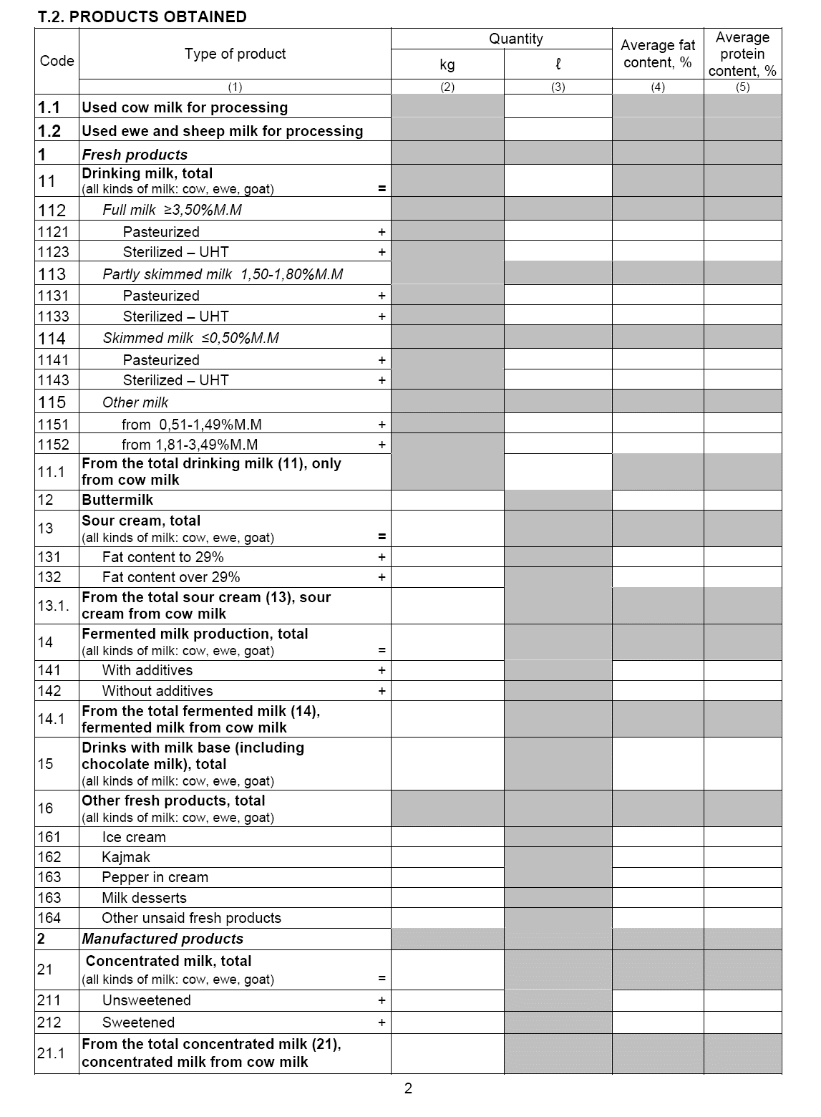

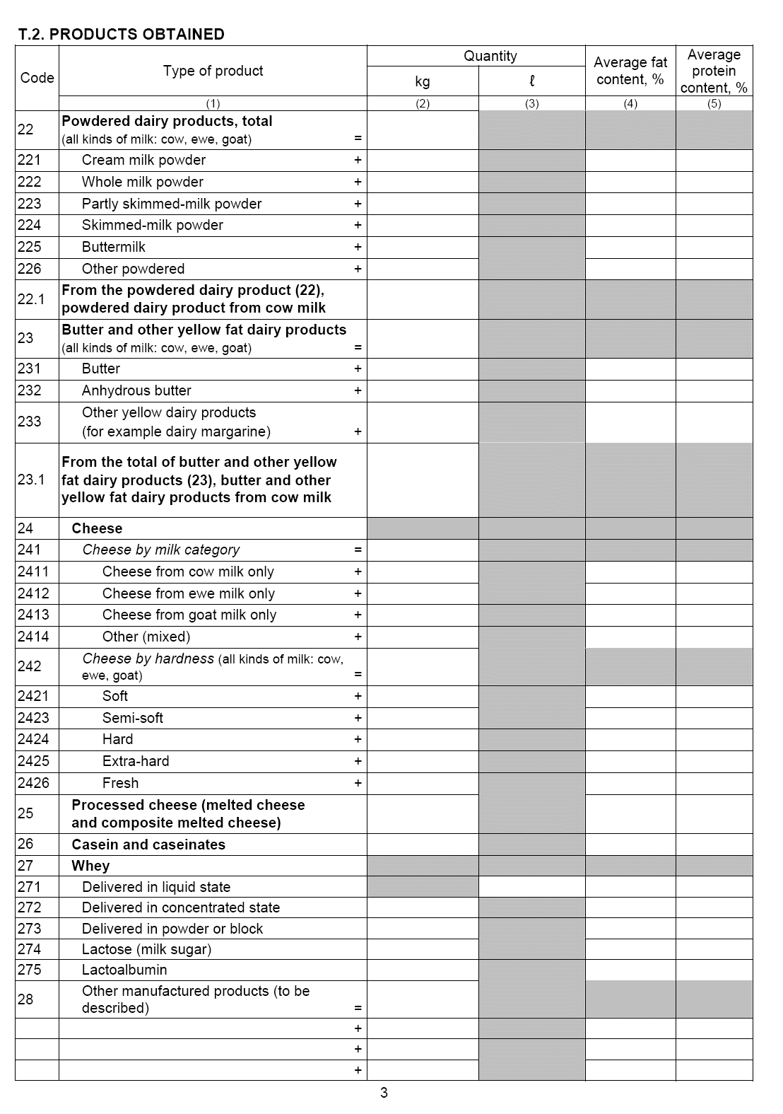

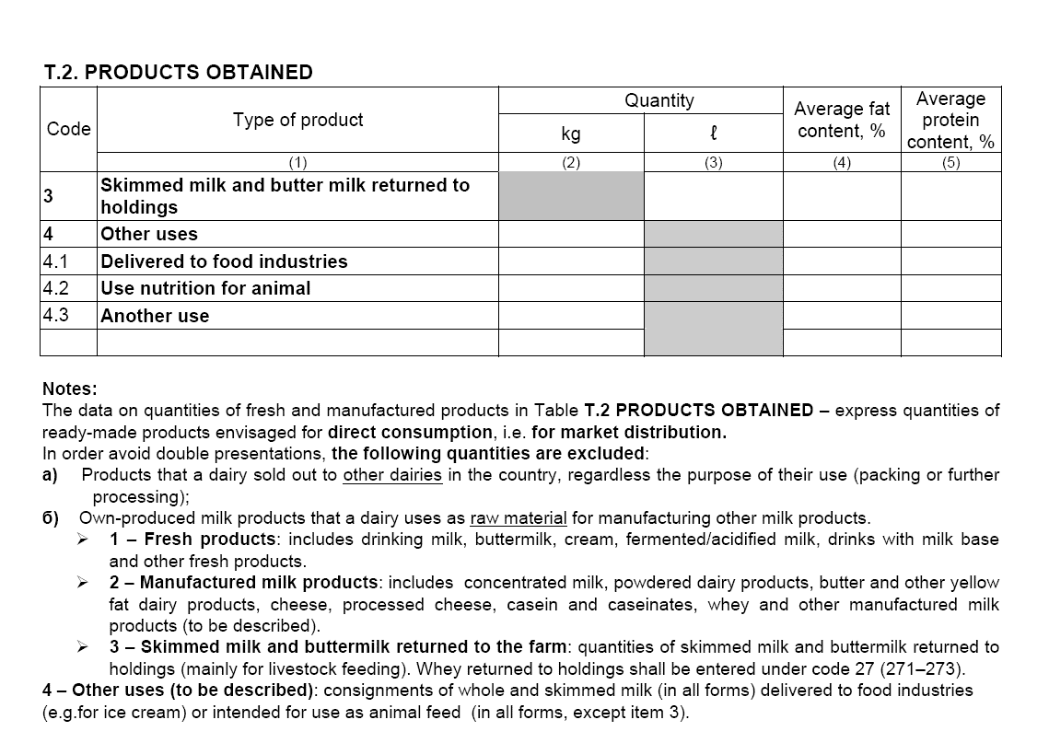

Annex VI

Content of the web form for data on activity of hatcheries

