 | Republic of Serbia  Statistical Office of the Republic of Serbia | ISSN 0353-9555
STATISTICAL RELEASE |  | GR20
Number 252 – Year LXX, 15/09/2020
Construction Statistics |  | SERB252 GR20 150920

Prices of dwellings of new construction
I half of 2020
- Preliminary results -
Average prices of new construction dwellings in the Republic of Serbia in the first half of 2020 amounted to RSD 166 764. Dwellings’ prices in the observed period ranged from RSD 47 514 per m² in Tutin up to RSD 395 633 in Belgrade municipality Savski venac.
Observed by municipalities, the highest prices of new construction dwellings were recorded in Belgrade municipalities, where average prices in urban settlements amounted to RSD 226 589. Beside Belgrade municipalities, high prices were also noted in Čajetina, Novi Sad, Vrnjačka Banja, Užice, Kragujevac and three Nis municipalities (Crveni krst, Medijana i Palilula).
Average area of sold dwellings of new construction was 54 m² and ranged in the interval from 40 m² in Čajetina up to 77 m² in Bujanovac.

Prices of dwellings of new construction by municipalities/ cities, I half of 2020
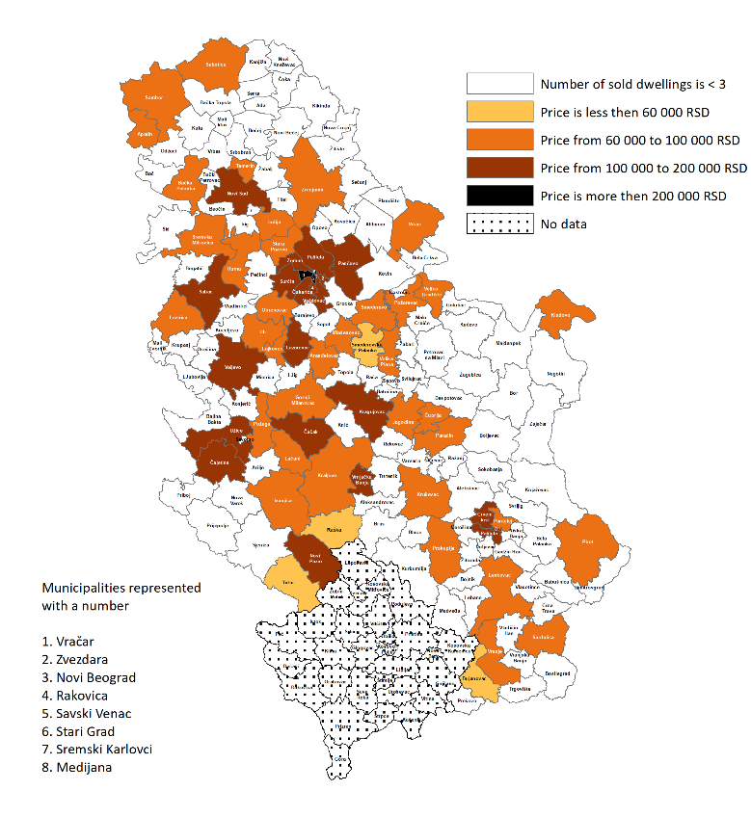
1. Prices of dwellings of new construction¹⁾, I half of 2020
 | Average dwellings’ area in m² | Price by 1 m², in RSD |  |  | Average dwellings’ area in m² | Price by 1 m², in RSD
Beogradskiregion |  |  |  | RegionVojvodine
Voždovac | 53 | 193807 |  | NoviSad | 54 | 141579
Vračar | 65 | 255428 |  | Apatin | 66 | 60333
Zvezdara | 47 | 172162 |  | BačkaPalanka | 67 | 89373
Zemun | 52 | 198138 |  | Vršac | 55 | 91815
Lazarevac | 54 | 100123 |  | Zrenjanin | 58 | 97181
Mladenovac | 53 | 89259 |  | Inđija | 47 | 95107
NoviBeograd | 68 | 280313 |  | Pančevo | 59 | 105407
Obrenovac | 45 | 99788 |  | Ruma | 61 | 80475
Palilula (Beograd) | 54 | 152365 |  | Sombor | 58 | 82877
Rakovica | 50 | 132308 |  | SremskaMitrovica | 52 | 90868
Savskivenac | 68 | 395633 |  | StaraPazova | 56 | 94130
Starigrad | 62 | 293842 |  | Subotica | 55 | 98310
Surčin | 50 | 121090 |  | Temerin | 57 | 94248
Čukarica | 51 | 193077
RegionŠumadijeiZapadneSrbije |  |  |  | RegionJužneiIstočneSrbije
Kragujevac | 51 | 115094 |  | Medijana | 60 | 118898
Aranđelovac | 66 | 77923 |  | Palilula (Niš) | 56 | 107474
Valјevo | 51 | 101380 |  | Pantelej | 53 | 91027
VrnjačkaBanja | 41 | 123893 |  | Crvenikrst | 40 | 139680
GornjiMilanovac | 49 | 97250 |  | Bujanovac | 77 | 50863
Ivanjica | 65 | 96186 |  | VelikaPlana | 60 | 72582
Jagodina | 55 | 83550 |  | VelikoGradište | 56 | 63142
Kralјevo | 64 | 94259 |  | Vranje | 56 | 67804
Kruševac | 66 | 88261 |  | Kladovo | 56 | 88550
Lajkovac | 51 | 75518 |  | Leskovac | 53 | 80049
Loznica | 53 | 80068 |  | Pirot | 60 | 81438
Lučani | 66 | 74257 |  | Požarevac | 52 | 92838
NoviPazar | 63 | 103533 |  | Prokuplјe | 50 | 66397
Paraćin | 58 | 69737 |  | Smederevo | 63 | 95151
Požega | 50 | 91112 |  | SmederevskaPalanka | 61 | 57088
Raška | 44 | 59612 |  | Surdulica | 58 | 69192
Tutin | 62 | 47514
Ćuprija | 43 | 72028
Ub | 63 | 79732
Užice | 56 | 118984
Čajetina | 40 | 169627
Čačak | 59 | 106207
Šabac | 48 | 101849
¹⁾Presented are cities/ municipalities in which buying and selling of at least three new constructed dwellings has been registered.
2.Average price of dwellings of new construction by development level of local self-government units, I half of 2020¹⁾
 | Average price by m², RSD
I group | 184456
II group | 111515
III group | 85084
IV group | 53898

¹⁾ Development level is setbythe Regulation for determining the unique list of regions and local self-government units development for 2014.

NOTES:
Data are overtaken from the administrative source, Real estate Cadastre kept by the Republic Geodetic Authority. Included are the agreements of sale and purchase of new constructed dwellings in urban settlements.
Detailed methodological explanations can be found on the website of the Statistical Office of the Republic of Serbia: http://www.stat.gov.rs/en-US/oblasti/gradjevinarstvo
Starting from 1999 the Statistical Office of the Republic of Serbia has not at disposal and may not provide available certain data relative to AP Kosovo and Metohia and therefore these data are not included in the coverage for the Republic of Serbia (total).

Contact: dejana.djordjevic@stat.gov.rs Phone: 011 2412-922 ext. 260
Published and printed by: Statistical Office of the Republic of Serbia, 11 050 Belgrade, Milana Rakica 5
Phone: +381 11 2412922 (telephone exchange) ● Fax: +381 11 2411260 ● www.stat.gov.rs
Responsible: Dr Miladin Kovačević, Director
Circulation: 20 ● Issued semi-annually

