|  |  |  |
| --- | --- | --- |
| ZnakRZS | Republic of Serbia  Statistical Office of the Republic of Serbia | ISSN 0353-9555 |
| **STATISTICAL RELEASE** | | **DD11** |
| Number 164 - Year LXX, 29.06.2020 | |  |
| **Education statistics** | | SERB164 DD11 290620 |

Primary schools

**– End of the school year 2018/2019 –**

At the end of the school year 2018/2019 in the Republic of Serbia there were 3 317 active regular primary schools, of which 1 133 main schools and 2 184 satellite classrooms. Lectures were attended by 524 518 pupils, of which 469 652 in main schools and 54 866 in satellite classrooms.

**Table 1. Primary schools and students in the Republic of Serbia**

|  |  |  |  |  |  |  |
| --- | --- | --- | --- | --- | --- | --- |
|  | Regular schools | | | Students in regular schools | | |
| total | main schools | regional school departments | total | in main schools | in regional school departments |
|  |  |  |  |  |  |  |
| **REPUBLIC OF SERBIA** | **3317** | **1133** | **2184** | **524518** | **469652** | **54866** |
|  |  |  |  |  |  |  |
| SRBIJA – SEVER | 821 | 527 | 294 | 266701 | 252938 | 13763 |
| Beogradski region | 286 | 176 | 110 | 127334 | 122844 | 4490 |
| Region Vojvodine | 535 | 351 | 184 | 139367 | 130094 | 9273 |
|  |  |  |  |  |  |  |
| SRBIJA – JUG | 2496 | 606 | 1890 | 257817 | 216714 | 41103 |
| Region Šumadije i Zapadne Srbije | 1344 | 328 | 1016 | 148794 | 124911 | 23883 |
| Region Južne i Istočne Srbije | 1152 | 278 | 874 | 109023 | 91803 | 17220 |
| Region Kosovo i Metohija | ... | ... | ... | ... | ... | ... |

**Graph. 1. Primary schools and students in the Republic of Serbia, total**

|  |  |
| --- | --- |
| Regular schools | Students in regular schools |

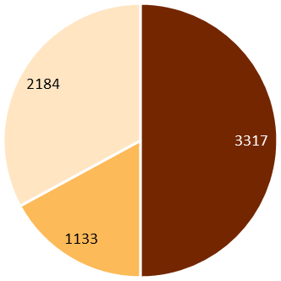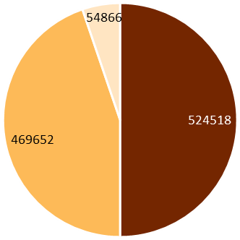

The first cycle of primary education (4th grades) was completed by 64 820 pupils, among whom the number of males was higher (51.7%) than the number of females (48.3%), while the whole primary education (8th grades) was completed by 67 765 pupils – 51.7% males and 48.6% females.

**Table 2. Students who completed the 4th grade and 8th grade**

|  |  |  |  |  |  |  |
| --- | --- | --- | --- | --- | --- | --- |
|  | Students who have completed the first cycle of primary education (4th grade) | | | Students who have completed school (8th grade) | | |
| total | males | females | total | males | females |
|  |  |  |  |  |  |  |
| **REPUBLIC OF SERBIA** | **64820** | **33488** | **31332** | **67765** | **34833** | **32932** |
|  |  |  |  |  |  |  |
| SRBIJA – SEVER | 33142 | 17109 | 16033 | 33045 | 17055 | 15990 |
| Beogradski region | 15881 | 8234 | 7647 | 15291 | 8023 | 7268 |
| Region Vojvodine | 17261 | 8875 | 8386 | 17754 | 9032 | 8722 |
|  |  |  |  |  |  |  |
| SRBIJA – JUG | 31678 | 16379 | 15299 | 34720 | 17778 | 16942 |
| Region Šumadije i Zapadne Srbije | 18505 | 9534 | 8971 | 20093 | 10258 | 9835 |
| Region Južne i Istočne Srbije | 13173 | 6845 | 6328 | 14627 | 7520 | 7107 |
| Region Kosovo i Metohija | ... | ... | ... | ... | ... | ... |

**Graph. 2. Students who completed the 4th grade and 8th grade in the Republic of Serbia, total**

As for foreign languages, English is undoubtedly the most studied by children (both in lower and higher grades) followed by German and French languages.

**Table 3. Students by foreign languages studied**

|  |  |  |  |
| --- | --- | --- | --- |
| Language | | Students by foreign languages studied | |
| ISCED 1 (1-4th grade) | ISCED 2 (5-8th grade) |
|  |  |  |  |
| Russian | 1st language | 1038 | 1461 |
| 2nd language | 348 | 47238 |
|  |  |  |  |
| English | 1st language | 252230 | 257204 |
| 2nd language | 1 | 7647 |
|  |  |  |  |
| French | 1st language | 3537 | 4172 |
| 2nd language | 874 | 67464 |
|  |  |  |  |
| German | 1st language | 2284 | 2591 |
| 2nd language | 659 | 125837 |
|  |  |  |  |
| Italian | 1st language | 0 | 1 |
| 2nd language | 20 | 11590 |
|  |  |  |  |
| Spanish | 1st language | 0 | 0 |
| 2nd language | 6 | 5107 |
|  |  |  |  |
| Other | 1st language | 0 | 0 |
| 2nd language | 0 | 4 |

**Мethodological explanations**

Data on primary education are collected using the standardized statistical questionnaires for the end of the school year (Form ŠO/K), filled in by each primary school in the Republic of Serbia (state-owned and private) for the central school and and regional school departments in another place – settlement (if the school performs the activity away from the seat). A primary school is an institution that performs its activity in the field of primary education. Its main task is to provide quality education for every child and student, under equal conditions, regardless of where the school is located or where the lessons take place.

A class in primary education in another place – settlement (activity outside the seat) is shown as a separate unit (school). A primary school can work as a complete (eight grades) and incomplete (with less than eight grades) primary school. Students from the first to the fourth grade attend general classes, and from the fifth to the eighth grade specialised classes..

The data presented in the statistical release refer to ISCED 1 and ISCED 2 levels of the International Standard Classification of Education (ISCED 2011).

Starting from 1999, the Statistical Office of the Republic of Serbia has no available data for AP Kosovo and Metohija; therefore they are not included in data coverage.

|  |
| --- |
| Contact: dusan.radovanovic@stat.gov.rs, Phone: 011 2412-922, Ext. 285  Published and printed by: Statistical Office of the Republic of Serbia, 11 050 Belgrade, Milana Rakica 5  Phone: +381 11 2412922 (telephone exchange) ● Fax: +381 11 2411260 ● www.stat.gov.rs  Responsible: Dr Miladin Kovačević, Director  Circulation: 20 • Periodicity: annual |