 | Republic of Serbia  Statistical Office of the Republic of Serbia | ISSN 0353-9555
STATISTICAL RELEASE |  | GR30
Number 092– Year LXX, 15/04/2020
Construction Statistics |  | SERB092 GR30 150420
Issued building permits, February2020
– Preliminary results –

In February 2020, 1 420 building permits were issued, presenting the increase of 27.2% related to February 2019.
Observed by types of constructions, in February 2020, 74.0% of building permits related to buildings and 26.0% to civil engineering. When referring only to buildings, 62.6% related to residential buildings and 37.4% to non–residential ones, while regarding civil engineering, the largest number related to pipelines, communication and electric power lines (59.9%).
According to the permits issued in February 2020 in the Republic of Serbia, building of 2 720 dwellings with average area of 65.5 m² was recorded. Out of the total number of dwellings in new residential buildings, 5.5% of dwellings will be built in single-dwelling buildings, with average area of 144.1 m², and 93.5% of dwellings will be in buildings with three and more dwellings, with significantly smaller average area of 59.9 m².
Index of anticipated value of works in February 2020 decreased by 7.1% relative to February 2019. Anticipated value of works of new construction in February 2020 amounted to 73.5% of totally anticipated value of works. Observed by areas, the greatest construction activity is expected in Beogradska oblast (34.2%) of totally anticipated value of works, followed by Južnobacka oblast (16.1%), Južnobanatska oblast (7.0%), Sumadijska oblast (6.9%), and Kolubarska oblast (6.5%), while the shares of other areas are from 0.2% up to 4.1%.

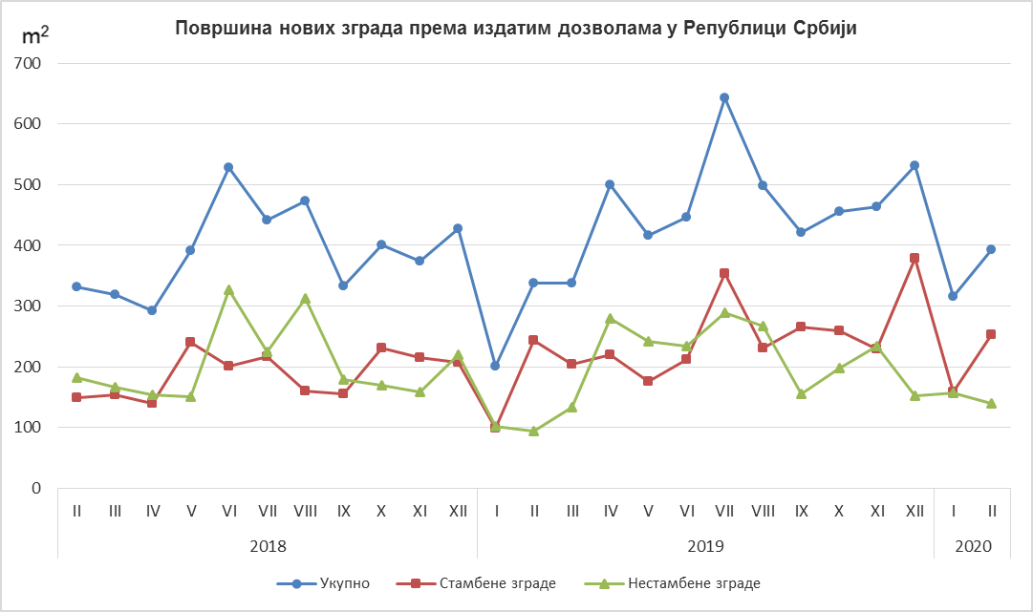
Non-residential buildings
Residential buildings
Total
Area of new buildings in the Republic of Serbia, according to the issued permits

Indices of issued building permits in the Republic of Serbia
 | I–II 2020  I–II 2019 | II 2020  I2020 | II2020  II 2019 | II 2020  ∅ 2019
Total
Number | 129.1 | 110.2 | 127.2 | 78.0
Anticipated value of works | 126.0 | 73.6 | 92.9 | 51.7
Buildings
Number | 131.2 | 113.9 | 132.4 | 74.0
Anticipated value of works | 118.0 | 104.6 | 82.3 | 86.0
Area | 129.4 | 130.3 | 118.1 | 92.4
Civil engineering
Number | 123.9 | 100.8 | 114.6 | 92.1
Anticipated value of works | 139.8 | 42.2 | 137.3 | 25.8
Dwellings
Number | 130.1 | 174.8 | 112.6 | 118.6
Useful area | 122.2 | 157.1 | 105.7 | 101.8

Notes:

The data on issued building permits are overtaken from the Central Register of Integrated Procedures, which has been, according to the Law on planning and construction (“Official Gazette of the Republic of Serbia“, number 132/14, article 8) administered by the Serbian Business Registers Agency (SBRA).
In the scope of this survey, the concept of „building permit” comprises the building permit for construction and the decision which approves the execution of works following the article 145 of the Law on planning and construction. The issued building permits and approvals for works executions, based on harmonized request, included are only if the construction is approved for the first time. This statistical survey comprises the issued building permits for all types of constructions described in the Classification of Types of Constructions, i.e. buildings and other civil engineering works and these are presented by territories where the planned works are performed in the country.
Starting from 1999 the Statistical Office of the Republic of Serbia has not at disposal and may not provide available certain data relative to AP Kosovo and Metohija and therefore these data are not included in the coverage for the Republic of Serbia (total).
Detailed methodological notes of this survey can be found on the site of the Statistical Office of the Republic of Serbia:

http://www.stat.gov.rs/istrazivanja/methodology-and-documents/?a=05&s=0

Contact: gabrijela.rosic@stat.gov.rs, Phone: 011 2412-922 ext. 260
Published and printed by: Statistical Office of the Republic of Serbia, 11 050 Belgrade, Milana Rakica 5
Phone: +381 11 2412922 (telephone exchange)● Fax: +381 11 2411260 ● www.stat.gov.rs
Responsible: Dr Miladin Kovačević, Director
Circulation: 20 ● Issued monthly

