Republic of Serbia
Statistical Office of the Republic of Serbia
 |  | ISSN 0353-9555
STATISTICAL RELEASE |  | GR21
Number 065 • Year LXX, 16/03/2020
Construction Statistics |  | SERB065 GR21 160320

Prices of dwellings of new construction in 2019

Average prices of dwellings of new construction in the Republic of Serbia in 2019 amounted to RSD 163 520.
Such high dwellings’ prices were most influenced by sale of dwellings in Belgrade municipalities where average price of sold dwellings of new construction in urban settlements amounted to RSD 215 842. Beside Belgrade municipalities, high prices were also noted in Cajetina, Novi Sad, Vrnjacka Banja, Kragujevac and three Nis municipalities (Crveni krst, Medijana and Palilula).
The lowest average prices of new construction dwellings were calculated for Tutin, Nova Varos and Bujanovac

Prices of dwellings of new construction by municipalities / cities, 2019
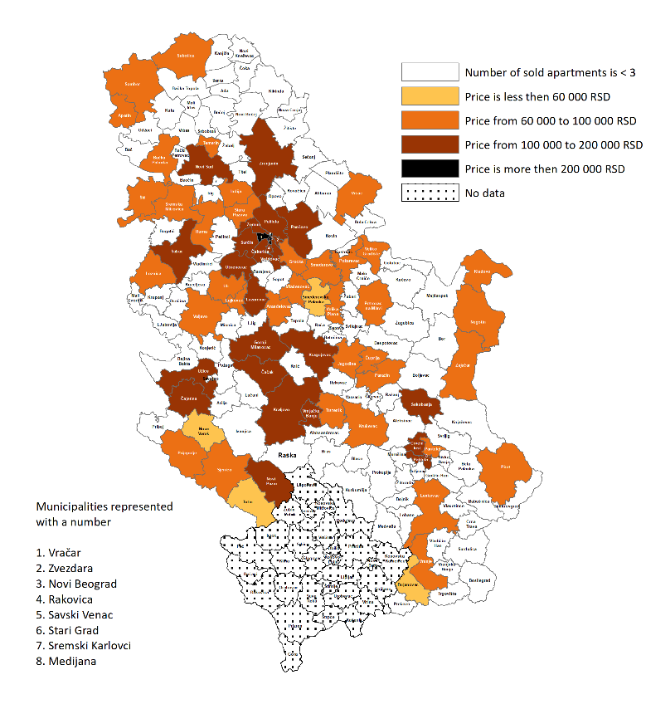

1. Prices of dwellings of new construction in 2019¹⁾
 | Average dwellings area in m² | Price by 1 m², in RSD, total |  |  | Average dwellings area in m² | Price by 1 m², in RSD, total
Beogradski region |  |  |  | Region Vojvodine
Voždovac | 51 | 189103 |  | Novi Sad | 54 | 138138
Vračar | 69 | 240703 |  | Apatin | 60 | 66285
Grocka | 50 | 89261 |  | Bačka Palanka | 59 | 84096
Zvezdara | 46 | 161044 |  | Vršac | 60 | 87361
Zemun | 52 | 185123 |  | Zrenjanin | 50 | 101273
Lazarevac | 55 | 100229 |  | Inđija | 53 | 96279
Mladenovac | 60 | 85622 |  | Pančevo | 62 | 101097
Novi Beograd | 61 | 274857 |  | Ruma | 52 | 74816
Obrenovac | 49 | 100333 |  | Sombor | 61 | 80746
Palilula (Beograd) | 54 | 151930 |  | Sremska Mitrovica | 50 | 91332
Rakovica | 45 | 122102 |  | Stara Pazova | 56 | 92139
Savski venac | 61 | 347475 |  | Subotica | 56 | 95727
Stari grad | 73 | 271152 |  | Temerin | 59 | 94172
Surčin | 50 | 124559 |  | Šid | 49 | 64085
Čukarica | 56 | 155735
Region Šumadije i Zapadne Srbije |  |  |  | Region Južne i Istočne Srbije
Kragujevac | 49 | 116063 |  | Medijana | 57 | 118099
Aranđelovac | 48 | 71321 |  | Palilula (Niš) | 51 | 112843
Valјevo | 50 | 94558 |  | Pantelej | 57 | 91010
Vrnjačka Banja | 38 | 127216 |  | Crveni krst | 54 | 122548
Gornji Milanovac | 58 | 107470 |  | Bujanovac | 73 | 52496
Jagodina | 56 | 80643 |  | Velika Plana | 57 | 75597
Kralјevo | 56 | 101468 |  | Veliko Gradište | 52 | 68615
Kruševac | 58 | 89566 |  | Vranje | 47 | 80481
Lajkovac | 49 | 82898 |  | Zaječar | 53 | 70637
Loznica | 49 | 76768 |  | Kladovo | 71 | 96796
Nova Varoš | 65 | 48575 |  | Leskovac | 59 | 80108
Novi Pazar | 57 | 101598 |  | Negotin | 50 | 88597
Paraćin | 63 | 74994 |  | Petrovac na Mlavi | 60 | 67412
Prijepolјe | 42 | 62086 |  | Pirot | 63 | 82661
Sjenica | 73 | 81098 |  | Požarevac | 57 | 94035
Trstenik | 59 | 72481 |  | Smederevo | 58 | 89504
Tutin | 65 | 46001 |  | Smederevska Palanka | 55 | 58965
Ćuprija | 60 | 66274 |  | Sokobanja | 41 | 108664
Ub | 51 | 80086
Užice | 53 | 112494
Čajetina | 41 | 172669
Čačak | 56 | 103540
Šabac | 50 | 103439
¹⁾ Presented are cities/ municipalities in which buying and selling of at least three new constructed dwellings has been registered.

2. Average price of dwellings of new construction by development level of local self-government units¹⁾, 2019
 | Average price by m², RSD
I group | 178310
II group | 112941
III group | 84379
IV group | 54943

¹⁾ Development level is set by the Regulation for determining the unique list of regions and local self-government units development for 2014.

NOTES:
Data are overtaken from the administrative source, Real estate Cadastre kept by the Republic Geodetic Authority. Included are the agreements of sale and purchase of new constructed dwellings in urban settlements.
Detailed methodological explanations can be found on the website of the Statistical Office of the Republic of Serbia http://www.stat.gov.rs/oblasti/gradjevinarstvo/.
Starting from 1999 the Statistical Office of the Republic of Serbia has not at disposal and may not provide available certain data relative to AP Kosovo and Metohia and therefore these data are not included in the coverage for the Republic of Serbia (total).
Contact: dejana.djordjevic@stat.gov.rs Phone: 011 2412-922, ext. 260
Published and printed by: Statistical Office of the Republic of Serbia, 11 050 Belgrade, Milana Rakica 5
Phone: +381 11 2412922 (telephone exchange) ● Fax: +381 11 2411260 ● www.stat.gov.rs
Responsible: Dr Miladin Kovačević, Director
Circulation: 20 ● Issued annually

