 | Republic of Serbia  Statistical Office of the Republic of Serbia | ISSN 0353-9555
STATISTICAL RELEASE |  | GR20
Number 064 – Year LXX, 16/03/2020
Construction Statistics |  | SERB064 GR20 160320

Prices of dwellings of new construction
II half of 2019
- Preliminary results -
Average prices of new construction dwellings in the Republic of Serbia in the second half of 2019 amounted to RSD 163 219. Dwellings’ prices in the observed period ranged from RSD 50 840 per m² in Tutin up to RSD 348 643 RSD in Belgrade municipality Savski venac.
Observed by municipalities, the highest prices of new construction dwellings were recorded in Belgrade municipalities, where average prices in urban settlements amounted to RSD 218 356. Beside Belgrade municipalities, high prices were also noted in Cajetina, Novi Sad, Vrnjacka Banja, Kragujevac and three Nis municipalities (Crveni krst, Medijana i Palilula).
Average area of sold dwellings of new construction was 53 m² and ranged in the interval from 38 m² in Vrnjacka banja up to 73 m² in Sjenica.

Prices of dwellings of new construction by municipalities / cities, II half of 2019
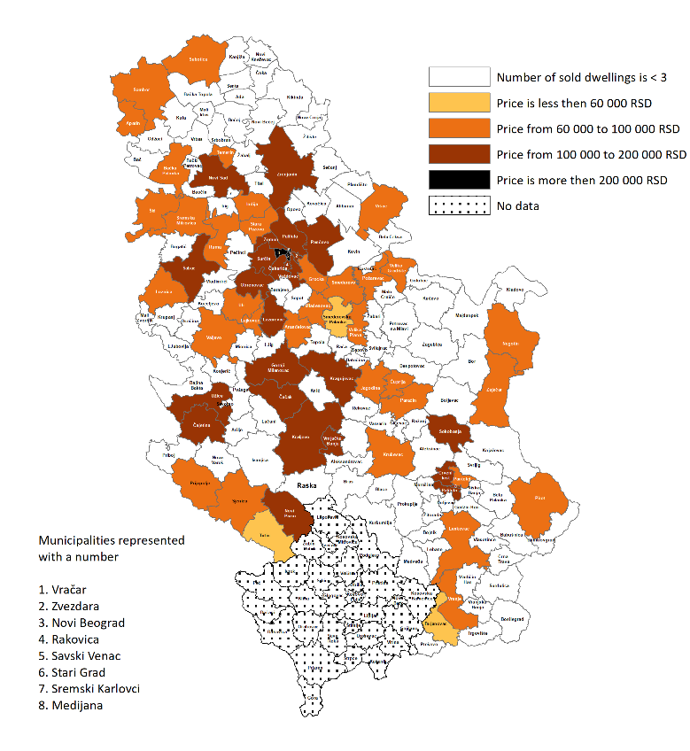
1. Prices of dwellings of new construction¹⁾, II half of 2019
 | Average dwellings’ area in m² | Price by 1 m², in RSD |  |  | Average dwellings’ area in m² | Price by 1 m², in RSD
Beogradski region |  |  |  | Region Vojvodine
Voždovac | 52 | 193201 |  | Novi Sad | 53 | 143481
Vračar | 70 | 244240 |  | Apatin | 60 | 66285
Grocka | 50 | 89261 |  | Bačka Palanka | 59 | 83735
Zvezdara | 46 | 159604 |  | Vršac | 57 | 88827
Zemun | 51 | 186637 |  | Zrenjanin | 51 | 102499
Lazarevac | 55 | 100396 |  | Inđija | 48 | 96952
Mladenovac | 64 | 88643 |  | Pančevo | 63 | 102483
Novi Beograd | 61 | 275601 |  | Ruma | 51 | 74011
Obrenovac | 51 | 100153 |  | Sombor | 61 | 81290
Palilula (Beograd) | 54 | 151196 |  | Sremska Mitrovica | 49 | 91628
Rakovica | 43 | 122367 |  | Stara Pazova | 56 | 93387
Savski venac | 62 | 348643 |  | Subotica | 53 | 97040
Stari grad | 72 | 268930 |  | Temerin | 59 | 93835
Surčin | 51 | 126439 |  | Šid | 49 | 64085
Čukarica | 57 | 160901
Region Šumadije i Zapadne Srbije |  |  |  | Region Južne i Istočne Srbije
Kragujevac | 48 | 116242
Aranđelovac | 43 | 73101 |  | Medijana | 58 | 115811
Valјevo | 53 | 93843 |  | Palilula (Niš) | 52 | 114700
Vrnjačka Banja | 38 | 128433 |  | Pantelej | 61 | 89426
Gornji Milanovac | 58 | 106386 |  | Crveni krst | 56 | 123322
Jagodina | 58 | 80965 |  | Bujanovac | 72 | 54608
Kralјevo | 59 | 101952 |  | Velika Plana | 53 | 79124
Kruševac | 59 | 90726 |  | Veliko Gradište | 56 | 69570
Lajkovac | 51 | 82055 |  | Vranje | 47 | 80001
Loznica | 50 | 76803 |  | Zaječar | 48 | 72565
Novi Pazar | 58 | 102016 |  | Leskovac | 57 | 82447
Paraćin | 66 | 75190 |  | Negotin | 49 | 88636
Prijepolјe | 42 | 62086 |  | Pirot | 63 | 84160
Sjenica | 73 | 81098 |  | Požarevac | 57 | 93921
Tutin | 70 | 50840 |  | Smederevo | 59 | 91345
Ćuprija | 60 | 66177 |  | Smederevska Palanka | 55 | 59538
Ub | 50 | 82327 |  | Sokobanja | 43 | 110461
Užice | 53 | 113428
Čajetina | 40 | 171025
Čačak | 55 | 105452
Šabac | 50 | 103394
¹⁾ Presented are cities/ municipalities in which buying and selling of at least three new constructed dwellings has been registered.
2. Average price of dwellings of new construction by development level of local self-government units, II half of 2019¹⁾
 | Average price by m², RSD
I group | 179941
II group | 109957
III group | 85861
IV group | 61408

¹⁾ Development level is set by the Regulation for determining the unique list of regions and local self-government units development for 2014.

NOTES:
Data are overtaken from the administrative source, Real estate Cadastre kept by the Republic Geodetic Authority. Included are the agreements of sale and purchase of new constructed dwellings in urban settlements.
Detailed methodological explanations can be found on the website of the Statistical Office of the Republic of Serbia: http://www.stat.gov.rs/en-US/oblasti/gradjevinarstvo
Starting from 1999 the Statistical Office of the Republic of Serbia has not at disposal and may not provide available certain data relative to AP Kosovo and Metohia and therefore these data are not included in the coverage for the Republic of Serbia (total).

Contact: dejana.djordjevic@stat.gov.rs Phone: 011 2412-922 ext. 260
Published and printed by: Statistical Office of the Republic of Serbia, 11 050 Belgrade, Milana Rakica 5
Phone: +381 11 2412922 (telephone exchange) ● Fax: +381 11 2411260 ● www.stat.gov.rs
Responsible: Dr Miladin Kovačević, Director
Circulation: 20 ● Issued semi-annually

