 | Statistical Office of the Republic of Serbia | ISSN 0353-9555
STATISTICAL RELEASE |  | GR50
Number 156 – Year LXVII, 15/06/2018
Construction Statistics |  | SERB156 GR50 150618

Construction work abroad, 2017
– Preliminary results –

The total value of works that contractors from the Republic of Serbia performed abroad in 2017 amounted to 36 581 mill. RSD. The largest construction activity, observed by countries, was noted in the Russian Federation, 46.6% of the total value of works performed, then in Montenegro, 12.0%, Germany, 6.8% and Uganda, 6.3%.
In 2017, when observed by type of constructions, works done on buildings amounted to 24 088 mill. RSD, which is almost 65.8% of the value of works done.
Construction materials and equipment from the Republic of Serbia were mostly incorporated in Kazakhstan and Montenegro.
The total number of employees from the Republic of Serbia that were engaged abroad by our contractors amounted to 1 604. Most of them worked in Germany, the Russian Federation, Montenegro and Bosnia and Herzegovina, while up to 54 workers were employed in other countries.
In 2017, most of works were contracted in the Russian Federation, followed by Montenegro, Bosnia and Herzegovina and Norway.

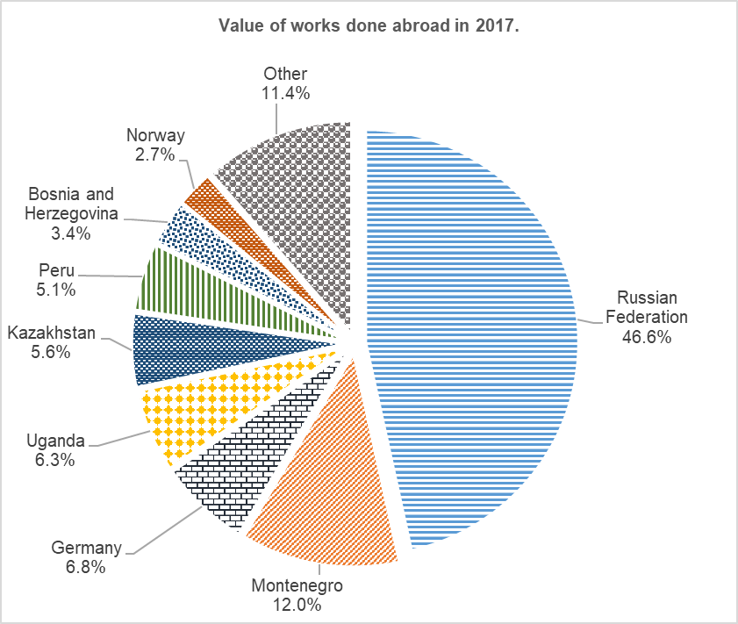
1. Construction work abroad, 2017¹⁾
 | Value of contracted works, thous. RSD | Value of works done, thous. RSD |  | Materials consumed and equipment incorporated from the Republic of Serbia, thous. RSD | Average number of employees from the Republic of Serbia | Hours worked from the Republic of Serbia
 |  | total | of which: on buildings
TOTAL | 30715665 | 36581243 | 24087751 | 891133 | 1604 | 2862735
Еurope | 28606342 | 27330039 | 20071618 | 505421 | 1390 | 2392593
Albania | 5049 | 5049 | 5049 | 4288 | 2 | 2352
Austria | 32200 | 32200 | 32200 | 0 | 8 | 9480
Belgium | 35268 | 6835 | 6835 | 0 | 3 | 5170
Belarus | 0 | 411280 | 411280 | 0 | 3 | 6805
Bosnia and Herzegovina | 1385955 | 1243189 | 307967 | 98783 | 133 | 164512
Greece | 18000 | 18000 | 0 | 0 | 7 | 13584
Italy | 2058 | 13358 | 0 | 0 | 3 | 770
Hungary | 97433 | 97433 | 3082 | 1679 | 23 | 44034
Macedonia | 565367 | 451695 | 579 | 3188 | 43 | 62770
Germany | 3074075 | 2502695 | 1348546 | 0 | 549 | 1032118
Norway | 1024519 | 1001983 | 951773 | 36591 | 45 | 83189
Russian Federation | 17565249 | 17030586 | 16776963 | 170 | 293 | 664485
Slovakia | 5619 | 5619 | 5619 | 3871 | 4 | 1250
Slovenia | 185514 | 36514 | 17374 | 10359 | 31 | 12332
France | 13796 | 13796 | 13758 | 0 | 1 | 350
Netherlands | 229 | 229 | 0 | 0 | 1 | 176
Croatia | 27421 | 27421 | 8611 | 5386 | 18 | 11215
Montenegro | 4540933 | 4404500 | 177486 | 341106 | 202 | 257228
Czech Republic | 411 | 411 | 0 | 0 | 1 | 73
Switzerland | 2050 | 2050 | 300 | 0 | 3 | 1600
Sweden | 4196 | 4196 | 4196 | 0 | 9 | 5500
Spain | 21000 | 21000 | 0 | 0 | 8 | 13600
Asia | 1179933 | 3449717 | 3153574 | 385712 | 127 | 256312
Kazakhstan | 64805 | 2038827 | 2038827 | 370293 | 54 | 110458
China | 11784 | 11784 | 0 | 0 | 2 | 3596
Kyrgyzstan | 0 | 307700 | 307700 | 0 | 8 | 17290
Kuwait | 85940 | 4685 | 0 | 4300 | 12 | 13800
Saudi Arabia | 269159 | 255664 | 255664 | 11119 | 11 | 26240
Таjikistan | 748245 | 831057 | 551383 | 0 | 40 | 84928
Africa | 599962 | 3925731 | 862559 | 0 | 78 | 184001
Algeria | 36497 | 36497 | 36497 | 0 | 4 | 7996
Ethiopia | 737 | 737 | 0 | 0 | 2 | 3343
South Africa | 562728 | 562728 | 0 | 0 | 40 | 90547
Nigeria | 0 | 826062 | 826062 | 0 | 1 | 2200
Rwanda | 0 | 198525 | 0 | 0 | 1 | 2200
Uganda | 0 | 2301182 | 0 | 0 | 30 | 77715
South America | 329428 | 1875756 | 0 | 0 | 9 | 29829
Peru | 329428 | 1875756 | 0 | 0 | 9 | 29829

¹⁾ Values have been calculated according to the exchange rate 1 USD = 117.1353 RSD or 1 EUR = 123.4723 RSD.

Detailed methodological explanations on this survey can be found in the edition of SORS “Methodologies and Standards”:
Annual survey on works done abroad, volume 27, http://webrzs.stat.gov.rs/WebSite/Public/PageView.aspx?pKey=123 and Classification of Types of Buildings, volume 15, on the website of SORS: http://webrzs.stat.gov.rs/WebSite/userFiles/file/Metodologije/Klasifikacije/mm152005.pdf

Contact: gabrijela.rosic@stat.gov.rs Phone: 011/24-12-922, ext: 260
Published and printed by: Statistical Office of the Republic of Serbia, Belgrade, Milana Rakica 5,
Phone: +381 11 2412922 ● Fax: +381 11 2411260 ● www.stat.gov.rs
Responsible: Dr Miladin Kovacevic, Acting director
Circulation: 20 ● Issued Annually

