 | Statistical Office of the Republic of Serbia | ISSN 0353-9555
STATISTICAL RELEASE |  | PM10
Number 022 - Year LXVIII, 31/01/2018
Turnover statistics |  | SERB022 PM10 310118

Retail trade turnover, December 2017
– Preliminary results –
According to the preliminary results, the turnover of retail trade in the Republic of Serbia in December 2017, compared to December 2016, increased by 5.1% at current prices and by 1.5% at constant prices. In December 2017, compared to November 2017, the turnover in goods increased by 12.1% both at current and at constant prices.
Retail trade turnover in 2017, compared with 2016, increased by 7.9% at current prices, and by 3.7% at constant prices.

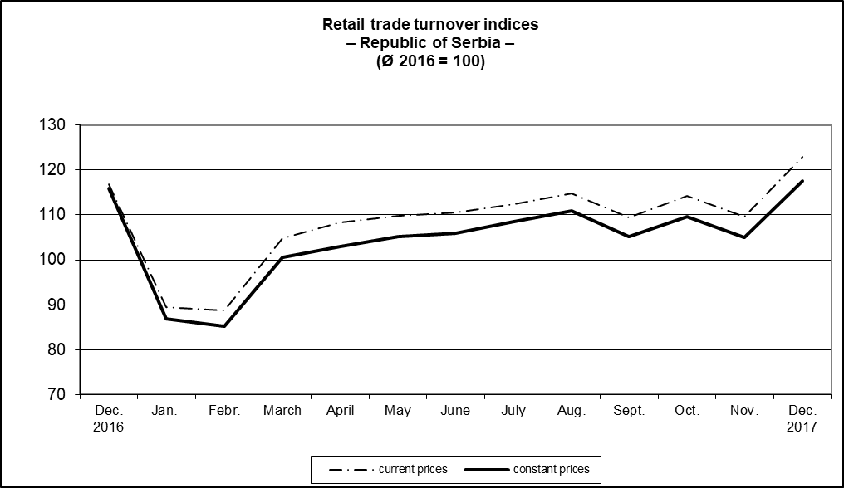

1. Retail trade turnover indices by territory
 | XII 2017  XII 2016 |  | XII 2017  XI 2017 |  | XII 2017  Ø 2016 |  | I-XII 2017  I-XII 2016
 | current prices | constant prices | current prices | constant prices | current prices | constant prices | current prices | constant prices
Republic of Serbia | 105.1 | 101.5 | 112.1 | 112.1 | 122.9 | 117.6 | 107.9 | 103.7
Srbija – Sever | 105.6 | 101.9 | 114.5 | 114.5 | 125.6 | 120.2 | 107.2 | 103.0
Region Vojvodine | 106.7 | 102.7 | 112.1 | 112.1 | 123.9 | 118.0 | 108.9 | 103.9
Srbija – Jug | 104.3 | 100.6 | 107.9 | 107.9 | 118.1 | 113.0 | 109.2 | 104.8

2. Retail trade turnover indices by main aggregates of the Classification of Activities
 | XII 2017  XII 2016 |  | XII 2017  XI 2017 |  | XII 2017  Ø 2016 |  | I-XII 2017  I-XII 2016
 | current prices | constant prices | current prices | constant prices | current prices | constant prices | current prices | constant prices
Republic of Serbia
Retail trade, except of motor vehicles and motorcycles | 105.1 | 101.5 | 112.1 | 112.1 | 122.9 | 117.6 | 107.9 | 103.7
Food, beverages and tobacco | 104.4 | 99.7 | 114.5 | 114.7 | 122.3 | 118.2 | 107.2 | 103.3
Non-food products, except of automotive fuel | 108.1 | 106.2 | 115.0 | 114.9 | 131.0 | 127.4 | 108.2 | 106.5
Automotive fuel | 101.3 | 96.9 | 101.4 | 101.1 | 109.9 | 100.7 | 109.2 | 100.0

Methodological notes: The indices published in this statistical release relate to turnover of all business entities (legal persons and unincorporated enterprises) dealing with retail trade, division 47 of CA (Classification of Activities – “Official Gazette of RS”, no. 54/10).
Retail trade turnover is obtained on the basis of regular monthly statistical survey “Monthly Survey of Retail Trade”, based on the sample and on VAT reports received from Tax administration.
The turnover in retail trade includes VAT.
The turnover indices at constant prices have been obtained by deflating the indices at current prices by the corresponding consumer price indices, excluding: water (from public utility systems), electricity and motor vehicles, motorcycles and parts.
All published indices ought to be regarded as preliminary, meaning that certain corrections can appear on the basis of the estimated results, obtained from the regular statistical surveys that are conducted on the increased number of sample units.
Starting from 1999 the Statistical Office of the Republic of Serbia has not at disposal and may not provide available certain data relative to AP Kosovo and Metohija and therefore these data are not included in the coverage for the Republic of Serbia (total).
Methodological notes on retail trade are available on the website of the Statistical Office of the Republic of Serbia http://webrzs.stat.gov.rs/WebSite/Public/PageView.aspx?pKey=105.
Series of monthly indices (chain and base), at current and constant prices are available on the website of the Statistical Office of the Republic of Serbia, in database http://webrzs.stat.gov.rs/WebSite/public/ReportView.aspx.

Contact: sonja.radoicic@stat.gov.rs Phone: 011 2412-922, ext. 216
Published and printed by: Statistical Office of the Republic of Serbia, 11 050 Belgrade, Milana Rakica 5
Phone: +381 11 2412922 (telephone exchange) ● Fax: +381 11 2411260 ● www.stat.gov.rs
Responsible: Dr Miladin Kovačević, Director
Circulation: 20 • Issued monthly

