Statistical Office of the Republic of Serbia | Press Release  Belgrade, Milana Rakica 5  Phone +381 11 2412-922  www.stat.gov.rs  stat@stat.gov.rs

November 24, 2017

AVERAGE SALARIES AND WAGES PAID IN OCTOBER 2017

The average gross salaries and wages paid in October 2017 amounted to dinars 64 602. The average net salaries and wages (tax and contributions excluded) paid in October 2017 totalled 46 879 dinars.
Compared to the average gross and net salaries and wages paid in September 2017, this was a decrease of 2.8% in nominal and 3.0% decrease in real terms.
Compared with the same month last year, average gross and net salaries and wages increased by 3.5% in nominal terms and by 0.7% in real terms.
Average salaries and wages and nominal indices | Trend of net salaries and wages real indices
X 2017 X 2017 X 2017  IX 2017 X 2016  Gross RSD 64.602 97,2 103,5  Net RSD 46.879 97,2 103,5  Net (EUR)1⁾ 393 97,2 106,9 | 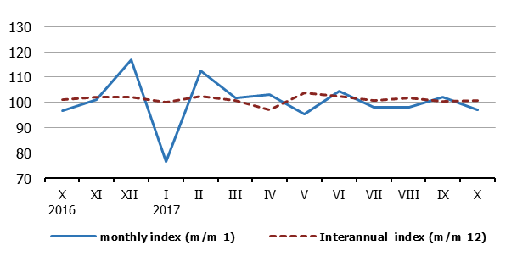
Monthly oscillations of average salaries and wages indices (m/m-1) are mostly influenced by dynamics of payment, while more objective trend of average salaries and wages is based on inter-annual indices (m/m-12).
NOTE: Starting from 1999 the Statistical Office of the Republic of Serbia has not at disposal and may not provide available certain data relative to AP Kosovo and Metohia and therefore these data are not included in the coverage for the Republic of Serbia (total).
Information: The Statistical Office of the Republic of Serbia will, from 2018, calculate average salaries and wages on the basis of Tax Administration data.
Contact person:  Jelena Milakovic, Head  Unit for earnings statistics  Phone: +381 11 2412 350  Information and Dissemination Unit  Phone: +381 11 2401-284  stat@stat.gov.rs | Director  Dr Miladin Kovacevic
¹⁾ Average monthly EUR exchange rate is overtaken from the NBS website.

