Statistical Office of the Republic of Serbia | Press Release  Belgrade, Milana Rakica 5  Phone +381 11 2412-922  www.stat.gov.rs  stat@stat.gov.rs

December 25, 2017

AVERAGE SALARIES AND WAGES PAID IN NOVEMBER 2017

The average gross salaries and wages paid in November 2017 amounted to dinars 65 609. The average net salaries and wages (tax and contributions excluded) paid in November 2017 totalled 47 575 dinars.
Compared to the average gross salaries and wages paid in October 2017, this was an increase of 1.6% in nominal and in real terms, while average net salaries and wages recorded increase of 1.5% both in nominal and in real terms.
Compared with the same month last year, average gross and net salaries and wages increased by 4.0% in nominal terms and by 1.2% in real terms.

Average salaries and wages and nominal indices | Trend of net salaries and wages real indices
XI 2017 XI 2017 XI 2017  X 2017 XI 2016  Gross RSD 65.609 101,6 104,0  Net RSD 47.575 101,5 104,0  Net (EUR)1⁾ 400 101,8 107,7 | 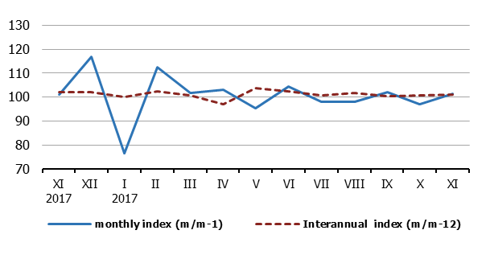
Monthly oscillations of average salaries and wages indices (m/m-1) are mostly influenced by dynamics of payment, while more objective trend of average salaries and wages is based on inter-annual indices (m/m-12).
NOTE: Starting from 1999 the Statistical Office of the Republic of Serbia has not at disposal and may not provide available certain data relative to AP Kosovo and Metohia and therefore these data are not included in the coverage for the Republic of Serbia (total).
Information: The Statistical Office of the Republic of Serbia will, from 2018, calculate average salaries and wages on the basis of Tax Administration data.
Contact person:  Jelena Milakovic, Head  Unit for earnings statistics  Phone: +381 11 2412 350  Information and Dissemination Unit  Phone: +381 11 2401-284  stat@stat.gov.rs | Director  Dr Miladin Kovacevic
¹⁾ Average monthly EUR exchange rate is overtaken from the NBS website.

