Statistical Office of the Republic of Serbia | Press Release  Belgrade, Milana Rakica 5  Phone +381 11 2412-922  www.stat.gov.rs  stat@stat.gov.rs

September 25, 2017

AVERAGE SALARIES AND WAGES PAID IN AUGUST 2017

The average gross salaries and wages paid in August 2017 amounted to dinars 65 094. The average net salaries and wages (tax and contributions excluded) paid in August 2017 totalled 47 220 dinars.
Compared to the average gross salaries and wages paid in July 2017, this was a decrease of 1.7% in nominal terms and 1.9% decrease in real terms, while the average net salaries and wages decreased by 1.8% in nominal terms and by 2.0% in real terms.
Compared with the same month last year, average gross salaries and wages increased by 4.2% in nominal terms and by 1.7% in real terms, while average net salaries and wages increased by 4.3% in nominal terms and by 1.8% in real terms.
Average salaries and wages and nominal indices | Trend of net salaries and wages real indices
VIII 2017 VIII 2017 VIII 2017  VII 2017 VIII 2016  Gross RSD 65.094 98,3 104,2  Net RSD 47.220 98,2 104,3  Net (EUR)1⁾ 395 98,9 107,5 | 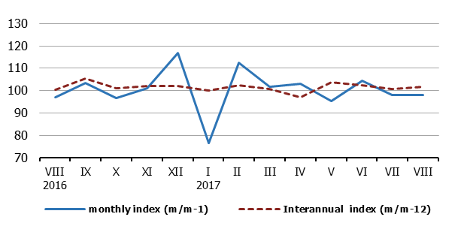
Monthly oscillations of average salaries and wages indices (m/m-1) are mostly influenced by dynamics of payment, while more objective trend of average salaries and wages is based on inter-annual indices (m/m-12).
NOTE: Starting from 1999 the Statistical Office of the Republic of Serbia has not at disposal and may not provide available certain data relative to AP Kosovo and Metohia and therefore these data are not included in the coverage for the Republic of Serbia (total).
Contact person:  Jelena Milakovic, Head  Unit for earnings statistics  Phone: +381 11 2412 350  Information and Dissemination Unit  Phone: +381 11 2401-284  stat@stat.gov.rs | Director  Dr Miladin Kovacevic
¹⁾ Average monthly EUR exchange rate is overtaken from the NBS website.

