 | Statistical Office of the Republic of Serbia
 |  | ISSN 0353-9555
STATISTICAL RELEASE |  | ZS20
Number 340 - Year LXVII, 15.12.2017
Environmental statistics |  | SERB340 ZS20 151217

Irrigation in Republic of Serbia, 2017
‒ Preliminary data ‒

During 2017, total water abstracted for irrigation was 75 265 thous. m³, of which most was pumped from rivers (89.5%), while the rest was abstracted from the groundwater, lakes and reservoirs and from public water supply network.
The Survey on irrigation includes reporting units (business entities and farm cooperatives) dealing with agricultural production and rendering agricultural services and/or managing irrigation systems.
Starting from 1999 the Statistical Office of the Republic of Serbia has not at disposal and may not provide available certain data relative to AP Kosovo and Metohija and therefore these data are not included in the coverage for the Republic of Serbia (total).

Graph 1. Abstracted irrigation water by abstraction source in the Republic of Serbia, 2017

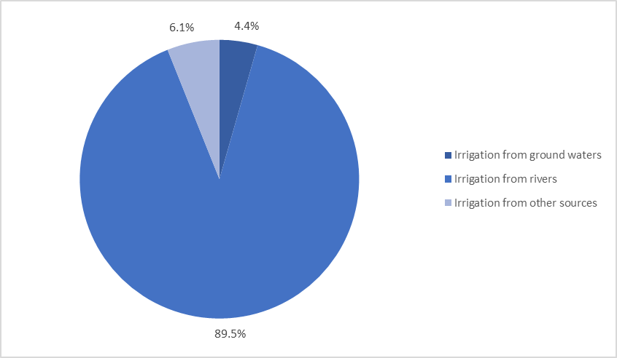

Graph 2. Water used for irrigation in the Republic of Serbia, mill. m³, 2012-2017

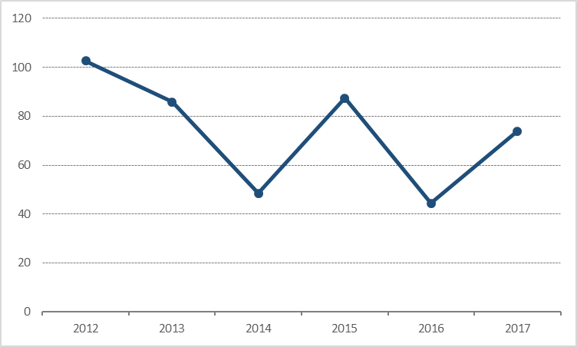

1. Abstracted and used irrigation water, 2017
thous. m³
 | Republic of Serbia
 | Total | Beogradski region | Region Vojvodine | Region Šumadije i Zapadne Srbije | Region Južne i Istočne Srbije | Region Kosovo i Metohija
Abstracted irrigation waters | 75 265 | 1 832 | 58 319 | 208 | 14 906 | ...
From ground waters | 3 322 | 167 | 2 861 | 159 | 135 | ...
From rivers | 67 381 | 1 651 | 50 952 | 45 | 14 733 | ...
From other sources | 4 562 | 14 | 4 506 | 4 | 38 | ...
Used irrigation waters | 73 858 | 1 831 | 56 917 | 207 | 14 903 | ...

Graph 3. Irrigated areas by irrigation type in the Republic of Serbia, 2017

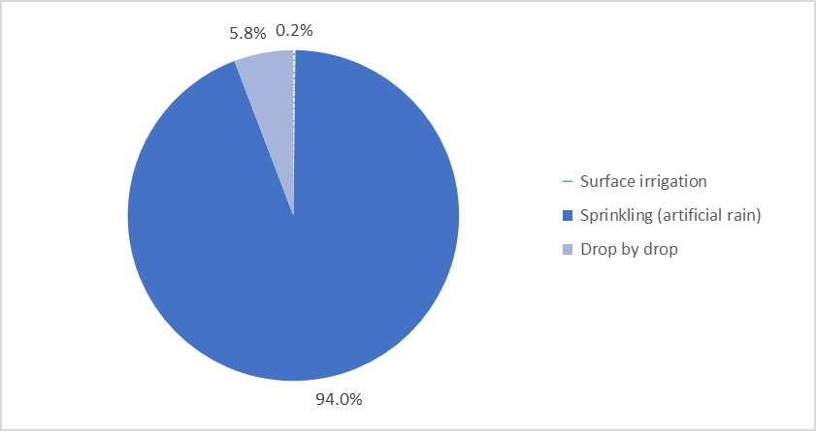

In 2017, 69 695 ha were covered by irrigation systems of which irrigated area was 50 366 ha, and the most frequent type of irrigation, as in the previous year, was sprinkling irrigation (artificial rain). Out of total irrigated area, 94.0% was irrigated by sprinkling irrigation, while the surface irrigation was 0.2 % and irrigation drop by drop covered 5.8% of the irrigated area.
2. Irrigated area under crops/plantations, 2017

ha
 | Surface irrigation | Sprinkling | Drop by drop | Utilized agricultural area
 |  |  |  | Total¹⁾ | From that: Irrigated area
Republic of Serbia | 94 | 47 374 | 2 898 | 3 437 423 | 50 366
Beogradski region | 9 | 1 912 | - | 136 389 | 1 921
Region Vojvodine | 26 | 40 815 | 1 621 | 1 608 896 | 42 462
Region Šumadije i Zapadne Srbije | 6 | 33 | 143 | 1 014 210 | 182
Region Južne i Istočne Srbije | 53 | 4 614 | 1 134 | 677 928 | 5 801
Region Kosovo i Metohija | ... | ... | ... | ... | ...

¹⁾ Census of Agriculture 2012.

The share of irrigated area in relation to the total utilized agricultural area was 1.5%, while in relation to area covered by irrigation systems, the share was 72.3%.

3. Facilities and equipment for irrigation, 2013-2017

Republic of Serbia
 | 2013 | 2014 | 2015 | 2016 | 2017¹⁾
Pumping plants (number) | 919 | 709 | 687 | 832 | 928
Sprinkler systems (number) | 772 | 883 | 882 | 940 | 927
Canals - total, km | 555 | 545 | 510 | 449 | 482
Pipelines - total, km | 1 361 | 1 465 | 1 363 | 1 503 | 1 349

¹⁾ Preliminary data.

Methodological explanations on irrigation can be found on the SORS website: http://webrzs.stat.gov.rs/WebSite/Public/PageView.aspx?pKey=201.
Data series on irrigation from the reference year 2009 are available within the SORS database: http://webrzs.stat.gov.rs/WebSite/public/ReportView.aspx, and as a part of the SORS publications: http://webrzs.stat.gov.rs/WebSite/Public/PageView.aspx?pKey=200.

Contact: gordana.isailovic@stat.gov.rs , neda.cukavac@stat.gov.rs; Phone: 011/32-90-242
Printed and published by: Statistical Office of the Republic of Serbia, Belgrade, Мilana Rakica 5
Telephone: +381 11 2412-922 (operator) • Fax: +381 11 2411-260 • www.stat.gov.rs
Responsible: Dr Miladin Kovačević, Director
Circulation: 20 • Issued: annually

