 | Republic of Serbia  Statistical Office of the Republic of Serbia | ISSN 0353-9555
STATISTICAL RELEASE |  | GR30
Number 284 – Year LXVII, 16/10/2017
Construction Statistics |  | SERB284 GR30 161017

Issued building permits, August 2017
– Preliminary results –

On the basis of the number of issued permits in August 2017, building of 1985 dwellings with average area of 75.1 m² was recorded. Number of dwellings increased, according to the issued permits, by 28.7% when compared to August 2016. Out of the total number of dwellings in new residential buildings, 11.3% of dwellings will be built in single – dwelling buildings, with average area of 153.6 m², while 86.0% of dwellings will be in the buildings with three and more dwellings, with significantly smaller average area of 61.9 m².
In August 2017, 1878 building permits were issued, presenting the increase of 48.7% in relation with August 2016. Index of anticipated value of works in August 2017 is by 17.4% higher than in August 2016.
Observed by types of constructions, in August 2017, 75.6% of issued permits related to buildings and 24.4% to civil engineering. When referring only to buildings, 61.3% related to residential buildings and 38.7% to non–residential ones, while regarding civil engineering, the largest number related to pipelines, communication and electric power lines (60.8%).
Anticipated value of works on new building in August 2017 amounts to 78.8% of totally anticipated value of works. Observed by areas, the greatest construction activity was noted in Beogradska oblast, 38.6% of the anticipated value of new construction, followed by Sremska oblast, 14.5%, Južnobačka oblast, 6.3%, Raška oblast, 4.6% and Nišavska oblast, 4.2%, while the shares of other areas were from 0.2% up to 3.4%.
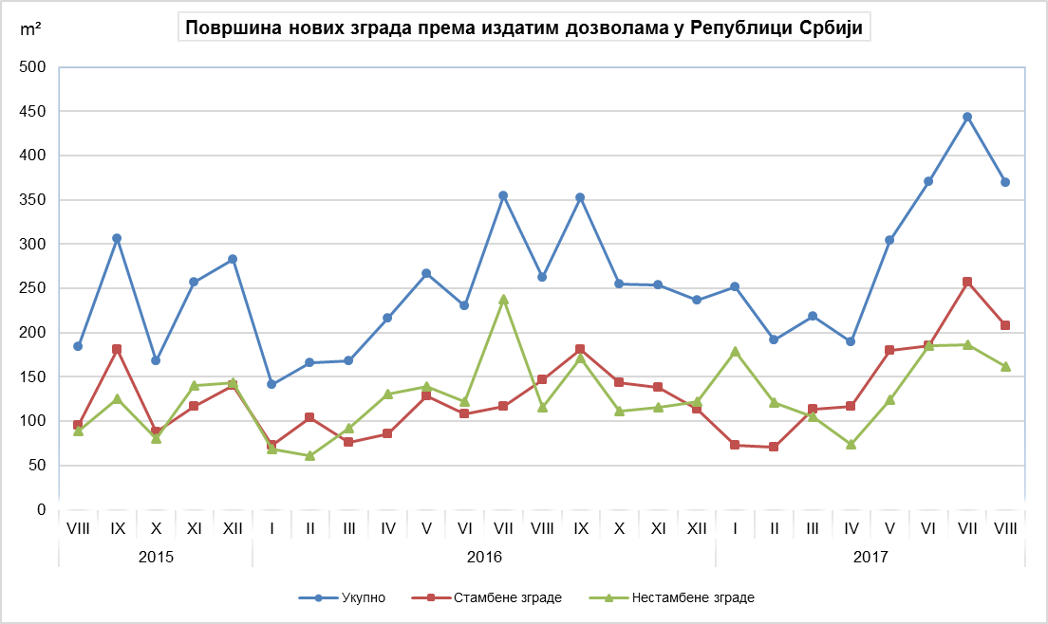
Non-residential buildings
Total
Residential buildings
Area of new buildings in the Republic of Serbia, according to the issued permits

Indices of issued building permits in the Republic of Serbia
 | I–VIII 2017  I– VIII 2016 | VIII 2017  VII 2017 | VIII 2017  VIII 2016 | VIII 2017  ∅ 2016
Total
Number | 158.3 | 115.9 | 148.7 | 177.9
Anticipated value of works | 151.2 | 40.8 | 117.4 | 141.7
Buildings
Number | 164.2 | 108.7 | 144.6 | 179.3
Anticipated value of works | 126.6 | 90.6 | 153.7 | 154.3
Area | 129.8 | 81.9 | 133.8 | 149.2
Volume | 128.0 | 69.0 | 120.1 | 141.3
Civil engineering
Number | 141.9 | 145.7 | 162.8 | 173.6
Anticipated value of works | 203.5 | 14.9 | 67.3 | 112.7
Dwellings
Number | 137.0 | 86.1 | 128.7 | 162.0
Useful area | 144.8 | 86.4 | 133.6 | 169.5

Notes:

The presented data are collected in the scope of monthly survey on building permits. The report is filled in by the Ministry competent for construction affairs, responsible authorities of the Autonomous Province, city or municipality that, according to the Law on planning and construction (“Official Gazette of the Republic of Serbia“, number 132/14, article 133), issue construction permits.
In the scope of this survey, the concept of „building permit“ comprises the building permit for construction and the decision which approves the execution of works following the article 145 of the Law on planning and construction. The issued building permits and approvals for works executions, based on harmonized request, included are only if the construction is approved for the first time.
This statistical survey comprises the issued building permits for all types of constructions described in the Classification of Types of Constructions, i.e. buildings and other civil engineering works and these are presented by territories where the planned works are performed in the country.

Data on issued building permits show the future trends of construction activity and enable an insight in investments’ structure on state and local self – government level.

Starting from 1999 the Statistical Office of the Republic of Serbia has not at disposal and may not provide available certain data relative to AP Kosovo and Metohija and therefore these data are not included in the coverage for the Republic of Serbia (total).
Detailed methodological notes of this survey can be found in the edition of SORS “Methodologies and Standards”. On the website of the Office, the following information can be obtained:

Monthly surveys on building permits, volume 22
(http://webrzs.stat.gov.rs/WebSite/userFiles/file/Gradjevinarstvo/SMET/SMET012010L.pdf), and
Classification of Types of Constructions, volume 15
http://webrzs.stat.gov.rs/WebSite/userFiles/file/Metodologije/Klasifikacije/mm152005.pdf).

Contact: gabrijela.rosic@stat.gov.rs, Phone: 011 2412-922 ext. 260
Published and printed by: Statistical Office of the Republic of Serbia, 11 050 Belgrade, Milana Rakica 5
Phone: +381 11 2412922 (telephone exchange) ● Fax: +381 11 2411260 ● www.stat.gov.rs
Responsible: Dr Miladin Kovačević, Director
Circulation: 20 ● Issued monthly

