 | Republic of Serbia  Statistical Office of the Republic of Serbia | ISSN 0353-9555
STATISTICAL RELEASE |  | PD10
Number 087 - Year LXVII, 03/04/2017
Survey on Income and living conditions |  | SERB087 PD10 030417
Poverty and Social Inequality in Republic of Serbia in 2016
The Survey on Income and Living Conditions (SILC) was implemented for the fourth time in the Republic of Serbia in 2016.
The goal of the Survey is to collect data in order to calculate the indicators of poverty, social exclusion and living conditions. The way in which the survey is conducted is of particular importance, knowing that it has been based on the standardized methodology, applied in all EU member states. The Survey is conducted once a year.
According to the results, the at-risk-of-poverty rate is 25.5% (these persons are not necessarily poor, but are at the higher risk of poverty than the others). Beside this, the at-risk-of-poverty or social exclusion rate amounts to 38.7% in 2016 (these persons at risk of poverty or are severely materially deprived or live in households with low work intensity).
The at-risk-of-poverty threshold (relative poverty line) in 2016 amounts to 15,416.00 dinars a month on an average for a single person household. For a household with two adults and one child aged below 14, the threshold is 27,748.82 dinars per a month, while for a four-member household with two adults and two children aged below 14, it amounts to 32,373.63 dinars.
Observed by age, the at-risk-of-poverty rate by age shows that individuals aged 18-24 are the most exposed to the poverty risk (32.7%), as well as individuals up to 18 years of age (30.2%). The lowest at-risk-of-poverty rate is found in the group of persons who are over 65 years (19.1%).
The highest at-risk-of-poverty rate have individuals in households composed of two adults with three or more dependent children, 49.8%, followed by individuals below 65, living in single-person households, 40.1%.
According to the activity status for persons aged 18 and over, the most exposed to the at-risk-of-poverty are unemployed persons (48.0%), while the lowest at-risk-of-poverty rate have employees working for employers (9%). In case of self-employed persons, this rate amounts to 32.4%. The at-risk-of-poverty rate for pensioners is 15.4%.

Graph 1. Main indicators on poverty and social exclusion, %

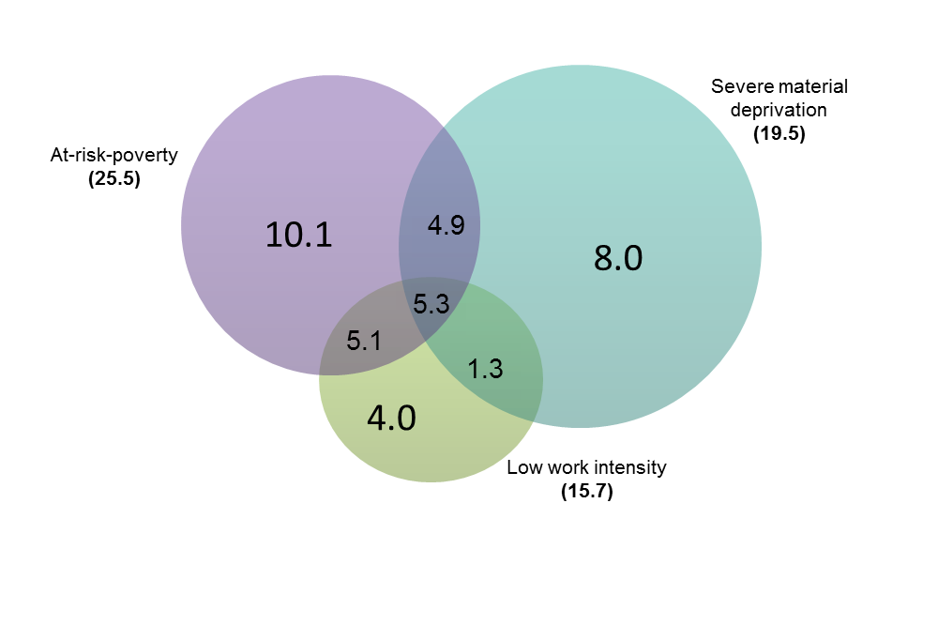
Table 1. Relative poverty and inequality indicators,
 | 2013 | 2014 | 2015 | 2016
At-risk-of-poverty rate, % | 24,5 | 25,4 | 25,4 | 25,5
At-risk-of-poverty rate before social transfers:
Social transfers not included in the income, % | 31,8 | 32,6 | 37,2 | 35,9
Pensions and social transfers not included in the income, % | 51,1 | 52,5 | 55,7 | 54,9
At-risk-of-poverty threshold (on a monthly level):
Single person household, in RSD | 13.680,00 | 13.500,00 | 14.920,10 | 15.416,00
Household with two adults and one child younger than 14 years, in RSD | 24.624,00 | 24.300,00 | 26.856,17 | 27.748,82
Household with two adults and two children younger than 14 years, in RSD | 28.728,00 | 28.350,00 | 31.332,20 | 32.373,63
Relative at-risk-of-poverty gap, % | 36,6 | 40,3 | 37,6 | 38,1
S80/S20 income quintile share ratio | 8,6 | 9,8 | 9,0 | 9,7
Gini coefficient | 38,0 | 38,6 | 38,2 | 38,6
Persistent at-risk-of-poverty rate |  |  |  | 15,7

Table 2. At-risk-of-poverty rate by sex and age, %
 | 2016
 | Gender |  | Total
 | Male | Female
REPUBLIC OF SERBIA | 25,8 | 25,2 | 25,5
Age groups
0-17 | - | - | 30,2
18-64 | 27,4 | 24,6 | 26,0
18-24 | 33,3 | 32,0 | 32,7
25-54 | 25,8 | 24,5 | 25,1
55-64 | 28,4 | 21,4 | 24,8
65 and over | 15,2 | 22,0 | 19,1

Table 3. At-risk-of-poverty rate by the type of household, %
 | 2013 | 2014 | 2015 | 2016
All households without dependent children | 21,3 | 22,9 | 21,7 | 21,5
Single person household | 26,3 | 28,7 | 29,0 | 32,5
Male | 29,5 | 32,9 | 34,9 | 36,2
Female | 24,4 | 26,1 | 25,3 | 30,0
Younger than 65 | 28,1 | 33,6 | 33,1 | 40,1
Older than 65 | 24,9 | 24,9 | 26,1 | 27,2
Two adults without dependent children | 21,4 | 20,9 | 20,3 | 17,9
Both younger than 65 | 24,6 | 24,0 | 24,1 | 21,8
At least one aged 65 years and over | 18,1 | 18,1 | 17,1 | 14,6
Other households without dependent children | 19,2 | 22,2 | 19,9 | 20,1
All households with dependent children | 27,0 | 27,4 | 28,2 | 28,5
Single parent with one or more dependent children | 34,2 | 33,8 | 35,4 | 40,0
Two adults with one dependent child | 24,9 | 19,8 | 21,0 | 22,4
Two adults with two dependent children | 24,6 | 26,8 | 26,7 | 23,6
Two adults with three or more dependent children | 44,4 | 36,7 | 35,8 | 49,8
Other households with dependent children | 25,8 | 28,0 | 29,3 | 29,3

Table 4. At-risk-of-poverty rate by the most frequent status in the labour market and by sex (for persons aged 18 and over), %
 | 2016
 | Gender |  | Total
 | Male | Female
Employed persons | 14,8 | 9,9 | 12,6
Employees | 10,2 | 7,7 | 9,0
Self-employed | 33,7 | 29,2 | 32,4
Not employed persons | 31,9 | 30,1 | 30,9
Unemployed persons | 50,8 | 44,9 | 48,0
Retired persons | 13,3 | 16,9 | 15,4
Other inactive persons | 29,8 | 36,7 | 34,7

Table 5. Dispersion around the at-risk-of-poverty threshold, %
 | 2013 | 2014 | 2015 | 2016
40% of the national median equivalised disposable income
At-risk-of-poverty rate | 13,3 | 14,1 | 13,6 | 14,1
50% of the national median equivalised disposable income
At-risk-of-poverty rate | 18,4 | 19,4 | 19,4 | 19,3
70% of the national median equivalised disposable income
At-risk-of-poverty rate | 30,4 | 32,0 | 31,7 | 31,6

Table 6. Material deprivation indicators, %
 | 2013 | 2014 | 2015 | 2016
Persons who live in a household that:
Cannot afford paying for one week annual holiday away from home | 67,2 | 68,4 | 68,5 | 62,8
Cannot afford a meal with meat, chicken, fish (or vegetarian equivalent) every second day | 30,6 | 26,1 | 24,6 | 20,3
Cannot afford unexpected financial expense (10,000 RSD) | 50,1 | 50,7 | 47,3 | 48,3
Cannot afford to keep home adequately warm | 18,3 | 17,1 | 15,2 | 13,3
Material deprivation rate (three or more items) | 44,3 | 44,1 | 40,9 | 37,4

Graph 2. Subjective poverty rate (Ability of the household to make ends meet), % | Graph 3. Financial burden of the total housing costs, %

Methodology

Territorial coverage: The survey is implemented on the territory of the Republic of Serbia and the processing provides data for the Republic of Serbia (total) and for the regions: Beogradski region, Region Vojvodine, Region Sumadije i Zapadne Srbije, and Region Juzne I Istocne Srbije. Since 1999, the Statistical Office of the Republic of Serbia has not collected data for the AP Kosovo and Metohia and therefore it is not included in the coverage of the data for the Republic of Serbia (total).

Sample: The sample design for the survey is a two-stage stratified sample with enumeration areas as the primary and households as the secondary units of selection. Out of total number of households envisaged for the survey in the fourth wave (6.366 households), a total of 5,554 households were surveyed (87.2%), i.e. 15.057 persons aged 16 and over.

Observation units are households selected according to the sample plan, whether these were one-person or several-member households, as well as all household members aged 16 and over. Collective households were not included in this survey.

- A household means any family or other community of persons who live together and jointly spend funds for meeting their basic life needs (food, housing, etc.), regardless of whether all members are permanently at the place where the household resides or some of them temporarily reside in some other place in the country or abroad on account of work, education or for some other reason.

- Collective (institutional) households are, e.g., monasteries, institutes for the placement of children without parental care, student dormitories, military facilities, boarding schools, establishments for carrying out prison sanctions and detention measures, etc.

Reference period for the collected data that refers to:

- income is 12 months in the previous calendar year – the year 2015 for the third wave,
- material deprivation is the moment of surveying – the year 2016 for the third wave.

Equivalised disposable income is the total household disposable income evenly distributed among the members of the household according to the modified OECD (Organisation for Economic Co-operation and Development) equivalence scale. In accordance with this scale, first adult member of the household receives the value of 1, other adults aged 14 and over 0.5, and children under the age of 14, 0.3. Household income does not include income in kind.

The at-risk-of-poverty threshold (relative poverty line) represents 60% of the median national equivalised disposable income and it is presented in dinars.

The at-risk-of-poverty rate represents the share of persons whose equivalised disposable income is below relative poverty line. These persons are not necessarily poor, but they are at the higher risk of poverty than others.

The relative at-risk-of-poverty gap represents the difference between the at-risk-of-poverty threshold and the median equivalised income of the persons who are below the at-risk-of-poverty threshold.

The S80/S20 income quintile share ratio compares the total equivalised disposable income of the upper income quintile (20% of the population with the highest equivalised income) with those from the lower income quintile (20% of the population with the lowest equivalised income).

The Gini coefficient represents the measure of inequality in the distribution of income. The value of this coefficient goes within the interval from 0 to 1, where 0 represents perfect equality, i.e. each person has equal income. As the value of the coefficient grows, so grows the income inequality.

Persistent at-risk-of-poverty rate presents the percentage of persons who are at-risk-of-poverty in the current year and who have been in the same position for at least two of the three previous years.
The most frequent status in the labour market refers to the activity status which the person had for at least 7 months during the reference period. It is calculated for the persons aged 18 and over.
The dispersion around the at-risk-of-poverty threshold shows sensitivity of the estimated at-risk-of-poverty rate to the selection of the poverty threshold – 40%, 50%, 70% of the median national equivalised disposable income.
The material deprivation of a household is an indicator of the material conditions that influence the quality of life of the household.
The material deprivation items are:
- inability of the household to keep its home adequately warm,
- inability of the household to afford the washing machine,
- inability of the household to afford a car,
- inability of the household to afford paying for one week annual holiday away from home,
- inability of the household to afford unexpected financial expenses (10,000 RSD)
- inability of the household to afford a telephone,
- inability of the household to afford a colour TV,
- inability of the household to afford a meal with meat, chicken, fish (or vegetarian equivalent) every second day,
- being in arrears with mortgage or rent payments, utility bills, hire purchase instalments or other loan payments.

The material deprivation rate is an indicator of the inability of a household to financially afford at least 3 out of 9 items of material deprivation.
The severe material deprivation rate is an indicator of financial inability of a household to afford at least 4 out of 9 items of material deprivation.
Subjective poverty rate (ability to make ends meet) represents a subjective feeling of the respondents about the difficulties faced by the household in its attempt to pay all of its necessary costs taking into consideration the total income of that household.
Financial burden of the total housing cost shows the degree to which housing costs represent a financial burden for a household. These expenditures include housing payments whether instalments for the repayment of a loan, if the household member is the owner of the dwelling, or rent, if the household members rents the dwelling. Housing costs also include utility services, expenditures related to housing and expenditures related to the maintenance of the dwelling.
The work intensity of the household refers to the number of months that all working age household members have been working during the income reference period as a proportion of the total number of months that could theoretically be worked within the household. The work intensity is defined as very low (0-0.20), low (0.20-0.45), medium (0.45-0.55), high (0.55-0.85) and very high (0.85-1). For example, low work intensity refers to households whose working-age members worked between 20% and 45% of the total number of months they could have possibly worked during a referent period.
The at-risk-of-poverty or social exclusion rate (AROPE) shows the share of individuals who are at risk of poverty or are severely materially deprived or live in households with very low work intensity. Since the enactment of the Europe 2020 Strategy this indicator became the headline poverty reduction indicator.

Contact : katarina.marjanovic@stat.gov.rs, phone: 011 2412-922 ext. 363
Published and printed by: Statistical Office of the Republic of Serbia, 11 050 Belgrade, Milana Rakica 5
Phone: +381 11 2412922 (telephone exchange) ● Fax: +381 11 2411260 ● www.stat.gov.rs
Responsible: Dr Miladin Kovačević, Director
Circulation: 20 • Issued annually

The revised results for 2014 are presented in the tables.
Since 1999, the Statistical Office of the Republic of Serbia has not collected data for the AP Kosovo and Metohia and therefore it is not included in the coverage of the data for the Republic of Serbia (total)
See methodological explanation for equivalised disposable income
„Dependent child“ refers to all persons below 18, as well as individuals aged 18-24, who live with at least one parent and are economically inactive.
Definitions of basic indicators are given in Methodological explanations.
Referent period is the previous year relative to the year indicated in the table.
The at-risk-of-poverty rate if social transfers and pensions would not exist.
Eng. Gini.
Referent period: previous year relative to the year indicated in the table.
For the age group 0-17, presented is only total at-risk-of-poverty rate, without gender divisions.
Referent period: previous year relative to the year indicated in the table.
Referent period: previous year relative to the year indicated in the table.
Self-employed persons also include farmers
Referent period: previous year relative to the year indicated in the table.
Referent period: the year indicated in the table.
Reference period: 2016
Reference period: 2016
Current year: 2016

