 | Republic of Serbia  Statistical Office of the Republic of Serbia | ISSN 0353-9555
STATISTICAL RELEASE |  | GR30
Number 065 – Year LXVII, 15/03/2017
Construction Statistics |  | SERB065 GR30 150317

Issued building permits, January 2017
– Preliminary results –

On the basis of the number of issued permits in January 2017, building of 754 dwellings with average area of 83.3 m² was recorded. Number of dwellings decreased, according to the issued permits, by 0.3% when compared to January 2016. Out of the total number of dwellings in new residential buildings, 14.2% of dwellings will be built in single – dwelling buildings, with average area of 149.0 m², while 81.0% of dwellings will be in the buildings with three and more dwellings, with significantly smaller average area of 70.9 m².
In January 2017, 756 building permits were issued, presenting the increase of 80.9% in relation with January 2016. Index of anticipated value of works in January 2017 is by 85.9% higher than in January 2016.
Observed by types of constructions, in January 2017, 74.2% of issued permits related to buildings and 25.8% to civil engineering. When referring only to buildings, 59.4% related to residential buildings and 40.6% to non–residential ones, while regarding civil engineering, the largest number related to pipelines, communication and electric power lines (75.9%).
Anticipated value of works on new building in January 2017 amounts to 85.2% of totally anticipated value of works. Observed by areas, the greatest construction activity was noted in Beogradska oblast, 52.0% of the anticipated value, followed by Šumadijska oblast, 15.4%, Raška oblast, 8.0% and Južnobačka oblast, 4.9%, while the shares of other areas were from 0.1% up to 3.0%.

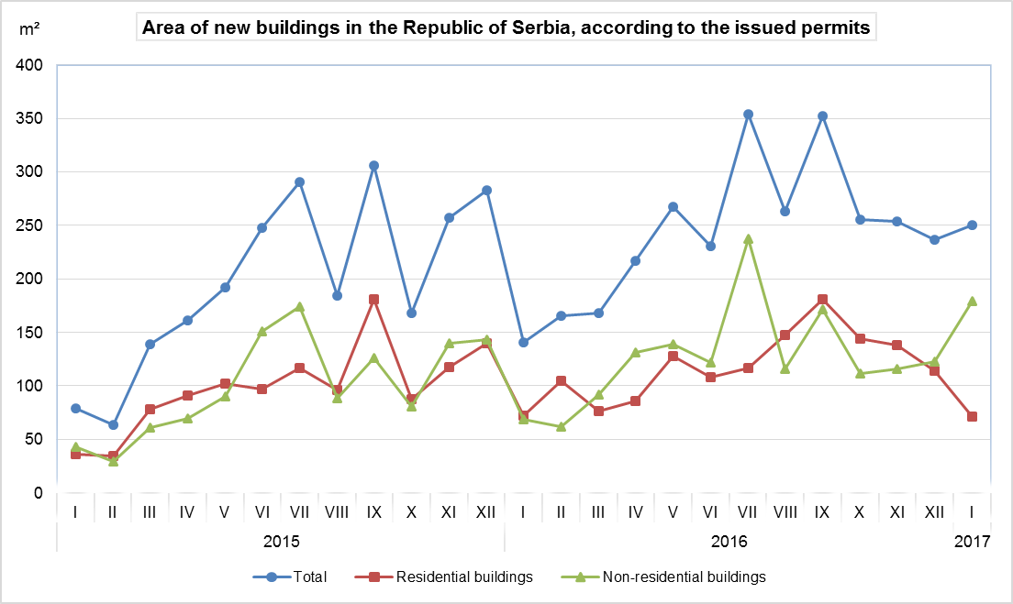

Indices of issued building permits in the Republic of Serbia
 | I–I 2017  I–I 2016 | I 2017  XII 2016 | I 2017  I 2016 | I 2017  ∅ 2016
Total
Number | 180.9 | 58.2 | 180.9 | 71.6
Anticipated value of works | 185.9 | 105.8 | 185.9 | 99.2
Buildings
Number | 179.8 | 56.4 | 179.8 | 70.9
Anticipated value of works | 233.8 | 122.2 | 233.8 | 120.9
Area | 181.4 | 103.8 | 181.4 | 101.6
Volume | 175.2 | 95.9 | 175.2 | 89.6
Civil engineering
Number | 184.0 | 63.9 | 184.0 | 73.7
Anticipated value of works | 86.0 | 60.2 | 86.0 | 49.2
Dwellings
Number | 99.7 | 61.5 | 99.7 | 61.6
Useful area | 113.3 | 72.7 | 113.3 | 71.5

Notes:

The presented data are collected in the scope of monthly survey on building permits. The report is filled in by the Ministry competent for construction affairs, responsible authorities of the Autonomous Province, city or municipality that, according to the Law on planning and construction (“Official Gazette of the Republic of Serbia“, number 132/14, article 133), issue construction permits.
In the scope of this survey, the concept of „building permit“ comprises the building permit for construction and the decision which approves the execution of works.
This statistical survey comprises the issued building permits for all types of constructions described in the Classification of Types of Constructions, i.e. buildings and other civil engineering works and these are presented by territories where the planned works are performed in the country.

Data on issued building permits show the dynamics of construction activity and enable an insight in investments’ structure on state and local self – government level.

Starting from 1999 the Statistical Office of the Republic of Serbia has not at disposal and may not provide available certain data relative to AP Kosovo and Metohija and therefore these data are not included in the coverage for the Republic of Serbia (total).
Detailed methodological notes of this survey can be found in the edition of SORS “Methodologies and Standards”. On the website of the Office, the following information can be obtained:

Monthly surveys on building permits, volume 22
(http://webrzs.stat.gov.rs/WebSite/userFiles/file/Gradjevinarstvo/SMET/SMET012010L.pdf), and
Classification of Types of Constructions, volume 15
http://webrzs.stat.gov.rs/WebSite/userFiles/file/Metodologije/Klasifikacije/mm152005.pdf).

Contact: gabrijela.rosic@stat.gov.rs , Phone: 011 2412-922 ext. 260
Published and printed by: Statistical Office of the Republic of Serbia, 11 050 Belgrade, Milana Rakica 5
Phone: +381 11 2412922 (telephone exchange) ● Fax: +381 11 2411260 ● www.stat.gov.rs
Responsible: Dr Miladin Kovačević, Director
Circulation: 20 ● Issued monthly

