 | Statistical Office of the Republic of Serbia | ISSN 0353-9555
Statistical release |  | SN70
Number 171 - year LXVI, 30/06/2016
Statistics of population |  | SERB171 SN70 300616

Estimates of population for the Republic of Serbia, 2015

The Statistical Office of the Republic of Serbia publishes the estimates of the number of population of the Republic of Serbia by age, sex and type of settlement. Presented are results of the estimations of the number of population of the Republic of Serbia for the year 2015, on the level of municipalities and regions. The estimates were calculated on the basis of 2011 Census of Population, Households and Dwellings and the data on natural and mechanic movements of population (internal migrations).
Starting from 1998 the Statistical Office of the Republic of Serbia has not at disposal and may not provide available certain data relative to AP Kosovo and Metohija and therefore these data are not included in the coverage for the Republic of Serbia (total).
According to the estimations made in mid-2015, the population of the Republic of Serbia numbers 7.095.383 inhabitants, of which the share of females equalled 51.3% and of males 48.7%. The trend of depopulation was carried on, and the rate on population increase was negative when related to the previous year, i.e. equalled -5.1‰.

Table 1. Estimated number of inhabitants of the Republic of Serbia, by areas, mid-year state
 | 2011 | 2012 | 2013 | 2014 | 2015
REPUBLIC OF SERBIA | 7236519 | 7201497 | 7166552 | 7131787 | 7095383
SRBIJA – SEVER | 3591096 | 3586235 | 3581647 | 3576978 | 3571596
Beogradski region | 1658151 | 1664218 | 1669552 | 1675043 | 1679895
Beogradska oblast | 1658151 | 1664218 | 1669552 | 1675043 | 1679895
Region Vojvodine | 1932945 | 1922017 | 1912095 | 1901935 | 1891701
Zapadnobačka oblast | 188447 | 186188 | 183967 | 181780 | 179639
Južnobanatska oblast | 294043 | 291686 | 289766 | 287739 | 285597
Južnobačka oblast | 615190 | 615616 | 616111 | 616378 | 616722
Severnobanatska oblast | 147890 | 146274 | 144672 | 143144 | 141612
Severnobačka oblast | 186985 | 185822 | 184756 | 183622 | 182470
Srednjobanatska oblast | 187860 | 186013 | 184311 | 182555 | 180772
Sremska oblast | 312530 | 310418 | 308512 | 306717 | 304889
SRBIJA – JUG | 3645423 | 3615262 | 3584905 | 3554809 | 3523787
Region Šumadije i Zapadne Srbije | 2033203 | 2018248 | 2003118 | 1987799 | 1972183
Zlatiborska oblast | 286825 | 284216 | 281475 | 278771 | 276210
Kolubarska oblast | 174760 | 173108 | 171466 | 169862 | 168290
Mačvanska oblast | 299345 | 296456 | 293598 | 290747 | 288034
Moravička oblast | 212752 | 211042 | 209365 | 207568 | 205631
Pomoravska oblast | 214872 | 212808 | 210795 | 208683 | 206491
Rasinska oblast | 242300 | 239866 | 237492 | 234990 | 232335
Raška oblast | 308927 | 308717 | 308386 | 308003 | 307408
Šumadijska oblast | 293422 | 292035 | 290541 | 289175 | 287784
Region Južne i Istočne Srbije | 1612220 | 1597014 | 1581787 | 1567010 | 1551604
Borska oblast | 125285 | 123616 | 121909 | 120156 | 118384
Braničevska oblast | 183860 | 181666 | 179451 | 177217 | 174888
Zaječarska oblast | 120216 | 118401 | 116665 | 114901 | 113131
Jablanička oblast | 216583 | 214184 | 211890 | 209691 | 207500
Nišavska oblast | 376522 | 374371 | 372220 | 370215 | 368088
Pirotska oblast | 92614 | 91358 | 90216 | 89191 | 88095
Podunavska oblast | 199497 | 197963 | 196285 | 194701 | 192934
Pčinjska oblast | 205811 | 204748 | 203577 | 202425 | 201170
Toplička oblast | 91832 | 90707 | 89574 | 88513 | 87414
Region Kosovo i Metohija | ... | ... | ... | ... | ...
Despite the decreased total number of inhabitants, Beogradska oblast and Južnobačka oblast noted a slight increase of population. When related to the population estimates for the previous year, the largest relative decrease of the number of inhabitants, i.e. by 1.5%, was noted in Zaječarska oblast, while the largest increase was noted in Beogradska oblast, namely by 0.3%.

Graph 1. Share of population in total population, by areas, estimate as of mid-2015
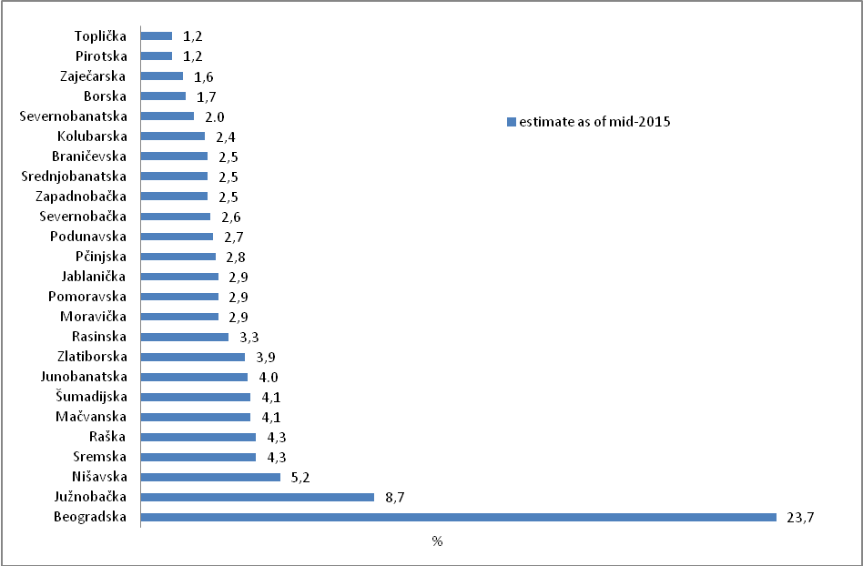

In the Republic of Serbia 50% of the total population lives in six areas only, mostly in Beogradska oblast (1.679.895 or 23.7%) and in Južnobačka oblast (616.722 or 8,7%), while the smallest number of inhabitants was noted for Toplička oblast (87.414 or 1.2%) and Pirotska oblast (88.095 or 1.2%).
The average age of the total population of the Republic of Serbia is constantly on the increase and in 2015 it equalled 42.7 years (males – 41.3 and females – 44.1). The process of population ageing is the result of the ever decreasing share of young population (aged 0 – 14) in the total population, which in 2015 equalled 14.4%, while the share of population aged over 65 in the total population equalled 18.7%. The share of working age population (aged 15 – 64) equalled 66.9% of the total population. The share of female population aged from 15 – 49 (fertile contingent) in the total population equalled 22.1%.

Table 2. Average age, ageing index and fertile contingent of population of the Republic of Serbia
Year | Average age, years |  |  | Ageing index ¹⁾ |  |  | Fertile contingent, %
 | Total | Males | Females | Total | Males | Females | Females
2002 | 40.2 | 39.0 | 41.5 | 99.1 | 84.2 | 114.8 | 24.1
2003 | 40.3 | 39.0 | 41.5 | 99.5 | 64.4 | 115.3 | 23.9
2004 | 40.4 | 39.1 | 41.7 | 100.4 | 84.9 | 116.6 | 23.7
2005 | 40.6 | 39.3 | 41.8 | 100.6 | 84.9 | 117.2 | 23.5
2006 | 40.7 | 39.4 | 42.0 | 101.4 | 85.4 | 118.2 | 23.4
2007 | 40.9 | 39.6 | 42.2 | 103.2 | 86.9 | 120.3 | 23.3
2008 | 41.1 | 39.7 | 42.4 | 105.9 | 89.3 | 123.4 | 23.2
2009 | 41.2 | 39.9 | 42.5 | 108.6 | 91.7 | 126.4 | 23.1
2010 | 41.3 | 40.0 | 42.6 | 111.4 | 94.2 | 129.6 | 23.0
2011 | 42.1 | 40.7 | 43.4 | 121.9 | 103.3 | 141.6 | 22.5
2012 | 42.2 | 40.8 | 43.6 | 125.4 | 106.5 | 145.5 | 22.4
2013 | 42.4 | 41.0 | 43.7 | 129.3 | 110.0 | 149.8 | 22.3
2014 | 42.6 | 41.2 | 43.9 | 133.2 | 113.5 | 154.0 | 22.2
2015 | 42.7 | 41.3 | 44.1 | 136.6 | 116.6 | 157.9 | 22.1

¹⁾ Ageing index of population presents the ratio between the population aged 60 and over and the population aged 0-19, estimated in the middle of the year of observation.

Estimated number of population by age and sex

Observed on the level of areas, in Zaječarka oblast the share of population aged 65 and over was the most expressive (26.1%), and at the same time the share of population aged below 15 was the smallest (11.6%). On the other side, the smallest share of population aged 65 and over was noted in Pčinjska oblast (14.5%); however the largest share of population aged below 15 was not found for Pčinjska oblast, but for Raška oblast (18.8%). The impact of these demographic trends mostly reflects the dependence of elderly population (number of persons aged 65 and over per 100 persons aged 15 – 64), which is the most expressive in Zaječarska oblast (41.8) and in Pirotska oblast (37.0); while the smallest burden for labour force/working age population was noted in Pčinjska oblast (21.2). According to the estimations made for 2015, in the Republic of Serbia the rate of dependence of elderly population equals 28.0.

Graph 2. Share of young and elderly population in total population, by area (estimate as in mid-2015)
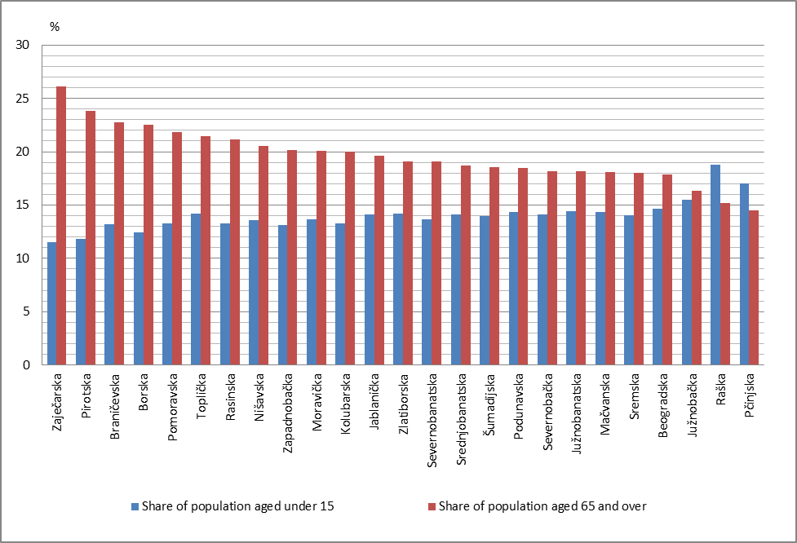

Table 3. Estimated number of inhabitants of the Republic of Serbia by age and sex, 2015 (beginning, middle and end of year)
Age | 1 January |  |  | Average |  |  | 31 December
 | Total | Males | Females | Total | Males | Females | Total | Males | Females
Total | 7114393 | 3464399 | 3649994 | 7095383 | 3455335 | 3640048 | 7076372 | 3446258 | 3630114
0 | 66079 | 34101 | 31978 | 65689 | 33965 | 31724 | 65311 | 33823 | 31488
1 | 65112 | 33453 | 31659 | 65576 | 33763 | 31813 | 66051 | 34088 | 31963
2 | 66811 | 34293 | 32518 | 65952 | 33870 | 32082 | 65104 | 33447 | 31657
3 | 65316 | 33787 | 31529 | 66054 | 34034 | 32020 | 66796 | 34284 | 32512
4 | 66099 | 33900 | 32199 | 65706 | 33846 | 31860 | 65309 | 33780 | 31529
5 | 67123 | 34719 | 32404 | 66613 | 34307 | 32306 | 66088 | 33896 | 32192
6 | 66719 | 34536 | 32183 | 66912 | 34625 | 32287 | 67115 | 34714 | 32401
7 | 66105 | 34036 | 32069 | 66413 | 34286 | 32127 | 66715 | 34532 | 32183
8 | 68234 | 34966 | 33268 | 67163 | 34491 | 32672 | 66095 | 34028 | 32067
9 | 69953 | 35786 | 34167 | 69086 | 35377 | 33709 | 68222 | 34961 | 33261
10 | 71228 | 36736 | 34492 | 70595 | 36255 | 34340 | 69943 | 35778 | 34165
11 | 72332 | 37227 | 35105 | 71769 | 36976 | 34793 | 71220 | 36732 | 34488
12 | 71933 | 36953 | 34980 | 72125 | 37090 | 35035 | 72323 | 37218 | 35105
13 | 72491 | 37252 | 35239 | 72216 | 37101 | 35115 | 71927 | 36949 | 34978
14 | 67819 | 34791 | 33028 | 70139 | 36017 | 34122 | 72474 | 37240 | 35234
15 | 68023 | 35210 | 32813 | 67935 | 35002 | 32933 | 67810 | 34784 | 33026
16 | 70050 | 35944 | 34106 | 69016 | 35569 | 33447 | 68007 | 35202 | 32805
17 | 72994 | 37488 | 35506 | 71510 | 36705 | 34805 | 70030 | 35932 | 34098
18 | 76873 | 39648 | 37225 | 74918 | 38554 | 36364 | 72968 | 37466 | 35502
19 | 81085 | 41889 | 39196 | 78966 | 40763 | 38203 | 76842 | 39624 | 37218
20 | 80897 | 41685 | 39212 | 80984 | 41785 | 39199 | 81063 | 41872 | 39191
21 | 82727 | 42636 | 40091 | 81790 | 42136 | 39654 | 80857 | 41656 | 39201
22 | 82790 | 42357 | 40433 | 82735 | 42484 | 40251 | 82687 | 42605 | 40082
23 | 86060 | 43939 | 42121 | 84420 | 43140 | 41280 | 82758 | 42333 | 40425
24 | 85869 | 43989 | 41880 | 85938 | 43944 | 41994 | 86014 | 43901 | 42113
25 | 86477 | 44119 | 42358 | 86147 | 44035 | 42112 | 85818 | 43950 | 41868
26 | 91576 | 47072 | 44504 | 88998 | 45574 | 43424 | 86433 | 44088 | 42345
27 | 92654 | 47475 | 45179 | 92117 | 47274 | 44843 | 91532 | 47041 | 44491
28 | 92324 | 47031 | 45293 | 92443 | 47217 | 45226 | 92610 | 47439 | 45171
29 | 94525 | 48259 | 46266 | 93390 | 47628 | 45762 | 92253 | 46989 | 45264
30 | 98786 | 50277 | 48509 | 96635 | 49250 | 47385 | 94452 | 48210 | 46242
31 | 99078 | 50574 | 48504 | 98886 | 50399 | 48487 | 98712 | 50231 | 48481
32 | 97678 | 49737 | 47941 | 98321 | 50122 | 48199 | 98987 | 50511 | 48476
33 | 97256 | 49260 | 47996 | 97435 | 49473 | 47962 | 97603 | 49686 | 47917
34 | 99144 | 50443 | 48701 | 98154 | 49821 | 48333 | 97159 | 49197 | 47962
35 | 98942 | 50330 | 48612 | 98993 | 50353 | 48640 | 99043 | 50377 | 48666
36 | 100228 | 51031 | 49197 | 99513 | 50629 | 48884 | 98806 | 50238 | 48568
37 | 100825 | 51173 | 49652 | 100454 | 51052 | 49402 | 100089 | 50935 | 49154
38 | 101807 | 51321 | 50486 | 101261 | 51213 | 50048 | 100696 | 51090 | 49606
39 | 101574 | 51234 | 50340 | 101614 | 51233 | 50381 | 101647 | 51217 | 50430
40 | 98544 | 49694 | 48850 | 99966 | 50397 | 49569 | 101415 | 51131 | 50284
41 | 98436 | 49430 | 49006 | 98409 | 49521 | 48888 | 98387 | 49597 | 48790
42 | 95568 | 47574 | 47994 | 96918 | 48441 | 48477 | 98247 | 49305 | 48942
43 | 95501 | 47896 | 47605 | 95430 | 47662 | 47768 | 95375 | 47441 | 47934
44 | 93272 | 46695 | 46577 | 94272 | 47226 | 47046 | 95271 | 47750 | 47521
45 | 94159 | 46932 | 47227 | 93581 | 46725 | 46856 | 93008 | 46528 | 46480
46 | 93339 | 46004 | 47335 | 93623 | 46386 | 47237 | 93873 | 46748 | 47125
47 | 93959 | 46412 | 47547 | 93469 | 46090 | 47379 | 93001 | 45783 | 47218
48 | 93728 | 46119 | 47609 | 93646 | 46143 | 47503 | 93581 | 46174 | 47407
49 | 96097 | 47315 | 48782 | 94722 | 46599 | 48123 | 93328 | 45869 | 47459
50 | 92871 | 45675 | 47196 | 94262 | 46340 | 47922 | 95635 | 47007 | 48628
51 | 96613 | 47285 | 49328 | 94470 | 46303 | 48167 | 92359 | 45324 | 47035
52 | 97742 | 47690 | 50052 | 96877 | 47307 | 49570 | 96003 | 46911 | 49092
53 | 101405 | 49160 | 52245 | 99247 | 48205 | 51042 | 97100 | 47262 | 49838
54 | 104523 | 50782 | 53741 | 102590 | 49719 | 52871 | 100636 | 48648 | 51988
55 | 100708 | 48955 | 51753 | 102186 | 49573 | 52613 | 103658 | 50204 | 53454
56 | 102008 | 49570 | 52438 | 100908 | 48963 | 51945 | 99796 | 48343 | 51453
57 | 100261 | 48250 | 52011 | 100624 | 48579 | 52045 | 101004 | 48914 | 52090
58 | 109048 | 52395 | 56653 | 104119 | 49965 | 54154 | 99171 | 47519 | 51652
Table 3. Estimated number of inhabitants of the Republic of Serbia by age and sex, 2015 (beginning, middle and end of year) (continued)
Age | 1 January |  |  | Average |  |  | 31 December
 | Total | Males | Females | Total | Males | Females | Total | Males | Females
59 | 112634 | 54337 | 58297 | 110169 | 52923 | 57246 | 107729 | 51530 | 56199
60 | 119045 | 57043 | 62002 | 115042 | 55157 | 59885 | 111049 | 53261 | 57788
61 | 115641 | 55318 | 60323 | 116540 | 55656 | 60884 | 117431 | 55996 | 61435
62 | 119036 | 56495 | 62541 | 116398 | 55286 | 61112 | 113753 | 54080 | 59673
63 | 101222 | 47775 | 53447 | 109234 | 51543 | 57691 | 117251 | 55310 | 61941
64 | 111199 | 51858 | 59341 | 105259 | 49221 | 56038 | 99324 | 46591 | 52733
65 | 103218 | 47852 | 55366 | 106203 | 49227 | 56976 | 109174 | 50586 | 58588
66 | 98555 | 45284 | 53271 | 99783 | 45866 | 53917 | 101030 | 46461 | 54569
67 | 90087 | 41241 | 48846 | 93279 | 42606 | 50673 | 96476 | 43981 | 52495
68 | 76035 | 34466 | 41569 | 82030 | 37239 | 44791 | 87995 | 39987 | 48008
69 | 55998 | 24934 | 31064 | 65189 | 29200 | 35989 | 74390 | 33479 | 40911
70 | 61037 | 26923 | 34114 | 57611 | 25412 | 32199 | 54167 | 23884 | 30283
71 | 60650 | 26729 | 33921 | 59835 | 26256 | 33579 | 59042 | 25800 | 33242
72 | 61624 | 26726 | 34898 | 60101 | 26152 | 33949 | 58597 | 25586 | 33011
73 | 63251 | 27217 | 36034 | 61242 | 26318 | 34924 | 59217 | 25415 | 33802
74 | 65506 | 28280 | 37226 | 62993 | 27026 | 35967 | 60465 | 25759 | 34706
75 | 61694 | 25897 | 35797 | 62078 | 26303 | 35775 | 62441 | 26699 | 35742
76 | 59482 | 24579 | 34903 | 59009 | 24476 | 34533 | 58557 | 24383 | 34174
77 | 57766 | 23670 | 34096 | 56859 | 23236 | 33623 | 55947 | 22802 | 33145
78 | 54114 | 22165 | 31949 | 54097 | 22038 | 32059 | 54082 | 21908 | 32174
79 | 50806 | 20542 | 30264 | 50444 | 20394 | 30050 | 50086 | 20241 | 29845
80 | 47935 | 19065 | 28870 | 47251 | 18860 | 28391 | 46586 | 18663 | 27923
81 | 42807 | 16726 | 26081 | 43184 | 16941 | 26243 | 43559 | 17168 | 26391
82 | 38680 | 14827 | 23853 | 38554 | 14871 | 23683 | 38417 | 14909 | 23508
83 | 32400 | 12607 | 19793 | 33330 | 12816 | 20514 | 34257 | 13013 | 21244
84 | 29430 | 10948 | 18482 | 28818 | 10909 | 17909 | 28214 | 10888 | 17326
85 and over | 103163 | 36405 | 66758 | 106951 | 37901 | 69050 | 110719 | 39376 | 71343

Graph 3. Estimated number of inhabitants of the Republic of Serbia by age and sex, mid-2015
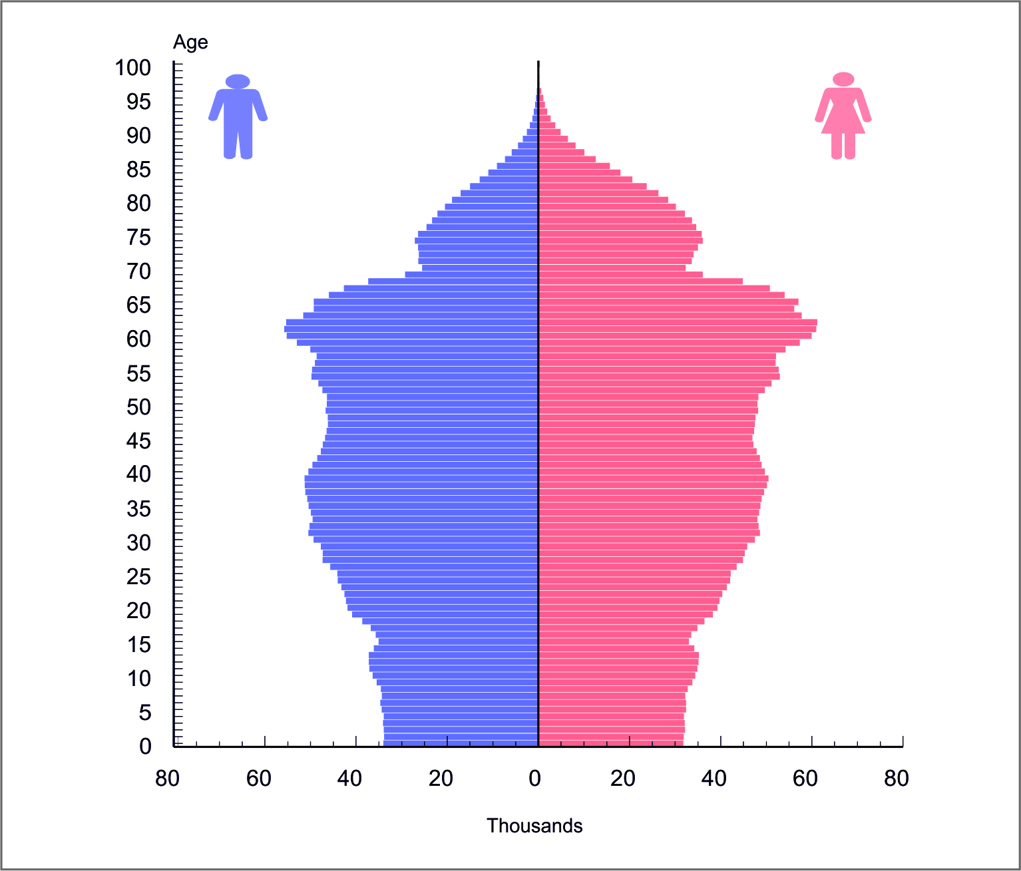
Estimated number of inhabitants by type of settlement

According to the population estimations by type of settlement, the share of urban population is prevailing in the Republic of Serbia (60.1%). From the demographic viewpoint, the urban population is younger when related to the population of other settlements; the average age of the urban population is lower than the average age of the population in so called other settlements and the difference is 2.4 years. In urban settlements the aging index noted a lower value (124.2 in relation to 156.6), as well as the rate of dependence of the population aged 65 and over to the working age population (25.3 to 32.3).

Table 4. Population of the Republic of Serbia by age groups, type of settlement and sex,
estimate as of mid-2015
Age groups | Population |  |  | Urban |  |  | Other
 | Total | Males | Females | Total | Males | Females | Total | Males | Females
Total | 7095383 | 3455335 | 3640048 | 4267079 | 2033446 | 2233633 | 2828304 | 1421889 | 1406415
0–4 | 328977 | 169478 | 159499 | 224741 | 115749 | 108992 | 104236 | 53729 | 50507
5–9 | 336187 | 173086 | 163101 | 206277 | 106039 | 100238 | 129910 | 67047 | 62863
10–14 | 356844 | 183439 | 173405 | 211354 | 108632 | 102722 | 145490 | 74807 | 70683
15–19 | 362345 | 186593 | 175752 | 210839 | 108428 | 102411 | 151506 | 78165 | 73341
20–24 | 415867 | 213489 | 202378 | 247157 | 125086 | 122071 | 168710 | 88403 | 80307
25–29 | 453095 | 231728 | 221367 | 283534 | 140390 | 143144 | 169561 | 91338 | 78223
30–34 | 489431 | 249065 | 240366 | 320106 | 157933 | 162173 | 169325 | 91132 | 78193
35–39 | 501835 | 254480 | 247355 | 325903 | 161122 | 164781 | 175932 | 93358 | 82574
40–44 | 484995 | 243247 | 241748 | 302813 | 147935 | 154878 | 182182 | 95312 | 86870
45–49 | 469041 | 231943 | 237098 | 280813 | 134537 | 146276 | 188228 | 97406 | 90822
50–54 | 487446 | 237874 | 249572 | 289380 | 135609 | 153771 | 198066 | 102265 | 95801
55–59 | 518006 | 250003 | 268003 | 304767 | 140783 | 163984 | 213239 | 109220 | 104019
60–64 | 562473 | 266863 | 295610 | 327869 | 148920 | 178949 | 234604 | 117943 | 116661
65–69 | 446484 | 204138 | 242346 | 260134 | 114317 | 145817 | 186350 | 89821 | 96529
70–74 | 301782 | 131164 | 170618 | 164678 | 69579 | 95099 | 137104 | 61585 | 75519
75–79 | 282487 | 116447 | 166040 | 152823 | 61673 | 91150 | 129664 | 54774 | 74890
80–84 | 191137 | 74397 | 116740 | 98387 | 37813 | 60574 | 92750 | 36584 | 56166
85+ | 106951 | 37901 | 69050 | 55504 | 18901 | 36603 | 51447 | 19000 | 32447

Table 5. Republic of Serbia population estimate by type of settlement, 2015
Type of settlement | Sex | Number of inhabitants | Average age, years | Ageing index | Dependence rate for population aged 65 and over
Total | Total | 7095383 | 42.7 | 136.6 | 28.0
 | Male | 3455335 | 41.3 | 116.6 | 23.8
 | Female | 3640048 | 44.1 | 157.9 | 32.1
Urban | Total | 4267079 | 41.8 | 124.2 | 25.3
 | Male | 2033446 | 40.2 | 102.8 | 21.6
 | Female | 2233633 | 43.2 | 146.8 | 28.8
Other | Total | 2828304 | 44.2 | 156.6 | 32.3
 | Male | 1421889 | 42.9 | 138.7 | 27.1
 | Female | 1406415 | 45.5 | 175.7 | 37.8

Observed on the lower territorial level, in eight areas only prevailing is the population that is not urban (in Pčinjska, Pomoravska, Jablanička, Sremska, Kolubarska, Braničevska, Rasinska and Mačvanska oblast).

Graph 4. Population by areas, by type of settlement, 2015
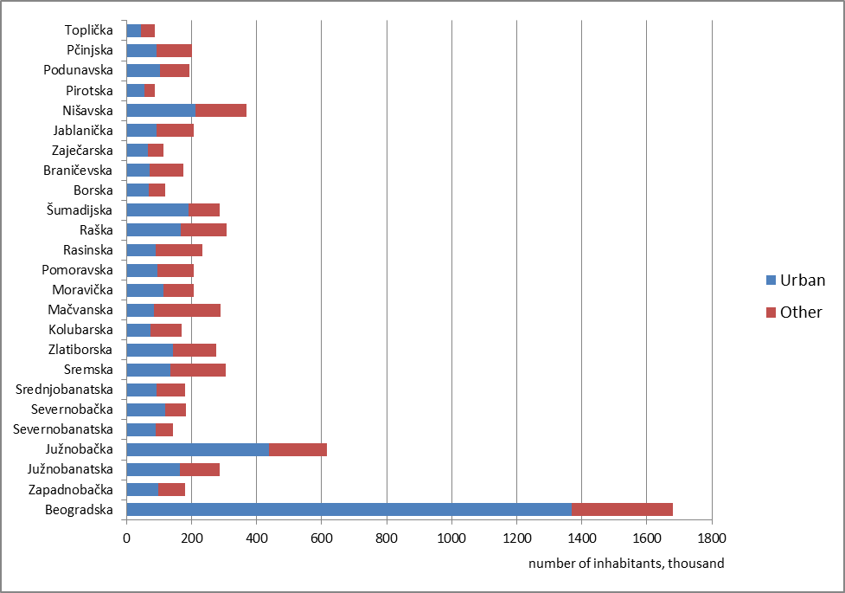

Graph 5. Age and sex structure of population of the Republic of Serbia by type of settlement (estimated as of mid-2015)

Urban population | Other population
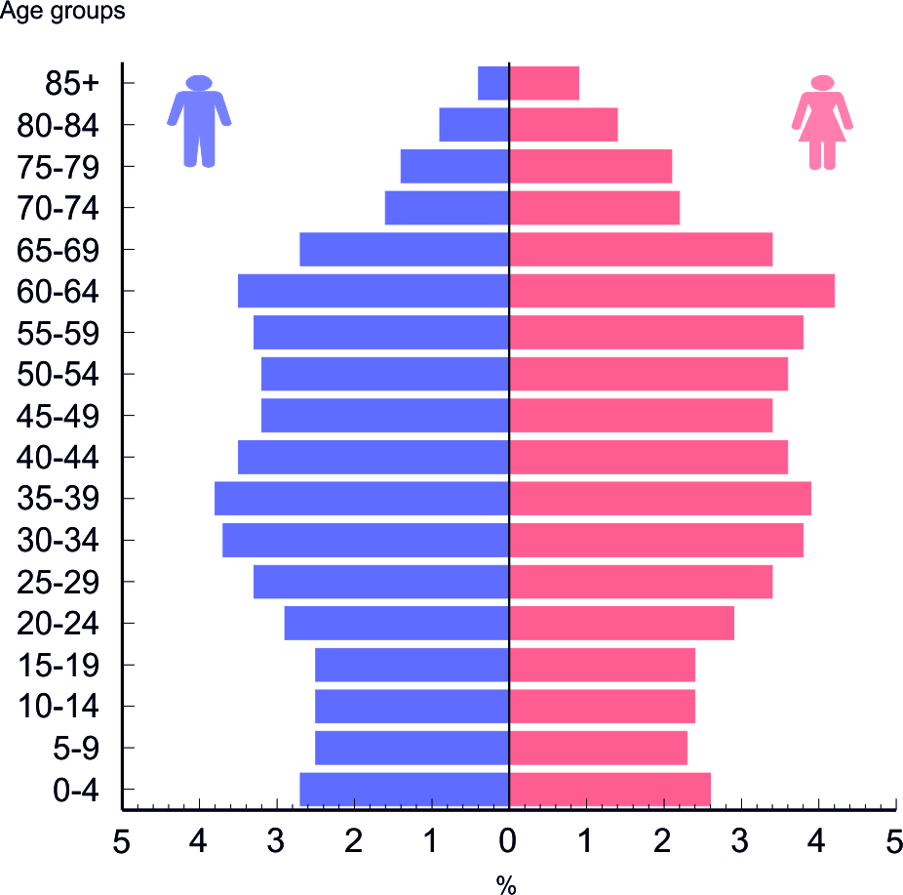 | 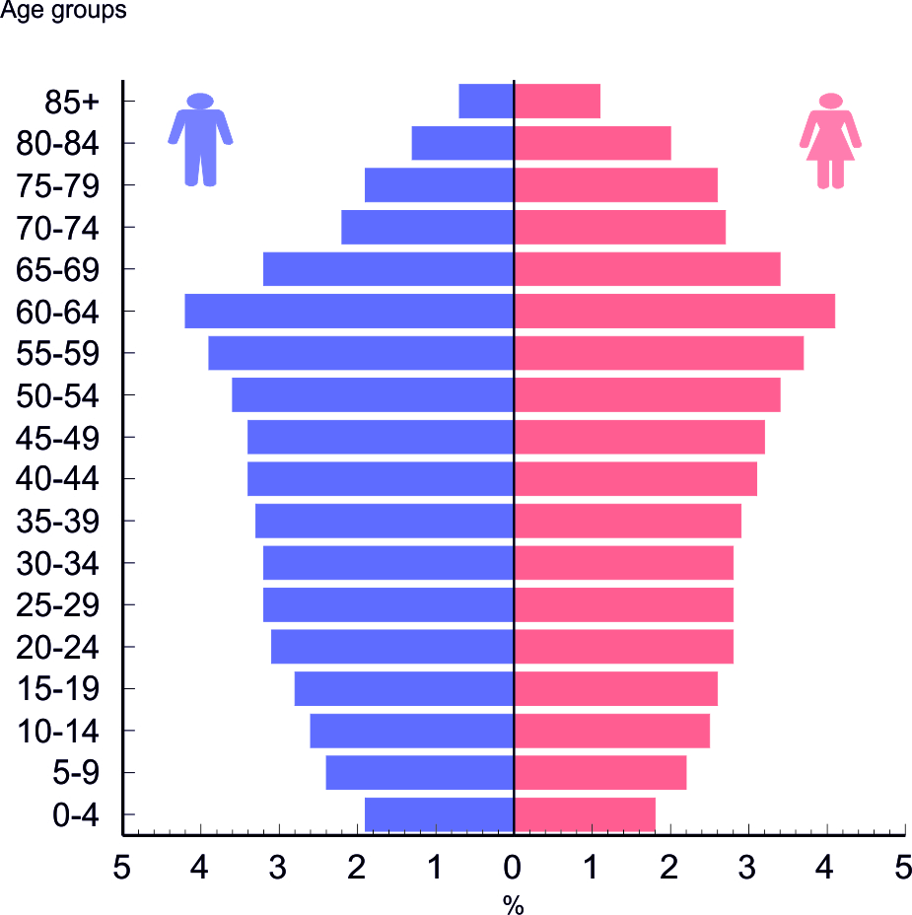

The various age structures of population by type of settlement were caused by the differences in fertility, however primarily by the differences regarding the direction and scope of migratory movements.
Table 6. Estimated number of inhabitants of the Republic of Serbia in 2015, by municipalities
Region  Area  City – municipality | Number of inhabitants by age groups |  |  |  | Average age, years | Ageing index
 | Total | 0-14 | 15-64 | 65 and over
REPUBLIC OF SERBIA | 7095383 | 1022008 | 4744534 | 1328841 | 42.7 | 136.6
SRBIJA – SEVER | 3571596 | 520084 | 2413841 | 637671 | 42.2 | 131.5
Beogradski region | 1679895 | 246412 | 1133715 | 299768 | 42.1 | 132.9
Beogradska oblast | 1679895 | 246412 | 1133715 | 299768 | 42.1 | 132.9
Grad Beograd | 1679895 | 246412 | 1133715 | 299768 | 42.1 | 132.9
Barajevo | 27013 | 3873 | 17459 | 5681 | 43.8 | 156.9
Voždovac | 165811 | 22875 | 112520 | 30416 | 42.4 | 140.6
Vračar | 57130 | 7214 | 37630 | 12286 | 44.4 | 183.1
Grocka | 85654 | 13510 | 58304 | 13840 | 41.0 | 116.7
Zvezdara | 159026 | 23647 | 108527 | 26852 | 41.3 | 124.7
Zemun | 171861 | 26738 | 116102 | 29021 | 41.4 | 119.3
Lazarevac | 57735 | 8909 | 39903 | 8923 | 41.1 | 113.2
Mladenovac | 52591 | 7757 | 35124 | 9710 | 42.6 | 137.0
Novi Beograd | 214229 | 30805 | 141858 | 41566 | 43.1 | 149.6
Obrenovac | 72323 | 11231 | 48514 | 12578 | 41.9 | 124.4
Palilula | 178670 | 26970 | 123415 | 28285 | 41.0 | 116.2
Rakovica | 108823 | 15935 | 72674 | 20214 | 42.2 | 131.8
Savski venac | 37275 | 5073 | 24645 | 7557 | 43.9 | 170.3
Sopot | 20126 | 2725 | 12988 | 4413 | 44.5 | 163.9
Stari grad | 46785 | 5755 | 30601 | 10429 | 44.9 | 198.7
Surčin | 45550 | 7488 | 31299 | 6763 | 40.3 | 102.5
Čukarica | 179293 | 25907 | 122152 | 31234 | 42.0 | 130.4
Region Vojvodine | 1891701 | 273672 | 1280126 | 337903 | 42.4 | 130.4
Zapadnobačka oblast | 179639 | 23548 | 119898 | 36193 | 44.0 | 156.2
Sombor | 82389 | 10677 | 54818 | 16894 | 44.2 | 160.5
Apatin | 27688 | 3648 | 18479 | 5561 | 44.1 | 157.1
Kula | 41078 | 5693 | 27403 | 7982 | 43.2 | 140.8
Odžaci | 28484 | 3530 | 19198 | 5756 | 44.4 | 167.3
Južnobanatska oblast | 285597 | 41287 | 192361 | 51949 | 42.6 | 133.3
Pančevo | 121482 | 17673 | 82667 | 21142 | 42.2 | 130.9
Alibunar | 19224 | 2621 | 12527 | 4076 | 44.1 | 151.5
Bela Crkva | 16652 | 2377 | 11125 | 3150 | 43.0 | 137.7
Vršac | 50558 | 7481 | 33857 | 9220 | 42.5 | 131.1
Kovačica | 24443 | 3662 | 16300 | 4481 | 42.4 | 126.7
Kovin | 32480 | 4674 | 22100 | 5706 | 42.4 | 126.9
Opovo | 10037 | 1573 | 6561 | 1903 | 42.3 | 126.3
Plandište | 10721 | 1226 | 7224 | 2271 | 45.7 | 180.9
Južnobačka oblast | 616722 | 95520 | 420441 | 100761 | 41.0 | 114.5
Grad Novi Sad | 350930 | 55483 | 241088 | 54359 | 40.3 | 108.4
Novi Sad | 316942 | 50665 | 217988 | 48289 | 40.1 | 105.9
Petrovaradin | 33988 | 4818 | 23100 | 6070 | 42.3 | 133.3
Bač | 13753 | 1842 | 9405 | 2506 | 43.0 | 137.2
Bačka Palanka | 53678 | 7661 | 35710 | 10307 | 43.2 | 141.6
Bački Petrovac | 13042 | 1878 | 8799 | 2365 | 42.7 | 135.0
Beočin | 15304 | 2344 | 10416 | 2544 | 41.7 | 115.7
Bečej | 36187 | 5557 | 24217 | 6413 | 41.9 | 119.6
Vrbas | 40634 | 6322 | 27401 | 6911 | 41.5 | 116.4
Žabalј | 25596 | 4347 | 17330 | 3919 | 40.2 | 95.7
Srbobran | 15822 | 2431 | 10753 | 2638 | 41.5 | 114.0
Sremski Karlovci | 8541 | 1165 | 5757 | 1619 | 43.2 | 144.3
Temerin | 27955 | 4265 | 19180 | 4510 | 41.3 | 117.0
Titel | 15280 | 2225 | 10385 | 2670 | 42.2 | 125.1
Severnobanatska oblast | 141612 | 19381 | 95187 | 27044 | 43.3 | 142.1
Kikinda | 56760 | 7819 | 38380 | 10561 | 43.3 | 142.1
Ada | 16400 | 2192 | 11009 | 3199 | 43.4 | 146.5
Kanjiža | 24406 | 3297 | 16424 | 4685 | 43.2 | 139.1
Novi Kneževac | 10761 | 1573 | 7248 | 1940 | 43.0 | 132.2
Senta | 22490 | 3099 | 14900 | 4491 | 43.2 | 142.1
Čoka | 10795 | 1401 | 7226 | 2168 | 44.1 | 152.3
Severnobačka oblast | 182470 | 25697 | 123579 | 33194 | 42.7 | 133.5
Subotica | 139011 | 19863 | 94129 | 25019 | 42.5 | 131.1
Bačka Topola | 31884 | 4125 | 21564 | 6195 | 43.8 | 151.2
Mali Iđoš | 11575 | 1709 | 7886 | 1980 | 41.8 | 118.4

Table 6. Estimated number of inhabitants of the Republic of Serbia in 2015, by municipalities (continued)
Region  Area  City – municipality | Number of inhabitants by age groups |  |  |  | Average age, years | Ageing index
 | Total | 0-14 | 15-64 | 65 and over
Srednjobanatska oblast | 180772 | 25473 | 121505 | 33794 | 43.0 | 138.7
Zrenjanin | 119710 | 16909 | 80499 | 22302 | 42.9 | 139.3
Žitište | 15814 | 2158 | 10461 | 3195 | 43.6 | 147.2
Nova Crnja | 9713 | 1344 | 6546 | 1823 | 43.2 | 134.9
Novi Bečej | 23116 | 3415 | 15771 | 3930 | 42.0 | 123.5
Sečanj | 12419 | 1647 | 8228 | 2544 | 44.4 | 155.5
Sremska oblast | 304889 | 42766 | 207155 | 54968 | 42.8 | 135.6
Sremska Mitrovica | 77667 | 10854 | 52615 | 14198 | 42.9 | 135.4
Inđija | 46641 | 6581 | 31412 | 8648 | 42.9 | 139.8
Irig | 10426 | 1297 | 6926 | 2203 | 44.9 | 172.8
Pećinci | 19492 | 2881 | 13293 | 3318 | 41.9 | 120.0
Ruma | 52651 | 7039 | 35912 | 9700 | 43.3 | 144.4
Stara Pazova | 65213 | 9735 | 44495 | 10983 | 41.8 | 124.2
Šid | 32799 | 4379 | 22502 | 5918 | 43.3 | 139.6
SRBIJA – JUG | 3523787 | 501924 | 2330693 | 691170 | 43.2 | 141.7
Region Šumadije i Zapadne Srbije | 1972183 | 286995 | 1310821 | 374367 | 43.0 | 137.4
Zlatiborska oblast | 276210 | 39252 | 184166 | 52792 | 43.3 | 140.1
Grad Užice | 75805 | 10305 | 51450 | 14050 | 43.5 | 146.2
Užice | 68965 | 9389 | 46676 | 12900 | 43.6 | 146.9
Sevojno | 6840 | 916 | 4774 | 1150 | 43.1 | 139.3
Arilјe | 18369 | 2665 | 12363 | 3341 | 42.8 | 132.4
Bajina Bašta | 24947 | 3367 | 16567 | 5013 | 44.3 | 155.0
Kosjerić | 11341 | 1441 | 7284 | 2616 | 46.1 | 188.4
Nova Varoš | 15444 | 1787 | 10109 | 3548 | 46.4 | 197.1
Požega | 28493 | 3635 | 18848 | 6010 | 44.9 | 168.6
Priboj | 25583 | 3150 | 17341 | 5092 | 44.7 | 164.1
Prijepolјe | 35818 | 5756 | 23845 | 6217 | 41.1 | 110.6
Sjenica | 26067 | 5306 | 17070 | 3691 | 37.8 | 72.1
Čajetina | 14343 | 1840 | 9289 | 3214 | 45.5 | 181.2
Kolubarska oblast | 168290 | 22352 | 112246 | 33692 | 44.1 | 154.9
Valјevo | 87944 | 11504 | 59574 | 16866 | 43.9 | 154.5
Lajkovac | 15046 | 2149 | 10142 | 2755 | 43.0 | 134.3
Ljig | 11893 | 1513 | 7602 | 2778 | 45.7 | 179.7
Mionica | 13638 | 1899 | 8618 | 3121 | 45.1 | 166.5
Osečina | 11701 | 1370 | 7562 | 2769 | 46.6 | 190.7
Ub | 28068 | 3917 | 18748 | 5403 | 43.3 | 139.0
Mačvanska oblast | 288034 | 41251 | 194673 | 52110 | 42.9 | 135.2
Šabac | 113113 | 16611 | 76951 | 19551 | 42.4 | 129.5
Bogatić | 27542 | 3903 | 18359 | 5280 | 43.2 | 138.6
Vladimirci | 16534 | 2172 | 10648 | 3714 | 45.2 | 172.3
Kocelјeva | 12331 | 1664 | 8158 | 2509 | 44.4 | 151.7
Krupanj | 16226 | 2113 | 11031 | 3082 | 44.1 | 150.0
Loznica | 76958 | 11415 | 52047 | 13496 | 42.5 | 128.5
Ljubovija | 13477 | 1817 | 9168 | 2492 | 43.9 | 144.1
Mali Zvornik | 11853 | 1556 | 8311 | 1986 | 43.3 | 134.3
Moravička oblast | 205631 | 28105 | 136271 | 41255 | 44.1 | 155.5
Čačak | 112558 | 15980 | 74816 | 21762 | 43.5 | 145.7
Gornji Milanovac | 42730 | 5609 | 28327 | 8794 | 44.4 | 166.5
Ivanjica | 30718 | 4197 | 20470 | 6051 | 44.2 | 153.8
Lučani | 19625 | 2319 | 12658 | 4648 | 46.5 | 197.4
Pomoravska oblast | 206491 | 27361 | 133960 | 45170 | 44.5 | 163.9
Jagodina | 70772 | 10104 | 46614 | 14054 | 43.2 | 142.1
Despotovac | 21722 | 2568 | 13734 | 5420 | 46.4 | 195.7
Paraćin | 52384 | 7281 | 34555 | 10548 | 43.6 | 148.3
Rekovac | 10035 | 957 | 5907 | 3171 | 50.4 | 300.9
Svilajnac | 22279 | 2758 | 13960 | 5561 | 46.1 | 189.3
Ćuprija | 29299 | 3693 | 19190 | 6416 | 45.0 | 174.8
Rasinska oblast | 232335 | 30863 | 152354 | 49118 | 44.5 | 163.0
Kruševac | 124795 | 17541 | 82538 | 24716 | 43.5 | 148.1
Aleksandrovac | 25248 | 3204 | 16449 | 5595 | 45.1 | 171.0
Brus | 15458 | 1856 | 10033 | 3569 | 45.6 | 180.6
Varvarin | 17086 | 2148 | 10919 | 4019 | 45.7 | 179.5
Trstenik | 40777 | 4968 | 26582 | 9227 | 46.0 | 193.3
Ćićevac | 8971 | 1146 | 5833 | 1992 | 45.1 | 173.6
Raška oblast | 307408 | 57649 | 203023 | 46736 | 39.2 | 88.1
Kralјevo | 121766 | 17683 | 80290 | 23793 | 43.1 | 138.9
Vrnjačka Banja | 26751 | 3585 | 17522 | 5644 | 44.3 | 157.5
Novi Pazar | 103892 | 24917 | 69126 | 9849 | 34.3 | 46.5
Raška | 23578 | 3222 | 15551 | 4805 | 44.1 | 155.1
Tutin | 31421 | 8242 | 20534 | 2645 | 32.6 | 38.4
Šumadijska oblast | 287784 | 40162 | 194128 | 53494 | 43.2 | 145.3
Kragujevac | 178610 | 25817 | 121854 | 30939 | 42.4 | 135.8
Aranđelovac | 44823 | 6446 | 30210 | 8167 | 42.9 | 138.1
Batočina | 11319 | 1535 | 7516 | 2268 | 43.8 | 154.9
Knić | 13456 | 1506 | 8465 | 3485 | 47.4 | 216.1
Lapovo | 7466 | 922 | 5026 | 1518 | 44.3 | 159.6
Rača | 10899 | 1311 | 7148 | 2440 | 45.4 | 187.0
Topola | 21211 | 2625 | 13909 | 4677 | 45.3 | 176.6
Region Južne i Istočne Srbije | 1551604 | 214929 | 1019872 | 316803 | 43.5 | 147.4
Borska oblast | 118384 | 14705 | 76975 | 26704 | 45.3 | 178.8
Bor | 46924 | 6525 | 31864 | 8535 | 42.9 | 138.4
Kladovo | 19532 | 2203 | 12201 | 5128 | 47.2 | 223.0
Majdanpek | 17431 | 2110 | 11807 | 3514 | 44.7 | 166.6
Negotin | 34497 | 3867 | 21103 | 9527 | 47.6 | 226.1
Braničevska oblast | 174888 | 23046 | 112020 | 39822 | 44.7 | 167.8
Grad Požarevac | 73861 | 11099 | 49426 | 13336 | 42.1 | 126.2
Požarevac | 60482 | 8668 | 40478 | 11336 | 42.6 | 135.8
Kostolac | 13379 | 2431 | 8948 | 2000 | 39.6 | 91.7
Veliko Gradište | 16714 | 2163 | 10429 | 4122 | 45.2 | 181.5
Golubac | 7795 | 845 | 4897 | 2053 | 47.2 | 211.4
Žabari | 10378 | 1222 | 6268 | 2888 | 47.2 | 214.6
Žagubica | 11899 | 1347 | 7173 | 3379 | 48.0 | 226.9
Kučevo | 14192 | 1551 | 8677 | 3964 | 48.1 | 233.9
Malo Crniće | 10640 | 1278 | 6639 | 2723 | 46.2 | 196.2
Petrovac na Mlavi | 29409 | 3541 | 18511 | 7357 | 45.9 | 193.8
Zaječarska oblast | 113131 | 13067 | 70547 | 29517 | 47.1 | 219.6
Zaječar | 56714 | 6766 | 36188 | 13760 | 46.1 | 199.6
Bolјevac | 11985 | 1369 | 7465 | 3151 | 47.5 | 222.9
Knjaževac | 29413 | 3208 | 17753 | 8452 | 48.7 | 256.7
Sokobanja | 15019 | 1724 | 9141 | 4154 | 47.6 | 227.0
Jablanička oblast | 207500 | 29364 | 137379 | 40757 | 43.1 | 138.6
Leskovac | 139291 | 19699 | 93072 | 26520 | 42.9 | 136.7
Bojnik | 10566 | 1755 | 6348 | 2463 | 43.5 | 134.6
Vlasotince | 28631 | 3940 | 19227 | 5464 | 43.1 | 138.6
Lebane | 20621 | 2875 | 13480 | 4266 | 43.2 | 141.2
Medveđa | 6982 | 1015 | 4441 | 1526 | 43.4 | 141.2
Crna Trava | 1409 | 80 | 811 | 518 | 54.8 | 536.9
Nišavska oblast | 368088 | 49866 | 242736 | 75486 | 43.6 | 153.9
Grad Niš | 257883 | 35952 | 174108 | 47823 | 42.6 | 139.1
Medijana | 85463 | 11462 | 57362 | 16639 | 43.3 | 155.9
Niška Banja | 14419 | 1780 | 9539 | 3100 | 44.5 | 171.1
Palilula | 73140 | 10659 | 49860 | 12621 | 41.7 | 124.4
Pantelej | 53351 | 7319 | 36367 | 9665 | 42.4 | 135.4
Crveni krst | 31510 | 4732 | 20980 | 5798 | 42.2 | 126.5
Aleksinac | 49290 | 6539 | 32140 | 10611 | 44.4 | 163.9
Gadžin Han | 7535 | 646 | 4042 | 2847 | 53.1 | 368.8
Dolјevac | 18208 | 2618 | 11700 | 3890 | 43.4 | 145.0
Merošina | 13449 | 1845 | 8293 | 3311 | 44.9 | 167.4
Ražanj | 8468 | 915 | 5004 | 2549 | 49.2 | 260.1
Svrlјig | 13255 | 1351 | 7449 | 4455 | 50.7 | 308.0
Pirotska oblast | 88095 | 10420 | 56678 | 20997 | 46.1 | 193.8
Pirot | 55885 | 6859 | 36704 | 12322 | 45.1 | 175.7
Babušnica | 11210 | 1133 | 6710 | 3367 | 49.5 | 273.1
Bela Palanka | 11377 | 1412 | 7124 | 2841 | 46.6 | 194.5
Dimitrovgrad | 9623 | 1016 | 6140 | 2467 | 47.3 | 224.2
Podunavska oblast | 192934 | 27748 | 129562 | 35624 | 42.7 | 135.5
Smederevo | 105774 | 15884 | 72107 | 17783 | 41.7 | 121.4
Velika Plana | 39231 | 5336 | 25957 | 7938 | 43.7 | 150.7
Smederevska Palanka | 47929 | 6528 | 31498 | 9903 | 44.2 | 157.3
Pčinjska oblast | 201170 | 34294 | 137727 | 29149 | 39.2 | 86.6
Grad Vranje | 81986 | 12532 | 56074 | 13380 | 41.2 | 111.3
Vranje | 72856 | 11300 | 49835 | 11721 | 41.0 | 108.5
Vranjska Banja | 9130 | 1232 | 6239 | 1659 | 42.9 | 135.6
Bosilegrad | 7588 | 909 | 4917 | 1762 | 45.7 | 182.5
Bujanovac | 37997 | 7211 | 26851 | 3935 | 35.1 | 50.3
Vladičin Han | 19718 | 2759 | 13107 | 3852 | 43.6 | 144.9
Preševo | 29784 | 7411 | 20283 | 2090 | 31.5 | 29.7
Surdulica | 19365 | 2859 | 13168 | 3338 | 42.2 | 123.0
Trgovište | 4732 | 613 | 3327 | 792 | 42.4 | 129.0
Toplička oblast | 87414 | 12419 | 56248 | 18747 | 43.6 | 146.1
Prokuplјe | 42515 | 6312 | 27704 | 8499 | 42.7 | 133.7
Blace | 11035 | 1315 | 6822 | 2898 | 46.8 | 202.7
Žitorađa | 15602 | 2315 | 9718 | 3569 | 43.9 | 148.5
Kuršumlija | 18262 | 2477 | 12004 | 3781 | 43.7 | 144.7
Region Kosovo i Metohija | ... | ... | ... | ... | ... | ...

Methodological explanations

Population estimates are calculated for the census year and post census years and they are based on the results of population census and the results of processing the statistics of natural and mechanical movements of population (internal migrations).
For calculating the estimates by sex, age and type of settlement for the observed year, the following data on the level of settlements were used:
- Results of the census of population as of 30 September 2011, by sex and calendar year of birth;
In the municipalities of Preševo and Bujanovac recorded was a reduced coverage of enumeration units due to the boycott by most of the members of the Albanian national community, thus the estimation of the international expert team on the number of usual population at the time of the Census of Population 2011 served as the basis to calculate the estimated number of inhabitants for these municipalities.
- Results of processing statistics of births in the year of observation, i.e. the number of live births by sex and calendar year of birth;
- Results of processing statistics of deaths in the year of observation, i.e. the number of deaths by sex and calendar year of birth;
- Results of processing statistics of internal migrations in the year of observation, i.e. the number of persons that moved in and moved out in this year, by sex and calendar year of birth.
In the first instance the number of inhabitants is reduced to the state as at the beginning of the observed year (1 January), and then calculated is the number of inhabitants at the end of the same year (31 December) on the basis of natural increase and migration balance.
The population estimate in the mid-year presents the estimated average number of inhabitants in this year.

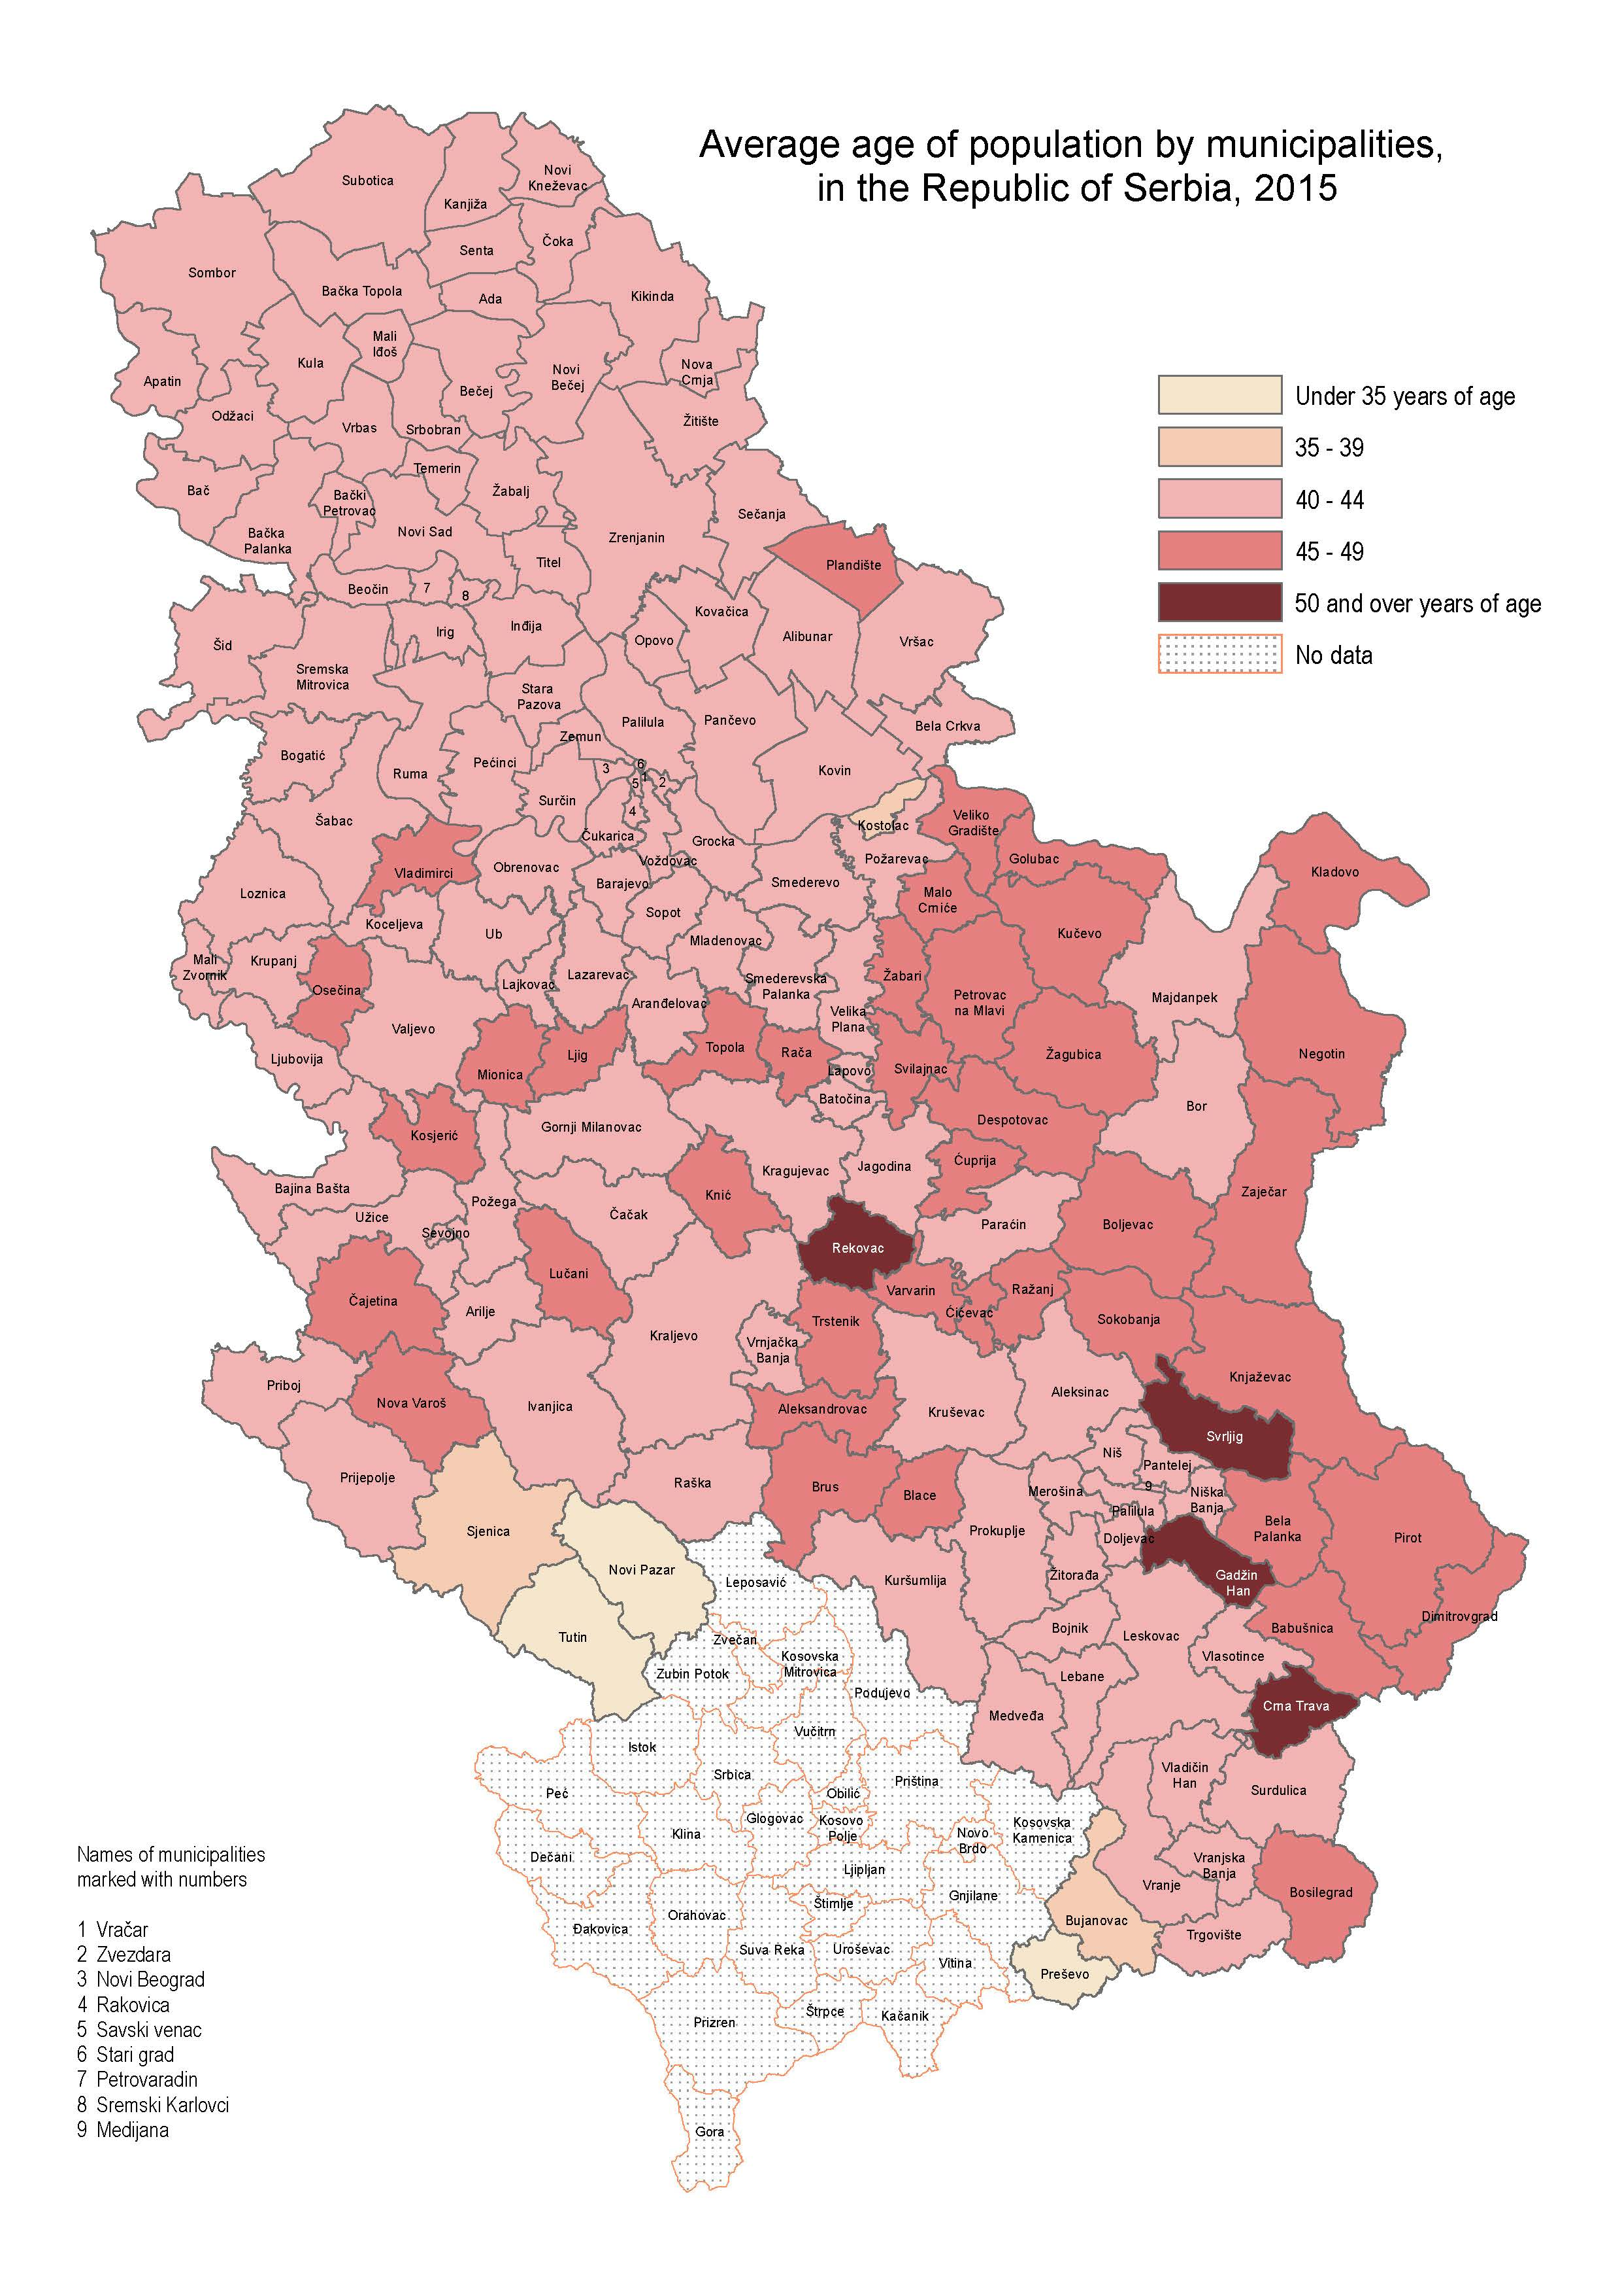
Contact: ljiljana.sekulic@stat.gov.rs, Phone: 011 2412-922, Ext: 295
Published and printed by: Statistical Office of the Republic of Serbia, 5 Milana Rakica St, Belgrade
Phone: +38111 2412922 (operator) ● Fax: +38111 2411260 ● www.stat.gov.rs
Responsible: Dr Miladin Kovačević, Director
Circulation: 20 ● Annual

