 | Republic of Serbia  Statistical Office of the Republic of Serbia | ISSN 0353-9555
STATISTICAL RELEASE |  | PD10
Number 084 - Year LXVI, 31/03/2016
Survey on Income and living conditions |  | SRB084 PD10 310316
Poverty and Social Inequality in Republic of Serbia in 2015
The Survey on Income and Living Conditions (SILC) was implemented for the third time in Serbia in 2015.
The goal of the Survey is to collect data in order to calculate the indicators of poverty, social exclusion and living conditions. The way in which the survey is conducted is of particular importance, knowing that it has been based on the standardized methodology, applied in all EU member states. The Survey is conducted once a year.
According to the results, the at-risk-of-poverty or social exclusion rate in 2015 is 41.3%. Beside this, the at-risk-of-poverty rate is 25.4%. These persons are not necessarily poor, but they are at the higher risk of poverty than the others.
The at-risk-of-poverty threshold (relative poverty line) amounts to 14,920.00 dinars a month on an average for a single person household. For a household with two adults and one child aged below 14, the threshold is 26,856.00 dinars per month, while for a four-member household with two adults and two children aged below 14, it amounts to 31,332.20 dinars.
The at-risk-of-poverty rate by age shows that individuals aged 18-24 are the most exposed to the poverty risk (30.3%), as well as individuals up to 18 years of age (29.9%). The lowest at-risk-of-poverty rate is found in the group of persons who are over 65 years (19.7%).
The highest at-risk-of-poverty rate have individuals in households with two adults with three or more dependent children, 35.8%, as well as single person households with dependent children, 35.4%.
According to the activity status for persons aged 18 and over, the most exposed to the at-risk-of-poverty are unemployed persons (46.2%), while the lowest at-risk-of-poverty rate have employees working for employers (8.5%). In case of self-employed persons, this rate amounts to 37.3%. The at-risk-of-poverty rate for pensioners is 15.2%.
Graph 1. Main indicators on poverty and social exclusion, %
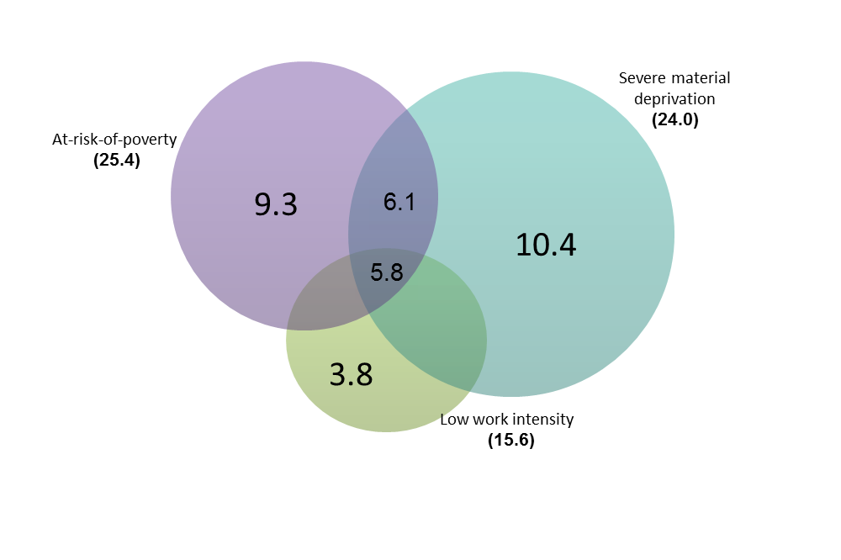
Table 1. Relative poverty and inequality indicators,
 | 2013 | 2014 | 2015
At-risk-of-poverty rate, % | 24.5 | 25.4 | 25.4
At-risk-of-poverty rate before social transfers:
Social transfers not included in the income, % | 31.8 | 32.6 | 37.2
Pensions and social transfers not included in the income, % | 51.1 | 52.5 | 55.7
At-risk-of-poverty threshold (on a monthly level):
Single person household, in RSD | 13,680.00 | 13,500.00 | 14,920.10
Household with two adults and one child younger than 14 years, in RSD | 24,624.00 | 24,300.00 | 26,856.17
Household with two adults and two children younger than 14 years, in RSD | 28,728.00 | 28,350.00 | 31,332.20
Relative at-risk-of-poverty gap, % | 36.6 | 40.3 | 37.6
S80/S20 income quintile share ratio | 8.6 | 9.8 | 9.0
Gini coefficient | 38.0 | 38.6 | 38.2

Table 2. At-risk-of-poverty rate by sex and age, %
 | 2015
 | Gender |  | Total
 | Male | Female
REPUBLIC OF SERBIA | 26.1 | 24.6 | 25.4
Age groups
0-17 | - | - | 29.9
18-64 | 27.1 | 24.4 | 25.8
18-24 | 30.5 | 30.0 | 30.3
25-54 | 26.3 | 25.1 | 25.7
55-64 | 27.4 | 19.9 | 23.5
65 and over | 16.8 | 21.9 | 19.7

Table 3. At-risk-of-poverty rate by the type of household, %
 | 2013 | 2014 | 2015
All households without dependent children | 21.3 | 22,9 | 21.7
Single person household | 26.3 | 28,7 | 29.0
Male | 29.5 | 32,9 | 34.9
Female | 24.4 | 26,1 | 25.3
Younger than 65 | 28.1 | 33,6 | 33.1
Older than 64 | 24.9 | 24,9 | 26.1
Two adults without dependent children | 21.4 | 20,9 | 20.3
Two adults younger than 65 | 24.6 | 24,0 | 24.1
Two adults. at least one aged 65 years and over | 18.1 | 18,1 | 17.1
Other households without dependent children | 19.2 | 22,2 | 19.9
All households with dependent children | 27.0 | 27,4 | 28.2
Single person with dependent children | 34.2 | 33,8 | 35.4
Two adults with one dependent child | 24.9 | 19,8 | 21.0
Two adults with two dependent children | 24.6 | 26,8 | 26.7
Two adults with three or more dependent children | 44.4 | 36,7 | 35.8
Other households with dependent children | 25.8 | 28,0 | 29.3
Table 4. At-risk-of-poverty rate by the most frequent status in the labor market and by sex (for persons aged 18 and over), %
 | 2015
 | Gender |  | Total
 | Male | Female
Employed persons | 15.7 | 10.6 | 13.5
Employees | 9.1 | 7.9 | 8.5
Self-employed | 39.4 | 32.2 | 37.3
Not employed persons | 31.7 | 29.5 | 30.5
Unemployed persons | 49.4 | 42.5 | 46.2
Retired persons | 14.5 | 15.7 | 15.2
Other inactive persons | 32.0 | 38.6 | 36.6

Table 5. Dispersion around the at-risk-of-poverty threshold, %
 | 2013 | 2014 | 2015
40% of the national median equivalised disposable income
At-risk-of-poverty rate | 13.3 | 14.1 | 13.6
50% of the national median equivalised disposable income
At-risk-of-poverty rate | 18.4 | 19.4 | 19.4
70% of the national median equivalised disposable income
At-risk-of-poverty rate | 30.4 | 32.0 | 31.7

Table 6. Material deprivation indicators, %
 | 2013 | 2014 | 2015
Persons who live in a household that:
Cannot afford paying for one week annual holiday away from home | 67.2 | 68.4 | 68.5
Cannot afford a meal with meat, chicken, fish (or vegetarian equivalent) every second day | 30.6 | 26.1 | 24.6
Cannot afford unexpected financial expense (10,000 RSD) | 50.1 | 50.7 | 47.3
Cannot afford to keep home adequately warm | 18.3 | 17.1 | 15.2
Material deprivation rate (three or more items) | 44.3 | 44.1 | 40.9

Graph 2. Subjective poverty (Ability of the household to make ends meet), % | Graph 3. Financial burden of the total housing cost, %

Methodology

Territorial coverage: The survey is implemented on the territory of the Republic of Serbia and the processing provides data for the Republic of Serbia (total) and for the regions: Belgrade region, Vojvodina region, Sumadija and Western Serbia, and Southern and Eastern Serbia. Since 1999, the Statistical Office of the Republic of Serbia has not collected data for the AP Kosovo and Metohia and therefore it is not included in the coverage of the data for the Republic of Serbia (total).

Sample: The sample design for the survey is a two-stage stratified sample with enumeration areas as the primary and households as the secondary units of selection. From an original sample design that included 6,663 of the households, 5,680 households were surveyed (85,2%), which included 15,552 persons aged 16 and over.

Observation units are households selected according to the sample plan, whether these were one-person or several-member households, as well as all household members aged 16 and over. Collective households were not included in this survey.

- A household means any family or other community of persons who live together and jointly spend funds for meeting their basic life needs (food, housing, etc.), regardless of whether all members are permanently at the place where the household resides or some of them temporarily reside in some other place in the country or abroad on account of work, education or for some other reason.

- Collective (institutional) households are, e.g., monasteries, institutes for the placement of children without parental care, student dormitories, military facilities, boarding schools, establishments for carrying out prison sanctions and detention measures, etc.

Reference period for the collected data that refers to:

- income is 12 months in the previous calendar year – the year 2014 for the third wave,
- material deprivation is the moment of surveying – the year 2015 for the third wave.

Equivalised disposable income is the total household disposable income evenly distributed among the members of the household according to the modified OECD (Organisation for Economic Co-operation and Development) equivalence scale. In accordance with this scale, first adult member of the household receives the value of 1, other adults aged 14 and over 0.5, and children under the age of 14, 0.3. Household income does not include income in kind.

The at-risk-of-poverty threshold (relative poverty line) represents 60% of the median national equivalised disposable income and it is presented in dinars.

The at-risk-of-poverty rate represents the share of persons whose equivalised disposable income is below relative poverty line. These persons are not necessarily poor, but they are at the higher risk of poverty than others.

The relative at-risk-of-poverty gap represents the difference between the at-risk-of-poverty threshold and the median equivalised income of the persons who are below the at-risk-of-poverty threshold.

The S80/S20 income quintile share ratio compares the total equivalised disposable income of the upper income quintile (20% of the population with the highest equivalised income) with those from the lower income quintile (20% of the population with the lowest equivalised income).

The Gini coefficient represents the measure of inequality in the distribution of income. The value of this coefficient goes within the interval from 0 to 1, where 0 represents perfect equality, i.e., each person has equal income. As the value of the coefficient grows, so grows the income inequality.

The most frequent status in the labor market refers to the activity status which the person had for at least 7 months during the reference period. It is calculated for the persons aged 18 and over.
The dispersion around the at-risk-of-poverty threshold shows sensitivity of the estimated at-risk-of-poverty rate to the selection of the poverty threshold – 40%, 50%, 70% of the median national equivalised disposable income.
The material deprivation of a household is an indicator of the material conditions that influence the quality of life of the household.
The material deprivation items are:
- inability of the household to keep its home adequately warm,
- inability of the household to afford the washing machine,
- inability of the household to afford a car,
- inability of the household to afford paying for one week annual holiday away from home,
- inability of the household to face unexpected financial expenses,
- inability of the household to afford a telephone,
- inability of the household to afford a colour TV,
- inability of the household to afford a meal with meat, chicken, fish (or vegetarian equivalent) every second day,
- being in arrears with mortgage or rent payments, utility bills, hire purchase instalments or other loan payments.
The material deprivation rate is an indicator of the inability of a household to financially afford at least 3 out of 9 items of material deprivation.
The severe material deprivation rate is an indicator of financial inability of a household to afford at least 4 out of 9 items of material deprivation.
Subjective poverty (Ability to make ends meet) represents a subjective feeling of the respondents about the difficulties faced by the household in its attempt to pay all of its necessary costs taking into consideration the total income of that household.
Financial burden of the total housing cost shows the degree to which housing costs represent a financial burden for a household. These expenditures include housing payments whether installments for the repayment of a loan, if the household member is the owner of the dwelling, or rent, if the household members rents the dwelling. Housing costs also include utility services, expenditures related to housing and expenditures related to the maintenance of the dwelling.
The work intensity of the household refers to the number of months that all working age household members have been working during the income reference period as a proportion of the total number of months that could theoretically be worked within the household. The work intensity is defined as very low (0-0.20), low (0.20-0.45), medium (0.45-0.55), high (0.55-0.85) and very high (0.85-1). For example, low work intensity refers to households whose working-age members worked between 20% and 45% of the total number of months they could have possibly worked during a referent period.
The at-risk-of-poverty or social exclusion rate (AROPE) shows the share of individuals who are at risk of poverty or are severely materially deprived or live in households with very low work intensity. Since the enactment of the Europe 2020 Strategy this indicator became the headline poverty reduction indicator.

Contact : tijana.comic@stat.gov.rs , phone: 011 2412-922 ext. 363
Published and printed by: Statistical Office of the Republic of Serbia, Milana Rakica 5, Belgrade
Phone: +381 11 2412922 ● Fax: +381 11 2411260 ● www.stat.gov.rs
Responsible: Dr Miladin Kovačević, Director
Circulation: 20 • Issued annually

The revised results for 2014 are presented in the tables.
Since 1999, the Statistical Office of the Republic of Serbia has not collected data for the AP Kosovo and Metohia and therefore it is not included in the coverage of the data for the Republic of Serbia (total)
See methodological explanation for equivalised disposable income
The notion “dependent child” refers to all individuals less than 18, as well as to persons aged 18 to 24 who live with at least one parent and are economically inactive
The definitions of the main indicators are given in the methodology section
Reference period: previous year of the year given in table.
The at-risk-of-poverty rate if social transfers and pensions would not exist
Reference period: previous year of the year given in table.
For the 0-17 age group only the total at-risk-of-poverty rate is shown, without any separation by sex
Reference period: previous year of the year given in table.
Reference period: previous year of the year given in table.
Self-employed persons also include farmers
Reference period: previous year of the year given in table.
Reference period: year given in table.
Reference period: 2015
Reference period: 2015

